MHRA Freeze Dryer/Ampoule line replacement project – Early Market Engagement

Introduction
The Medicines Healthcare products Regulatory Agency (MHRA) are an Executive Agency of the Department for Health and Social Care (DHSC) within the UK government. They are the UK regulatory body responsible for the safety and efficacy of medical products used within the UK.
One of the MHRA’s statutory delegated functions is the provision of biological reference materials, these are available to support all stages of the product life cycle and play an essential role in supporting the development of safe and effective biological medicines that underpin patient health.
We play a critical role in developing new standardisation technologies and methodologies and we evolve our NIBSC biological standards to reflect industry innovation. This is crucial to how we bring confidence to complex and rapidly changing areas of medicine and healthcare.

Manufacturing facility
As well as government offices in London, the MHRA also has dedicated laboratory and manufacturing facilities at a site in Hertfordshire.
The manufacturing facility operates on a smaller scale than many pharmaceutical sites and as final products are not for clinical administration does not operate under GMP. Instead, aseptic principles are observed with environmental monitoring performed to inform product bioburden. The facility is certified to ISO 9001 for the delivery of much of the portfolio and ISO 13485 for the delivery of CE marked diagnostic reference materials that must conform the incoming In Vitro Diagnostic Regulation (IVDR).
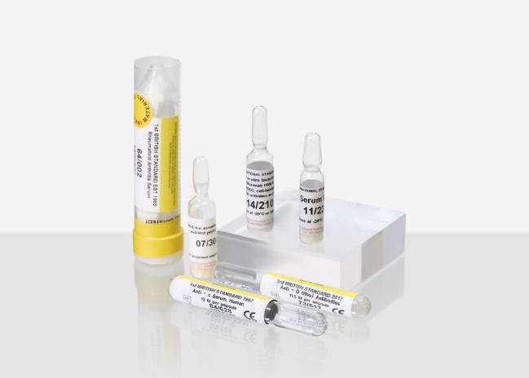
The facility delivers a broad portfolio of over 1300 different types of material ranging from infectious materials that support blood safety to monoclonal antibodies for new therapies and small proteins that support drug dosing such as insulin. Materials can comprise a variety of excipients both biological and synthetic in nature.
In total the facility delivers in the order of ~ 500,000 units/year.
The facility houses two filling lines for ampoule and vial filling, and batch freeze dryers that support a capacity up to 25,000 ampoules or 15,000 vials in a single run.

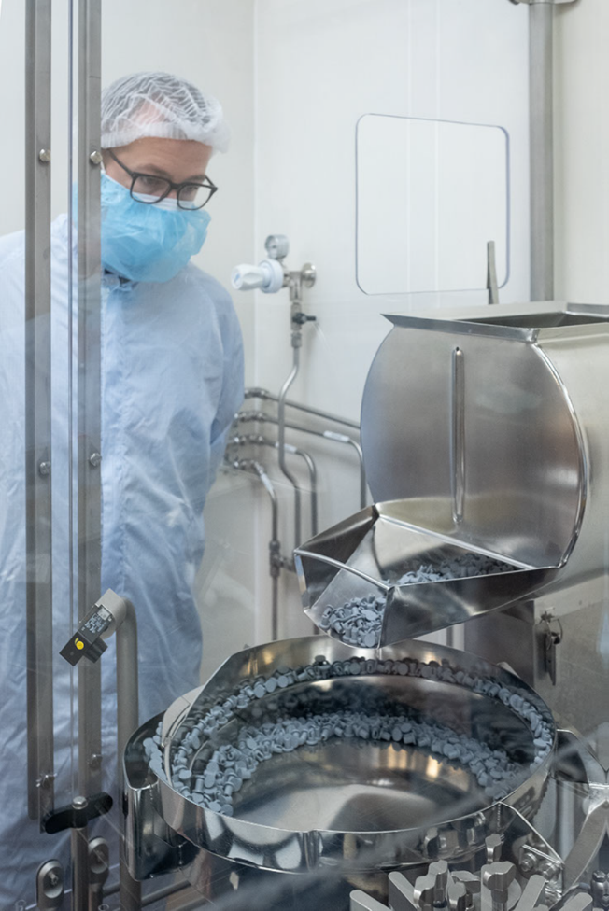
Current equipment to be replaced:
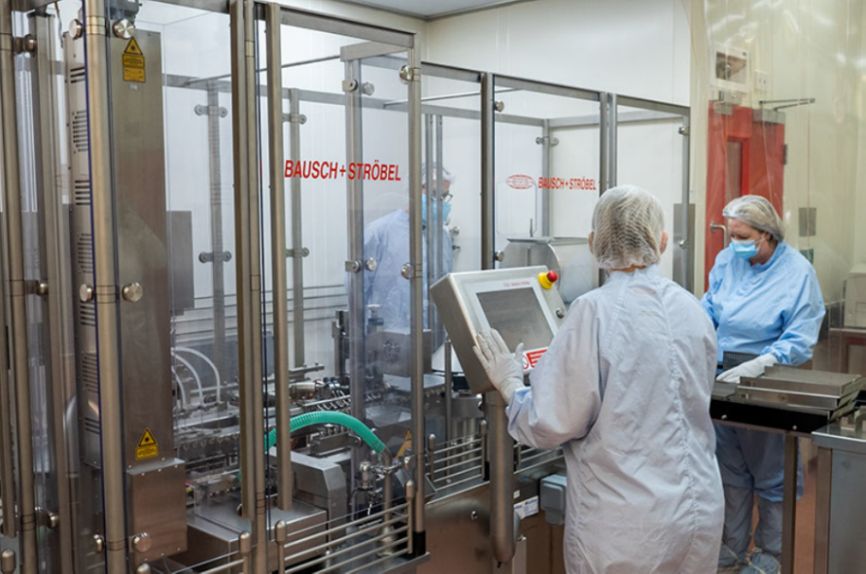
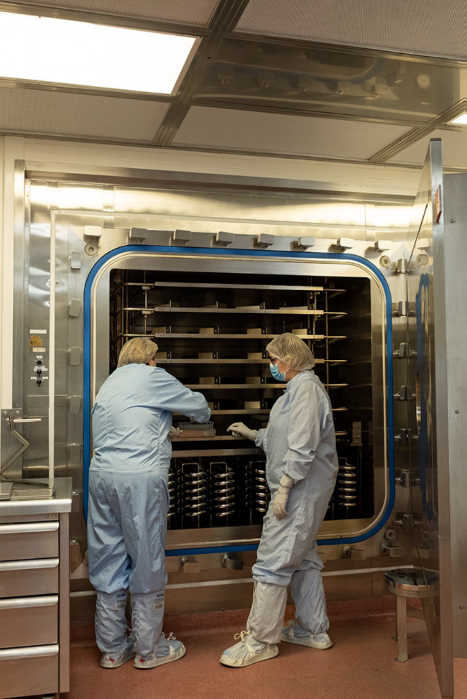

- AMPOULE FILLING LINE/FREEZE DRYER
The current equipment comprises a Bausch & Stroebel AFV 5090, ampoule filling & sealing with a throughput of up to 6,000/hour. The line operates as a semi-automated feed with manual intervention required for loading glass ampoules and the transfer of filled ampoules to the freeze dryer shelves. Automated check weighing is performed on 3 of every 90 ampoules filled.
This project will deliver improved freeze-drying capacity for the facility. It will see the removal of a small scale 1.0m² Serail CS15 freezer dryer to be replaced with a medium scale 6.0m2, production, steam sterilizable freeze dryer
- LASER ETCHING
Each glass vial or ampoule is laser etched at the point of liquid filing with a unique code number.
Pumps and lines are manually stripped down between runs and cleaned via sonication & autoclaving.
- FLAME SEALING
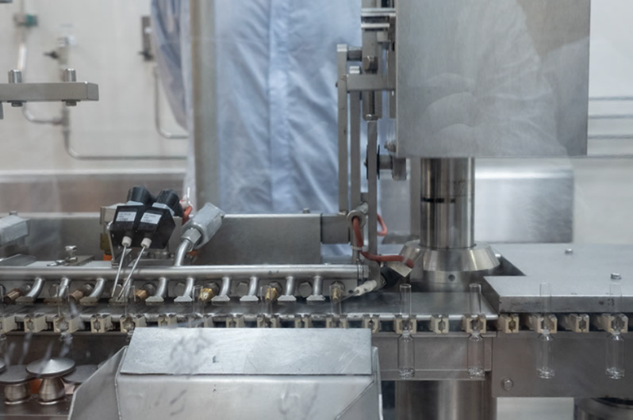
After freeze drying the ampoules are run back down the line for flame sealing. The current flame sealing device comprises 3 individual flame seal jets.
Lyophilised products are currently backfilled with nitrogen gas following drying.
A steam sterilization cycle is carried out at the end of each run.
- IT INTERFACES
Each freeze dryer is reliant on an independent PLC (Programmable Logic Controller), HMI (Human Machine Interface) and SCADA (Supervisory Control and Data Acquisition) systems that interface between site IT servers and the freeze dryers.
Final product QC for residual moisture and oxygen headspace are carried out by manual methods.

Our request to Market
The described equipment is approaching end of life and no longer provides business efficiencies both in time and environmental impact. The MHRA are therefore carrying out a market engagement exercise to inform an investment journey that will allow the MHRA to secure the future supply of global reference materials, but also look to improve process efficiencies but the introduction of newer equipment.
Questions to be discussed during a supplier day visit to site.
Please note that we are not expecting definitive answers to these questions during the visit to site. These questions are designed to help facilitate the drafting of our specifications for a subsequent tender.
Equipment

What current marketplace solution would you advise to allow us to:
- Continue our current BAU provision.
- Be agile to future innovations in the field of liquid filling and lyophilisation.

In the solutions that you outline, can you provide details on product quality checks that the equipment is capable of?

Are you able to supply a full end to end solution or part? If part, what part

What would be a typical footprint for a) Freeze Dryer, b) Filling line, c) supporting plant

Can you provide an off the shelf solution for our needs or would it be a bespoke build?

Would new technology interface with our current IT solutions?

Can you outline what metrics current IT solutions supply.

What would be the typical lifespan of new equipment with regards to:
- On-going support and maintenance
- Adaptability for innovation

Project delivery

Would you be able to manage the entire installation, or would you need to subcontract parts out?

Can you describe in your view what the end-to-end project would look like?

What do you perceive the biggest risk to this project being?

How long would the build time take. How long would the install time take?

Procurement

Can you provide an indicative price for your outlined solutions?

Can you outline likely lifetime costs for the solutions?

Could you give indicative timeframes for parts procurement?

Infrastructure

Please provide details of infrastructure dependencies that each proposed solution would require (gas supply, high voltage, air cooling, steam etc)

Please provide information around any specialist contractors, their locations (UK based) that would be required to service any of the plant or equipment provided as part of this ‘solution’

Environmental

Can you outline the environment footprint of the options you describe, giving consideration to the consumption of electricity/water/gas (or downstream outputs from gas use) and the use of refrigerant gases.

Would the service contract and serviceable parts required for the solutions you present be provided from the UK or overseas?

Proposed date for supplier visit: 11th October 23
Suppliers visit agenda
- Presentation and introduction to the MHRA
- Q and A session:
- This will start with a group session. Any questions that can be answered on the day will be answered to the whole group of attendees. Where we cannot answer a question on the day, we may have to take your questions away a provide a considered response via email.
- If requested, single supplier meetings will be accommodated.

