INTRODUCTION
This Request for Information (RFI) sets out the information which is required by West Sussex County Council (the Council) from potential suppliers to better refine the buying/procurement process for a future procurement of duct and dark fibre infrastructure design services.
No information contained in this RFI, or in any communication made between the Authority and any Potential Provider in connection with this RFI, shall be relied upon as constituting a contract, agreement or representation that any contract shall be offered in accordance with this RFI. Under no circumstances shall the Authority incur any liability in respect of this RFI or any supporting documentation.

BACKGROUND
West Sussex has a mixed and generally diverse economy that supports coastal, urban and rural areas as well as the South Downs National Park. 42% of West Sussex resident population, and over half of its businesses are located in rural areas.
The majority of the population lives in the four largest towns, Bognor Regis, Crawley, Horsham and Worthing. The M23 corridor runs down the eastern side of the county connecting Brighton with London and the A27 provides east/west links through coastal towns.
The Council has an ambition to enable a regional innovation zone linking economic hubs and functional economic areas across the wider West Sussex area. High quality, accessible, versatile, resilient and future proofed digital infrastructure is key to this ambition and will be a critical enabler for creating the conditions for innovation and growth across sectors and businesses in the region.
The Council wants to enable innovation by supporting collaboration between connected partners enabled by a high-quality technology platform to underpin sharing, networking, research and development opportunities. Open Access Digital Infrastructure can offer secure and scalable connectivity between businesses, research centres, manufacturing sites, education providers and innovators which could develop into a network of connected economic hubs and productivity centres. It can unlock new connectivity solutions for individual businesses and their supply chains, create the conditions for test beds and data and knowledge sharing and provide resilient future proof connectivity that could attract inward investment.
The Council along with its district and borough councils and Brighton and Hove Council has already invested in duct and dark fibre infrastructure known as the “OpenNetwork”. This network links strategic economic sites from Gatwick airport at the north of the county to the Brighton Digital Exchange on the coast.
The Council is exploring the potential to further extend the OpenNetwork to connect the West Sussex coastal region to the OpenNetwork and maximise benefits. A business case is currently being developed to understand the use cases and benefits that this level of connectivity can bring to the coastal region.
The business case will explore shortlisted options for the infrastructure that would enable such connectivity. Therefore the Council will be seeking a partner to support this element of the business case. The partner will bring its infrastructure design expertise and apply this to the potential 50km coastal extension of the OpenNetwork spine and its connection points to particular sites, as well as variant options currently being shortlisted.

- OUR AIMS – WHAT WE WANT TO ACHIEVE
The Council, working with public sector partners has invested in the build of the new 50km OpenNetwork which is in public ownership. Our aim is to further extend the network to support the creation of an innovation ecosystem across the region.
The Council is seeking a partner to deliver :
- A high-level design of a coastal spine network (approx. 50km)
- A high-level design of the spine’s access network to a number of strategic sites (number of locations TBC)
- A high-level design of a number of (typically 1 or 2) variants that will be comparators for the short-listed options in the business case.
- High level costings for the above designs
- Develop “blueprints” for business parks, residential sites and sites of innovation
The outputs of the design and costings will then be used in defining high level costs for a Green Book Business Case.
Map of current and proposed infrastructure
The red outline along the coast shows the indicative area under consideration (Brighton to Chichester) for extension. The current OpenNetwork is itself shown to the east of the county in segments (Crawley to Brighton).
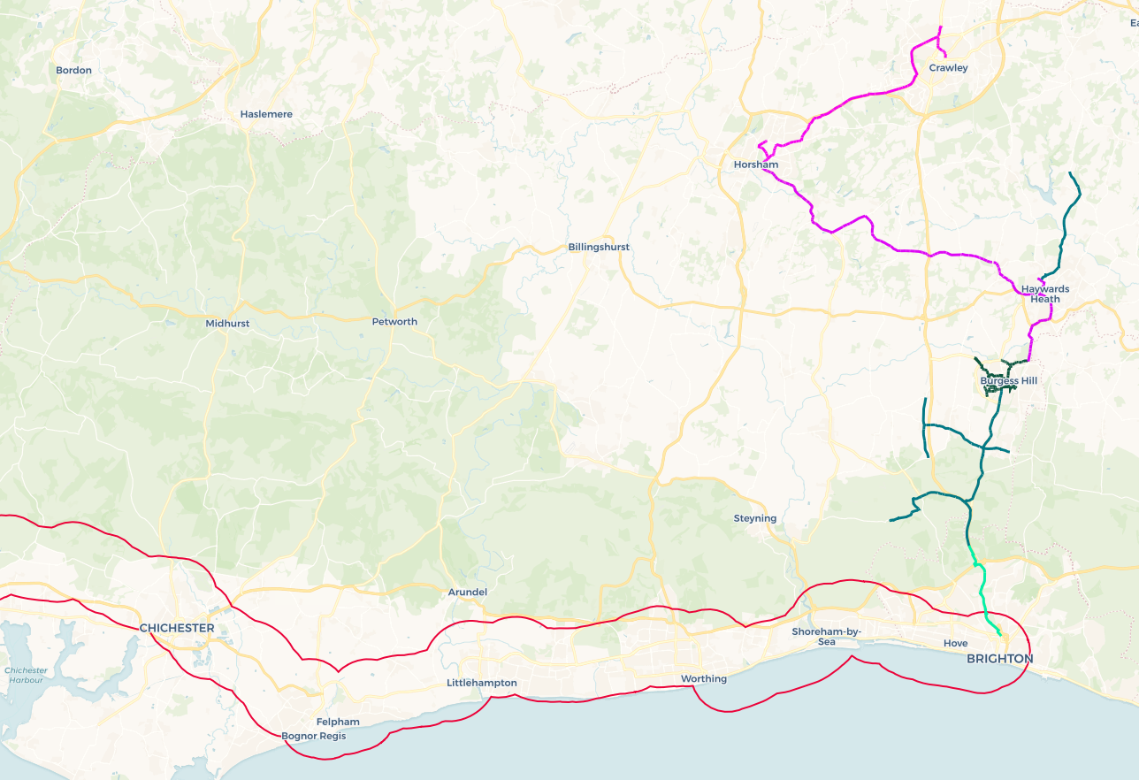

OUR TIMELINE
DATE | ACTIVITY
7/10/22 | Publication of the Request for Information
21/10/22 | Deadline for submission of a RFI Response
24/10/22 | Analysis of RFI responses
28/10/22 | Confirm next steps to RFI Respondents

OUESTIONS AND CLARIFICATIONS
• Potential Providers may raise questions or seek clarification regarding any aspect of this RFI document at any time to rachel.ayres@westsussex.gov.uk

GENERAL CONTACT POINT FOR THIS RFI
RFI Lead
Name: | Rachel Ayres
Telephone Number: | 0330 222 5702
Email Address: | rachel.ayres@westsussex.gov.uk

Attachments
Supplier Questionnaire

