Overview

PGHS has a requirement for the long-term hire/lease (10 years) of new modular classrooms comprising of two classrooms, two inner store areas and one central entrance lobby area. The modular building will be connected to the main school building, as shown in the aerial photo below:

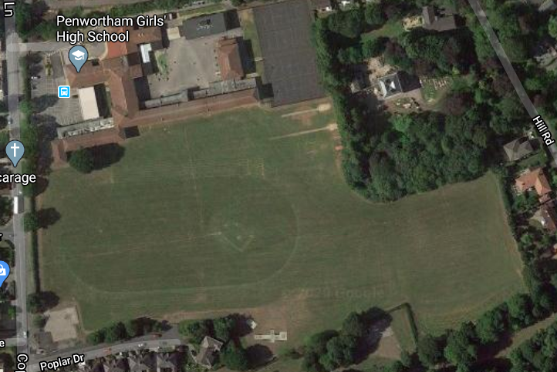
Position of modular building

The distance between both buildings will be in line with local authority and fire services regulations. PGHS will manage planning and building control applications to South Ribble Borough Council.

All structural design and building construction to be carried out in accordance with the appropriate Code of Practice, standards and reference to:-

BS6399, BS5950, BS 8110, BS648, BS5268.

Technical and Qualitative Specification

In addition to providing the weekly/monthly building hire/lease rates for 10 years, tender submissions should include detailed information including costs supporting the type of modular building in reference to the following technical and qualitative specification:

- Track lay from carpark to proposed location
- Delivery of building onto site including all transportation and crane hire costs if applicable
- All foundation and ground works
- Installation of buildings
- External skirting to cover open areas from building to ground
- Connection of modular building to main building (Est 2-3m)
- External finish e.g. ivory coloured cladding/panels similar to current main building wall colour
- Roof drainage and connection into surface water drainage system
- Intruder alarm linked to main school intruder alarm system
- Fire alarm linked to main school fire alarm system
- Fire MCP
- Emergency lighting with test switch and illuminated signage
- Emergency fire exits from each classroom
- All entrances and exits in line with current DDA regulations
- Ramps and pathways from each fire exit leading to assembly point
- 8kw heat and cooling air conditioning unit in each classroom with frost protection
- External vandal proof cage for air conditioning
- Single phase 63A consumer unit connected to power supply within the main school building
- Internal dado trunking to facilitate 3 x double power outlets and 3 double x Cat5 data connection outlets in each classroom
- Cat 5 data cables connected back to main building patch panel located within the ICT managers office
- External bulkhead lighting controlled by time switch and photo cell
- Internal suspended ceiling with 600x600mm tiles
- 600x600 LED lighting panels operated by PIR movement detection
- Telephone connection for each classroom linked to main school network
- School bell in lobby area linked into main school bell system
- 2KW high level heater in lobby area
- Mesh window guards
- Internal, walls, floor and ceiling specification and finish including sound insulation between rooms
- Internal doors with vision panels and kick panels
- External door specification with locks suited to current school keys
- Double glazed windows with sun bronze glass, white uPVC frames , top openers with restrictors, trickle vents and lockable handles
- Carpet tiles flooring for classrooms
- Nonslip vinyl flooring for lobby and store room areas
- Roof covering
- Welfare accommodation for installation team
- Storage area for building materials
- Heras fencing to segregate from sports field and pedestrians during installation
- Removal of all waste materials
- Warranty period
- Planned and reactive maintenance included / additional?
- Registration with appropriate professional bodies e.g. FENSA, CHAS, Constructionline, NICEIC, MPBA etc.
- Previous examples of similar installations within a school environment
- Previous customer feedback

Tender Evaluation Marking Criteria

Tenders will be evaluated against the marking criteria as described below. All tenders submitted will be assessed by the Headteacher, School Governors, Business Manager, Assistant Business Manager and Premises Management Consultant from PGHS.

The number of marks available for the Commercial and Technical Qualitative elements of the tenders received will be as follows:

Description | Maximum score available | Maximum points available
Commercial | 60 | 60
Technical & Qualitative | 40 | 110
Total | 100 | 170

Commercial

60% of the overall assessment of tenders will be based on the commercial review. The tender offer submitted to be the most commercially acceptable i.e. the best price including rental/lease and installation costs will receive a full score of 60% weighting with other tenders submitted receiving lower scores based on the degree to which the best price is exceeded.

The commercial assessment will use the following pricing evaluation:

The tenderer offering the lowest tendered price will be awarded a pricing score of 60 with the other tenderers being awarded a pricing score based on a percentage (%) difference method. An example of how this works is provided below:

Tenderer A provides a tendered price of £100000 the lowest
Tenderer B provides a tendered price of £120000

Tenderer B score is calculated as follows:

Total available percentage x lowest price/higher price e.g. 60x100000/120000 = 50.

Technical and Qualitative Specification

Marks will be awarded on a scale of 0 to 5 as set out in the Table below:

0 | Not Answered | There is no evidence the specification has been answered at all.
1 | Poor | There is limited evidence; some information is provided but lacking in detail.
2 | Satisfactory | There is some evidence of meeting the specification, however there are some gaps.
3 | Good | There is evidence of meeting the specification.
4 | Very Good | All detail against the specification has been provided.
5 | Excellent | All detail has been provided covering all areas with clear evidence of similar projects with every confidence of delivering within timescales.

There are 3 individual areas with a maximum of 5 marks as shown below. Each area is then weighted, giving a maximum possible score of 110 as shown in the following table:

Criterion No | Area | Max Score | Weighting | Weighted Max Score (c x d)
(a) | (b) | (c) | (d) | (e)
1 | External works | 5 | 7 | 35
2 | Internal works | 5 | 10 | 50
3 | Customer Feedback | 5 | 5 | 25
Maximum Possible Score |  |  |  | 110

The number of points scored by each tenderer will form their final Technical and Qualitative score. The most compliant tenderer will be allocated the full 110 marks, with the other tenderers being allocated a final score using a percentage (%) difference method. An example of how this works is provided below:

Tenderer A is awarder an initial Technical & Qualitative score of 110 (highest)
Tenderer B is awarded an initial Technical & Qualitative score of 90.
Tenderer A’s final Technical & Qualitative score is therefore 40 points (maximum score available as shown in the table in page 1)
Tenderer B’s final Technical & Qualitative score is calculated as follows:

Final Technical & Qualitative Score = Total available marks x (tender technical & qualitative mark / highest technical & qualitative mark)

e.g. 40 x (90/110) = 32.72 (rounded up to 33).

PGHS may seek clarification of bids where it requires further explanation or understanding of what has been submitted or if any part of the submission cannot be evaluated adequately because it lacks the required information, contains apparent errors or its meaning or intent is unclear. This will be in the form of formal written questions and responses will then form part of the Tenderers submission. As a result the marking awarded to those areas may be revised on receipt of the clarification.

Final Evaluation

The scores for all compliant Commercial, Technical and Qualitative tenders will be added together to get a final winning tender. The tender with the highest score will be the winner.

You must submit your tender to arrive no later than 10:00am on the 12th August 2020 by email to g.oneill@penworthamgirls.lancs.sch.uk

Any tender received after 10:00 on the 12th August 2020 will be rejected unless the tenderer can provide irrefutable evidence that the tender was received in full by the due date and time.

G. O’Neill
Premises Management Consultant

