

Publication Date: 25 October 2024
Submission deadline: 7th January 2025 MIDDAY
Invitation to tender for: Christmas Lights for 2025-2027
Document 1: Instructions and Specification

Contents
Background 3
Instructions to tender 3
Tender process 3
Preparation of tenders 4
Timetable 6
Tender submission guidelines 6
Format and Cost Summary 7
Arithmetic Accuracy 8
Indicative Budget 8
Evaluation & weightings 8
Selection Questionnaire 9
Quality Criteria Assessment 11
Quality Scoring 15
Price Criteria Assessment 15
Scoring methodology (quality and price criteria) 16
Final Submissions 17
Specification 18
Preamble 18
Aylesbury Town Council Objectives 18
Scope of Services 19
Installation requirements 21
Structural Integrity testing 22
Installation Method Statement 22
Appendix 1 23
Primary area locations within current scheme 2022- 2024 see maps below 23
Appendix 2 24
Locations of lights in the town centre 24

Background
Aylesbury Town Council (the Council) has the responsibility for the Christmas lights displays throughout the town centre. Prior to this, the responsibility was held by Buckinghamshire Council, but it was devolved to the Council in 2022. Buckinghamshire Council continues to oversee and maintain the electrical highway infrastructure, while non-highway electrical infrastructure is managed through agreements with landlords for the use of bracketry and eye bolts on their properties.
The Council is inviting tenders for the high-quality design and supply of Christmas Lights, encompassing their installation, removal, storage, and annual maintenance and testing. This contract will cover the festive light displays commencing in November 2025 and continuing through the 2026 and 2027 festive seasons.
The Council is committed to delivering a Christmas Lights display of the highest standard for the residents of Aylesbury town centre. We aim for a display that is festive, modern, and delivers a WOW factor. Spanning three years, this procurement welcomes innovative ideas and suggestions on how to enhance the display.
All fixings are expected to meet or exceed the current lighting, design and arrangement and comply with all relevant legislation.
If you intend to tender for the above-mentioned services, please read the following instructions carefully. Failure to comply with the instructions and failure to return all the required documents and information before the deadline stated may invalidate your tender submission.

Instructions to tender

Tender process
This tender is being conducted under the Open Procedure in accordance with the Public Contract Regulations 2015.
These instructions are designed to ensure that all tenders are given equal and fair consideration. It is important therefore that Tenderers provide all the information asked for in the format and order specified. Please raise clarifications via email as per the contact details and timescales below, if Tenderers have any doubts as to what is required or have difficulty in providing the information requested. Pre-tender negotiations are not allowed. Direct communication with the Council or representatives of the Council is not allowed. All communications must be directed through the email address provided.
For your tender to be compliant, please ensure that the instructions set out in these tender documents are followed carefully. Please note that failure to comply with the instructions and failure to return all the required documents and information before the deadline stated may result in your tender submission being invalid.
Tenders may be rejected if the information asked for is not given at the time of tendering.
If you plan to bid for this tender please email diane.harrison@aylesburytowncouncil.gov.uk with an expression of interest by 20/12/2024.
All bids must be returned electronically using the following email address: christmastender@aylesburytowncouncil.gov.uk

Preparation of tenders
- Comprehensive Information: While this document aims to be as complete and comprehensive as possible, potential tenderers must obtain all necessary information for developing and costing their proposal and entering a contract.

- Access to Information: The Council will ensure that tenderers have access to the information they need to produce their response.

- Clarification: Potential tenderers must clarify any points of doubt or ambiguity before submitting their tender.

  - The deadline for clarifications is Friday 20th December 2024 at 17:00.

  - Any questions regarding these documents and the specific requirements of the Council must be made in writing by email to diane.harrison@aylesburytowncouncil.gov.uk, specifying that the email relates to the Aylesbury Christmas Lights displays contract.

  - Any clarifications or additional information provided as a result of such enquiries and clarifications shall be circulated to all tenderers that have expressed an interest in this tender opportunity.

  - The Council reserves the right to cancel or amend the tender process at any time without incurring liability. Prior to the submission deadline, the Council may issue clarifications, revisions, or additional documentation, which will replace the original documents. Any such updates will be communicated to all Tenderers and will be incorporated into the tender documentation.

- Site Visits: Tenderers must confirm in their submission that they have visited the sites. The sites are open to public access, and Tenderers can attend without notifying or having the Council present.

  - If a Tenderer wishes to meet a representative of the Council, please contact Diane Harrison via email using diane.harrison@aylesburytowncouncil.gov.uk who shall provide an accompanied site visit at a mutually agreed time between 18th and 20th November 2024.

- Tenders: should be emailed to christmastender@aylesburytowncouncil.gov.uk clearly marked as “Christmas Tender,” to be received no later than Tuesday, 7 January 2025, 12 noon. Tenders received after this time will not be considered.

- Interviews: Tenderer interviews will be used for post tender clarification purposes only. The interviews will provide each Tenderer with the opportunity to give an overview of their tender proposal and designs and discuss any clarifications arising. Interviews will enable the evaluation team to reconsider, and where appropriate re-evaluate, the scores previously awarded to the quality criteria responses. The outcome may be a revision to the scores initially allocated to those responses.

- Basis of contract: The proposed conditions of contract can be found as part of this tender pack. The contract awarded will be based on the published contract terms, tender responses, clarifications, quality and commercial responses, incorporating the pricing schedule.
  - Please see Terms and Conditions Document 5.

- Duration of contract: The contract is to be for a period of three (3) years with the possible extension of one (1) further year (3+1).

- Tenderer Warranties: In submitting their Tender, the Tenderer warrants, represents and undertakes to the Academy that it:
  - has full power and authority to enter into the Contract and provide the goods, services or works and will, if requested, produce evidence of such to the Council; and
  - is of sound financial standing and the Tenderer and its partners, directors, officers and employees are not aware of any circumstances which may adversely affect such financial standing in the future.

- Contact Details:
  - Tenderers are requested to confirm their expressions of interest in this tender process, by email to diane.harrison@aylesburytowncouncil.gov.uk by 20/12/2024 so that the Council can inform you of any clarifications that arise during tender process.
  - Any question regarding these documents and the specific requirements of the Council and requests for accompanied site visits (within the dates stipulated in the timetable) must be made in writing by email to diane.harrison@aylesburytowncouncil.gov.uk and specify that the e-mail relates to the Aylesbury Christmas Lights displays contract.

Timetable
This timetable is provisional and may be subject to change but will be adhered to by the Council as far as reasonably possible.

Target Date | Task
25/10/2024 – 20/12/2417:00 | Clarifications period
25/10/2024 – 20/12/2417:00 | Tenderers to confirm expression of interest to the Council
18/11/2024 – 20/11/2024 | Host site visits
7/1/2025 12:00 MIDDAY | Tender return deadline
7/1/2025 12.01PM | Tender returns download and compliance checks
8/1/2025 – 13/1/2025 | Tender evaluations
13/1/2025 | Confirm interview times
17/1/2025 | Interviews at Aylesbury Town Hall
21/01/2025 - 7/2/2025 | Award recommendations and approvals
11/2/2025 | Issue intention to award letters
12/2/2025 – 22/2/2025 | Standstill period
24/2/2025 | Administer call off contract with winning tenderer
1/3/2025 | Contract commencement
5/3/2025 | Award Notice

Tender submission guidelines
- Submission Invitation: Interested tenderers are invited to submit a fully costed tender proposal along with all supporting documents as specified in this Tender Request.

- Additional Information: The Council reserves the right to request additional information from a tenderer to clarify their proposal. This information must be supplied at the tenderer’s expense and within the timescales requested by the Council.

- Supporting Documents: Please include any supporting documents where appropriate, clearly marking the name of your organisation and the number of the question to which you refer on all documents. Provide an index of all documents referred to in the completed tender. Any photographs used to demonstrate suggested lighting schemes must be of sufficient quality to be photocopied.

- Submission Method: Tenderers must email one copy of the completed tender and any supporting documentation to christmastender@aylesburytowncouncil.gov.uk by 12:00 GMT Tuesday 7th January 2025. Tenders should include fully completed:
  - Document 2
  - Document 3 (including signed declaration)
  - Document 4
  - Supporting documents and certification requested.

- Detailed Tender: The tender document should detail precisely how the Tenderer will meet the Council’s requirements, referencing the Council’s schedule of requirements. This includes the completion of the enclosed quality questions and pricing schedule.

- Right to Reject: The Council does not bind itself to accept the lowest bid or any tender. It reserves the right to withdraw any part of the tender document prior to the award of the contract and to discontinue the tender process at any time. There is no guarantee that a contract will be awarded.

- Notification of Decision: The Council will notify all tenderers of the Council’s decision at the conclusion of the tender selection process, providing a debrief to unsuccessful tenderers.

- Compliance: The Council may reject any tender that does not comply in any matter, and their decision in this regard shall be final.

Format and Cost Summary
- Cost Details: Tenderers must provide full details of all costs, exclusive of VAT, as per the enclosed pricing schedule.

- Pricing Schedule: The completed pricing schedule and cost information, Document 4, must be attached as an addendum to the final submitted proposal.

- No Alterations: Once the tender has been submitted, no alterations to the text or pricing will be permitted. Failure to complete any part of the tender documents may result in rejection of the tender.

- Cost Clarity: Clearly state what is to be provided within each area of cost. The Council will not make payments for any costs not listed here and/or ancillary to the service provision.

- Three-Year Agreement: Prices should reflect a three-year agreement. Any subsequent cost increases over those three years that are not part of this formal tender will not be the responsibility of the Council. Please take into consideration any inflation when quoting for the 3-year contract.

- Preferred Cost Structure: The Council prefers that all costs be spread evenly over the period of the contract.

- Format of tenders: All tenders should be submitted be in Microsoft Word, Microsoft Excel or PDF. The Pricing Schedule (Document 4) should be submitted in Excel format.

Arithmetic Accuracy
Responsibility for Accuracy: It is the tenderer’s responsibility to ensure all costs are identified, entered in the pricing schedule, and are accurate. Any area of cost not identified and included with the submission will be treated as free of charge.

Post-Contract Mistakes: If arithmetical mistakes are found after the contract has been awarded, they will not be taken into account. The figure agreed at the time of the contract will prevail.

Indicative Budget
The Council has a budget of £270,000 allocated to meet this requirement over the term of the contract. Tenderers should endeavour that pricing submitted falls within this budget.

Evaluation & weightings
This tender process has been designed to ensure that tenders are evaluated fairly to ascertain the most economically advantageous tender. The Council reserves the right to decline to make any award. The award criteria will be based on the most economically advantageous tender.
All tenders will be evaluated in accordance with the evaluation criteria set out in these documents.
The Council will complete the full evaluation process for all compliant tenders, which meet all the mandatory requirements as set out within the documents.
Award criteria will be evaluated by an Evaluation Panel. Tenderers should note that not all Panel Members may assess every question, but all tenders will be evaluated in the same manner and by the same Panel. Evaluation Panels may include other key stakeholders.
Please provide detailed and relevant responses that demonstrate your ability to meet the requirements of the contract whilst not providing superfluous marketing or sales materials.
Please only supply additional documents where specifically requested by the Council and ensure they are clearly referenced in the relevant response.
A staged process of evaluation is, as follows. The process includes weightings/sub- weightings where applicable:
Stage 1 Selection Questionnaire Pass/Fail
Stage 2 Quality Assessment 60%
Stage 3 Pricing Assessment 40%

Selection Questionnaire
The Selection Questionnaire will be evaluated by the Council on the basis of pass or fail and can be identified as Document 2 Selection Questionnaire (SQ).
The Council will consider the information in Parts 1 and 2 of the SQ. The Council will exclude any Tenderer who answers 'Yes' to the Exclusion Grounds in Section 2 of the SQ and may exclude any Tenderer who answers 'Yes' to the Exclusion Grounds in Section 4 of the SQ. The decision to exclude Tenderers in relation to the Exclusion Grounds will be subject to evidence of self-cleaning being provided by Tenderers demonstrating the reliability of the Tenderer despite the existence of a relevant exclusion ground and the Council considering such evidence to be sufficient.
The Council will then assess the remaining SQ submission responses to ascertain that its minimum pass/fail compliance requirements have been met. The pass/fail criteria are set out in the table below:
Section/Question Number | Pass/Fail Criteria
Part 3: Section 5 Economic and Financial Standing | To constitute a pass, Tenderers must provide evidence of their economic and financial standing:  •If available electronically financial statements filed with Companies House.  •If unavailable electronically commit to providing copies of their last 2 years of accounts upon request.  •Alternative evidence and information if the above are unavailable.  Checks will be undertaken on the preferred Tenderer’s accounts to determine a Tenderer’s financial standing. A credit check will be carried out (using Creditsafe/Experian). A credit score range of 71-100 is required. Where a Tenderer’s score falls below this range, the Council reserves the right to undertake a further financial appraisal and due diligence checks to ascertain and satisfy financial standing.
Part 3: Section 6.1 Relevant experience and contract examples | To constitute a pass, the contract examples provided shall be relevant to the requirement, with a sufficient level of detail that provides confidence in the Tenderer’s established past experience in similar and relevant projects/contracts. The absence of relevant contract examples in 6.1 means the Tenderer will need to demonstrate in 6.2 that the Tenderer can procure the necessary skill sets and experience to deliver the contract satisfactorily.
Part 3: Section 6.2 Alternative evidence demonstrating ability to deliver the contract | To constitute a pass, If Tenderers are unable to provide at least one example for question 6.1, they must provide an explanation for this and demonstrate how they meet the selection criteria relating to technical and professional ability.
Part 3: Section 6.3 Sub-contracting and Supply Chain Management | To constitute a pass, the response must be able to provide confidence in the Tenderer’s past experience in effective supervision of sub-contractors or consortium members and ability to deliver the whole contract seamlessly and effectively.
Part 3: Section 7.1 Insurance | To constitute a pass, Tenderers must confirm whether they have or commit to obtain the necessary levels of insurance.
Part 3: Section 7.2 (a) Data Protection | To constitute a pass, Tenderers must confirm that they have in place the human and technical resources to perform the contract to ensure compliance with the UK General Data Protection Regulations.
Part 3: Section 7 7.2 (b) Data Protection | To constitute a pass, the response provided shall include a sufficient level of detail that provides confidence in the Tenderer’s technical facilities and measures to ensure compliance with the UK General Data Protection Regulations and to ensure the protection of the rights of data subjects.
Part 3: Section 7.3 Health & Safety | To constitute a pass, Tenderers must describe the arrangements they have in place to manage health and safety effectively and control significant risks relevant to the requirement.
Part 3: Section 7.4 Payment Terms Supply Chain | To constitute a pass, Tenderers must indicate “yes”.
Part 3: Section 8 Mandatory Requirements 8.1 – 8.5 | To constitute a pass, Tenderers must supply evidence of ALL of the accreditations requested below by attaching such to their submission. Such accreditation should be in date and current, and / or assurances made that any renewals will be in place for delivery of the scheme.  - HERS Highway Electrical Association  - IPAF International Powered Access Federation  - Traffic management plans  - SWQR Card (Street works qualification register]  - Please
Part 3: Section 8 Mandatory Requirements 8.6 | To constitute a pass, Tenderers must indicate “yes”.
Part 3: Section 8 Mandatory Requirements 8.7 | To constitute a pass, Tenderers must confirm that they can meet the specification in full.

Quality Criteria Assessment
Quality criteria assessment, which represents 60%, will be based upon:

Section No | Question No | Question | Section Weighting | Question Weighting
- | - | Please confirm your acceptance of the Contract Terms, as published in Document 5 (pass / fail): | - | PASS/FAIL
1 | - | DESIGN AND SUPPLY  Please provide a detailed description of how your organisation will approach the design & supply of the scheme, taking into consideration and detailing the following: | 30% | -
 | A | a. The volume and range of products recommended for the new scheme  • The scheme needs to offer different designs and elements in each location however consistency of product located in the trees would be acceptable | - | 50%
 | B | b. How will you incorporate the Clock tower into the scheme on Market Square  The Council does not have permission to fix anything to the Clock Tower for this contract.  • Please explain how the Clock Tower could be utilised within the scheme as this is a very key feature. | - | 15%
 | C | c. Please provide a detailed breakdown of all wattage output of the proposed design  • Please supply a detailed breakdown of wattages per product with an estimated hourly cost and an 8-hour cost. | - | 10%
 | D | d. What customised products do you offer for the lighting scheme.  • What can you offer to the scheme that makes it unique to the town? | - | 15%
 | E | e. Please detail examples of previous Christmas lighting schemes you have designed and installed.  • Please either submit photographs or give websites of other light schemes you have designed and installed.  • Please also share testimonials that you have received from other clients | - | 10%
2 | - | SUSTAINABILITY & SOCIAL VALUE  Please provide a detailed description of how your organisation will provide a sustainable approach to the provision of Aylesbury Town Council Christmas lights over the 3 years of the contract, this should also take into account any social value that can be delivered within the Town and the following factors: | 20%
 | A/B | a. Detail the energy efficiency and environmentally friendly properties of the proposed scheme  b. Detail, with examples, your sustainable practises for the disposal or recycling of old lights. | - | 75%
 | C | c. What social value benefits could you deliver to the town? | - | 25%
3 | - | MOBILISATION AND SCHEDULING  Please outline your approach to mobilisation of the contract and scheduling of the permissions and installations phases of the contract, taking into consideration and detailing the following: | 10%
 | A | a. Please provide an indicative design for the proposal at the point of tender showing examples of what type of lighting structures would be used? |  | 20%
 | B | b. What kind of support do you offer before, during and after the installation | - | 20%
 | C | c. Please detail your process for appointing a project lead and their responsibilities for this scheme? | - | 20%
 | D | d. What communication is in place once installation starts between the installers and Aylesbury Town Council on a daily/nightly basis | - | 20%
 | E | e. How you handle any disputes or issues that may arise during the contract period | - | 20%
4 | - | INSTALLATION  Please outline your approach to the installation of the Christmas lights, taking into consideration and detailing the following: | 10% | -
 | A/B | a. Do you propose to undertake the installation inhouse or will this be subcontracted?  b. Any sub-contractors proposed should be identified in your SQ submission. Any sub-contractors assigned to this contract will also need to have all the mandatory documentation to do the installation. Please confirm your process for checking such is in date and meets the Council’s requirements. Please provide evidence of sub-contractor light installation works undertaken elsewhere. | - | 10%
 | C | c. What guarantees or warranties do you offer on your products and services? | - | 20%
 | D | d. How you plan the scheduling for installation across the 2 required phases | - | 20%
 | E | e. Eyebolt testing will need to be actioned as installation occurs. Detail how you provide certification to prove that this has been done. | - | 10%
 | F | f. How you manage the appearance of the transformers in trees so that they look neat and tidy | - | 15%
 | G | g. Please detail the maintenance services provided during the Christmas holidays. | - | 15%
 | H | h. Whilst working on Market Square the power access is taken from inside the Clock Tower. The Tower is not the asset of Aylesbury Town Council and as such belongs to the unitary authority Buckinghamshire Council. Buckinghamshire Council are happy for Aylesbury Town Council to have a Key, but that key must be signed for on a nightly basis and return to the Aylesbury Town Council offices every night during installation. What process would you put in place to ensure that this takes place? | - | 10%
5 | - | REMOVAL  Please detail your approach to switch-off and removal, taking into consideration and detailing the following: | 7.5%
 | A/B | a. Confirm that the Christmas lights will be turned off on the night of 5 January.  b. Detail arrangements/resources for the removal of all lights from the Christmas tree on 5 January, so arrangements to remove the tree can commence? | - | 40%
 | C | c. Detail arrangements/resources for the removal of all lights before the end of January? |  | 40%
 | D | d. Do you propose to leave any product installed for the duration of the contract? If so, how would you ensure that PAT testing of this product is undertaken and certified? | - | 20%
6 | - | STORAGE  Please detail your approach to the storage of the lighting displays, taking into consideration and detailing the following: | 7.5% | -
 | A-E | a. Where the scheme will be stored during the off season  b. The storage facilities climate controls, to prevent damage from temperature fluctuations or humidity  c. The logistics of transporting the lights to and from the storage facility  d. The packing and handling of the lights to prevent tangling or breakage  e. The arrangements in place to replace lights that are damaged or lost whilst in storage or transit  Please note, responsibility sits with the supplier for any repairs or replacement needed due to storage related damage. |  | 100.00%
7 | - | MAINTENANCE & TESTING  Please detail your approach to the maintenance and testing arrangements in place that ensure proper operation of the lights upon installation, taking into consideration and detailing the following: | 7.5%
 | A/B | a. How and when maintenance checks are carried out on the scheme before installation  b. What is your approach to dealing with maintenance on site during installation | - | 100%
8 | - | VALUE FOR MONEY | 7.5% | -
 | A | Explain why you believe you scheme is appropriate for our town and why you believe it offers good use of the taxpayer’s money. | - | 100%

Quality Scoring
Scoring of responses to the quality questions in Document 3 shall be undertaken in accordance with the following scoring scale: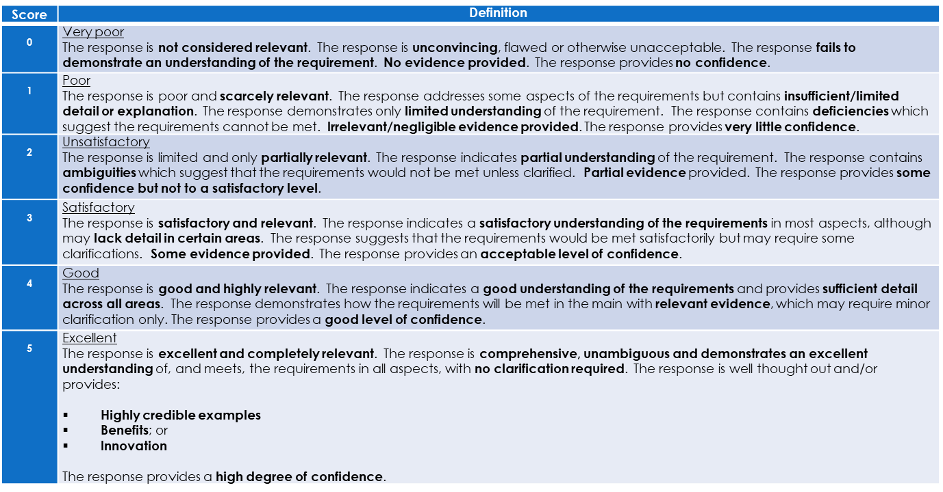

Price Criteria Assessment
The Tenderer with the lowest total price for the Council over the core contract period (3 years) will be awarded the full 40% the marks available for overall price. All other Tenderers’ scores will be calculated relative to this best overall financial offer, using the formula:
Tenderers Price Score = Tenderer Price Weighted Score / Lowest Price Weighted Score x 40
Section No | Cost description | Section Weighting
Installation, Testing, Inspections, Design, Maintenance, Contingency | Testing and replacement of light installations | 70%
 | Inspection and testing of street lighting units | 70%
 | Testing of all wall fixings in masonry | 70%
 | Testing electrical connections | 70%
 | Design of the display and provision of lights | 70%
 | Installation | 70%
 | Maintenance of lighting | 70%
 | Contingency | 70%
 | Other Costs | 70%
 | Testing and replacement of light installations | 70%
 | Inspection and testing of street lighting units | 70%
Emergency Call Out | Out of hours | 10%
Emergency Call Out | Normal working hours | 10%
Removal and Storage | Removal | 10%
Removal and Storage | Storage | 10%
Staffing | Cost | 10%

The sub-total for each cost criteria identified in the table above will be multiplied by its respective weighting to arrive at a weighted score. The sum of all weighted scores will then be added together to provide a weighted total price score for evaluation.
Tenderers Price Score = Tenderer Price Weighted Score / Lowest Price Weighted Score x 40.

Scoring methodology (quality and price criteria)
The following table provides an example of how total scores will be calculated:
Tender | Quality (60%) |  | Pricing (40%) | Total Scores
Tender | Total Quality Score % | Weighted Score % | Score % | Total Scores
Tender A | 100.00 | 60.00 | 27.00 | 60 + 27 = 87.00
Tender B | 80.00 | 48.00 | 20.00 | 48 + 20 = 68.00
Tender C | 60.00 | 36.00 | 40.00 | 36+ 40 = 76.00

Final Submissions
- The Council does not bind itself to accept the lowest, or any quote, and will not accept responsibility for any expense or loss which may be incurred by any potential tenderer in the preparation of the Tender Request.

- Tenderers are required to complete the Declarations in Document 3 as part of their final submissions.

- You must supply all details and certificates requested as part of this request.

- Lack of information may deem your tender unacceptable and will result in the failure of your submission.

- The Council will not accept incomplete or non-specific/generic submissions.

- Unless specifically and clearly stated by tenderers, they will be required to meet all the requirements specified within the tender request price submitted.

- A formal contract will be signed between both parties, based on the attached Contract Document. See Document 5.

Specification

Preamble
The Tenderer shall deliver the services in accordance with the requirements set out in this specification.
Please also refer to Appendix 1 and Appendix 2 Locations of lights in the town centre.

Aylesbury Town Council Objectives
The following objectives apply to all services and shall be adhered to throughout the contract period, as further detailed in the Scope of Services:
- Hire of Equipment: Equipment should be hired by the Council, not purchased.
- Design and Installation: Design, supply, and install a high-quality Christmas festive themed display for Aylesbury Town Centre in specific locations for a 3-year contract starting in March 2025 with installation taking place from October 2025.
- Quality and Value: Deliver a service that offers both quality and value for money.
- Christmas Tree Decoration: Dress a 25ft Christmas tree provided by the Council.
- Compliance: Meet or exceed all statutory and legal obligations related to the provision of services. This includes, but is not limited to: HERS Certification, G39, IPAF, SWQR Card, and required levels of insurances as detailed in the Standard Selection Questionnaire for Christmas Lights for 2025-2027.
- Environmental Considerations: It is important to the Council that a reasonable proportion of the products are expected to be environmentally friendly.
- Storage: Store all products when not in use in a dry, secure, safe environment where they will come to no damage.
- Annual PAT Testing: Conduct annual PAT testing of all equipment and supply relevant certification.
- Installation and Removal: Handle the installation and removal of the displays.
- Maintenance: Provide quotes for potential maintenance issues.

Scope of Services
1. Equipment Hire
- Hire of Equipment: The Supplier will provide all necessary equipment to deliver the agreed lighting scheme as the Council does not wish to purchase any elements towards the scheme.
2. Design and Supply
- Design: The Supplier will design a Christmas lighting scheme for various locations around the town, including a 25ft real Christmas tree supplied by the Council. Any design must incorporate the existing use of previously installed catenary wire and existing eye bolts, however if there is a recommendation for new bolts to be installed in a new location, the Council would seek landlord permission for that.

The colours of choice for the design would be warm white with a hint of cool white with no other colours, no flashing lights, and static lights rather than twinkling where possible.

The design would consist of a range of cross street banners, lamp column motifs, zig zags, icicles, possible curtain ceiling, technology driven devices, large lite tree decorations for varying trees around the town. The vision for how the Christmas tree will be decorated, all creating a wow factor for the town.

The final designs need to be submitted for approval to diane.harrison@aylesburytowncouncil.gov.uk by April 30 and will be signed off by the Town Clerk within 2 weeks of submission. This gives sufficient time for the Supplier to order the required product.

- Supply: The Supplier will supply all decorations and lights required for the scheme.
- Wattage specifications: The Supplier must be able to provide relevant technical specifications for the complete order so that this can be submitted when requesting an unmetered supply to the relevant electricity provider.
3. Installation and Removal
- Annual Installation: The installation will occur in two phases, on dates to be agreed, each year, with the Council:
Phase 1: Mid to late October.
Phase 2: After Remembrance Sunday each year.
- Switch-On Event: The Light Switch on will be at 5:30 PM on a Sunday 23/11/2025, Sunday 22/11/2026 and Sunday 21/11/2027.The lights will be switched off on January 5th each year. The lights will be on daily from 4:00 PM to 11:30 PM. Timers are fitted in some places and should be used where possible.
- Lighting Period: The lights will remain on until January 5th each year. The Christmas tree lights will be turned off and removed on January 5th, and the remainder of the lights will be removed by the end of January.
4. Decoration Specifications
- Colour Scheme: Decorations should be primarily warm gold, with white allowed. Coloured, twinkling, flashing, or phased lights are not permitted.
- The lights and materials used for the scheme will be weather resistant and suitable for outdoor use.
5. Testing and Maintenance
- Eye Bolt Testing: Required for all products secured to walls at the point of installation.
- Structural Integrity Testing: To be organised by the Council for lamp columns.
- Pre-Event Inspection: The lights must be installed and inspected before the switch-on date. Any remedial works required must be carried out before the event.
- Full Test: A Physical visual test of the lights switch on will be conducted with the Town Centre Officer prior to the event.
- Maintenance: All reported lighting repairs require a next working day response, unless it is an emergency.
6. Sustainability
Sustainable Sourcing: All lights must be energy efficient and environmentally friendly.
7. Personnel
- Switch-On Personnel: The Supplier will provide an agreed number of trained personnel to ensure all lights, including the main tree, are switched on at the Switch-On Event simultaneously around the town.
8. Storage and Logistics
- Storage: The Supplier will quote for the storage of the lighting scheme in its entirety.
- Structural Inspection and Assessment: The Supplier will undertake any structural inspection and assessment of the lighting columns.
- Logistics: Tenders should include delivery, testing, build and dismantle time, and transport costs.
9. Contract and Confidentiality
- Three-Year Tender: The Council seeks to agree a three-year tender for this event. Tender submissions must provide a three-year summary and breakdown of costs.
- Confidentiality: The details of this document and all associated documents are to be treated as private and confidential for use only in connection with the Tender Request and contract purposes.
- Contract Agreement: The Council will generate the contract of agreement with the chosen supplier based upon the attached terms and conditions (Document 5).
- Please note, that as we approach the end of the 3rd year of contract, Aylesbury Town Council will be going out to tender for the following 3 years.

Installation requirements
Buckinghamshire Council continues to oversee and maintain the electrical highway infrastructure, while non-highway electrical infrastructure is managed through agreements with landlords for the use of bracketry and eye bolts on their properties.
A Structural Integrity report and a corresponding installation Rams & Methodology statement should be submitted for review and approval prior to progressing to installation. Along with G39 Highway Electrical Safety certification.
Any Electrical work must be undertaken by Contractors registered with the Highways Electrical Registration Scheme.
HERS is operated by the Highways Electrical Association.
https://thehea.org.uk/hers-hesa/about/
Additional risk assessments may also be required dependant on the equipment proposed such as G39 and Traffic management plans
Any permits or traffic management required for the installation will need to be arranged directly with the Council and all relevant documentation submitted a minimum of 28 days prior to the date of installation to diane.harrison@aylesburytowncouncil.gov.uk who will arrange the permit with Buckinghamshire Council. Failure to do this could result in the installation being delayed due to not having the relevant permits in place.
Details of the supplier together with a programme of works will be required prior to approving installation. After Approval and upon completion of installation will be required to allow any post completion inspections to be conducted as well as the updating of our inventory to record these additions ensuring reinstatement should the asset be replaced.
Installations found not to be satisfactory by either the Council or Buckinghamshire Council may be subject to remedial or removal for safety reasons.
Should the Buckinghamshire Council / Aylesbury Town infrastructure need to be accessed for future maintenance or removal purposes prior consent will be required from Buckinghamshire Transport.
Any electrical connections will require registration with an Energy Supplier through Aylesbury Town Council. All wattages and the scheme must be submitted to the Council in order for a certificate to be gained from UK Power. The Council will then seek to take on an unmetered connection supply with an energy Supplier prior to the event. All wattages must be sent through to the council no later than by the end of June. Buckinghamshire Transport reserve the right to remove and dispose of any items or equipment installed without prior approval, any costs associated with this, and remedial work deemed necessary may be subsequently pursued.
Market Square power access is taken from inside the Clock Tower. The Tower is not the asset of the Council and as such belongs to the unitary authority Buckinghamshire Council, with whose permission access is granted via Aylesbury Town Council.

Structural Integrity testing
The Council carries out Structural integrity testing for the required lamp columns and has full certification to prove that. An independent test will be required to establish that any assets identified for the possible attachment of additions have sufficient structural integrity and practical remaining life expectancy to accommodate the additional weight and wind load. The Council currently have a 2-year permit for specific 15 Lamp columns for 2024 & 2025. If any further structural test needs to be administered the Council will need to know by end of May to organise any further testing
A structural test can be undertaken with prior permission from Buckinghamshire Transport who will also be able to advise on suitably accredited testing companies who provide this service.
- To complete this process, it is important to provide the following information.
- Identification of the proposed asset / column.
- Dimensions of the attachment, a drawing, datasheet or photograph is often helpful.
- The weight of the attachment and any brackets supporting it.
- The mounting height of the attachment above ground level.
- The offset distance of the attachment from the column centre line.
Raise and Lower, Hinged and Passive Safe Columns cannot be considered for any items to be added.

Installation Method Statement
To ensure that any proposed additional items are installed in a way that is both safe and mitigates against any detrimental effects to the asset a method statement would need to be provided with comprehensive details of the equipment, materials and their installation process. Should an electrical connection also be required the details of this are to be included to ensure that the additional electrical load can be accommodated and that the corresponding installation standards are adhered to.

Appendix 1

Primary area locations within current scheme 2022- 2024 see maps below
• 10 Trees on Market Square
• Dressing of the Christmas tree
• 3 Trees in Kingsbury
• 5 Trees on Exchange Street opposite the theatre
• Dress the Christmas tree approx. 25 ft
• 1 fir tree next to the Theatre
• Lamp columns in Temple Square x 2
• Lamp columns on the Lower High Street x 4
• Lamp columns on Exchange Street x 3
• Lamp columns on Bourbon Street x 2
• A feature in the Upper High Street
• Cross street banners on both Upper and Lower High Street.
• Cross street banner on the entrance to Kingsbury
• Lights zig zag across Temple Street
• Lights zig zag on Market Street
• Lighting on Long Lional from Market Square back to the Manor Restaurant
• We do not have permission to fix anything to the Clock tower on Market Square for this contract so keen to understand how it could be utilised.

Secondary areas as new areas to be considered if budget allows see page 26-27
• Buckingham Street potential lamp columns and or cross street banners
• Ring road around the town centre with possible lamp columns

Appendix 2

Locations of lights in the town centre
Upper & lower High Street
Power taken from sundry points along the route
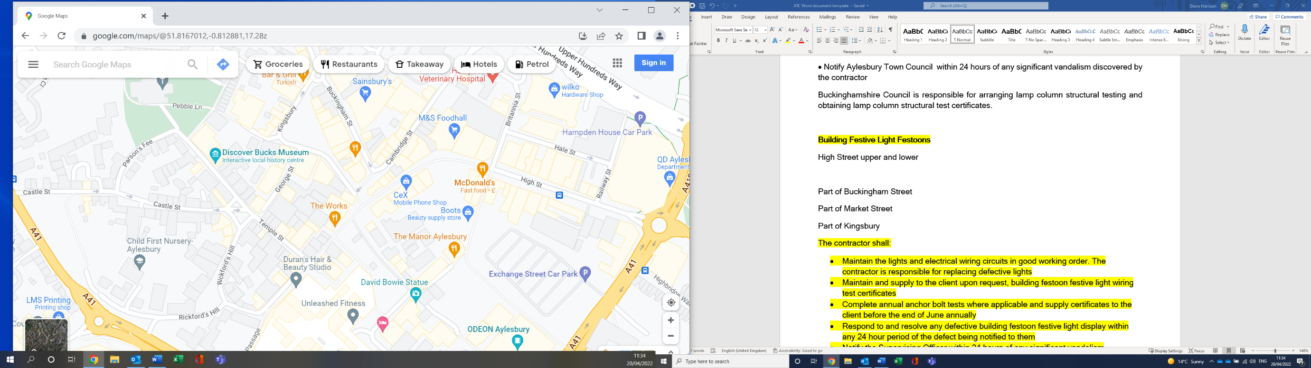

Market Square
6 trees upper Market Square
4 trees Lower market Square
Power taken form the clocktower
Clock tower however we cannot fix lights to the clock tower
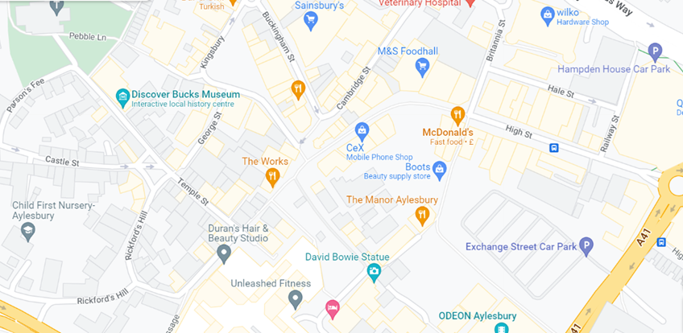
Kingsbury
3 trees in Kingsbury
Power taken from one of the buildings behind the tree
Christmas tree location
Outside HSBC Bank by the semi circle of seats
Power taken from one of the lamposts

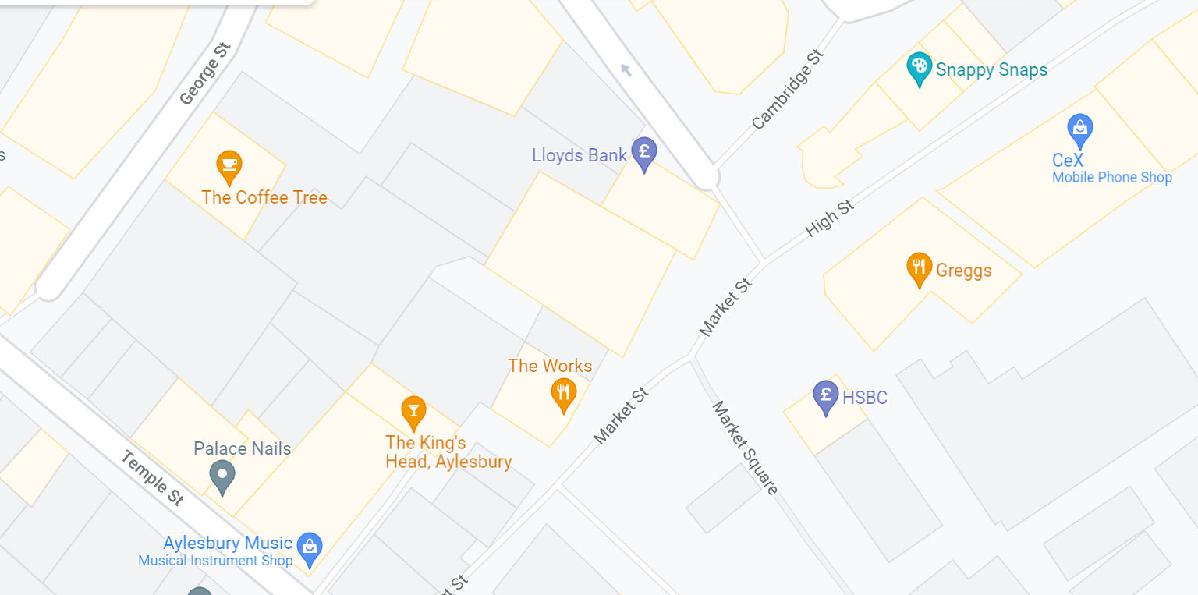

Long Lional
Along the building above Vietnameses street food and herali, but can only be just above their signage, see eyebolts as a guide.
Power taken from a commando socket at the strat of Long Lional

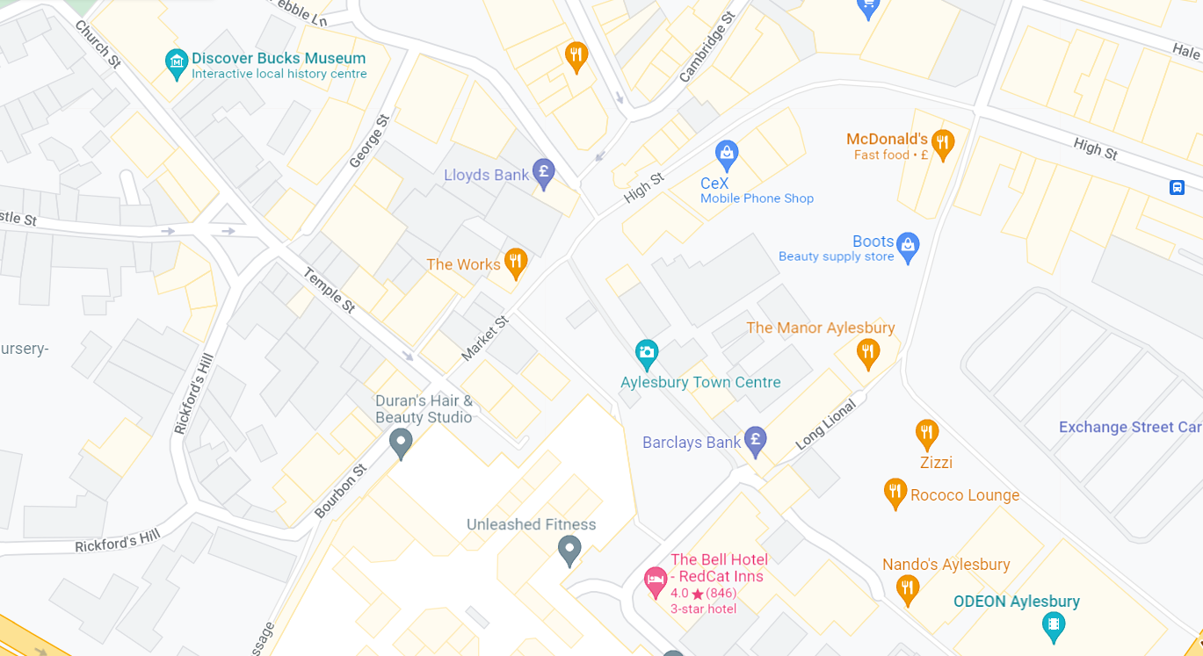

Exchange Street
5 trees on the Odeon side of the road
Power taken from the lampcolumns
1 pine tree outside the theatre
Power taken from the power in the tree off theatre
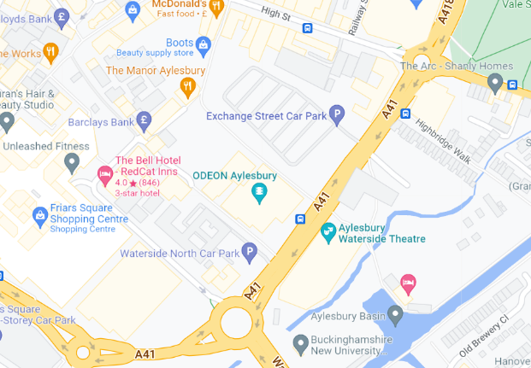

Temple Street & Market Street
Power taken of lampcolumns and buildings

Potential new areas for consideration cost permitting.
Buckingham Street
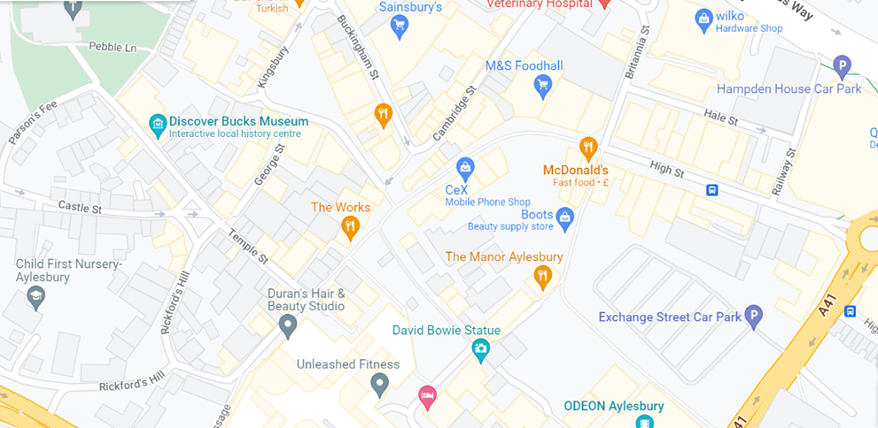

Road around Aylesbury for lamp columns

