# Appendix B – SPECIFICATION

# PURPOSE

## The Research Systems Delivery Partner shall deliver the **Health Research Authority’s Research Systems Digital Transformation Programme**, working in close collaboration with the HRA.

# the Health Research Authority

## The HRA’s mission is to protect and promote the interests of patients and the public in health and social care research, working with partners across the UK. The HRA does this by providing expert advice and guidance to researchers and by reviewing research studies through 80 Research Ethics Committees across the UK (with the devolved administrations), the Confidentiality Advisory Group and undertaking specialist review and assurance of research on behalf of NHS organisations.

## The HRA works across the whole of the UK’s health and care system - reviewing around 6,000 new research studies each year, from multi-centre clinical trials of new medicines and advanced therapeutics, to observational studies using tissue banks or health data. The HRA also reviews 18,000 amendments to research studies each year.

## The HRA provides a UK-wide research review system, coordinated across the regulators in the four nations, streamlining governance and promoting good practice across health and social care research. The HRA’s staff enable collaboration to streamline the set-up and review of research, to provide specialist advice, guidance and learning and to support the HRA’s committees and advisory groups.

## The HRA manages the technology platforms for national health and social care research approval on behalf of its partners across the UK. This includes the Integrated Research Application System (IRAS) and the back-office systems that support the review of applications to enable researchers to apply for research approvals from a number of different regulators, committees, and review bodies.

# The Research Systems Programme (RSP)

## **Vision**

## The purpose of the RSP is to replace the HRA's existing primary research systems. **The RSP vision** is as follows:

## *“The Research Systems Programme will create a world-class hub for health and social care research in the UK. It will offer smooth and intuitive access to gaining research approvals for regulatory and NHS purposes and best practice guidance and lay-friendly information about the results of all health and care research studies taking place in the UK. It will ensure that the HRA can deliver its strategic objective to make the UK a great place to do health and social care research.”*

## The RSP will play a key role in enabling fast, efficient, and integrated approval of research in the UK across multiple approval bodies, 80 Research Ethics Committees and numerous other committees. This major improvement programme will create **intuitive research systems that interact with other systems in the research sector** **- creating one seamless online resource for users**. This will build on and enhance the HRA’s existing work with partners to further improve its services. The new systems will support researchers throughout the lifecycle of their projects.

## **Background**

## Work on RSP was initiated in 2017 and a strategic supplier was appointed in 2020 to deliver the transition from the HRA’s legacy system to a new platform.

## However, by October 2021 the programme was significantly behind the strategic ambition for delivery and the HRA recognised that a review was needed to identify the root causes of the delay and to get the programme back on track.

## In January 2022, PA Consulting Services Ltd (Company No. 00414220) were appointed via the CCS G-Cloud Framework to support the HRA in carrying out the review. The review was completed in Q1 of FY2022/23 and the main findings were:

### The operating model for delivery was not fit for purpose for a digital transformation programme of this size.

### The chosen technology platform did not appear to have delivered the **promised speed** and reuse benefits of **a low code platform**, and **licences** are expensive. Lack of reuse was impacting both initial development and ongoing costs.

### There was a lack of a human-centred design methodology, approach or governance. The system ran the risk of not meeting the needs of users or addressing their problems. **Ease of use is a key requirement for RSP**, given most users don’t use the system day-to-day, but the current platform is not able to easily support an **intuitive, GDS approved user experience and interface**.

## Further details of the strategic review findings and recommendations are set out in Appendix F – RSP Strategy Review Report (‘HRA FinalDeck 110522 – commercial redactions’). This report has been redacted of commercially sensitive and personal data, to protect the legitimate interests of the parties referred to in the redactions. However, the Authority has assessed that the redacted information is not relevant or advantageous for the purpose of Potential Providers preparing a Tender for this Further Competition.

## **Updated Strategy**

## In response to the strategic review findings and recommendations, the HRA has adopted a new strategy. The strategy places a focus on providing greater clarity of vision, a robust delivery approach and a scalable technology stack:

### A clear vision for the RSP, understood by all, an insight-driven future target experience (a high-level ‘To Be journey’) that spans all user touchpoints.

### A technology stack and supplier ecosystem (based around a microservices architecture) that will be fit for purpose to deliver the vision for RSP.

### A robust delivery model, including the addition of enterprise delivery expertise to the HRA team and a human-centred design approach.

## The Delivery Partner **will lead on the technical delivery of the new strategy**, working closely with the HRA staff, and under the direction of a joint strategic programme board. The board will comprise of senior managers of both the Delivery Partner and the HRA (the RSP Delivery Leadership Team), and will be chaired by the HRA’s Chief Digital Transformation Officer, or deputy.

# OUTCOMES

## The intended outcomes of the delivery partnership for the RSP are set out below. The Delivery Partner will lead on the technical delivery of the new strategy, working closely with the HRA.

## **A clear vision for the RSP**:

### Take the unified insight-driven target ’to-be’ experience created as part of the strategic review and use this to inform and guide all transformation activity throughout the Contract Term.

### Test this vision with users, refine it and ensure the illustrated ‘To Be’ journey is widely socialised and understood by all team members / stakeholders.

### Pivot to a custom-build stack, based on a modern / extensible / flexible microservices architecture. This will separate concerns, keep components loosely coupled, and be interoperable and highly scalable in small increments. This will empower a highly complex application whilst: fully meeting business and user needs; enabling scalability in the solution / development approach; facilitating delivery at pace; utilising skillsets that are readily available in the market; and promoting re-use.

### Deploy a suitably resourced, efficient, cost effective and empowered team to reset the RSP, expediting method / experience / expertise, upskilling the existing team and / or helping to recruit new team members.

### Align RSP delivery to Government Digital Standards (GDS) approaches

### Leverage service standards, user experience/user interface (UX/UI) component libraries, and other artefacts as proven accelerators to delivery.

## **Technology stack and supplier ecosystem**:

### Select an architectural approach / technology stack that can support the required integration consolidation / standardisation / open standards, is appropriate for the target state, can support the required data migration / data analysis / data extraction to third-parties / the HRA Data Warehouse, and facilitates easier supplier selection​.

### Select a technology stack that can meet GDS / accessibility standards, branding and mobile requirements from the outset, facilitating streamlined assessments and acting as an accelerator to design and build speed and quality. This will ensure the HRA keeps a structured and semantically consistent data model at the heart of the solution, consolidating / standardising integrations and providing open standards.

## **Delivery model:**

### Embed a human-centred design methodology and robust design governance, with a team of experienced user researchers, service design and UX / UI practitioners. Ensure user needs drive prioritisation of the product roadmap​.

### Prototype and iterate quickly, using design prototypes to test with users, and technical prototypes to prove solutions to complex areas of the system will work, being unafraid to learn quickly and adapt​.

### Multiple delivery streams to achieve the target timescales. Common ways of working, including shared quarterly releases and RSP leadership across teams.

### Implement a resilient, scalable infrastructure to support the delivery of the strategy, and be able to manage iterative reviews and updates as needed over the life of the product. It must be supported by a robust agile method, mindsets and behaviours; a defined and well-described product roadmap; a well-groomed and estimated backlog of activity; and clearly defined transitional states in the product roadmap.

### Use the exemplar role descriptions in the EDT Structure (Appendix E) to agree the allocation of unambiguous roles and responsibilities for both the Delivery Partner and HRA staff, empowering team members to feel ownership of overall outcomes within the RSP.

### Provide clarity around delivery approach, set the bar for what “good” looks like and embed proactive supplier management into this operating model​.

# Long Term Project Goals

## Implement a product and ways of working that can be sustainably delivered throughout and beyond the Contract Term.

# PARTNERSHIP

## The Delivery Partner will provide the HRA with the required breadth and depth of technology capabilities to build the required architecture, provide RSP leadership and management under the governance of the joint strategic programme board, and work as a single, blended team alongside the HRA’s staff. The Partner’s understanding of the intended working relationship, and demonstrable expertise and value add gained from relevant experience, will be significant factors in the evaluation process:

## **Relationship:**

### The Delivery Partner and the HRA will form an integrated and complementary delivery team that will work together seamlessly to ensure the RSP delivery meet the HRA’s needs. In order to achieve this, the Delivery Partner will need to:

#### Understand and be aligned with the HRA’s values;

#### Have extensive experience and maturity in programme delivery, enabling them to provide professional and necessary challenge throughout the RSP, to continually improve the delivery approach and ensure the optimal outcomes for the HRA are achieved;

#### Bring creativity and innovation to problem solving, ensuring obstacles to delivery are overcome;

#### Have senior leadership that are aligned to the HRA’s strategic ambitions, and are able to make decisions which contribute to the HRA’s long-term success and direction;

#### Have and demonstrate a growth mindset in systems development;

#### Maintain agility and stamina, delivering motivation and reinforcement from its leadership to ensure a high-performing team. The Delivery Partner will not focus solely on milestones, but will ensure quality and success is delivered throughout all aspects of the RSP.

## **Delivery expertise:**

### The Delivery Partner will have a detailed understanding of the UK research ecosystems of which the HRA is a part. Knowledge of the roles and relationships between the HRA, MHRA (Medicines and Healthcare products Regulatory Agency), NIHR (National Institute for Health and Care Research), and the research support organisations in Northern Ireland, Scotland, and Wales, in particular, would be advantageous in helping the HRA consider the external interdependencies and political factors which may impact successful delivery of the RSP.

### The Delivery Partner will support the HRA in meeting the requirements of the Government Functional Standards (GFS), Government Digital Standards (GDS) and associated assessments (GDS assessment and DHSC gateway reviews).

### The Delivery Partner will deliver a human-centred design (HCD)-driven software product delivery approach and an agile approach at scale (multiple delivery teams, quarterly planning).

### The Delivery Partner will excel in delivery management and building capability within the customer organisation.

### The Delivery Partner will bring a culture of working in partnership with customers as a single team to the HRA, improving delivery culture, and educating in-house teams on good practice and full / comprehensive adoption of digital standards.

## **Technical expertise:**

### The Delivery Partner will provide expertise of modern microservice architectures and migrating legacy research systems to the Authority.

### The Delivery Partner will provide expert advice and facilitate the migration of data from complex legacy systems, and systems that have data anomalies as a result of a lack of system data governance.

### The Delivery Partner will provide extensive expertise in the development of digital services using open source code and public code repositories.

### The Delivery Partner will provide extensive expertise in creating digital services with coding / components that are highly re-usable.

### The Delivery Partner will provide extensive expert advice and support to the HRA in creating digital services using Gov.uk styles, components and patterns.

### The Delivery Partner will provide mature in-house coding, development and technology centres of excellence based on industry good practices.

### The Delivery Partner will provide expertise in knowing what code, components etc. can't be shared and ensuring these are not published.

### The Delivery Partner will provide Digital Service delivery expertise, whilst working collaboratively with other / multiple Gov.uk, public sector and NHS organisations.

# Scope of requirement

## “To Be” Architecture

### The Delivery Partner will help create a custom (React / .NET) microservices-based solution, which offers flexibility / agility for delivery at pace. Whilst the solution will leverage out-of-the-box features and functionality where possible, the business needs are complex (in terms of UX, question sets, workflow engine, integration, amendments etc.) which will require the creation of “custom” code as needed.

### The solution will be heavily externally-facing. Therefore, user volumes are key, with a growth of 1,000 new users every month and an anticipated concurrency rate of 25,000 each month (*note: user volumes will scale as more user types, e.g. Sites, are assimilated into the journey*). Consequently, the solution needs to have controlled and regular releases (having gone through a robust test / release cycle) and needs to be designed to be flexible and scalable to future needs as innovation unfolds.

### The HRA has recently completed a significant piece of work which has produced the “to-be” microservices-based architecture and RSP transition roadmap. This work has identified some architecturally significant and complex areas which will require an early proof of concept.

## The technology stack to support the “to-be” architecture will:

### be hosted on the public cloud;

### incorporate defence-in-depth to protect users’ privacy and data;

### fully leverage open standards and open source to avoid vendor lock-in;

### provide full and easy interoperability and integration with other systems; and

### be flexible and scalable to future needs and as innovation unfolds, by providing modularisation of the HRA business into modern and widely used microservices.

### *Figure 1 – ‘To Be’ architecture*

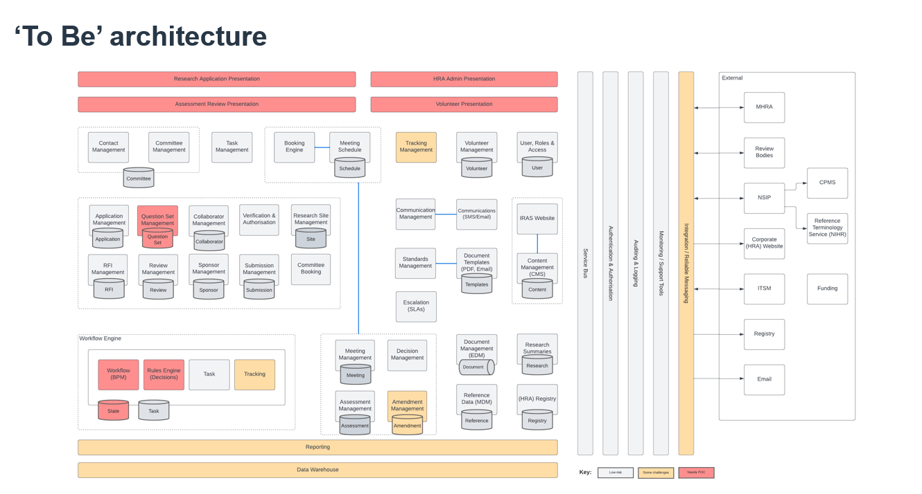

# The requirement

## **Technical Requirements**

### The Delivery Partner is required to:

#### Fully implement and deliver the HRA’s “to-be” .NET microservices based architecture and technology stack along with the production of associated architecture design artifacts.

#### Develop and deliver the loosely coupled microservices using open source code.

#### Deliver an early proof of concept for the identified architecturally significant and complex areas.

#### Use REACT and REACT Native UX layer for the delivery of all User Interfaces. These interfaces will be mobile-friendly, meet WCAG AA accessibility requirements, incorporate corporate branding and utilise GDS UI templates and components to accelerate both delivery and NHSX Assessments.

#### Implement and deliver the integration layer, leveraging widely used integration patterns and technologies to deliver standardised interfaces using open standards across the 15+ integrations that the HRA requires.

#### Deliver a structured storage of data using an enterprise-wide taxonomy and governance to facilitate question set management and streamlined data migration.

#### Implement and deliver a reporting layer, leveraging structured data to provide rich operational reporting and extracts of data to power detailed outcome analysis.

#### Implement and deliver a commercial, off-the-shelf, open source workflow and rules engine specialising in microservice orchestration and human workflow to facilitate accelerated development, leveraging subject matter expertise.

#### Deliver using industry best practice and fully automated CI / CD pipelines which incorporates controlled and regular releases going through a robust test and release cycle.

#### Build and deliver the digital services to meet Government Functional Standards (GFS), Government Digital Standards (GDS) and associated assessments (GDS assessment and DHSC gateway reviews).

#### Undertake timely and continuous testing throughout the delivery cycle.

#### Follow Software Test Lifecycle (STLC) aligned with the HRA’s Test Strategy. Testing is to include: Unit Testing including Accessibility Conformance, System Testing (User Interface Testing, Microservice Testing, API Testing, Database Testing), Integration Testing, User Acceptance Testing, Migration Testing, Volume / Load / Performance testing, Disaster Recovery Testing, Post-go-live Testing, and Automation Testing (configurable to DevOps pipelines).

## **Service Requirements**

### The strategic programme review has highlighted the fact that the current programme uses a mixture of delivery methods, rather than the recommended agile, iterative user-centred approach, which is laid out by GDS and has proven to be successful in large scale digital transformations of this kind.

### As described in the GDS Service Standards*, “using agile methods means getting your service in front of real users as soon as possible. Then observing and generating data on how they use it, and iterating the service based on what you’ve learned”*. Unfortunately, the HRA has been unable to fully establish and embed this methodology with previous suppliers. Therefore, a key requirement of the Delivery Partner is to utilise this approach, and support the HRA in utilising and adopting it, through their leadership and experienced digital delivery practitioners, who will become a seamless part of the cross-functional delivery team.

### A lack of capabilities and experience in the Authority’s current team, will need to be mitigated with support from the Delivery Partner. Teams will need to be bolstered with the right expertise, training and coaching and a definitive view of what “good” looks like for agile delivery. The new combined product development needs to be supported to adopt a user-first approach.

### RSP will be managed as a single programme (which includes the HRA IRAS (Integrated Research Application System) website and other research system related projects as they come onstream e.g. research registration) using a common architecture, governance structure and delivery cadence. The Delivery Partner will engage proactively in the delivery model, expediting method, experience and expertise, upskill the existing team and / or help recruit new team members.

### The proposed programme delivery team structure will consist of three blended teams, including roles from both the HRA and the Delivery Partner, to start the delivery of Future IRAS. These teams will run on the same cadence to take advantage of planning cycles, shared routines (i.e., ‘scrum of scrums’ and joint demos) to maximise velocity against the product roadmap. The joint strategic programme board will be responsible for ensuring overall delivery, standards and quality are met by the team, and that the delivery team structure continues to be fit for purpose or adapted according to the RSP’s needs through a structured process of managed change as required. The Delivery Partner will ensure that the appropriate capacity and capability of resources are available within their delivery team as required, to meet the overall delivery timetable, standards and quality.

### The Delivery Partner shall align to product mindsets and behaviours, deliver best-practice and align to industry standards in all design, development and testing activities, and to help implement and drive the following delivery enablers:

#### One agile product development method rigorously applied. All of the teams working in aligned sprints, with consistency in ceremonies, definitions and tooling;

#### An empowered, experienced product owner with a clear product vision, principles and roadmap, driving a mindset of ‘products over projects’;

#### Human-centred design, to ensure user needs drive product decisions;

#### Ongoing rolling wave, multi-level planning and dependency mapping;

#### A well-articulated, regularly groomed, estimated and prioritised backlog of requirements;

#### Sprints that have goals and deliver an increment of working software;

#### High-fidelity UX / UI designs, specified for build and mapped to stories, define the product design – running ahead of development;

#### Developing on cadence, release to plan – with continuous testing and flow of value;

#### Functioning feedback loops and / or metrics at all levels;

#### Small, cross functional teams with shared responsibility for outcomes, prioritising value over activity; and

#### Skilled practitioners, supported by coaching where development needs exist.

# Roles and responsibilities

## The Authority has an exemplar delivery team structure (the EDT Structure) for the RSP.

## The roles to be fulfilled by the Delivery Partner in the EDT Structure are shown in grey in Figure 2 below:

## *Figure 2.:*

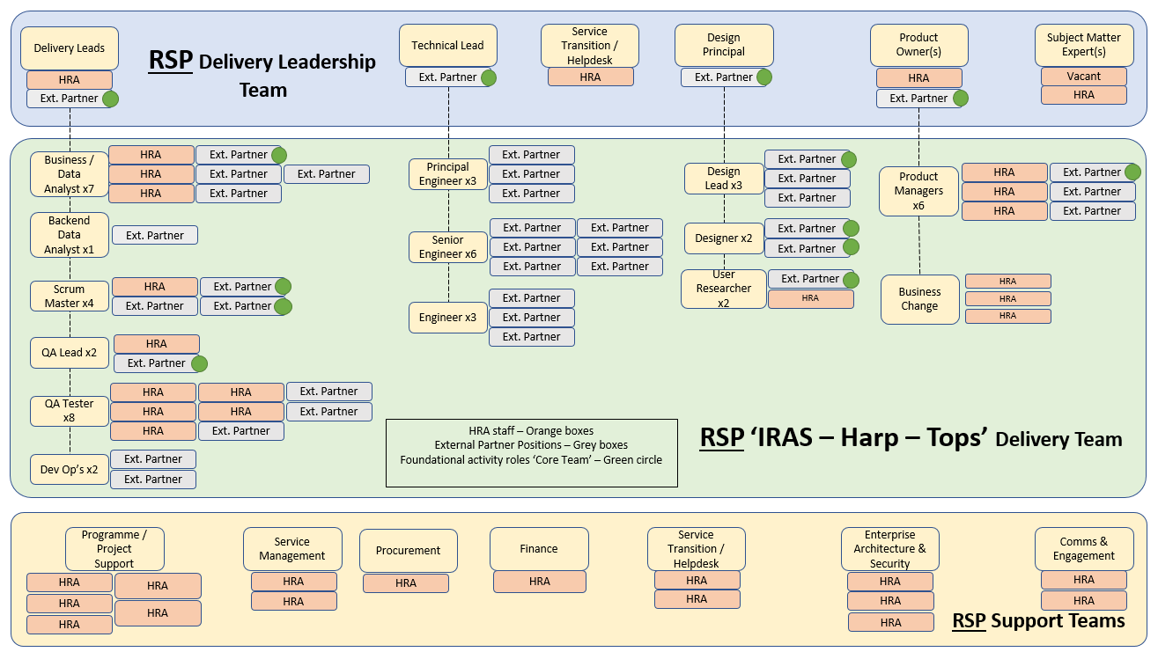

## The roles identified by green dots are designated as part of the “Core Team”. The Core Team will be required to be available from day one of the onboarding period (see Foundation Stage, Section 9.1 below) and as required (i.e. team members should be consistent) throughout the Contract Term. All appointments to the Core Team will require the HRA’s prior approval.

## The RSP Delivery Leadership Team roles must be based onshore to enable face-to-face working as needed. However, it is for the Potential Provider to determine their preferred split between onshore and offshore resource for the remaining members of their team in the EDT Structure.

## Appendix E sets out exemplar role descriptions for all of the EDT Structure roles to be delivered by the Delivery Partner, comprised of the following:

* 1 x Delivery Lead (Core Team and RSP Delivery Leadership role)
* 4 x Business Data Analyst (of which 1 (one) shall be part of the Core Team)
* 1 x Backend Data Analyst
* 3 x Scrum Master (of which 2 (two) shall be part of the Core Team)
* 1 x QA Lead (Core Team role)
* 3 x QA Tester
* 2 x Dev Ops
* 1 x Technical Lead (Core Team and RSP Delivery Leadership role)
* 3 x Principal Engineer
* 6 x Senior Engineer
* 3 x Engineer
* 1 x Design Principal (Core Team and RSP Delivery Leadership role)
* 3 x Design Lead (of which 1 (one) shall be part of the Core Team)
* 2 x Designer (both part of the Core Team)
* 1 x User Researcher (part of the Core Team)
* 1 x Product Owner(s) (Core Team and RSP Delivery Leadership role)
* 3 x Product Manager (of which 1 (one) shall be part of the Core Team)

# DELIVERY STAGES

## **Foundation Stage** (12-14 weeks)

## The joint strategic programme board will ensure that:

### **Onboarding**

#### The combined delivery team will run a number of ‘kick-off’ sessions to agree the plan, goals, ways of working and required governance, map known risks and dependencies.

#### The Delivery Partner’s team will be familiarised with the detail of the product vision, roadmap user insight, current understanding of legacy data and other key artefacts and findings.

#### The Delivery Partner will undertake proof of concepts to provide assurance regarding the HRA’s “to-be” microservices architecture.

### **Planning**

#### This will be a period of human-centred product design and definition, focused entirely on detailed low-fidelity user flows and journeys, user research, fragment sketching and rough prototyping, alongside detailed technical swim-laning, technical spikes and next-stage detailed planning.

#### This period will be used to create the detailed low fidelity flows and user journeys for a number (not all) of the key journeys and test them with users. Taking the ‘Alpha’ mindset, the merged team will ‘test the riskiest assumptions’, and derive sufficient detailed journey flow information to inform detailed user stories to support the first sprints of design and development work.

#### Alongside the detailed flows the merged team will swim-lane the data flows and operational impacts, as well as updating any architectural transition states.

#### The design team will onboard to the GDS design system and undertake an assessment of it, alongside the known Epics (large groupings of features / themes) and high-level requirements of the ‘To Be’ journey.

#### The Delivery Partner will run an Agile coaching programme for the HRA’s product owners and other HRA team members, to get them ready for the commencement of the design and development work.

#### A visual depiction of the “Planning” stage is shown in Figure 3 below:

#### *Figure 3.:*

### 

## **Design and build**

### Following the successful Foundational Activity, features and functionality will be elaborated and prioritised, designed and validated with users, built, iterated, and deployed.

### The delivery team will undertake quarterly planning:

#### Define goals, map risks and dependencies

#### Agree ways of working, routines, estimating, approvals

#### Detail the product backlog and acceptance criteria

#### Design planning and estimating

#### Backlog analysis and prioritisation

### Following this, the three blended product delivery teams will work in agile design and build sprints, visually depicted in Figure 4 below:

### *Figure 4.:*

## 

# Contract milestones / deliverables:

## Please find below an architecture roadmap (Figure 5), that shows a series of transitions, migrating from the “As Is” architecture to the “To Be” target architecture. Each transition is a quarter (running from October 22 to March 2025 as per original tender, although now is likely to be April 23 to September 2025). The diagrams show architecture states and the bottom row identifies the key milestones. From Q1 2023 an additional left column has been included that shows the Epics (large groupings of features / themes) to be delivered. The roadmaps will need to be developed and reviewed during the 1st quarter of the Contract to ensure an optimal deployment, taking into account lessons learned to date.

## *Figure 5.:*

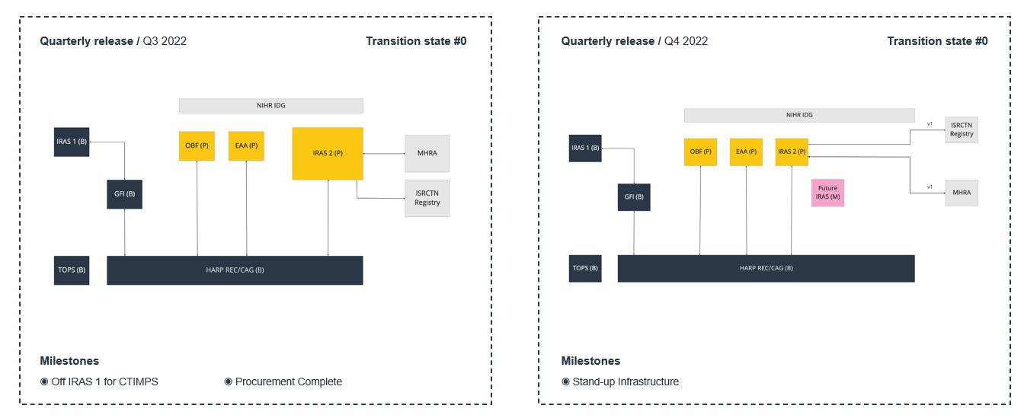

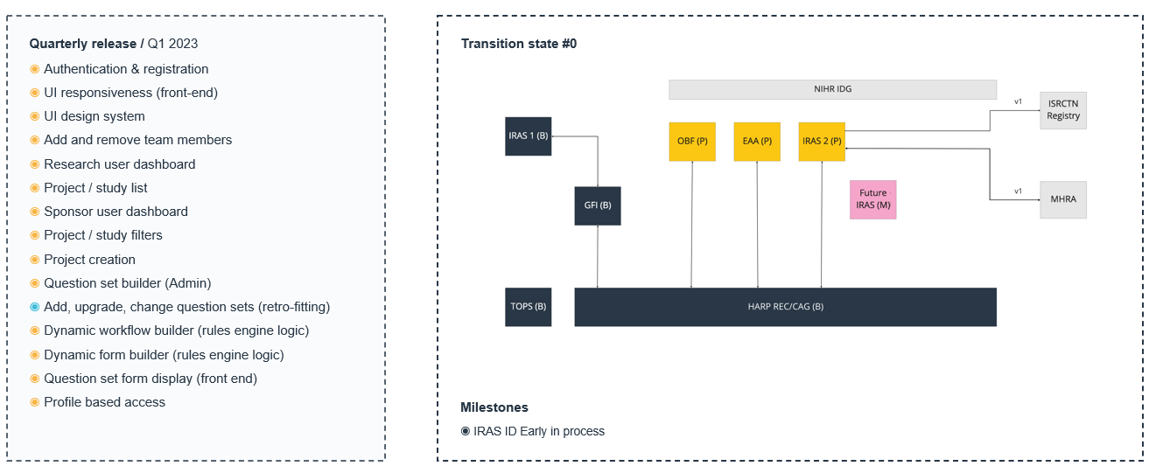

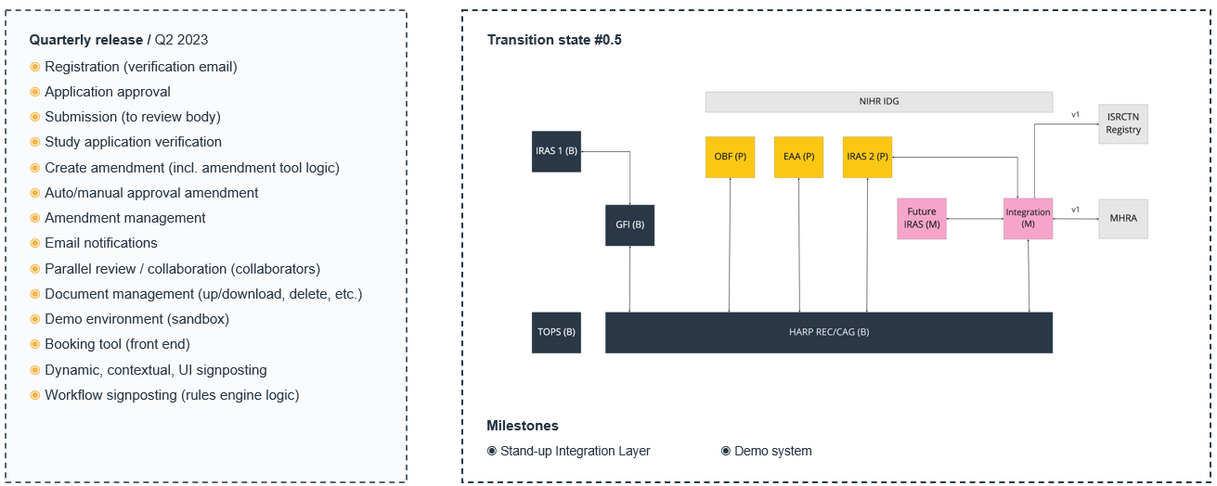

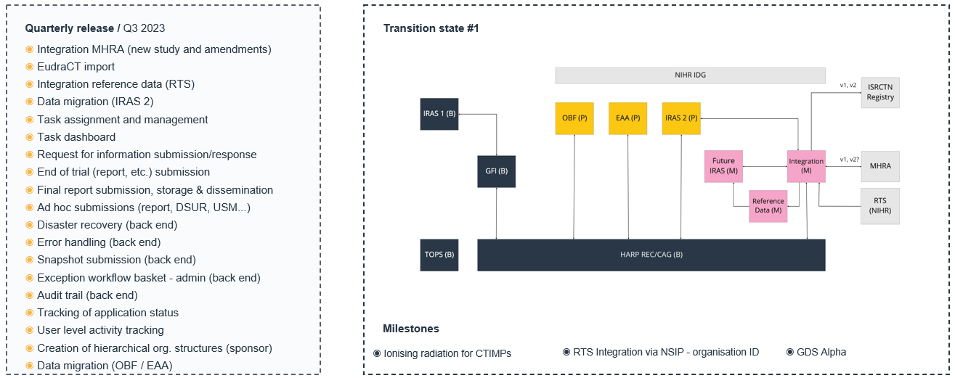

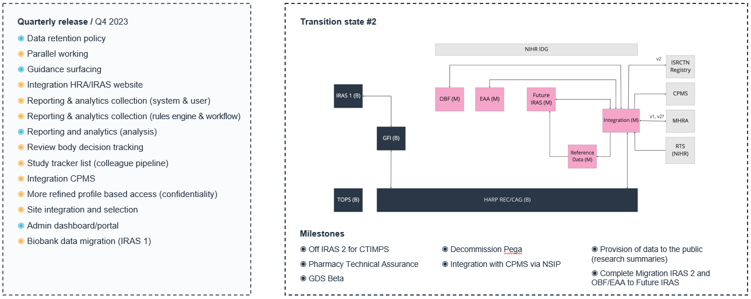

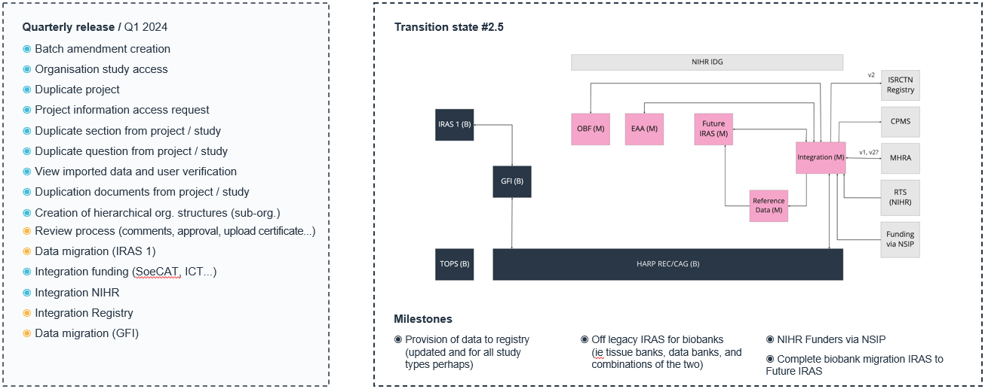

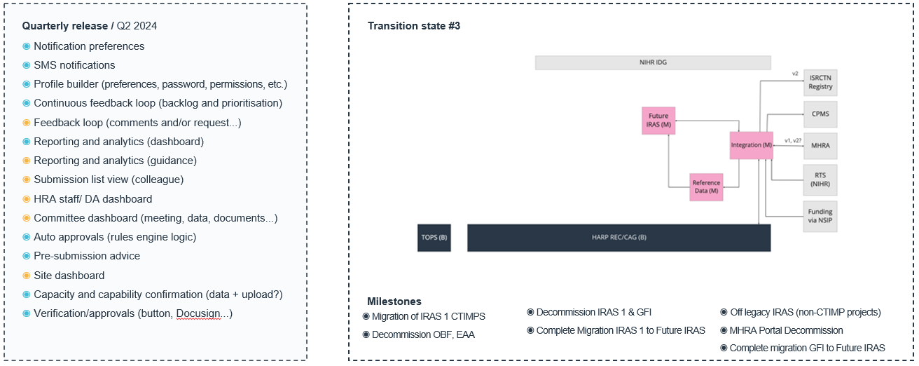

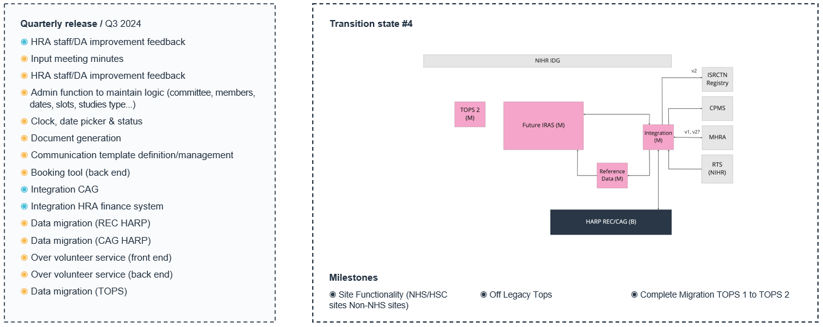

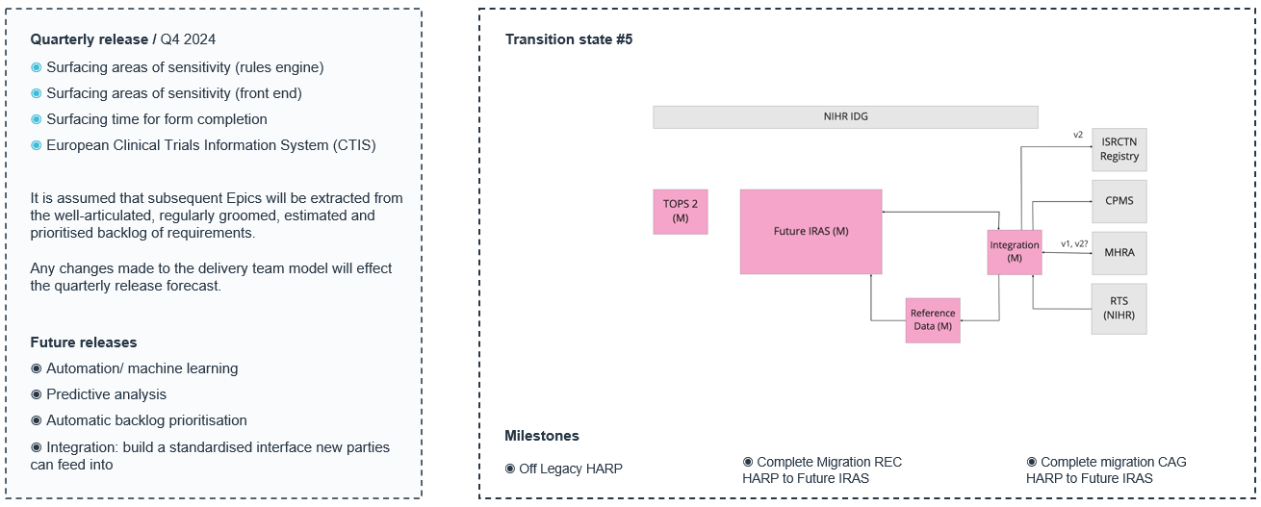

# MANAGEMENT INFORMATION / reporting

## The Delivery Partner shall provide effective Management Information ("MI") to ensure and support delivery measurement and inform the joint strategic programme board. The MI required will include the following:

### Monthly reports, illustrating performance against all KPIs, progress against plan, issues, risks, achievements, finances, resource utilisation and required resources for the next three months

### These reports must illustrate examples of how the user research approach and resulting ‘Service Design’, ‘User Experience Design’ and ‘User Interface Design’, are compliant with latest GDS guidelines

### Compliance with the NCSC Cloud Security Principles (where applicable / appropriate)

# Service level requirements and Performance indicators

## The Delivery Partner must be capable of providing the HRA with an agreed quality of service, and enable measurement of this against pre-agreed (during the onboarding period) Service Level Agreements. Example SLAs and performance indicators are provided below, with key indicators that will be used for contract management marked with an asterisk*:

### A monthly KPI illustrating the number of issues discovered post release of any new software - this includes number of incidents per microservice.*

### A monthly KPI around number of issues raised after unit testing, system testing and UAT

### A monthly KPI around number of change requests recorded to agreed scope

### Monthly measures around ‘Technical Debt’ to help inform the HRA of the predicted overall future cost of the RSP infrastructure.

### AGILE Ceremonies:

#### A weekly/monthly KPI around the number of daily stand-ups

#### Sprint planning: where the HRA will plan out the content of the current sprint and future sprints based upon product owner priority

#### Sprint retrospectives: ensuring the HRA is continuously improving in the ways it works

#### Backlog refinement: ensuring the overarching backlog is well understood and prioritised to business needs

### RSP management monthly KPIs:

#### Planned Value (PV) KPI - Also referred to as Budgeted Cost of Work Scheduled (BCWS)

#### Actual Cost (AC) KPI - Also referred to as the Actual Cost of Work Performed (ACWP)

#### Earned Value (EV) KPI - This KPI is also referred to as Budgeted Cost of Work Performed (BCWP)

#### Return on Investment (ROI) - ROI reflects on profitability and shows whether the understood benefits of the RSP exceed its cost

#### Cost Variance (CV) (Planned Budget vs Actual Budget) - Project’s cost variance reflects the project expenses.*

#### Cost Performance Index (CPI) - Helps to approximate how much time the project is behind or ahead of the approved project schedule.

#### Overdue project tasks / crossed deadlines - An overview of how many project activities are overdue.

#### Missed milestones - Similar to the number of missed deadlines, this KPI is widely used in dashboards. It indicates whether capacities have been overestimated and the project is running behind schedule or if the project is meeting all milestones*

#### Percentage of tasks completed

#### Percentage of milestones completed on time*

## As the RSP has close working connections with both the NIHR and MHRA, the Delivery Partner will provide resources and capabilities to support resolution activities (may include either a complete fix or a work-around solution) to restore live environments. Current SLAs pertaining to this service are detailed below:

|  |  |  |  |
| --- | --- | --- | --- |
| **SLA Level** | **Description** | **Response Target** | **Resolution Target** |
| *Priority 1* | Outage or, major impact to the availability and /or performance of client’s digital service | *15 minutes* | *3 business hours* |
| *Priority 2* | Impact to the availability or performance of a critical part of the client’s digital service | *1 business hour* | *8 business hours* |
| *Priority 3* | Impact to the availability or performance of a non-critical part of the client’s digital service | *8 business hours* | *3 business days or next release?* |
| *Priority 4* | Non availability or performance impacting client digital service issue. | *8 business hours* | *4 business days of next release?* |
| *Priority 5* | Non availability or performance impacting client digital service issue, may be a service request or normal change request. | *8 business hours* | *5 business days or next release?* |

# SOCIAL VALUE

## The Delivery Partner will also deliver social value through the Contract in the three Social Value Model Policy Outcome areas of: Increasing supply chain resilience and capacity; Effective stewardship of the environment; and Health and Wellbeing in the Contract workforce. The Delivery Partner will achieve these policy outcomes by implementing the measures proposed as part of their Tender submission to meet the respective Social Value Model Award Criteria (MAC) set out below:

|  |  |
| --- | --- |
| **Social Value Model Policy Outcome** | **Social Value Model Award Criteria (MAC)** |
| Increase supply chain resilience and capacity | Effective measures to deliver any/all of the following benefits through the Contract:   * MAC 3.1: Create a diverse supply chain to deliver the Contract including new businesses and entrepreneurs, start-ups, SMEs, VCSEs and mutuals. * MAC 3.2: Support innovation and disruptive technologies throughout the supply chain to deliver lower cost and/or higher quality goods and services. * MAC 3.3: Support the development of scalable and future-proofed new methods to modernise delivery and increase productivity. * MAC 3.4: Demonstrate collaboration throughout the supply chain, and a fair and responsible approach to working with supply chain partners in delivery of the Contract. * MAC 3.5: Demonstrate action to identify and manage cyber security risks in the delivery of the Contract including in the supply chain. |
| Effective stewardship of the environment | Effective measures to deliver any/all of the following benefits through the Contract:   * MAC 4.1 Deliver additional environmental benefits in the performance of the Contract including working towards net zero greenhouse gas emissions. * MAC 4.2 Influence staff, suppliers, customers and communities through the delivery of the Contract to support environmental protection and improvement. |
| Improve Health and Wellbeing | Effective measures to deliver any/all of the following benefits through the Contract:   * MAC 7.1: Demonstrate action to support health and wellbeing, including physical and mental health, in the Contract workforce. * MAC 7.2: Influence staff, suppliers, customers and communities through the delivery of the Contract to support health and wellbeing, including physical and mental health. |

# CONTRACT Governance

## The HRA and the Delivery Partner shall establish and maintain throughout the Contract, a number of meetings / boards and teams through which the governance between the two shall be managed.  At the top of this governance structure for the Contract shall be a joint strategic programme board (comprised of, but not limited to, the RSP Delivery Leadership Team), which in turn will report to the HRA RSP programme board.

## Detailed descriptions of each of the meetings, including Contract-level meetings, will be developed during the onboarding (Foundation Stage) including the terms of reference, inputs, outputs, attendees, agenda, operational arrangements and escalation.

## The purpose is to create a structure for the ongoing management of the Contract.  The HRA and the Delivery Partner agree that additional Boards / meetings may be convened from time to time to address aspects of Contract delivery.

# PRICING and contract BUDGET

## The maximum available budget for the Initial Contract Term (30 months) is £8.5M (the Maximum Initial Budget). If extension options are exercised, the Total Contract Value may reach up to £17.5M over the maximum 5-year Contract Term, subject to further governance approvals, including Cabinet Office Spend Control approvals, as required.

## All prices included within the Rate Card Schedule (Appendix D) must be exclusive of VAT, but inclusive of all other expenses relating to Contract delivery.

## The tendered rates will apply, unchanged, for the duration of the Initial Contract Term. Should the HRA choose to extend the Contract Term, the Delivery Partner will be able to amend their tendered rates at the commencement of any Extension Period. Any increase in rates will be limited to the lower of either RPI or 5%.

# CONTRACT VARIATIONS AND EXTENSIONS

## The Authority reserves the right to instruct additional requirements and/ or modify activities that were agreed as part of the initial tender where it is deemed to be in the Authority’s and the project’s best interest to do so, provided always that any modifications to the Contract shall be in compliance with PCR 2015.

## Where a modification is required,

### The Authority will clearly set out to the Delivery Partner what is required; this may be a specific activity such as training or a change to an outcome or a change in performance/ solution methodology.

### The Delivery Partner will scope up and detail what activities are required, price this change using the Rate Card and issue a draft Contract Change Notice (CCN) to the Authority for Review

### The Authority may engage in discussion with the Delivery Partner on the draft CCN regarding both the activities and costs until a final CCN can be produced or a decision is made not to proceed with the change.

### Once finalised, both parties must sign the CCN in accordance with the Contract requirements.

## Where an extension is required, the same process will be followed (including completion of a Rate Card) as detailed above. These discussions and activities must be completed before the live Contract expires, in accordance with the Contract requirements.

# payment model

## Payments under this Contract shall be predominantly outcomes based (on achievement of agreed deliverables).

# PAYMENT AND INVOICING

## Invoices will be raised by the Delivery Partner upon the successful completion of the agreed deliverables.

## Each invoice must include the Contract Reference number, the Authority’s Contract manager name (TBC), a detailed breakdown of the work completed and the associated costs.

Hardcopy invoices should be sent to:

Health Research Authority

T71 Payable F275

Phoenix House

Topcliffe Lane

Wakefield, West Yorkshire

WF3 1WE

However, electronic invoices are preferred.As the HRA’s accounts payable service is provided by NHS SBS the Delivery Partner should contact NHS SBS for a Tradeshift account which will allow them to submit e-invoices. Further details can be found here: <https://www.sbs.nhs.uk/supplier-einvoicing>

**PLEASE DO NOT SEND BOTH HARDCOPY AND ELECTRONIC INVOICES AS THIS WILL CREATE DUPLICATE INVOICES IN THE SYSTEM.**

## Compliant, approved invoices will be paid within 30 days of receipt.

# Location

## The Delivery Partner will predominantly operate remotely, with travel to the HRA’s locations across the UK as required. All prices quote by Potential Providers must include travel and subsistence.