Bidders Questions and response

Date: | Question: | Response
09/07/20 | We cannot locate the specific questions that relate to the evaluation criteria below  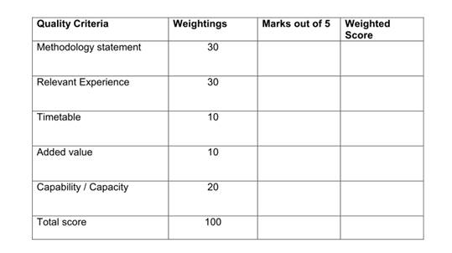 | In response to your questions please see below which adds reference to the sections referred to.  Methodology Statement – Refers to the below sections shown within the tender document.  Section 3.0 - Employers Agent Specification and Core aims and objectives  Section 4.0 - Health and Safety – With ref to CDM and RIBA  Relevant experience – Refers to the experience criteria as outlined within the Tender document.  Timetable – I can give further narrative if required.  Added Value – Will be measured against criteria that shows additional facilitation/experience to assist the process.  Capability and Capacity - I can give further narrative if required
13/07/20 | Do you happen to have a word limit? | We don’t have a word limit for the tender application.
22/07/20 | We note the item 3.2 on the tender document “Act on LTC behalf in relation to client obligations as outlined with CDM regulations 2015. Give specialist advice to ensure contractors are delivering on required contractual arrangements and in line with CDM regulation.” Please confirm if this is providing advice or are you are expecting the EA to act as an Appointed Principal Designer under the CDM regulations. If just advice then please confirm who is appointed as Principal Designer for CDM. | This will be in an advice capacity and HDA will retain role of principle designer.
22/07/20 | For avoidance of doubt please confirm what procurement is envisaged, acting as EA suggests this is a design and build procurement. If so, please confirm and do the authority envisage the architect being novated once a contractor is selected. If the scheme is to be procured as a traditional procurement then this will have a bearing on the fees/fee profiling | I can confirm on appointment of Principle contractor the architect will be novated across.
24/07/20 | - Please could you provide further narrative including key programme dates to assist with response to the timetable question.  - Please could you provide further narrative with any specific information required as a part of the capability and capacity question.  - Please could you confirm the opportunity is for Employer's Agent Services only. Item 3.5 of the scope of services states "Review the designs and comment on the adequacy of the Health and Safety information provided by the Designers." which would normally fall under the role of a Principal Designer. Please could you advise if a Principal Designer is being appointed separately or if we are to also provide this service as part of the tender? | On point one I have listed an indicative timetable in the specification. Key dates Sep 2020 planning , Jan 2021 Appoint Principle Contractor , Mar 2021 start on site , Dec 2021 complete. These dates are just a guide.  On point two we do not give the assessment questions but a guide is ability to deliver in timeframe (ref to Covid-19) / capacity of in house team (or will elements be subcontracted ie Guidance on M&E) / Qualifications and project specific additional info .  On point three Principle Designer will be HDA however Employers Agent will act on our behalf as specialist to quality check.
27/07/20 | Will expectation be to prepare specification for principle contractor tender. | Yes.
29/07/20 | Will this be design and build contract | Yes

