

**JAGGAER Commercial System**

**Supplier Registration Guidance**

**February 2023**

Contents

**1.** **Introduction** 3

**2.** **How to register as a supplier** 3

**2.1** **How to access the Supplier Registration page** 3

**2.2** **Registration Data** 4

# **Introduction**

This document will take the user through the steps required to register as a supplier.

# **How to register as a supplier**

### **How to access the Supplier Registration page**

#### Navigate to the Jaggaer log in page

**url for Jaggaer registration**

<https://education.app.jaggaer.com/web/login.html>

Click the ‘Click here to register!’ button

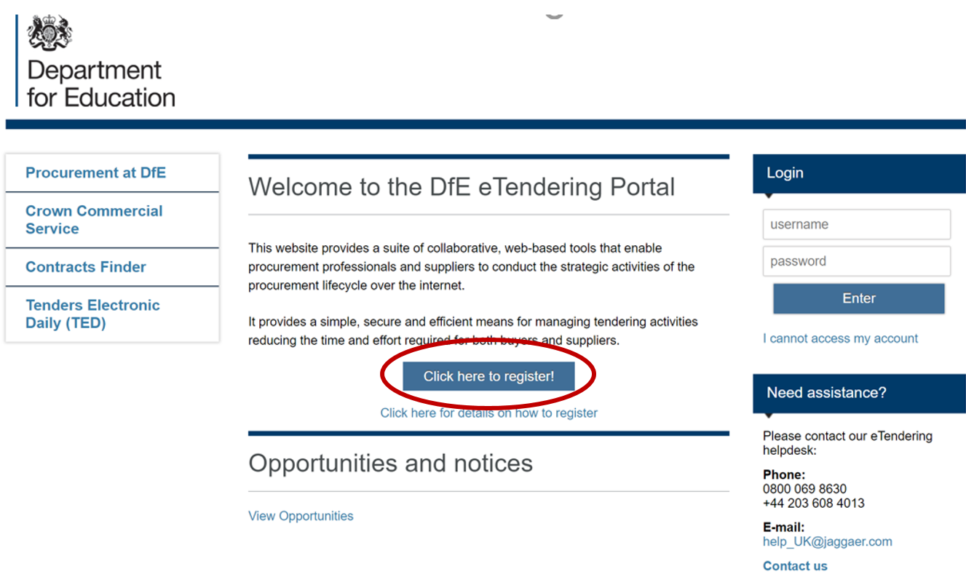

### **Registration Data**

To register as a supplier on Jaggaer it is necessary to complete the information in the three tabs shown below:

‘Registration data’, ‘Basic Profile Forms’, ‘My Category Selection’

#### Registration Data tab

The mandatory fields should be completed for ‘Organisational Details’ and ‘User Details’. Once satisfied with your answers click the ‘Save’ button.

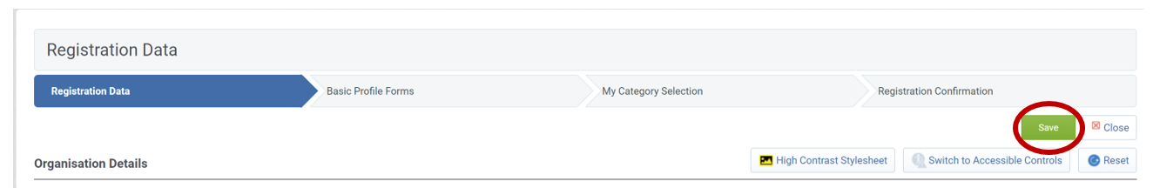

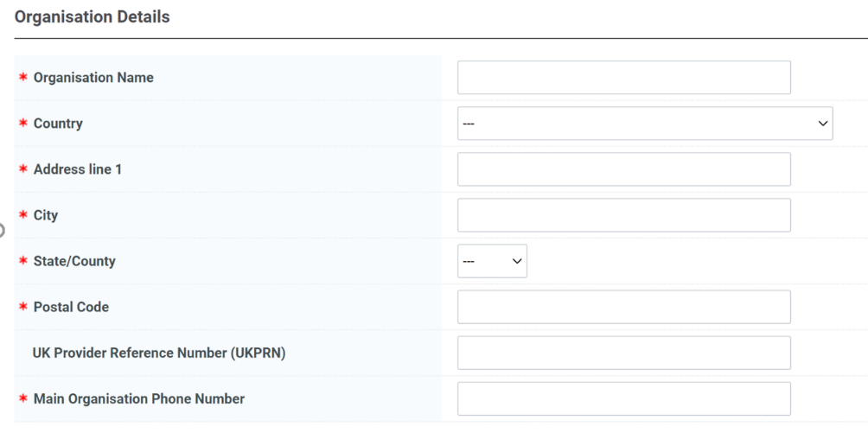

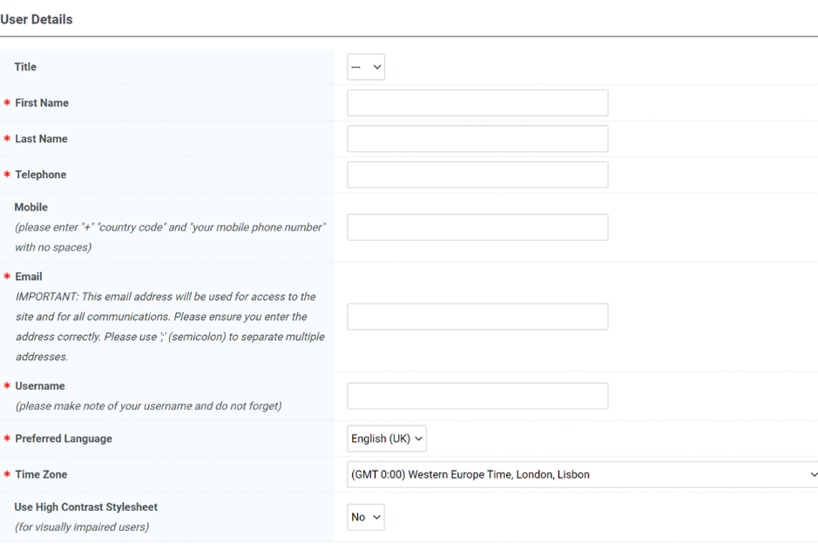

If any mandatory fields have been missed there will be a pop-up message stating the error. Revisit the answers and check for blank answers in the form, then click save when completed.

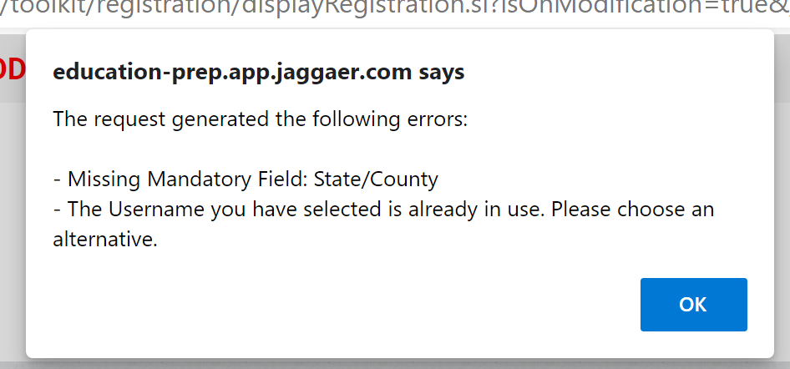

#### Basic Profile Forms

There are 3 mandatory questions to answer in the ‘Basic Profile Forms’.

Once complete click the ‘Save & Continue’ button.

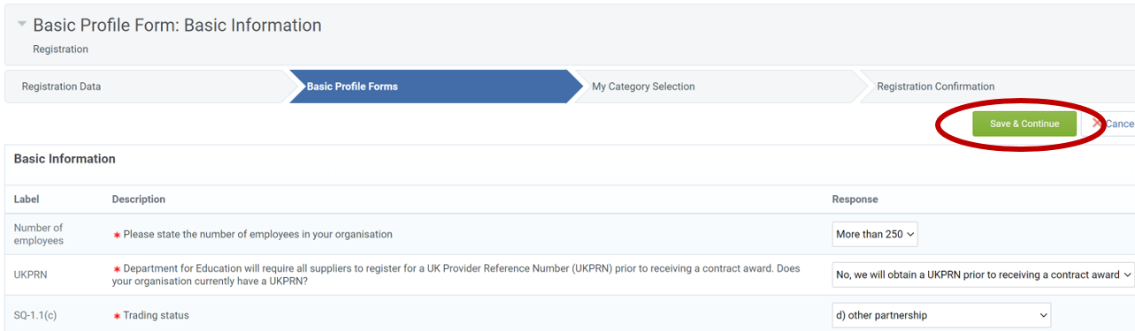

#### My Category Selection

You will receive alerts to any open opportunities published by the DfE that align to categories you have selected. Please add categories to your profile that describe the services your organisation delivers.

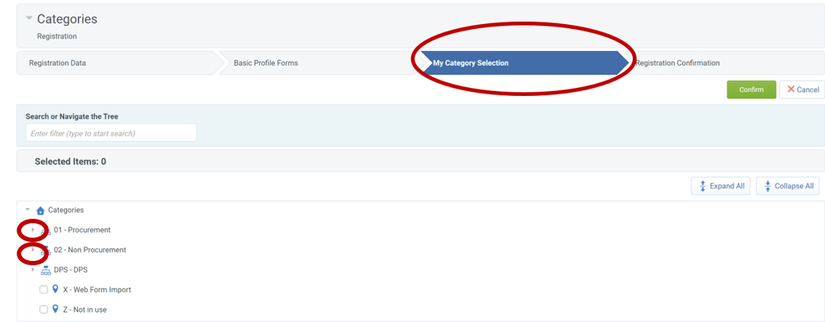

An example of the drop-down menu when opened is shown below:

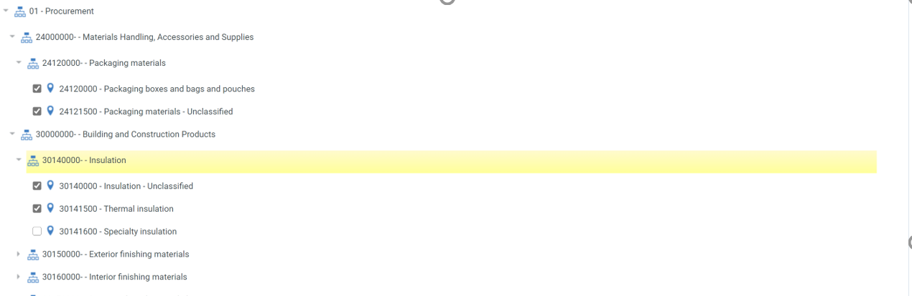

#### Registration Complete

Once all the information is complete, the final tab is ‘Registration Confirmation’. You will receive an email with your username and password, which you can use to log into Jaggaer, please notify us by reply to this email and you will be added to the opportunity.

