Church Green Recreation Ground (Kickabout Park)
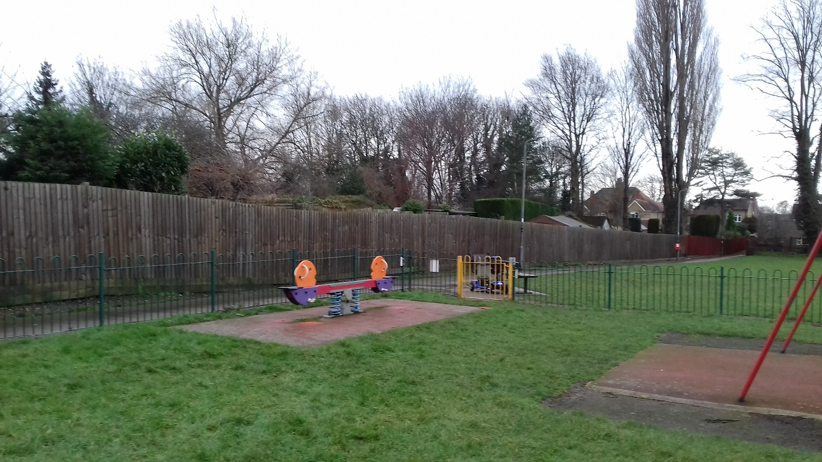
Seesaw – replace wetpour
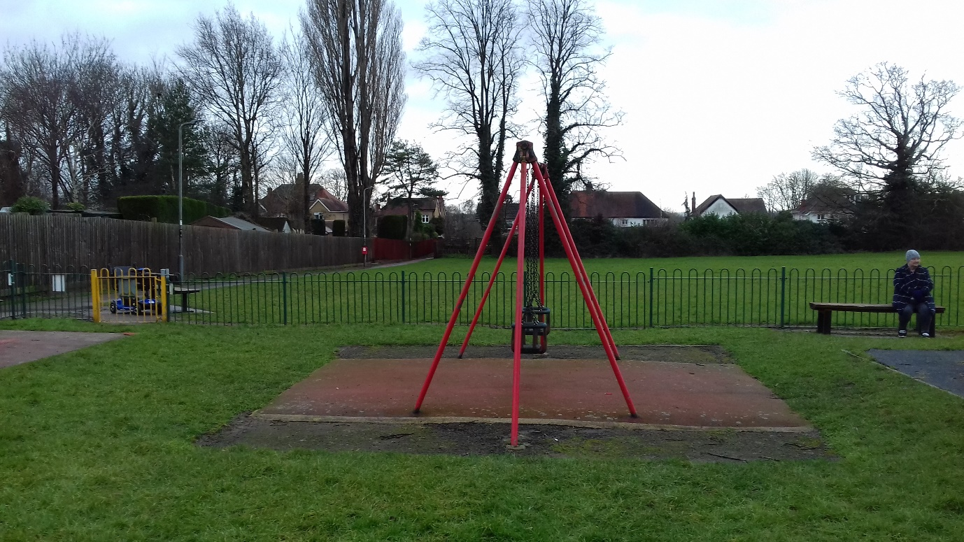
Cradle swings – paint frames, replace wetpour and cradle seats/chains
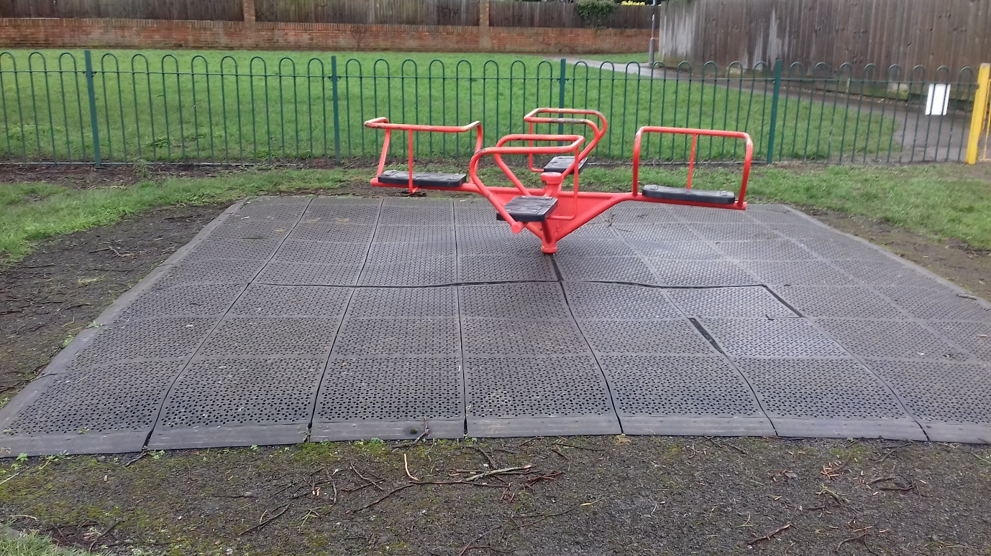
Roundabout – paint and replace surface with wetpour
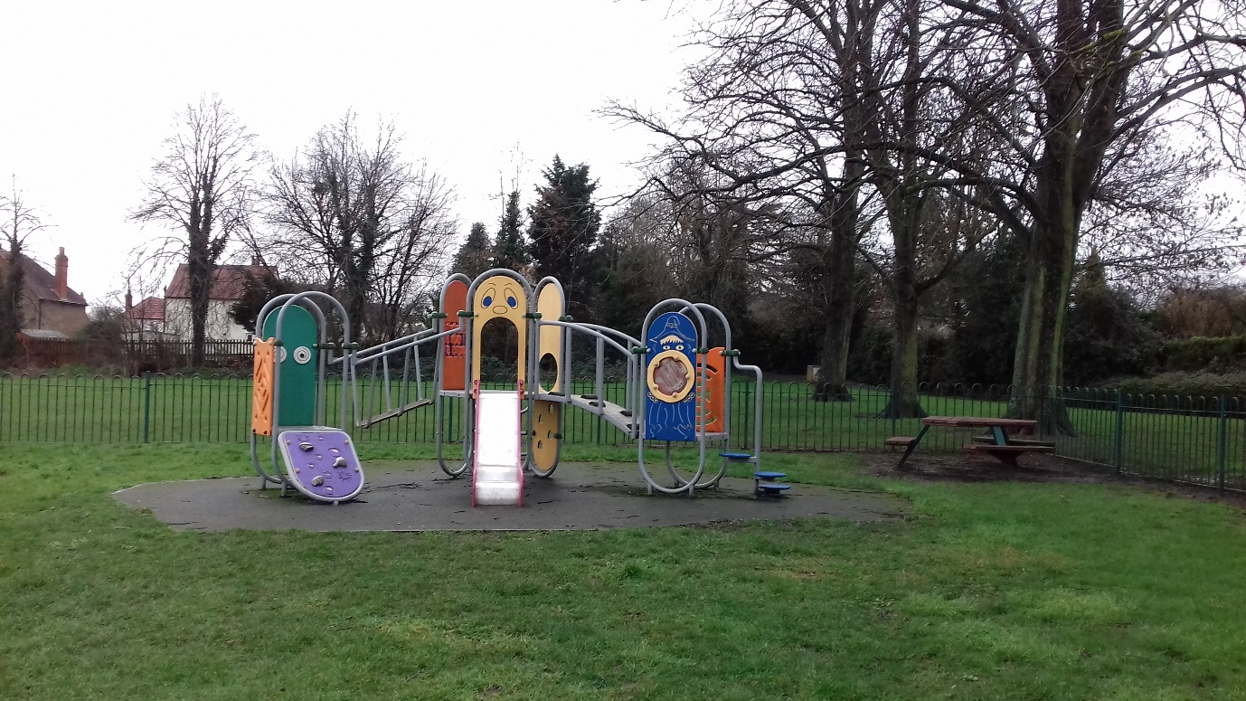
Toddler climbing unit – jetwash and replace wetpour
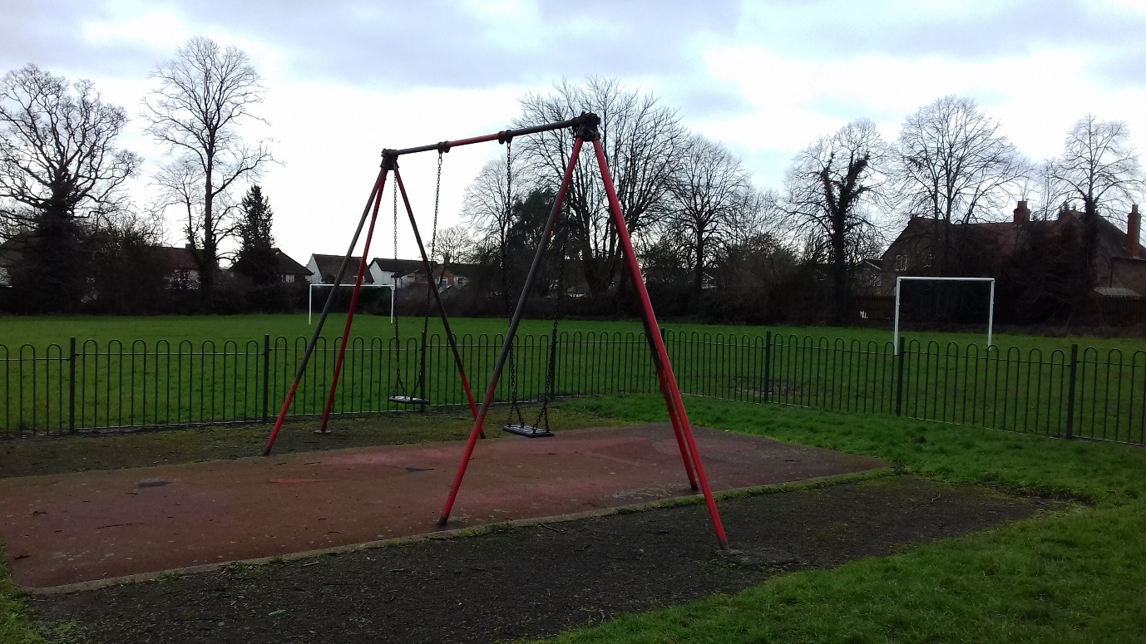
Flat seat swings – remove and replace as per specification
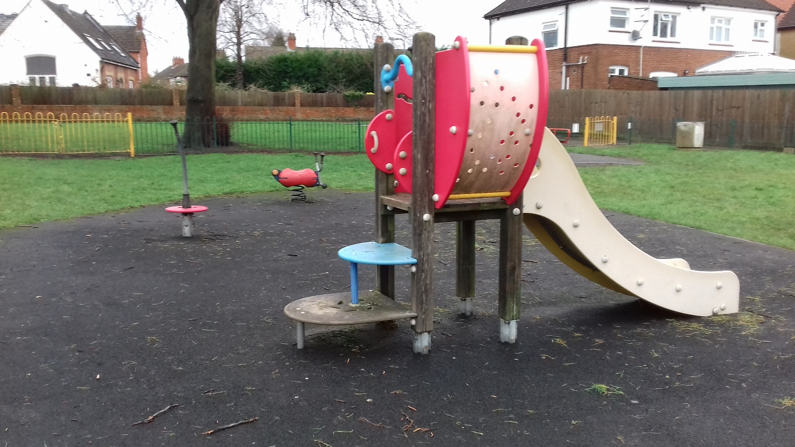
Central unit and springers – remove and replace as per specification
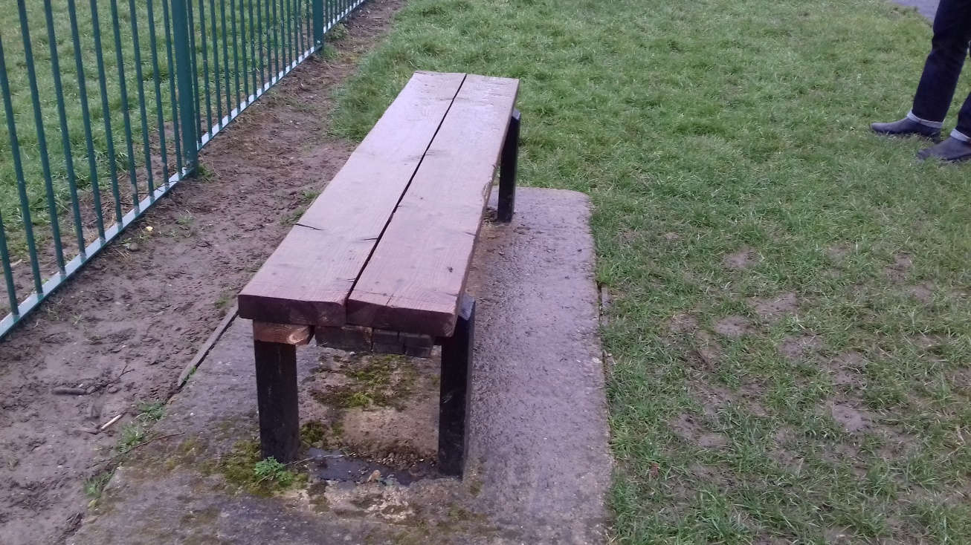
Bench – wooden slats to be replaced to match below
