

DIO BELIZE

BOOKLET 3

SPECIFICATION

FOR THE

25 FLIGHT HANGAR RECLADDING.

AT

PRICE BARRACKS, DIO BELIZE

References

- The Health & Safety at Work Act 1974 (HASWA).
- JSP 755 MOD manual of Health and Safety
- Construction (Design & Management) Regulations 2015 (CDM 2015).
- The Latest Edition of the UK Building Regulations.
- The Latest Applicable JSPs.
- BS EN 14782:2006 Self-supporting metal sheet for roofing, external cladding, and internal lining.
- BS EN 15651-1: 2017 Sealants for façade elements.
- BS 8414-2:2020 Fire performance of external cladding system
- BS EN 15048-1:2016 Non-preloaded structural bolting assemblies
- BS 476 Fire Tests
- BS 5228-1:2009 Code of practice for noise
- BS 5228-2:2009 Code of practice for vibration
- BS EN 14509:2013 Self-supporting metal faced insulating panels
- BS EN ISO 13788:2012 Hygrothermal Performance of building components and building element.
- The Electricity at Works Act 1989.T
- he Electricity Safety, Quality and Continuity Regulations 2002.
- BS 7671-18th edition IET Wiring Regulations.
- BS 5427:2016 Code of practice for the use of profiled sheet for roof and wall cladding on buildings.
- BEK044 RUK PBK_584: Building 263, Structural inspection report, Ramboll
- Regulatory Article 3266 Aerodrome maintenance

The drawings attached to this document, are to be read in conjunction with this Performance Specification (PS) for the 25 Flt Hangar refurbishment, (Building 263). It should be noted that these drawings are ‘Concept Only’ and the contractor is to produce a full set of design drawings with accompanying design calculations for this project. All design drawings will require Authority acceptance and approval before works commences on site.
Contractors Design

The Contractor is to advise the PM DIO Belize of all design consultants/sub-contractors who will be employed on this project and the areas of their design responsibility. Any works undertaken without prior issue of full information for the necessary approvals will be entirely at the Contractor’s own risk.

The Contractor shall not commence any work in accordance with any Design Document until the PM has agreed the relevant Design Document. The Contractor shall keep one copy of each Design Document on the Site, to which the PM or his representatives may have access at all reasonable times.
Design Responsibilities

Contractor’s Design Responsibilities. The Contractor is responsible for the design of all elements of the recladding of 25 Flight Hangar (Building 263). All designs are to be submitted to the Authority for concurrence and authorisation. The Authority’s conceptual drawings submitted in the ITT documentation are to be used as a reference guide only.

The Contractor shall ensure all designs are in accordance with reference A to S, and includes the applicable requirements as contained within References A to S and all other design documents specified within this Performance Specification. These standards should be considered as the minimum requirement for all works. Where there is conflict between the contractor’s design drawings and Performance Specification, the Performance Specification will take precedence in all cases. It is also the Contractor's responsibility to ensure that the design and construction activities meet the latest methods, requirements, guides, and widely accepted practices relevant to the project, its environment, and operations.

UK Building Regulations. All works shall comply with the latest UK Building Regulations where possible. Should any variation be required, approval from the Authority shall be obtained in writing prior to the commencement of any works.

Health and Safety. All works shall be carried out in accordance with the Health & Safety at Work Act 1974 (HASWA). The Contractor shall submit a pre-construction H&S file to the Authority for approval, including all risk assessments, method statements, hazardous material procedures, etc. to comply fully with Construction (Design & Management) Regulations 2015 (CDM 2015).

Upon project completion the H&S file shall be presented to the Authority 10 days before the Board of Officers is convened and in compliance with CDM 2015.

Construction Drawings. All works shall be constructed in accordance with the final construction drawings and where a conflict in design is found, authorisation shall be obtained in writing prior to any changes in design. No construction shall commence prior to obtaining written approval of the final construction drawings by the Authority.

Design Life. The design life of all new structural components and assemblies to first major overhaul, repair or replacement shall be a minimum of 15 years. The Contractor shall supply and install all components, elements and systems/structures to satisfy this requirement, and provide documentary evidence as per CDM 2015 and any additional contractual requirements that may apply.

Existing Services. The Contractor is responsible for ensuring all services on or adjacent to the site that will be affected by the works are identified, located and appropriate action taken to prevent damage before work commences. The Contractor shall ensure that any existing services and concrete slabs are reinstated to a condition at least similar to existing, with the minimum of disruption to existing facilities and services during construction. All works that could possibly influence existing services may only commence with written approval – this includes but is not limited to a Permit to Dig. The Authority must be informed immediately if any unknown services are discovered that will have an impact on the works.
Scope of the Overall Project

General. This Performance Specification (PS) outlines the requirements for the re- cladding of 25 Flight hangar, including the roof cladding, elevation cladding, all flashing, and soffits. All ventilation openings are to be reinstated as per the original design.

The Authority. DIO Belize is the Authority for the project. For the purpose of this Performance Specification, the PM is any person from within the Authority acting on behalf of the PM, the Superintending Officer (SO) in most cases.

Site location. The site is situated in the Southwest corner within Price Barracks. Price Barracks (PB) is located 15 km Northwest of Belize City. The nearest town is Ladyville located 2 km to the North. The site consists of a steel portal frame hangar structure, with two lean-to steel framed annex structures to the north and south of the main hangar area. The site-specific location can be seen in DWG 12/62/43611/P4/G/001.

Use of the Site. The Site shall not be used for any purpose other than undertaking the specified works. The Contractor shall erect the site and storage compound in a location agreed with the Authority for no longer than is required to complete the works. No storage of materials, parking of vehicles, temporary accommodation, or any other use of areas beyond the boundaries shall be permitted. Under no circumstances shall it be permissible for the Contractor to cause an obstruction to normal pedestrian or vehicular movements within the vicinity of the site. The sites and site compounds are to be suitably fenced off to prevent injury through access. Special attention shall be paid to the location of the Helicopter Landing Site (HLS) located 70 m to the West of building 263 the site shown on DWG DIO/BATSUB/EXT/C/01 and DIO/BATSUB/E/008. The drawings are located at annex A

Restrictions to the Works. The works are to be undertaken without interfering with every day running of the Authority’s operations within the area. The demarcation of the site boundary is to be obvious and clearly marked to restrict access to the site whilst the works are being undertaken.
Proposed Works

The proposed works for DIO Belize are as follows:

Ensure all services are isolated and proved dead before the project starts

Test and commission all reinstated electrical works.

Commission an asbestos report from a suitably qualified contractor

Prepare details of existing services including drawings.

Disconnect any Modnet services which will conflict with the deconstruction of 25 Flt Hangar (Building 263)

Complete the necessary steps of the building notification of construction works as per JSP 850.

Identify any components to be recycled and produce a register for the contractor.

The proposed works for the Contractor are as follows:

Deconstruction works.

In accordance with Work at Height (WaH) Regulations and JSP 375 Volume 3 Chapter 7, erect safe working platform or alternatively utilise MEWP.

Disconnection of any mechanical and or electrical services required to complete the deconstruction of the roof cladding. Air conditioning units are to be removed if necessary, suitably stored for refitment during the construction phase.

Removal of old cladding system on the roof and elevations.

Removal of damaged and unserviceable sheeting rails.

Removal of any doors, windows, fixtures and fittings deemed necessary to remove the old cladding system.

Not Used

Removal of all waste from the site to prevent the migration of Foreign Objects and Debris (FOD) to the HLS and/or Philip SW Goldson airport. To reduce FOD, waste must be contained in such a manner that wind cannot move it around the site.

Cleaning and preparation of the steel structure to enable recladding.

Re-cladding of the main hangar roof and all elevations including hangar sliding doors.

Installation of single skin metal profile sheet cladding.

Installation of high-level translucent panels as per the original design.

Installation of ridge cap, flashing, soffits, barge boards and gable ends.

Re-instatement of all ventilation Opening as per the original installation.

Reinstatement of any mechanical and/or electrical services including air conditioning removed as part of the deconstruction or installation works.

Not used

Not used

Not used

Re-cladding of annex offices to the north and south of the structure.

Installation of fire compliant Insulated sandwich panel roof panel.

Installation of all flashing and soffits.

Re Installation of the cavity barrier and fire barriers between roof panels and compartmentation of the office space. If removed as part of deconstruction

Re-instatement of all ventilation openings as per the original installation.

Reinstatement of any mechanical services including air conditioning units removed as part of the deconstruction or installation works.

Re-instatement of all ventilation openings in soffits with protection against animal nesting.

Not used

Not used

Not used

Not used
Management of the Works

Personnel. The Contractor is fully responsible for ensuring all personnel within the workforce are authorised to gain access to, and work within, Price Barracks. The Contractor is solely responsible for the submission and approval of passes and the Authority will not grant extensions to performance periods based on delays obtaining passes for access to the Base. The Contractor shall be always responsible for the transportation of contractor personnel both to and from the site.

Liaison with the Authority. The Contractor shall designate a Liaison Officer from their organisation who will be responsible for liaising with the PM or their representative (SO) on a day-to-day basis and as the need arises. The person so designated shall be responsible for communicating with the Authority regarding notification of intended work and explaining the effect within the building. Additionally, the Liaison Officer will be responsible for responding to the Authority’s enquiries and dealing with any issues or complaints. It is a requirement that the Contractor’s Liaison Officer makes daily contact with the Authority such that an active rather than a responsive attitude to liaison is maintained. The Contractor’s Liaison Officer is a key person in achieving the successful execution of this Contract.

Supervision. The Contractor shall accept responsibility for design, co-ordination, supervision and administration of the Works, including all subcontracts. They shall arrange and monitor a programme with each subcontractor, supplier, local Employer and any statutory undertaker, and obtain and supply information as necessary for co-ordination of the work. In addition to constant management and supervision of the Works provided by the Liaison Officer, all significant types of work must be under the close control of competent trade supervisors to ensure maintenance of satisfactory progress and quality.

Co-ordination of Engineering Services. The site organisation staff must include one or more persons with appropriate knowledge and experience of mechanical and electrical engineering services to ensure compatibility between engineering services, one with another and each in relation to the Works generally.

Approvals. Where products or work are specified to be approved or the PM instructs or requires that they are to be approved, the same must be supplied and executed to comply with all requirements.

Photographs. No photographs shall be taken of the site without the express Authority of the PM.

Programme of Works. Prior to the commencement of the works, the Contractor shall liaise with the Authority, in order to produce a detailed programme of works. This programme shall be agreed and approved and shall form the baseline programme for the project. Any deviations from the agreed programme shall be communicated to the Authority, with programme updates being produced if required and approved by the Superintending Officer. The programme must be daily resolution and show when stores equipment and plant deliveries will occur.

Programme Status. The Contractor shall also show on this programme each state of both design and construction of the various elements of the works so as to illustrate the latest dates by which instructions requiring changes can be accommodated in each part of the Works without effecting the completion thereof. Thereafter, the Contractor shall amend and revise the programme as required by the Conditions of Contract and as required by the PM. The submission of a programme will not relieve the Contractor of his responsibility to apply in writing for instructions, drawings etc. in accordance with the Conditions of Contract.

Commissioning Period. One month Prior to commencing the commissioning of any of the reconnected mechanical and electrical services, the contractor shall submit a Commissioning Plan, outlining the steps, tasks, activities and responsibilities to be conducted and adhered to, ensuring that the project commissioning process is understood and delivered by all parties involved. This is to include the preparation of the handover document.

Commencement of Work. Inform the PM at least five days before the proposed date for commencement of work on site.

Monitoring. The contractor is to record progress on a copy of the programme kept on site. If any circumstances arise, that may affect the progress of the works, put forward proposals or take other action as appropriate to minimise any delay and to recover any lost time. A daily site diary in an appropriate format is to be kept by the contractor. The site diary is to include details of personnel and plant/equipment on site and is also to include delays and their reasons, visitors to site and works progress. Variation orders and both written and verbal site instructions are also to be included. This is to form the basis of the Weekly Progress Report that is to be submitted to the Authority weekly. A proposed format for the Weekly Progress Report can be obtained from the Authority.

Site Meetings. The PM, or his representative, will hold regular site meetings to review progress and other matters arising from the administration of the Contract. It will be the Contractors responsibility to ensure the availability of accommodation and attend all such meetings.

Contractors Site Meetings. The Contractor is to hold meetings with appropriate subcontractors and suppliers shortly before site meetings with the Authority to facilitate accurate reporting of progress.

Notice of Completion. The Contractor is to provide the PM at least seven days notice of the anticipated dates of Practical Completion of the whole or parts of the Works.

Extension of Time. When it is necessary to report a cause of a delay or likely delay in the progress of the Works this shall be given in the form of a written notice that must also be given of all other causes, which apply concurrently. The notice shall state the following details.

The cause of delay or likely delay.

Relevant particulars of the expected effects if appropriate related to the concurrent causes.

An estimate of the extent, if any, of the expected delay in the completion of the Works beyond the Date of Completion.

Any other relevant information required by the PM.

Quality Standards/Control. The contractor will provide evidence to the PM of his quality standards and controls, and will produce a plan detailing QC activities in order for the PM to plan for witnessing of critical activities.

General Quality of Products. All products shall conform to the following subparagraphs:

Products to be new unless otherwise specified by the Authority.

For products specified to a BS or EN obtain certificates of compliance from manufacturers when requested. In cases where locally procured materials do not have such certificates, the contractor must provide evidence demonstrating that these products will exhibit equivalent performance in terms of safety, serviceability, robustness and durability as specified in the relevant BS or EN standards.

Where a choice of manufacturer or source is allowed for any particular product, the whole quantity required must be of the same type, manufacture and/or source unless otherwise approved. Produce written evidence of sources of supply when requested by PM.

Ensure that the whole quantity of each product required to complete the work is of consistent kind, size, quality and overall appearance.

Where consistency of appearance is desirable ensure consistency of supply from the same source. Do not use different colour batches where they can be seen together.

If products are prone to deterioration or have a limited shelf life, order in suitable quantities to a programme and use in appropriate sequence. Do not use if there are any signs of deterioration, setting or other unsatisfactory condition.

Proprietary Products. All products shall conform to the following subparagraphs.

Handle, store, prepare and use or fix each product in accordance with its manufacturer's current printed or written recommendations/instructions. Inform PM if these recommendations/instructions conflict with any other specified requirement. Submit copies to PM when requested.

The tender will be deemed to be based on the products specified and recommendations on their use given in the manufacturer’s literature current at the date of tender.

Obtain confirmation from manufacturers that the products specified and recommendations on their use have not been changed since that time. Where such change has occurred inform PM and do not place orders for or use the affected products without further instructions.

Checking Compliance of Products. The Contractor shall check all delivery tickets, labels, identification marks and where appropriate the products themselves to ensure that all products comply with the project documents. In particular, check that the products comply with the following sub-paragraphs.

The sources, types, qualities, finishes and colours are correct, and match any approved samples.

All accessories and fixings that should be supplied with the products have been supplied.

Sizes are correct. Where tolerances are critical, measure a sufficient quantity to ensure compliance.

The delivered quantities are correct, to ensure that shortages do not cause delays in the work.

The products are clean, undamaged and otherwise in good condition.

Any products with a limited shelf life are not out of date.

Protection of Products. All products shall be protected to ensure that they remain in the condition they are required to be in. In particular the contractor is to ensure that products are to be prevented from overstressing, kept clean, protected from the elements and kept in original wrappings until required for the project.

Prohibited Products. The Contractor shall not employ on or incorporate in the Works any of the following products and shall impose a like obligation upon all Sub-Contractors.

Asbestos materials as described in the Asbestos Prohibitions Regulations 1985 and the Asbestos Products (Safety) Regulations 1985.

Lead or any products containing lead for use in connection with drinking water.

Materials that are generally composed of mineral fibres either manmade or naturally occurring which have a diameter of 3 microns or less and a length of 200 microns or less or which contain any fibres not scaled or otherwise stabilised to ensure that fibre migration is prevented.

Other products or substances generally known to be deleterious to health and safety at the time of use or to the durability of the property in the particular circumstances in which they are being used.

Air conditioning refrigerants R12 & R22 (all refrigerants used must be Montreal Protocol compliant).

Setting Out. The Authority will establish a local control point. A detailed setting out drawing will be issued to the Contractor. The Contractor is responsible for all setting out and shall check out the dimensions of the site against those shown on the drawings, and record the results on a copy of the drawings. The Contractor shall inform the PM when overall setting out is complete and before commencing construction.

Record Drawings. The Contractor shall record details of all grid lines, setting out stations, bench-marks and profiles on the site setting out drawing. Retain on site throughout the contract and hand to PM on Completion.

Service Runs. The Contractor shall make adequate provision for services, including unobstructed routes and fixings. Wherever possible ducts, chases and holes are to be formed during construction rather than cut.

Mechanical and Electrical Services. Mechanical and Electrical Services must have final tests and commissioning carried out by the Contractor so that they are in full working order at Practical Completion.

Access. The Contractor shall provide at all reasonable times, access to the Works. The Contractor shall supply the PM or his representative with copies of any documentation and drawings, which may reasonably be required for the purposes of monitoring the work performed under this or any sub-contract. The PM is to be provided with three copies of all construction drawings prior to the commencement of the works. These drawings are to be updated as necessary by the Contractor during the works.

Defects in Existing Construction/Services. This shall be reported to the PM without delay. Obtain instructions before proceeding with work which may be covered up or otherwise hinder access to the defective construction, or be rendered abortive by the carrying out of remedial work. This is particularly relevant in relation to the expansion of the existing service runs.

Timing of Tests and Inspections. The Contractor is to agree dates and times of tests and inspections with PM four days in advance, to enable the PM and other affected parties to be present. On the previous working day to each such test or inspection the Contractor is to confirm to the PM that the work or sample in question will be ready or, if not ready, agree a new date and time.

Test Certificates. The Contractor is to submit a copy of each certificate to PM as soon as practicable and keep copies of all certificates on site. Copies should be included in the Health and Safety File on handover of the works.

Proposals for Rectification of Defective Work/Products. As soon as possible after any part(s) of the work or any products are known to be not in accordance with the Contract, or appear that they may not be in accordance, the Contractor is to submit proposals to the PM for opening up, inspection, testing, making good, or removal and re-execution. Such proposals may be unacceptable to the PM and he may issue contrary instructions.

Quality Control. The Contractor is to establish and maintain procedures to ensure that the works, including the work of all Subcontractors, comply with specified requirements. This is to include all testing of materials that are to be incorporated into the project (e.g. concrete). The Contractor is to maintain full records, keep copies on site for inspection by the PM, and submit copies of particular parts of the records on request. The records must include the following:

Identification of the element, item, batch or lot including location in the works.

The nature and dates of inspections by the Contractor or PM, tests and approvals.

The nature and extent of any non-conforming work found.

Details of any corrective action.

Work at or after completion. The Contractor is required to undertake the following works prior to handover.

Make good all damage consequent upon the work.

Remove all temporary markings, coverings and protective wrappings unless otherwise instructed.

Clean the works thoroughly inside and out including all accessible ducts and voids; remove all splashes, deposits, efflorescence, rubbish and surplus materials consequent upon the execution of the work.

Cleaning materials and methods to be as recommended by manufacturers of products being cleaned, and to be such that there is no damage or disfigurement to other materials.

Obtain COSHH dated data sheets for all materials used for cleaning and ensure they are used only as recommended by their manufacturers.

Touch up minor faults in newly painted/repainted work, carefully matching colour and brushing out edges. Repaint badly marked areas back to suitable breaks or junctions.

Adjust, ease and lubricate moving parts as necessary to ensure easy and efficient operation, including doors, windows, drawers, ironmongery, appliances, valves and controls.

Security at Completion. The Contractor is to leave the Works secure with all accesses locked. Account for and adequately label all keys and hand over to PM with itemised schedule, retaining duplicate schedule signed by PM as a receipt.

Making Good Defects. The Contractor is to make arrangements with the PM and give reasonable notice of the precise dates for access to the various parts of the Works for purposes of making good defects. The PM is to be informed by the Contractor when remedial works to the various parts of the Works are completed and ready for approval.
Documents to Be Provided By Contractors

Design Information. Particular reference is made to Clause 46 of the Conditions of Contract. The Contractor is to submit all design information to the Authority prior to commencement of the construction phase. The PM will examine design documentation and shall be entitled to reject a design as unsatisfactory where it is not in accordance with the specification, statutory regulations, or if it would be unfit for purpose. One copy of all construction drawings is to be provided by the Contractor to the PM prior to commencing Works. Amended or updated drawings are to be provided as necessary. The minimum design information to be provided by the Contractor shall include the following:

Not used.

Not used

Detailed structural design, drawings.

Not used

Not used

Not used.

Manufacturer product details, including safety data sheets.

Project Programme, to be regularly updated or upon request by the Authority and provided electronically on Microsoft Project 2003, or equivalent.

Health and Safety File to include all calculations and ‘As Built Drawings’.

All drawings shall be prepared to best practice and should include all relevant data required to construct the facilities in question. Design drawings shall be submitted for approval as a group, using consistent sheet sizes. All drawings within the submittal for approval shall have identical title blocks and shall include a consistent numbering schedule, indicating amendments where applicable.

The signed and approved drawings shall be used as the construction drawings on site for all work purposes and to satisfy the requirements as specified by CDM 2015.

Construction and ‘As Built’ Drawings. During the contract period and as directed by the Authority, the Contractor / Sub-Contractor shall use the signed and approved construction drawings indicating his intentions to comply with specified work and service installations. Any construction drawing on site must be approved by the Authority prior to commencement of any works, with any amendments required during the works clearly and timely communicated to the Authority for agreement and approval. ‘As Built’ drawings shall be submitted 28 days after completion of the works as directed by the Authority.

Site Diary. The Contractor shall keep an up to date, daily, site diary. This document is to be used to record all decisions made on the site both verbal and written. The document is also to be used to record visits to site and note anything, which has a direct effect on the project in terms of cost and extensions to time, or any other occurrence that affects the project programme. All changes must have been agreed and authorised by the Authority. The site diary shall list in writing all issued variation orders and site instructions, including amended drawings, and verbal decisions made on site. All verbal decisions must be recorded in writing no less than 24hrs after they have been made and entered in the site diary. The Contractor shall on request make the site diary available for the Authority to inspect. This document will be used as the audit trail in light of any disputes, concerning the project.
General Conditions

Preparatory Works. All local services are to be identified and adequate precautions taken to protect such services from damage for the duration of the works, or alternatively to relocate or disconnect with alternate provision, as per design and site requirements. The Authority shall be informed immediately if any unknown services are discovered that will have an impact on the works. All existing buildings and other facilities if any shall be identified, and precautions taken to mitigate the effects of works on going operations and facilities. This includes but is not limited to dust, noise, security, H&S, maintaining unobstructed access, establishment of clearly demarcated works and storage areas.

The Contractor shall verify with the Authority which site features are to be removed and protected during construction works. All setting out shall be completed by the Contractor, as well as any and all ongoing monitoring of works to ensure accuracy, plumb and level.

Signage. The Contractor shall supply and erect all applicable and appropriate signage to the site. This shall include as a minimum all H&S signage, directions and location of site office and emergency contact details of the Contractor’s representative on site. Temporary warning signs and careful demarcation of works areas must be undertaken with care to ensure compliance with any and all requirements.

Workmanship. Not withstanding any clauses in the Conditions of Contract or elsewhere in the Specifications or Scope of Works, the Contractor shall be responsible for ensuring that all work-related activities shall be carried out in a neat and workmanlike manner, in accordance with accepted good practice. The Contractor shall pay full attention to quality control and adherence to the specifications. Particular care shall be taken in respect to Health and Safety matters, which shall include the provision of any relevant temporary warning signs and safety barriers. All working areas are to be kept clean and tidy on a daily basis. All redundant materials must be cleared to the requirements laid down in the Authorities Environmental Regulations.

Site Manager. At all times the Contractor shall have a Site Manager present on site that has the capability of reading, writing, speaking and receiving instructions in the English Language, including being able to understand and interpret technical drawings and specifications. This Site Manager must be able to explain the work operations to persons performing the work in a language that those performing the work are capable of understanding. The PM shall have the right to determine, whether the proposed representative has sufficient technical and linguistic capabilities.

Dust Protection. Where work is carried out in an occupied building/area containing personnel or equipment, or adjacent to sensitive areas/facilities (airfields, hospitals, etc.) the Contractor shall ensure that all necessary dust control measures are taken to protect the same. This may include the following, but not limited to: Mechanical protection to equipment and personnel, suppression of dust on roads.

Visit to Site. The Contractor shall acquaint himself completely with the exact conditions relating to access and site environment, along with the layout, conditions and positions of existing services, the full extent of the works required, and the supply and conditions affecting labour, carriage, carting, unloading, storage, tools, scaffolding, etc., as well as any security and access constraints.

Existing Record Drawings. The Contractor will upon request, be supplied with copies of all available and relevant existing record drawings. The Contractor during tender stages shall fully acquaint himself with the nature and extent of all existing services within the area of the contract works.

Permits to Work and Authorisations. The contractor shall comply with the Client’s permit to work system and the JSP 375, Volume 3, (details of which are obtainable from the Authority SO), including the provision of method statements, risk assessments, switching/isolating safety programmes, working at height, etc.

The responsibility remains with the Contractor to obtain all necessary authorisations including but not limited to a permit to dig, security and access to the camp and site, fencing/screens to isolate runways, taxiways, and other existing facilities from the works, etc. required to commence and complete the works.

The Contractor shall at all times ensure that full coordination, cooperation and liaising with the Superintending Officer of the Client and Authorities is achieved and maintained.

Site Instructions. Where there is a change in design or specification, which does not have a cost or time implication a Site Instruction shall be issued by the SO to authorise the proposed change at nil cost to the Authority. The site instruction shall also be used to authorise a change in a specified material/item/equipment as long as the replacement meets the standards required by the original specification and is authorised by the SO.

Variation Order. Where there is a change in design or specification, which does have a cost or time implication a Variation Order shall be raised by the Superintending Officer to describe the proposed change, this will have a cost implication to the Authority. The Works Contract Officer will issue the Variation Order to the Contractor for pricing; the Contractor will price the variation and return it to the Works Contract Officer. All Variation Orders must be authorised by the Project Manager, Financial Officer and issued via the Works Contract Officer prior to the commencement of any works on site. All Variation Orders are incorporated into the Contract by the issue of a Contract Amendment.

Rejection of Work. The Authority reserves the right to reject or condemn any area of the works that he considers to be below an acceptable standard and the Contractor shall replace or repair the said works within 7 days of being notified in writing of the rejection by means of a Non Conformance Report.

Operations and Maintenance Documentation. Upon completion of the works the Contractor shall forward all manufacturers’ details relating to equipment/materials used to the Authority for inclusion into the O&M Manual/H&S File. Refer also to CDM 2015, this documentation less ‘As Built Drawings’ is to be made available at the Pre Board of Officers not less than 10 days before the due project handover date. A full list of snagging items shall be produced and presented to the Authority with a rectification programme at this very same board.

Regulations. It is the Contractors duty to be fully conversant with all local/MOD regulations and requirements in respect of fire, safety, security and occupational health, etc. These are to be fully complied with throughout the contract period.

Inspection, Testing and Commissioning. The installations shall be tested and inspected in accordance with but not limited to the current CIBSE Codes, BS7671:2008– Requirements for Electrical Installations, IEE Wiring Regulations 18th Edition where appropriate, etc. Advance notice of tests shall be given (minimum of 7 days prior to notification). Test and inspection certificates are to be approved by the Authority, preferred document templates will be provided by the Authority on request. Test certificates shall serve as a record that the item referred to has been shown under test to meet the requirements of the specifications and of British Standards as applicable and shall be dated, numbered and clearly referenced to the item tested by means of serial, chassis or other manufactures reference number permanently marked in a conspicuous position. On completion, all original test and inspection certificates are to be provided to the Authority and included in the H&S file CDM 2015. All test instruments shall be provided by the Contractor. The calibration certificates for the testing of the equipment are to be available on request to be shown to the Authority for scrutiny. The Contractor shall ensure all calibrations are in date. The Authority reserves the right to have an independent electrician available during the test and inspection phase. Any defects of workmanship, materials or non-compliance with the specifications or other irregularities which become apparent during the tests shall be rectified by the Contractor, at his own expense, until the whole work is free from defects and in full working order to the complete satisfaction of the Superintending Officer.

All materials used for construction of permanent works shall have suppliers’ specifications and/or testing certificates available. Where materials are used as part of a whole or in conjunction with other materials, and in any case where site testing is required by best practice, verification of quality and specifications should be allowed for the parts / items / products (suppliers’ specification) as well as the whole (site testing).

Defects Liability Period. A defects liability period of 12 months shall apply for the works. The Contractor will be responsible for making good at his own expense defects in the works for a 12 month period from handover.
Transportation and Tracking of Equipment

It is expected that the Contractor will not require a forward resources area other than the site. Should one be required a location within an existing base area shall be made available, as agreed by the PM. Packaging shall be to a good standard capable of withstanding transportation and handling loads. The Contractor shall be solely responsible for storage and movement of all equipment to site. The Contractor shall remain at all times responsible for the security of equipment including prevention of theft.
Construction Preliminaries

Location Plan. The location of the proposed works is within Price Barracks shown in the following drawings DIO/BATSUB/EXT/C/01 and DIO/BATSUB/E/008. These drawings can be seen at Annex A.

Preparatory Works. All local services are to be identified and adequate precautions taken to protect such services from damage for the duration of the works, or alternatively to relocate or disconnect with alternate provision, as per design and site requirements. The Authority shall be informed immediately if any unknown services are discovered that will have an impact on the works. All existing buildings and other facilities if any shall be identified, and precautions taken to mitigate the effects of works on operations and facilities. This includes but is not limited to dust, noise, security, H&S, maintaining unobstructed access, establishment of clearly demarcated works and storage areas. The location of the area must be approved by DIO Belize and BATSUB.

Works on an aerodrome. DIO Belize, in conjunction with SO3 Aviation (BATSUB), are to ensure a Work in Progress map is produced and provided in line with Regulatory article 3266 (RA3266) and given to all HLS users. In addition, the contractor is to be provided with a detailed brief. As a minimum, the brief should include the following details:

Limits of work area

direction of Air System movements including the approach and take-off routes of any helicopters.

Route to be taken by works vehicles moving in and out of the construction site.

Parking area for works vehicles and equipment.

Control to be exercised over works vehicles and workmen.

Lamp and pyrotechnic signals that may be employed.

Foreign Object Damage (FOD) prevention.

Any additional measures to be employed.

If the risk to the HLS cannot be reduced to an acceptable level, DIO Belize are to arrange with BATSUB an alternative HLS.

Obstructions. As the proposed works are to be carried out in the existing compound and surrounding areas, there are obstructions in the form of fences and ISO containers, the contractor is to review the site before commencing works.

Provision of Information. Unless otherwise specified the following is to be provided:

copies of all information, including valid certification, in respect to work, goods and materials proposed by the Contractor, shall be supplied to the Authority in electronic format. Where the original document is written in a language other than English, it shall be accompanied by an English translation.

Information and certificates shall be supplied at least two weeks prior to the use of the work, goods or materials in the Works.

Three copies of detailed working and fabrication drawings and calculations shall be submitted to the Authority for reference purposes. Such submittal shall in no way relieve the Contractor of his responsibilities for the work under the contract.

Health and Safety Restrictions, Precautions and Monitoring. The Contractor shall implement the requirements described in the Health and Safety at Work Act 1974 (HASAW) to protect members of the public and persons visiting the site from risks arising from the use of equipment, materials or substances defined therein.

Control of Noise and Vibration. The Contractor shall comply with the recommendations for practical measures to reduce noise set out in BS 5228: Parts 1, 2 and 4.

Deconstruction specification

Before starting deconstruction work, examine available information and carry out a survey of 25 Flight and the surrounding area. Submit a deconstruction method statement describing the following:

Any mechanical services which require disconnecting to carry out the deconstruction.

Identify the positioning of both above and below ground services, as well as any necessary services for the contractors, and establish plans for their disconnection and removal.

Form and location of materials identified for reuse or recycling, and proposed methods for removal and temporary storage.

Proposed programme of work, including sequence and methods of. Deconstruction.

Arrangements for protection of personnel and the general public, including exclusion of unauthorized persons.

Arrangements for control of site transport and traffic.

Extent of deconstruction. Subject to retention requirements specified elsewhere, deconstruct/demolish the cladding system only.

Features to be retained. Keep in place and protect all mechanical and electrical services wherever possible, they are only to be removed if they conflict with the deconstruction of the cladding. Before removal DIO Belize are to be notified.

Services affected by deconstruction. If any services are affected by the deconstruction of the cladding system the contractor must comply with the following:

Services regulations. Any work carried out on the services shall be carried out in accordance with the byelaws and/ or regulations of the relevant Statutory Authority.

Location of services. Any services affected shall have the positions marked.

Disconnection. DIO Belize shall arrange for the isolation of all services before work is to start. All electrical services are to be proved dead and locked off for the duration of the project.

Workmanship. The deconstruction is to be conducted in accordance with BS6187:2011. Site staff responsible for supervision and control of work are to be experienced in the assessment of risks involved and methods of deconstruction to be used.

Asbestos-containing materials - unknown occurrences. On discovery, give notice immediately of suspected asbestos-containing materials when discovered during deconstruction work. Avoid disturbing such materials. Submit statutory risk assessments and details of proposed methods for safe removal.

Unforeseen hazards. On discovery, give notice immediately when hazards such as unrecorded voids, tanks or chemicals are discovered during deconstruction. Submit details of proposed methods for filling, removal, remediation, etc.

Construction Specification

This performance specification outlines the requirements for recladding the 25 Flight Hangar with the aim of extending its life span by 15 years. The hangar consists of a metal portal frame and Sliding doors with single skin profile metal cladding sheet and was built 25 years ago. The recladding project includes the complete installation of a single skin profile metal sheet along with translucent panels on the entire roof over Mandatory Equipment Inspection (MEI) facility. A Insulated sandwich panel roof panel will be installed over the two lean-to-steel-framed annexes that house the technical accommodation. All work shall comply with the current UK regulations and relevant British Standard (BS),particular attention should be paid to BS 5427.

Cladding system. Recladding of the structure requires a variety of cladding materials and installation types procured from the different locations. 24 gauge Single Skin profile metal sheets can be locally procured compliant to UK standards Locally procured profile metal sheet must closely resemble the features and aesthetic qualities of the insulated roof panels procured from the UK. The curved panels may be single skin metal sheets matching the profile of the insulated and single skin cladding elements. The re-cladding project is to preserve the curved edges of the hangar, maintaining their original design.

Profile metal sheet. The single skin profile metal sheet shall be corrosion- resistant, weatherproof with minimum 24 gauge to ensure longer life span. It shall maintain structural integrity and not visually deform or detach from the frame. Sheets are to be attached as per manufacturer’s instructions and attached in such a way to prevent uplift in the event of category 2 hurricanes.

Insulated sandwich panel. The insulated sandwich panels above the office space must provide a minimum of 30-minute fire rating and be compliant to British standards.

Translucent panels: Translucent panels, integrated into the profile metal cladding system should be installed to allow natural light into the hangar while maintaining the water tightness and sufficient structural strength to withstand wind loads. They are to be of the same surface area and be installed in the same quantity and locations as the existing translucent panels. The panels should be protected with a UV- absorbing surface film on or both faces, to minimize long term discoloration or loss of light transmission.

Avoidance of surface condensation. Determine surface condensation risk of cladding/ covering system. Re-install obsolete gutter and funnel system in each bay. Ensure that damage and nuisance from surface condensation does not occur.

Prevention of electrolytic action. Isolating tape or insulating tape is to be installed to contact surfaces of supports and sheets of dissimilar metals ensuring joints are overlaps between strips. Tape should have good adhesion properties and temperature resistance suitable for the operating conditions of the metal sheet to ensure long term performance.

Supports. The existing purlins have been assessed and found to be in a satisfactory condition for the recladding project. A structural inspection report was produced by Ramboll which found the overall structure to be in good condition (Ref. R). A copy of the report is at enclosure 1. In an event of replacement, all purlins shall be structural grade steel with like for like replacement. Purlins shall be capable of supporting the weight of the profile metal sheet cladding, including any additional loads such as wind uplifts.

Fasteners. The location of the site is susceptible to a Category 2 hurricane. It is crucial to employ suitable fixings or fasteners to secure the profile metal cladding to withstand the wind forces associated with a Category 2 hurricane ranging 96 mph and 110mph to ensure the structure’s durability for its intended design lifespan for 15 years. All fasteners, including screws, bolts, and brackets, shall be made of corrosion-resistant materials and suitable for the cladding system. They shall comply with the requirements of BS EN 14566:2008 for self-drilling screws and BS EN 15048-1:2016 for bolts.

Fixing sheets. Penetration openings to be the minimum size necessary and edges shall be reinforced. All fasteners should be drilled and positioned at regular intervals in straight lines, centred on support bearings. Sheet ends, laps and raking cut edge are to be fully supported and with fixings at the top of the overlap. All fixings and sealants are to be checked to ensure that they are watertight, and that fixings, and sheets are secure with no buckling or distortion. All cut edges shall be painted to match face finish.

Sealant. Sealants shall be used to seal gaps, joints, and penetrations to prevent water ingress. They shall be compatible with the cladding materials and capable of withstanding the expected environmental conditions. The sealants shall comply with the requirements of BS EN 15651-1:2017.

Flashing. Flashing shall be provided at all transitions, joints, and intersections to ensure water tightness. They shall be made of the same materials and be the same colour as the cladding sheets and installed according to the manufacturer’s recommendations. Where possible they shall be fixed to the structure in conjunction with the adjacent sheeting, where not possible they shall be fixed to the sheeting.

Fire protection. All methods used in the construction and compartmentalisation elements such as cladding, cavity barriers, fire barriers, fire stops and fire doors must adhere to the Building Regulation 2010 Approved Document B, BS8414, BS476 and any other relevant BS to the materials used.

Any works carried out on fire compartmentation and fire doors including repairs and installation MUST be undertaken by a competent person that holds current 3rd party accreditation (3PA) by a UKAS certification scheme, e.g., BM TRADA, Certifire, FIRAS etc.

All completed works must be provided with suitable documentation to ensure repairs are undertaken by accredited persons to a recognised compliant standard. This information must be made available to the Responsible Person and documents be provided to the MMO & DIO for inclusion in the buildings Operation & Maintenance (O&M) manual.

Any repairs to fire compartmentation must be equal to or greater than the existing level of fire resistance.

Only firestopping products that are UKCA/CE marked, 3rd party certified and tested for the intended application by a UKAS accredited organisation or assessed as suitable by a competent, suitably qualified fire engineer as an ‘expert judgement,’ with evidence captured and recorded, can be used.

Firestopping products from different manufacturers should not be mixed in the same opening unless there is clear test evidence to substantiate their mixed use.

Ventilation. All ventilation openings are to be reinstalled to the original design, they must provide the same or improved equivalent area as detailed in Approved Document F, Volume 2.

Mechanical ventilation. Reinstate all mechanical ventilation removed during demolition. The original air conditioning units removed during deconstruction are to be reinstated.

Air conditioning. All air-conditioning removed as part of the deconstruction is to be reinstated to its original position and orientation.

Natural ventilation openings. The louvred panels, which were originally installed for natural ventilation purposes, need to be replaced both on the gable ends and main hangar doors. These panels should be installed in the exact same locations as the previous openings, maintaining the same equivalent area for natural ventilation. The design of the new panels should effectively prevent the ingress of rain, ensuring water protection.

Soffit ventilation. All soffit ventilation should be installed with the same dimensions as the original design.

Ventilation covers. All ventilation covers must prevent the ingress of rain and animal nesting. The covers must not affect the equivalent area of the vent.

Services. All other services that were removed as part of the deconstruction that have not yet been mentioned are to be refitted tested and commissioned.

Drainage. Rainwater is to be diverted into the existing perimeter drain.

Not used

Not used

Not used

Not used

Not used

Not used

Not used

Not used

Supervision. Strict supervision by the Contractor’s Site Manger is critical to the successful completion of the task. The Contractor’s Site Manager is to liaise with the PM and SO on a regular basis to keep all personnel informed and current with future works.

Commissioning. All commissioning is to be carried out in strict accordance with BS/EN codes of practice, noting any expedient regulations pertaining to specialist equipment or installations. All test and commissioning certificates are to be included with the relevant As Built Drawings in the Health and Safety File.

The Health and Safety (H&S) File. The Contractor shall be required to complete the Project Health and Safety File on completion of the project and to present it to the Authority at handover in compliance with CDM 2015. The H&S File provides information required for future construction work, which includes cleaning, maintenance, alterations, refurbishment, and demolition.

Annex A to
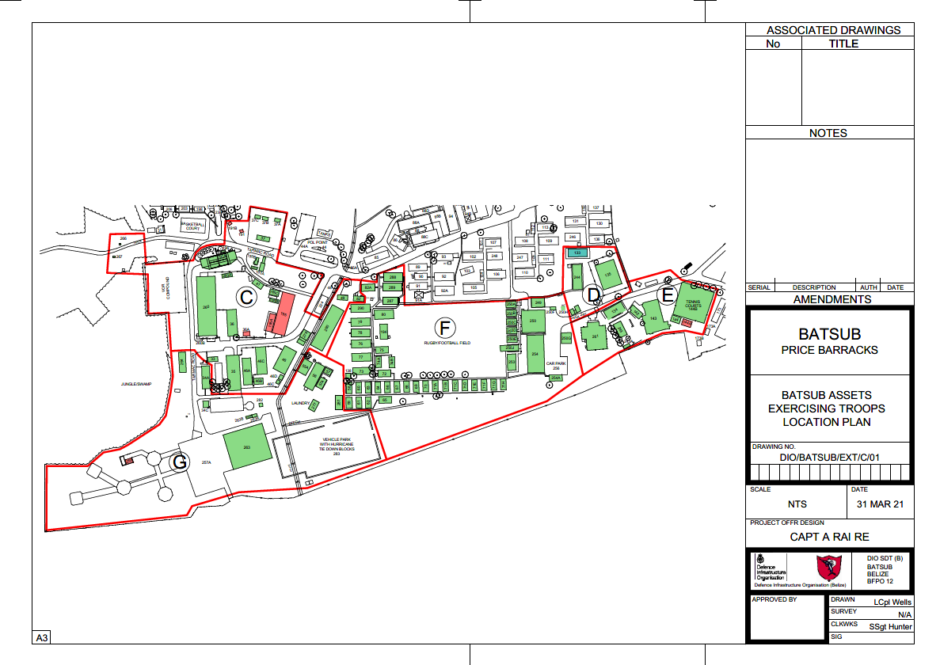
ITT/BEL/GE/2303
Dated 3 Nov 23

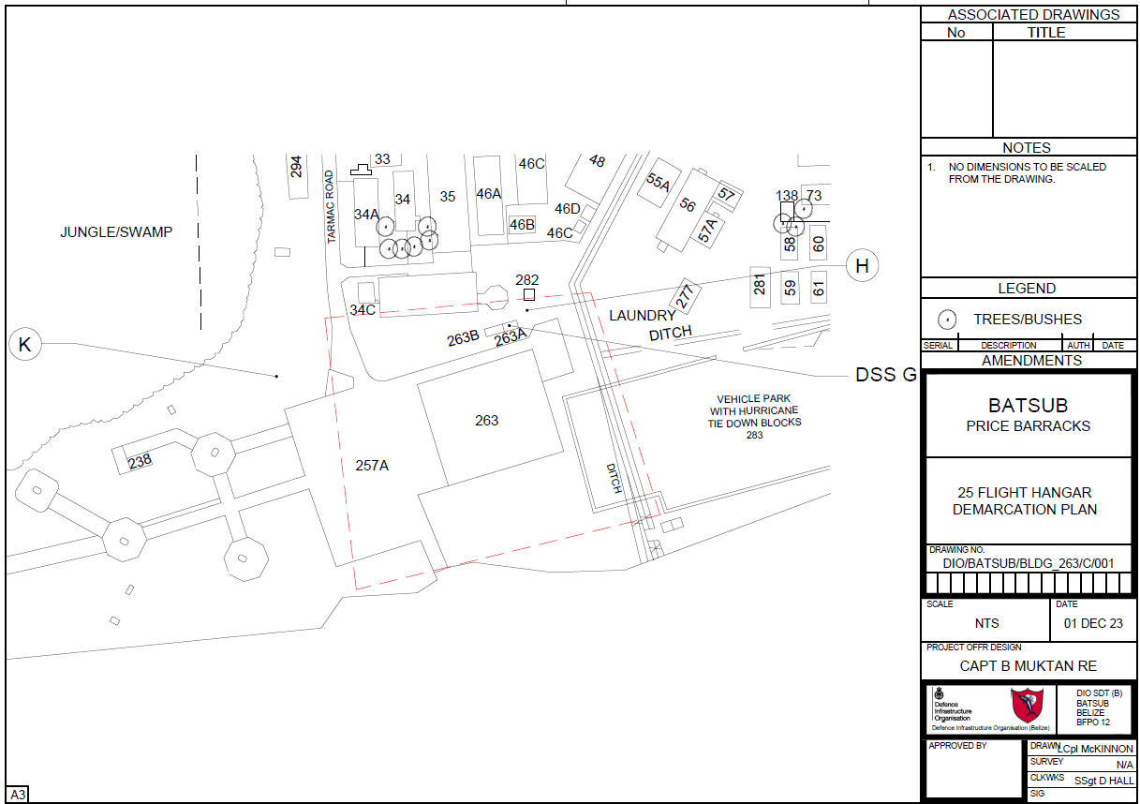
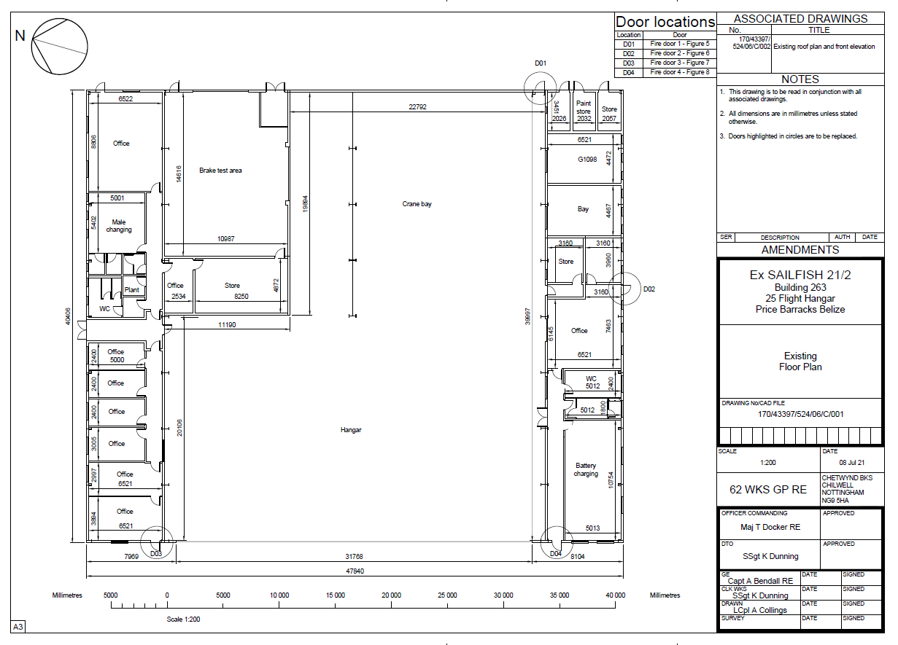

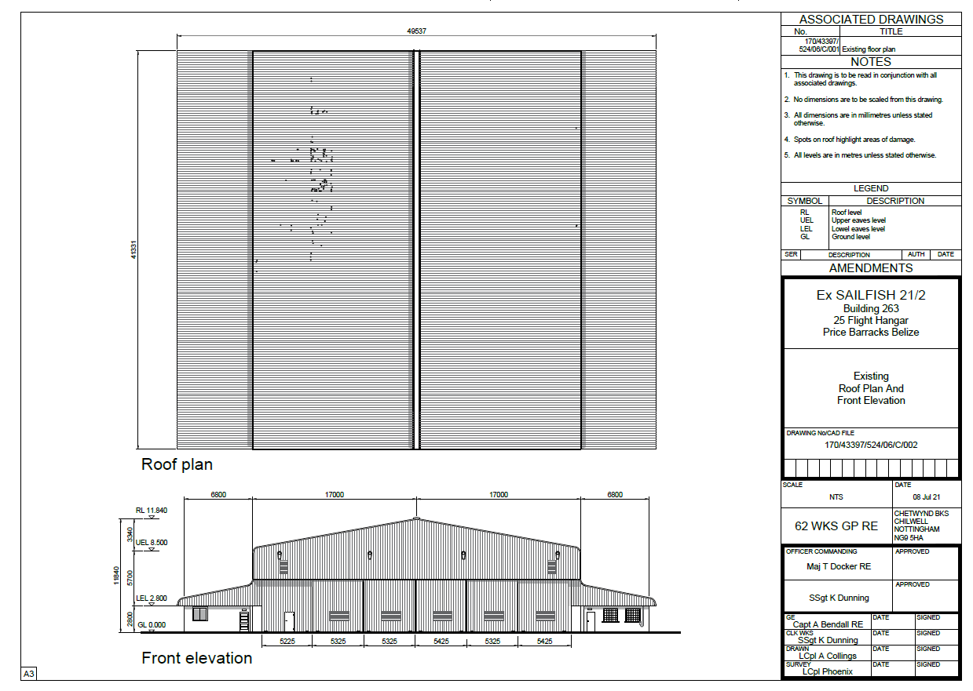

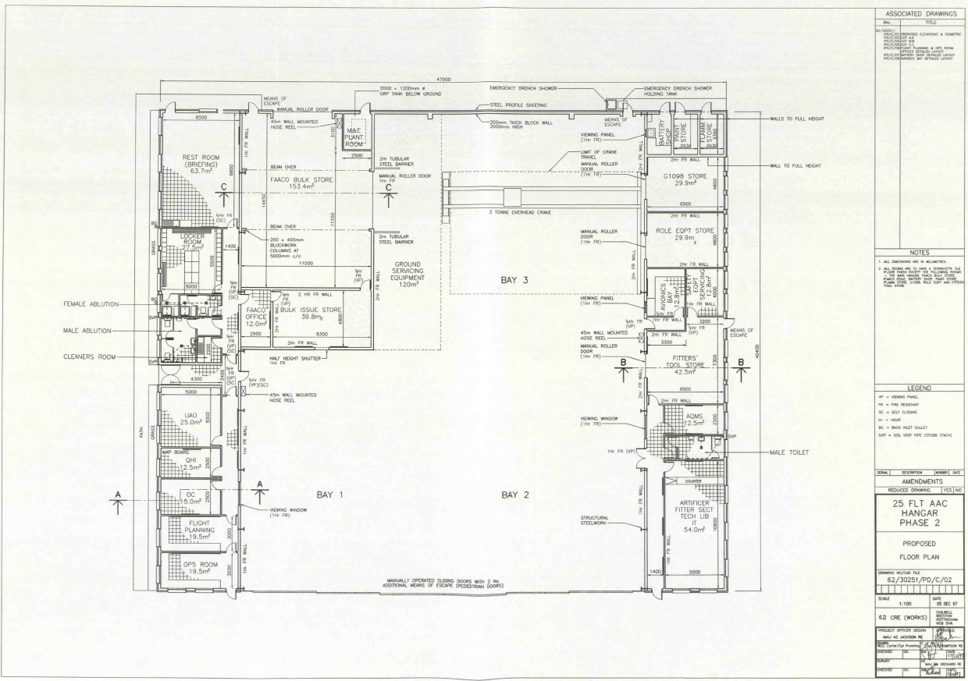

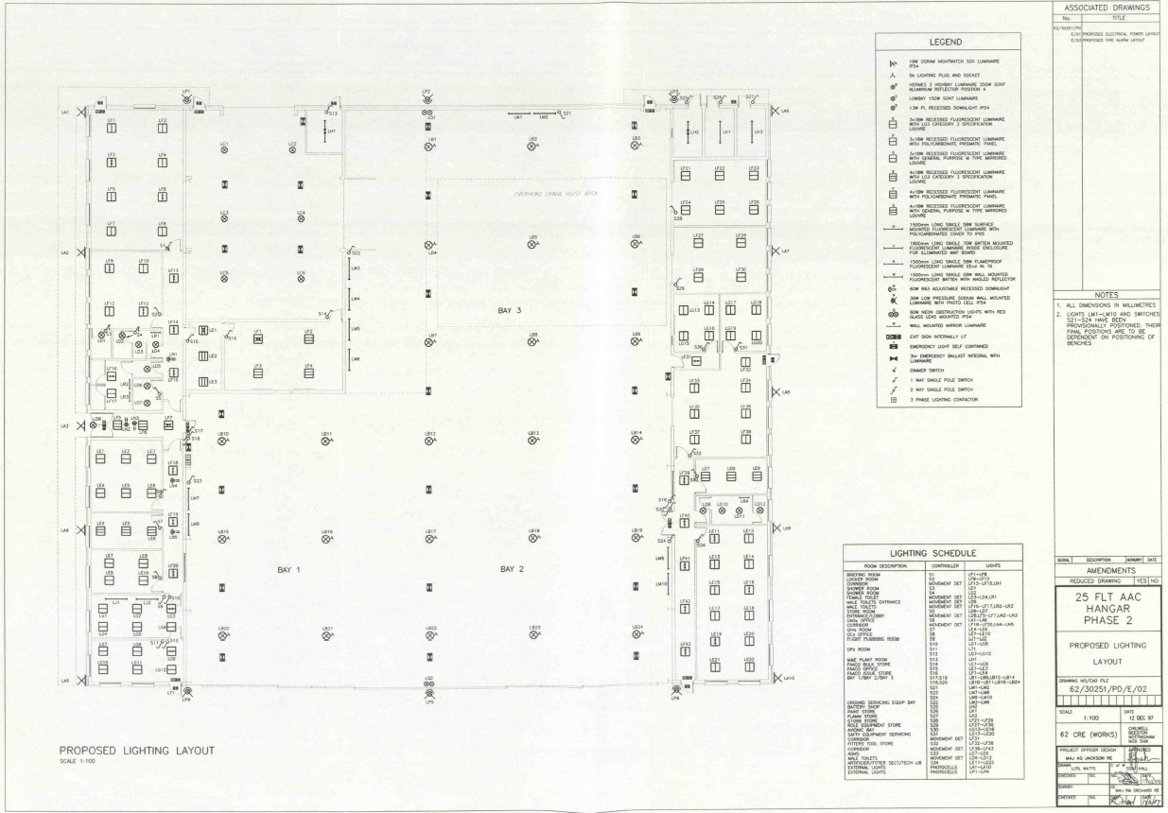

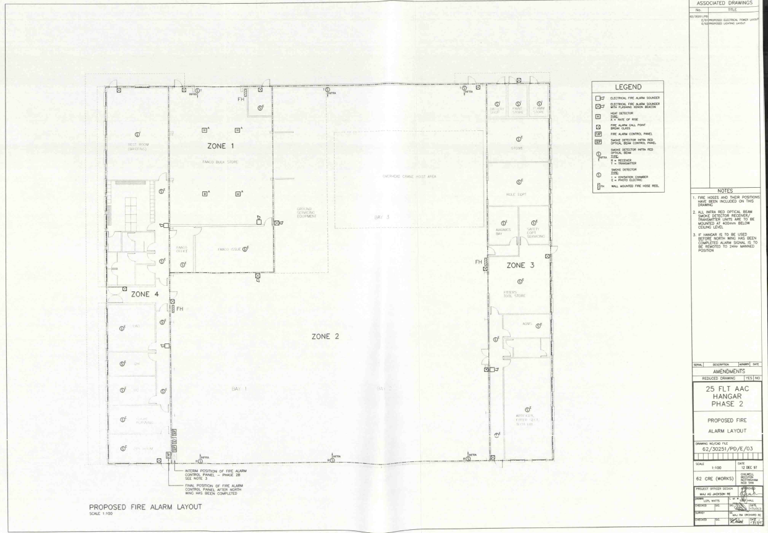

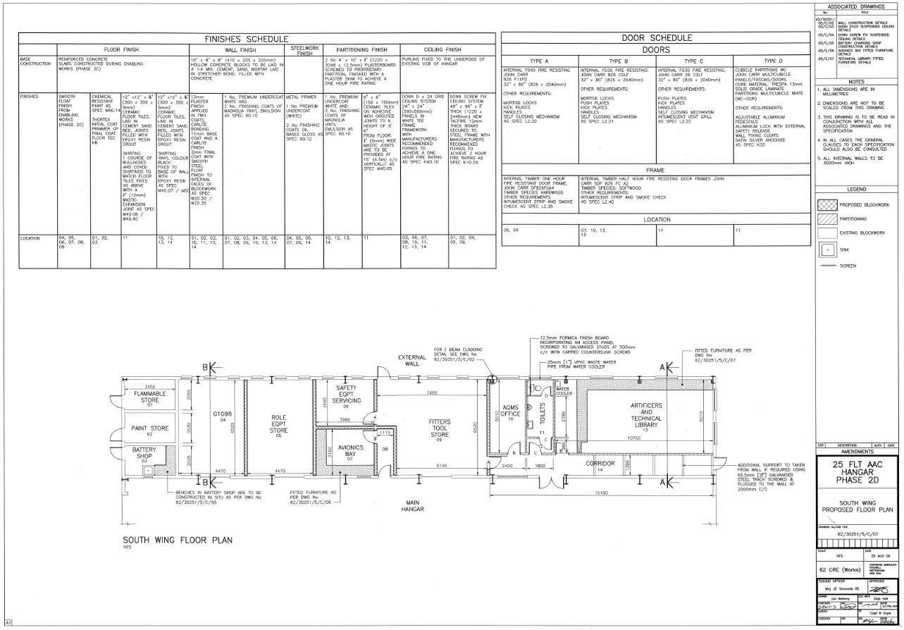

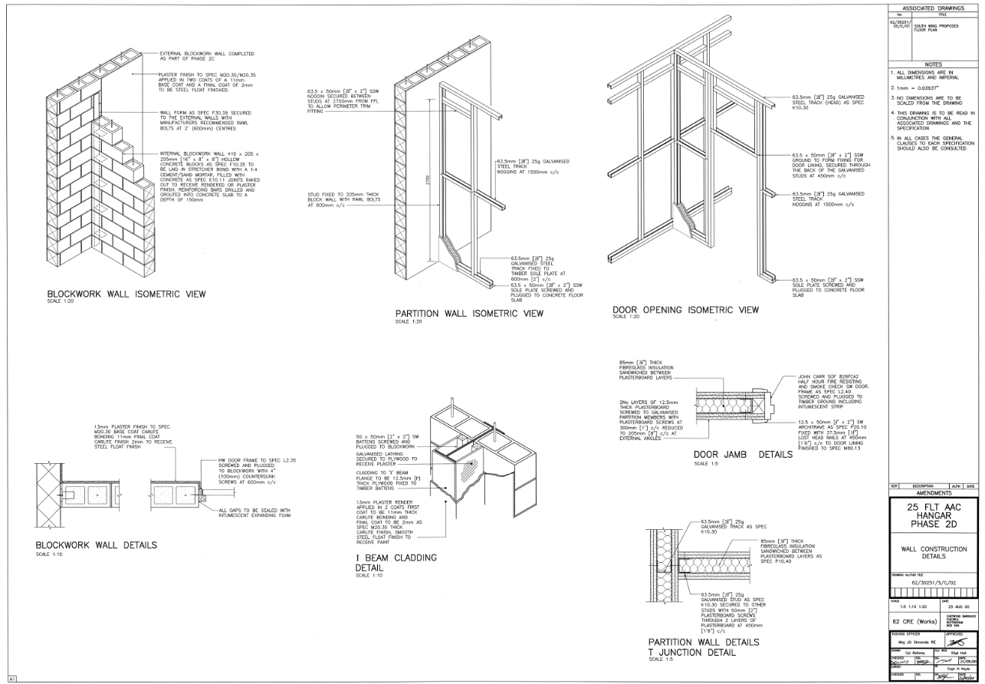

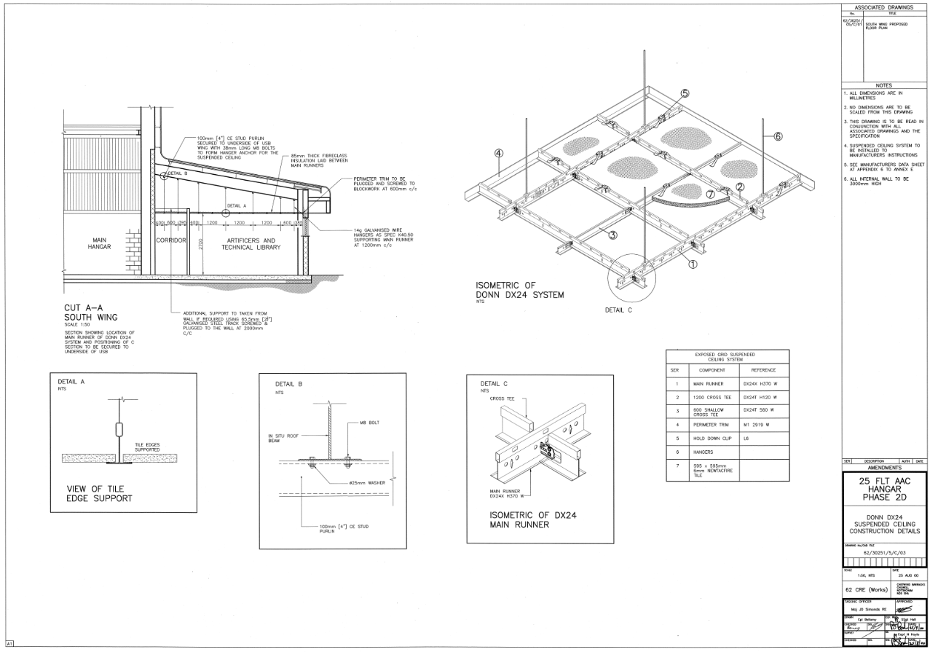

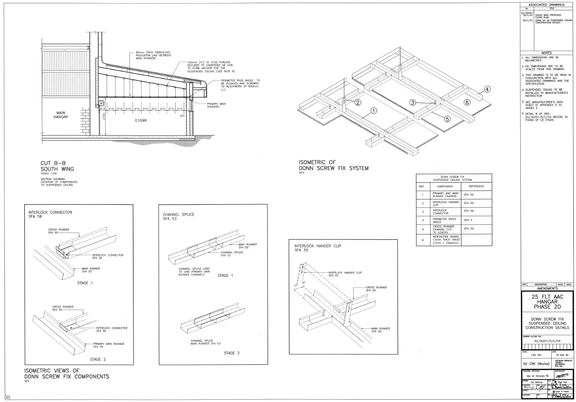

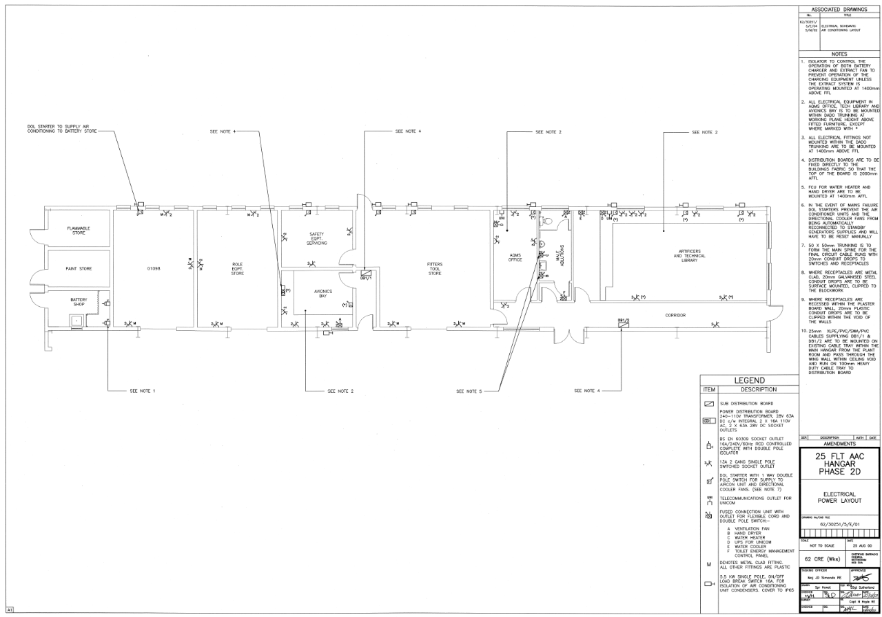

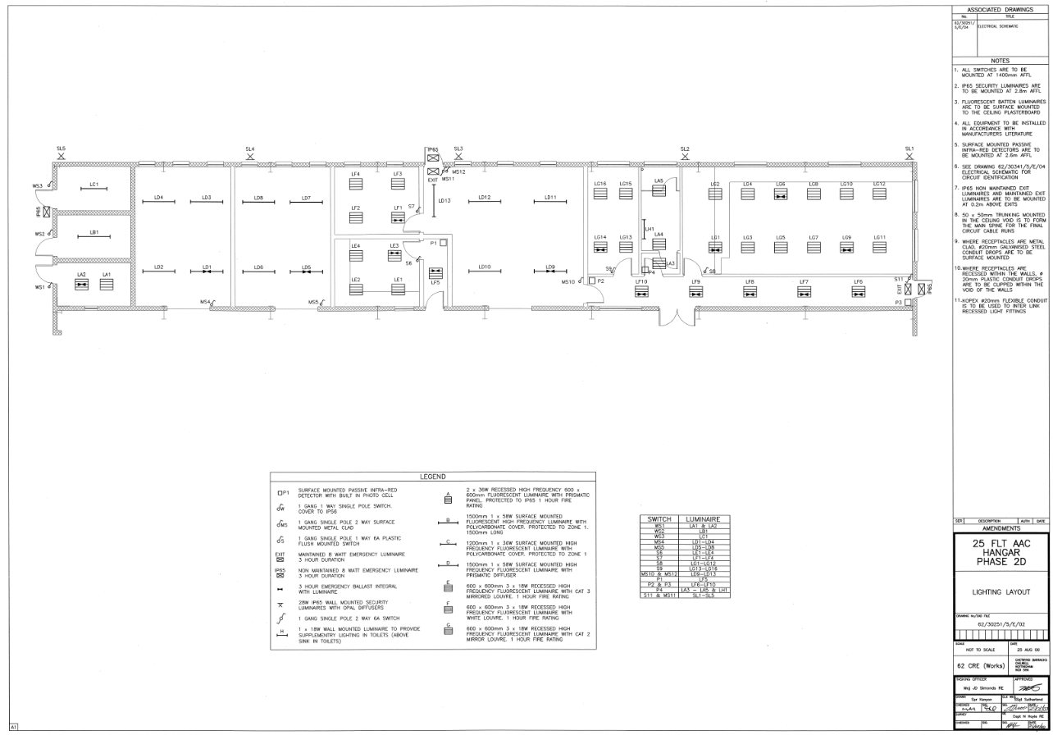

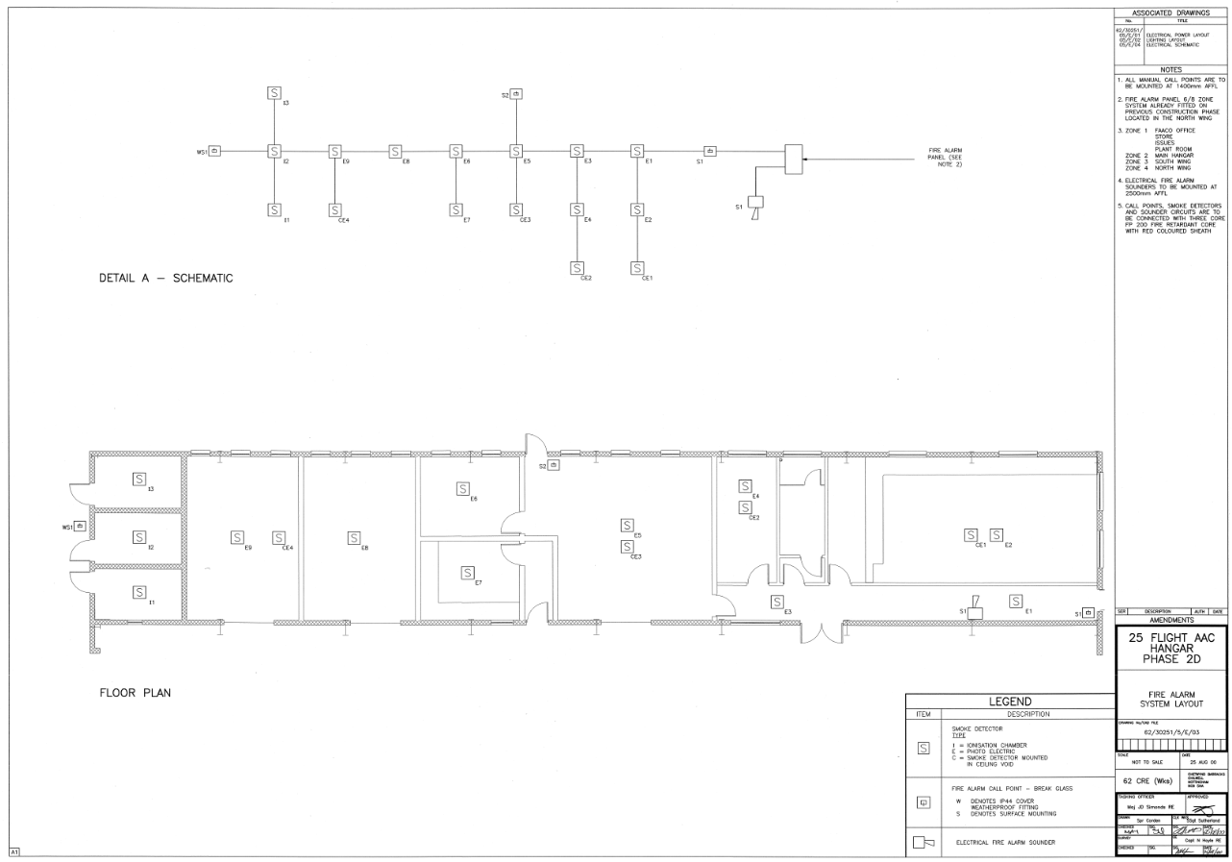

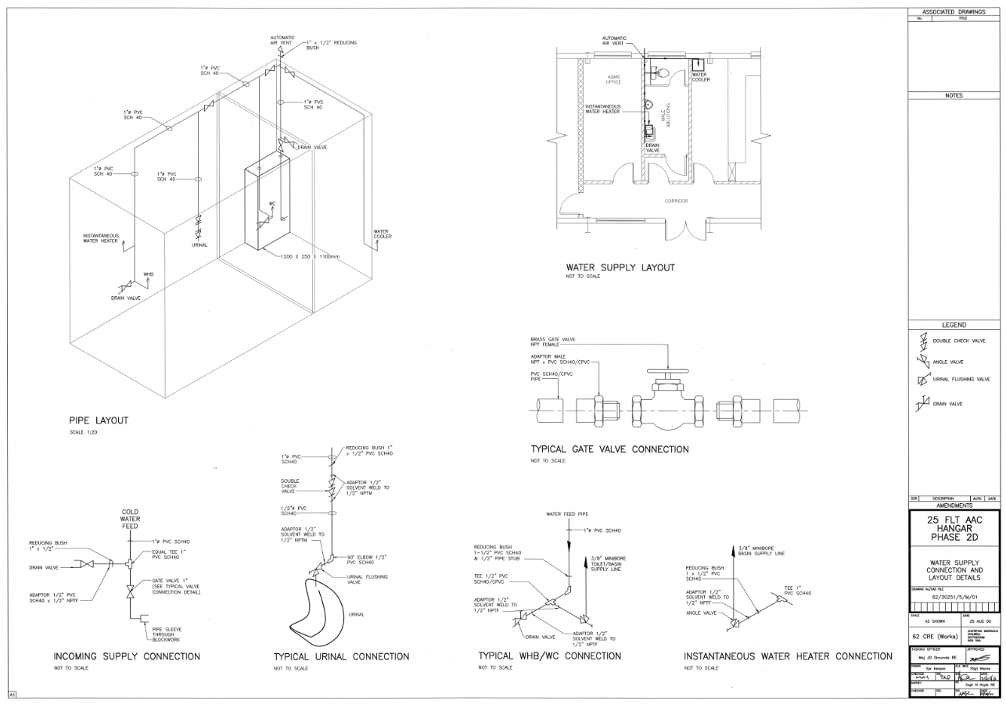

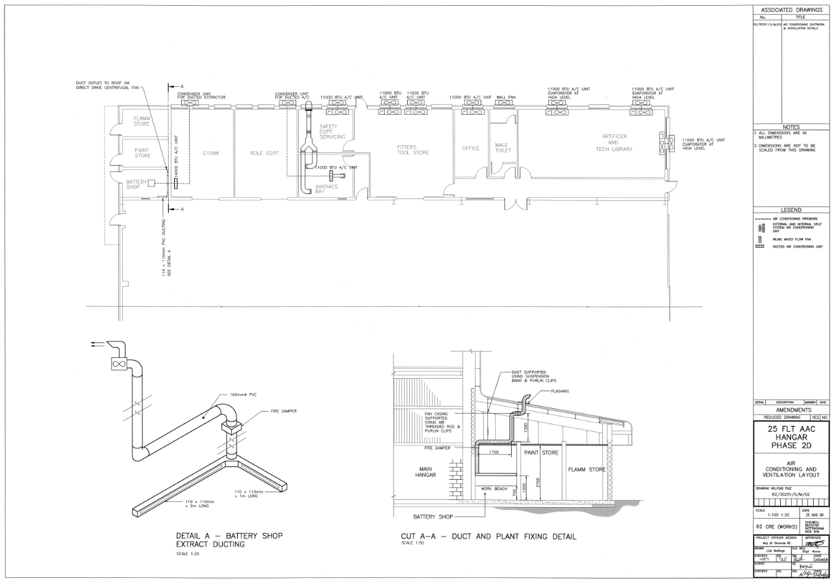

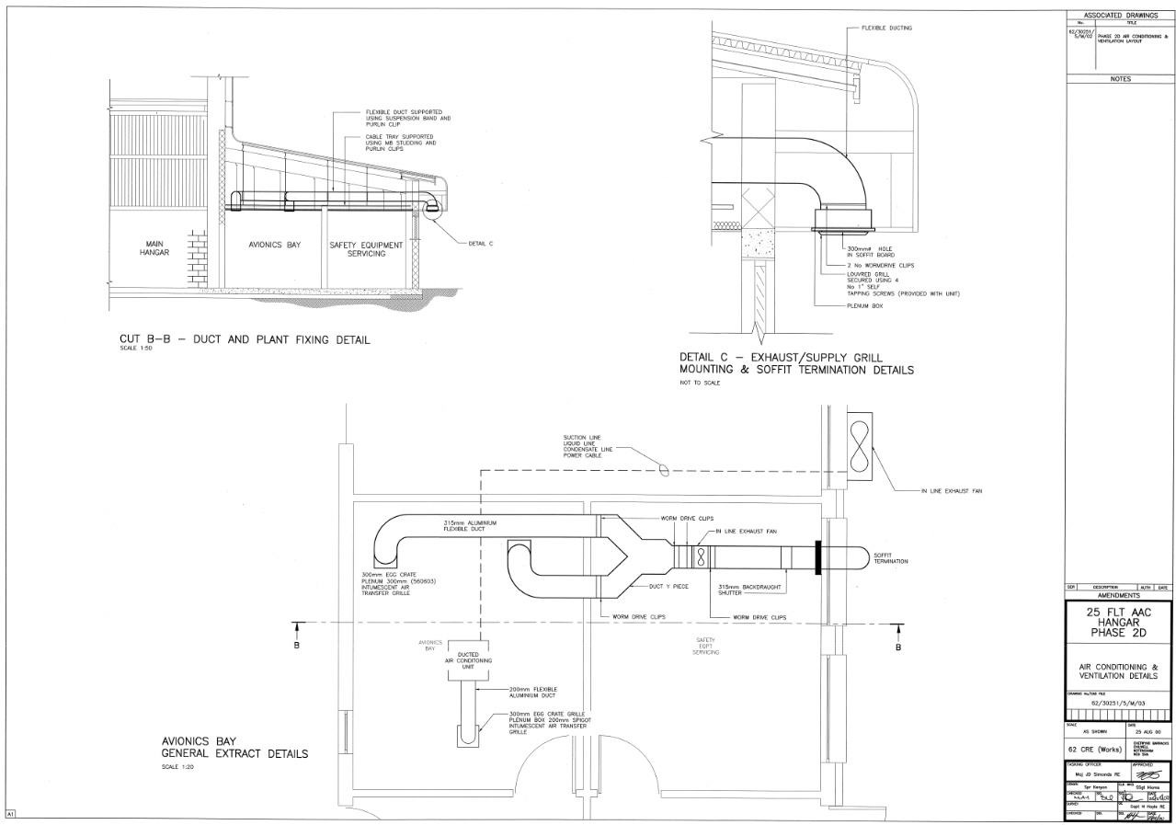

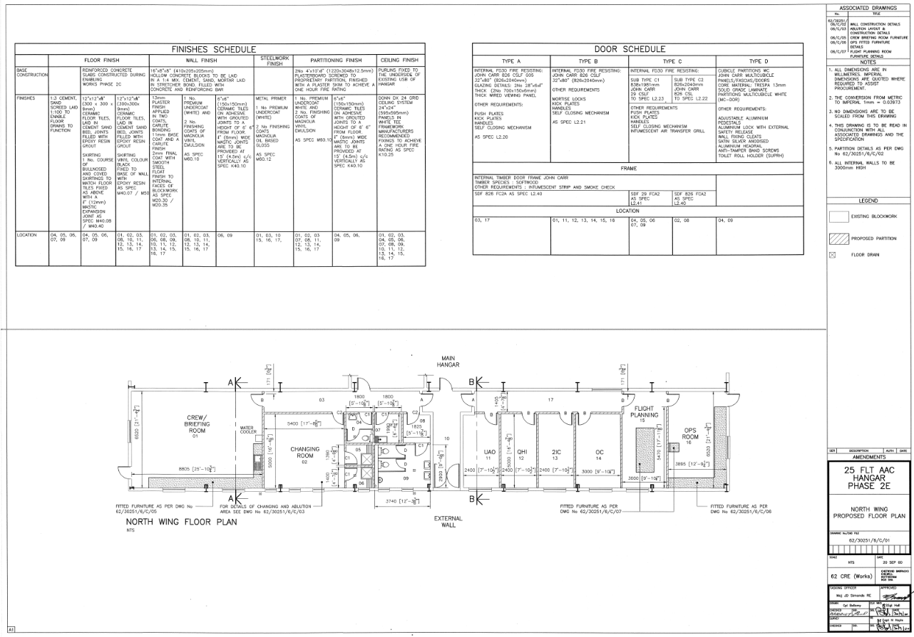

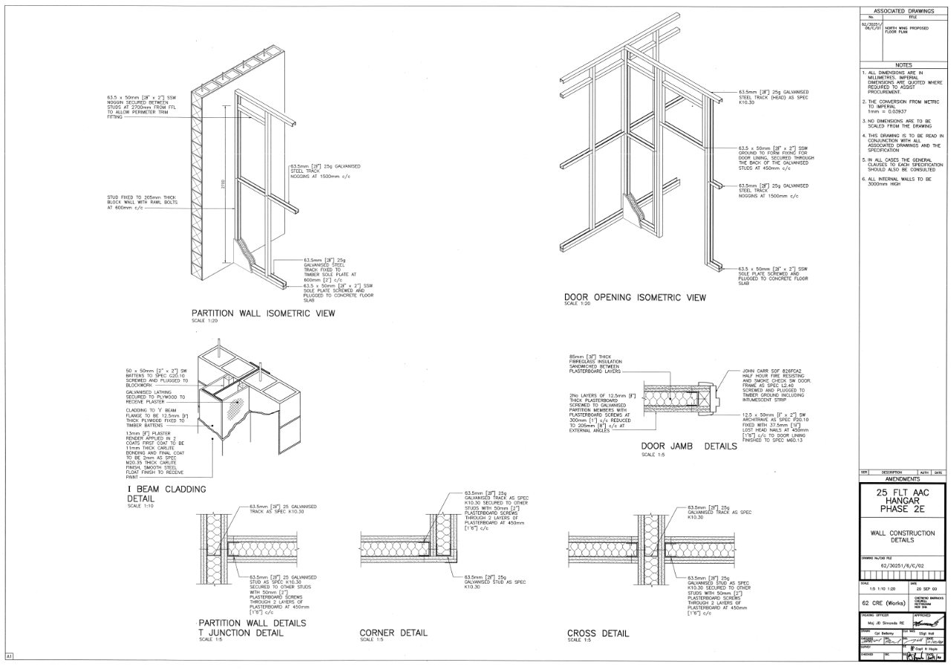

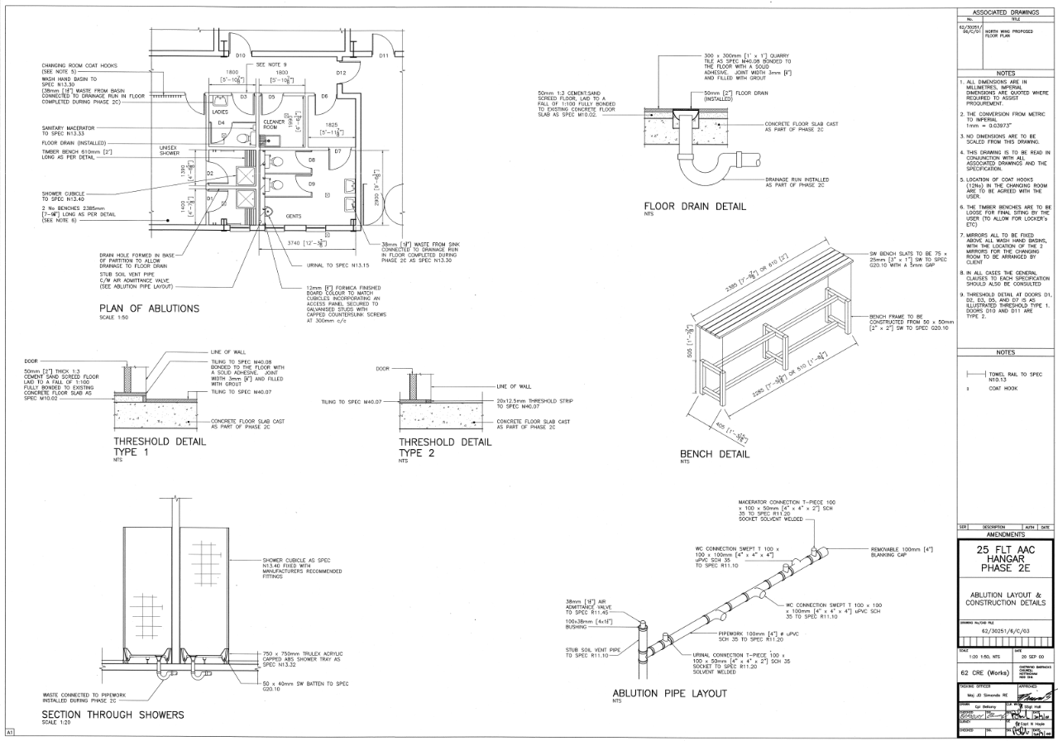

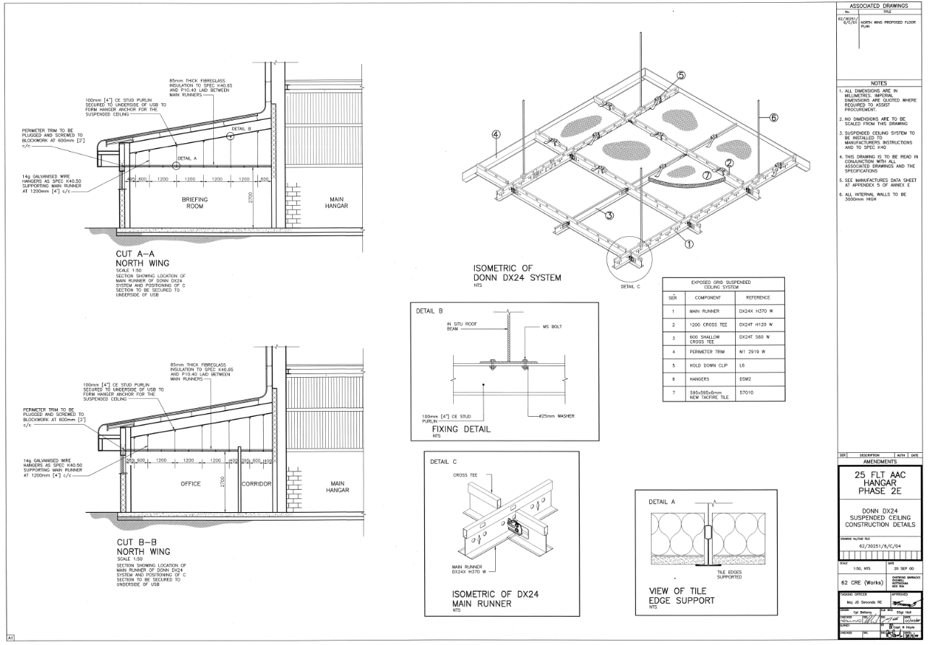

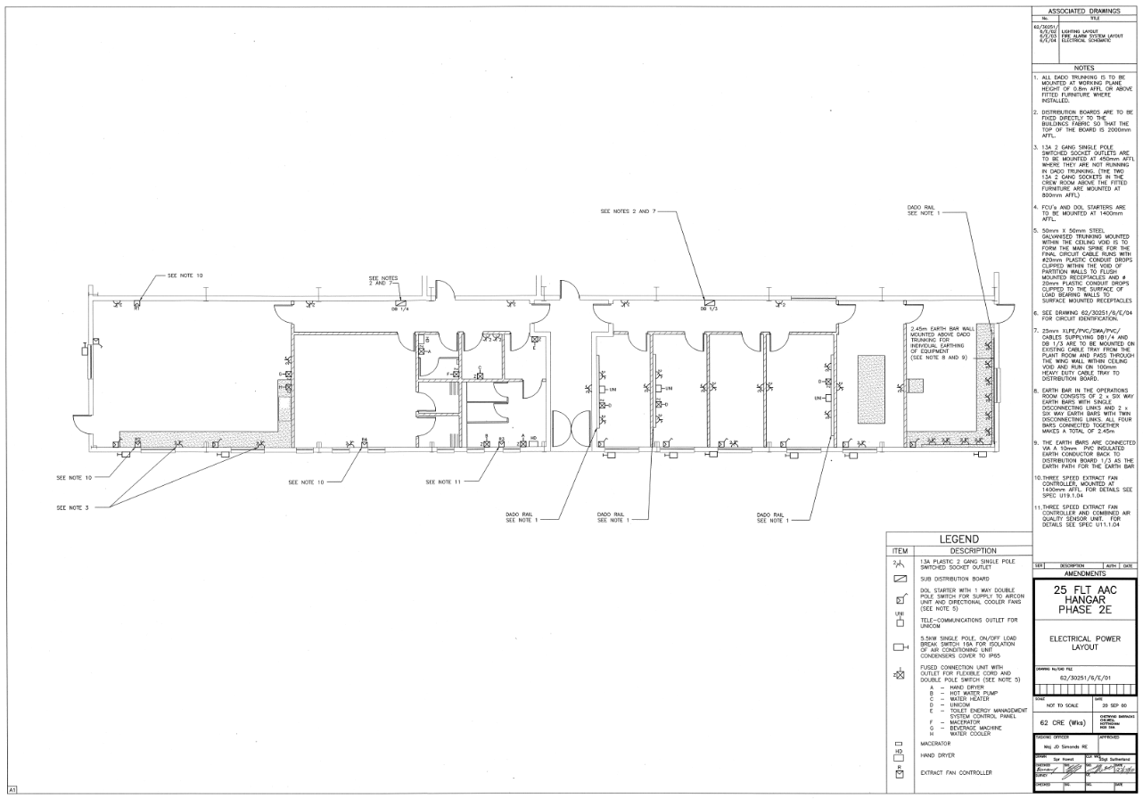

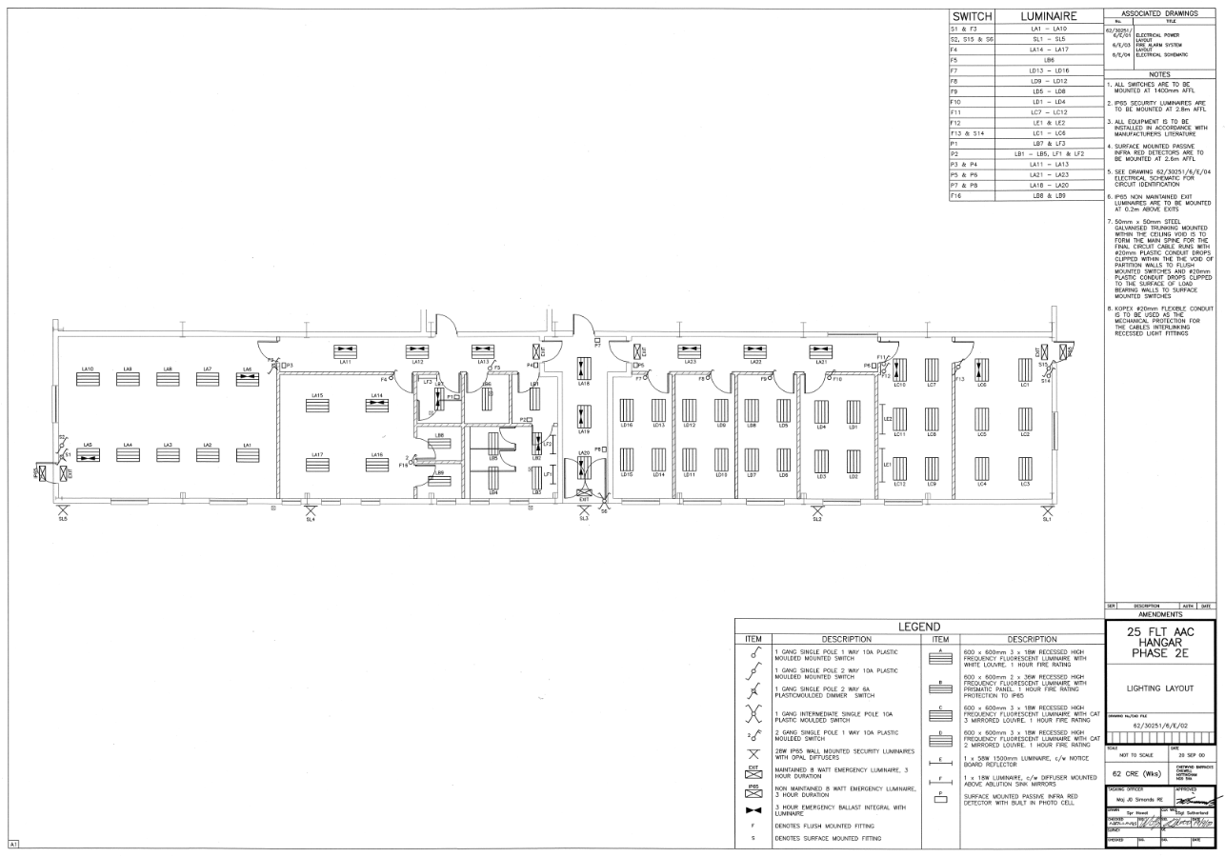

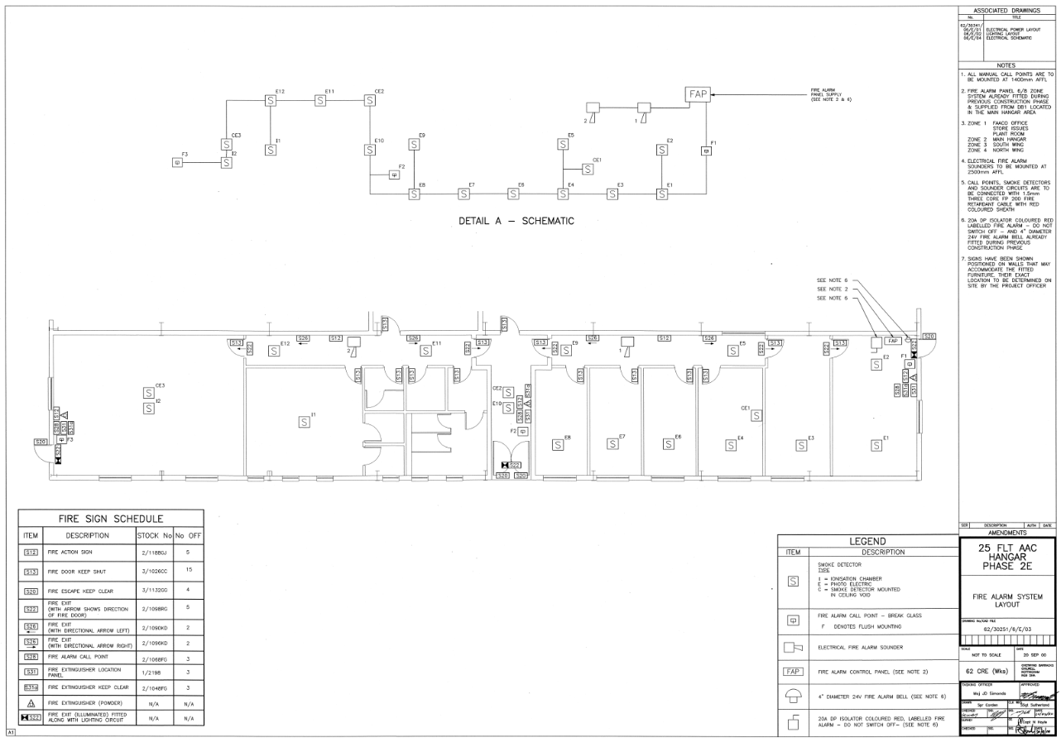

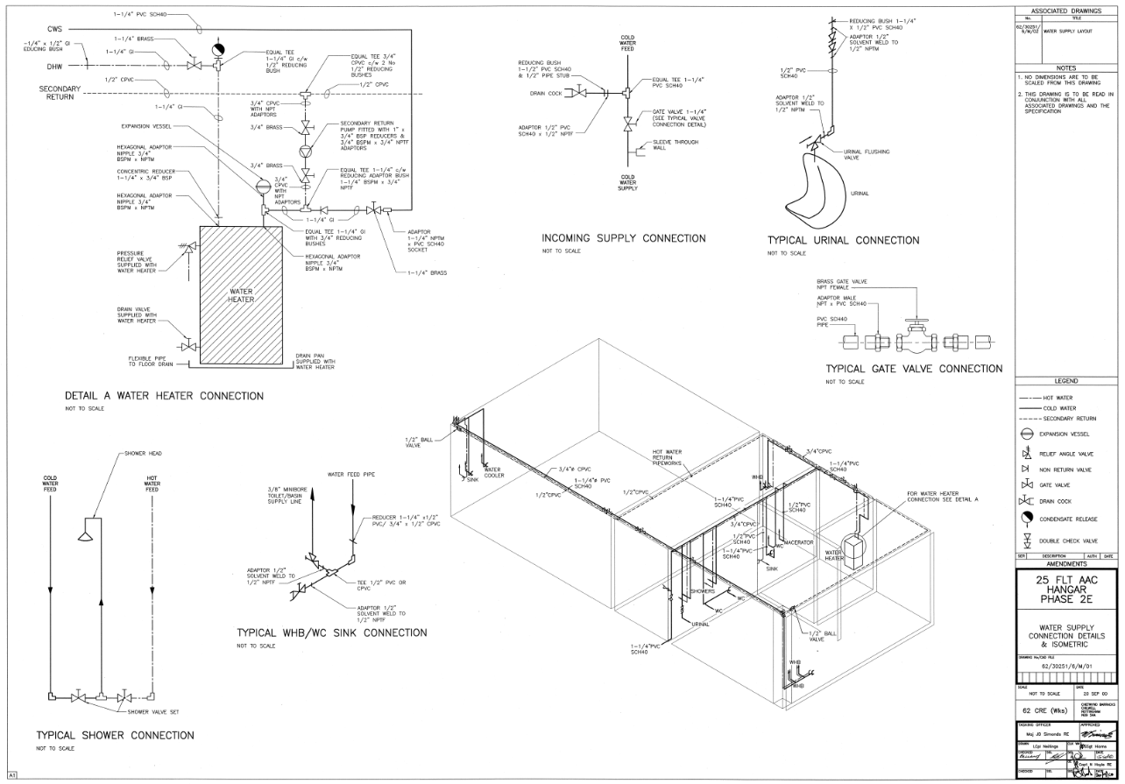

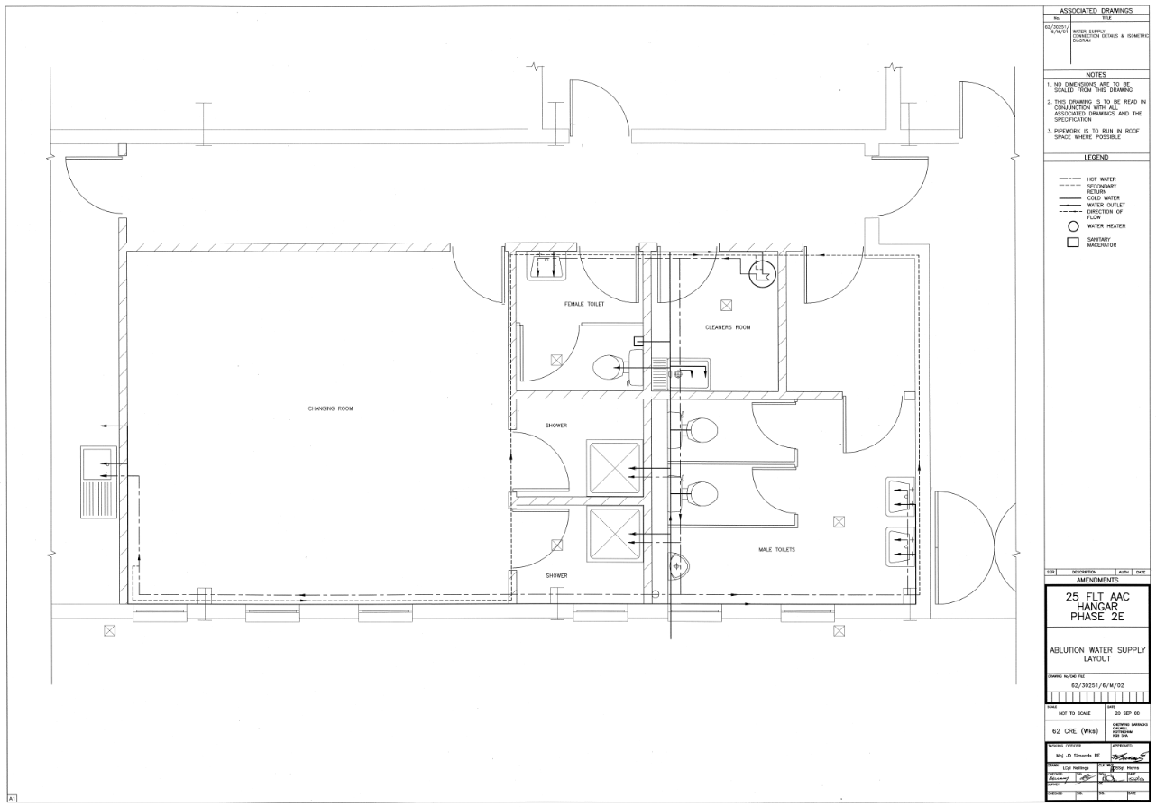

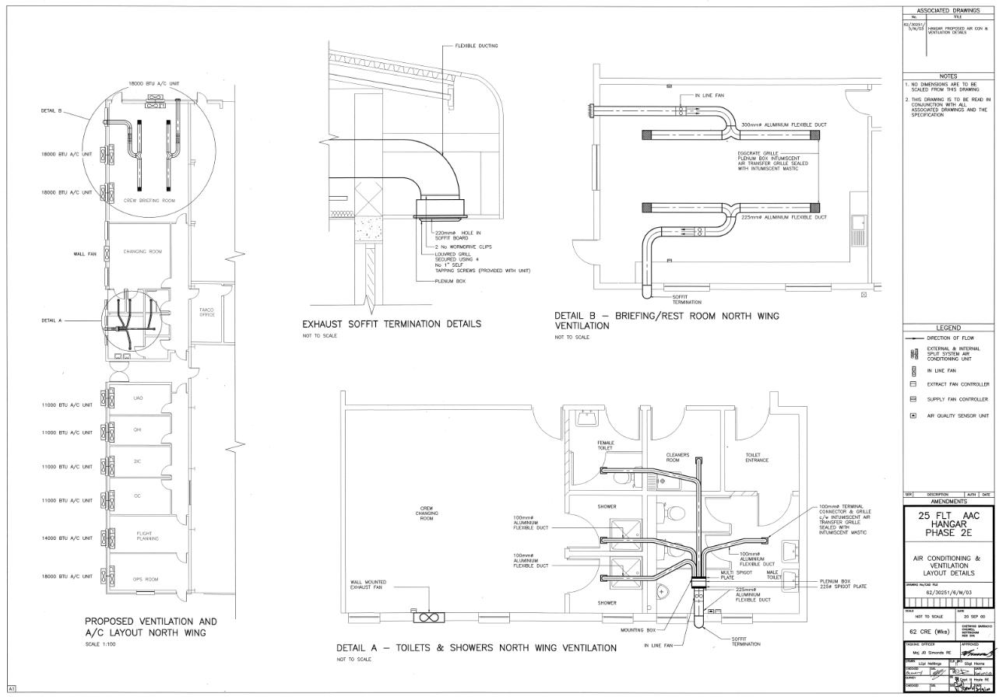

NOT USED

DIO Belize is the Authority for this contract / project.

