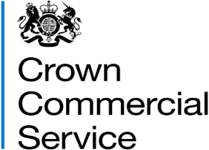

Invitation to tender

Attachment 2c – Lot 2 General Recruitment (Non Clinical) Case Study

Framework Reference: RM6229
Permanent Recruitment 2

Please note that this applies only to suppliers submitting a bid for Lot 2 only. The case study does not need to be completed if you are bidding for Lot 1.

We require that suppliers provide in the form of a case study evidence of your ability to both work with customers and demonstrate an understanding of their subjective campaign requirements for lot 2 General Recruitment (Non Clinical).
The case study response must not exceed 6000 characters and failure to provide a response will be deemed non compliant and you will be excluded from the procurement.
The case study will not be formally evaluated but CCS reserves the right to verify these case studies over the lifetime of the framework for those suppliers awarded a place, as referenced in 4.9 of the Framework Specification.
The case study responses will be used as part of the contract management process throughout the life of the Framework to ensure that successful suppliers are able to work with customers at the planning stages to understand specific needs and deliver outcomes which maximise customer benefits and meets their service expectations.
Any shortfalls in actual and expected performance will be discussed at the Supplier Review meetings and Suppliers will be given an opportunity will be given to suppliers to remedy any shortfalls as part of the supplier action plan.

Case Study Topic : Customer Planning
CCS requires you to demonstrate by way of case study, how you have approached working with a customer.

The response should demonstrate:

- the process you used for understanding customer requirements, including volume campaigns

- the process you used for promoting the customer to the candidate market, including their requirement and EVP

- the process you used for ensuring that customer expectations have been met and how services are evaluated to ensure they will continue to meet future need

