Project Name: | Southern Windermere Trails Section 3) | 
Location: | Southern Windermere Basin –  Windermere and Coniston Valleys
Document: | Heritage, Design and Access Statement  (Part 4) Trail route Images

Section 3C – View N From C5026 Highway (Opposite Lakeside Hotel)
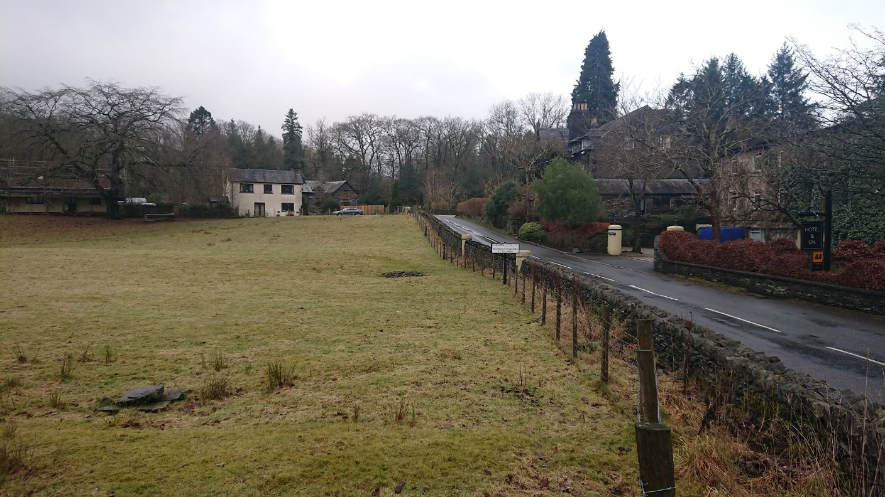
3 C
View W From C5026 Highway (Opposite Lakeside Hotel)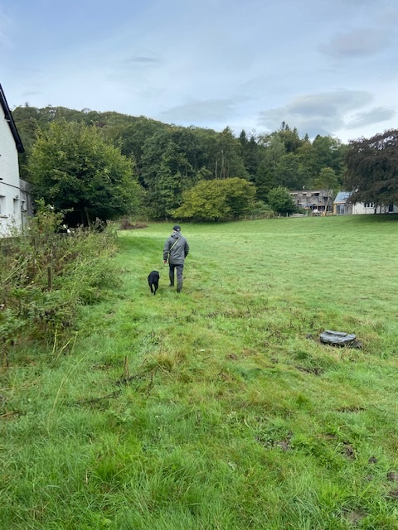

View NW towards Great Knott Woods
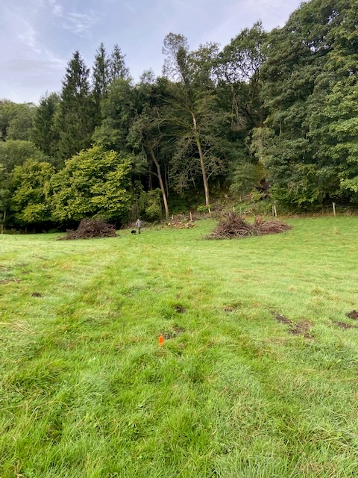

View NW towards Great Knott Woods

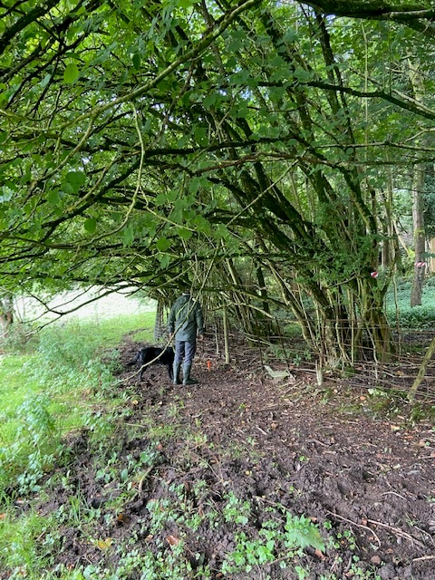

Section 3C – View NW
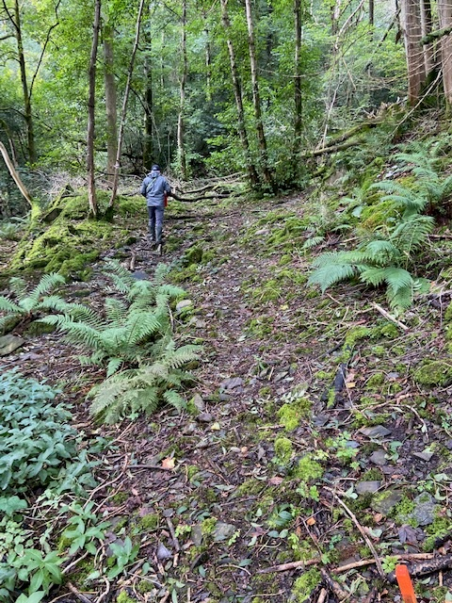
Section 3C – View NW
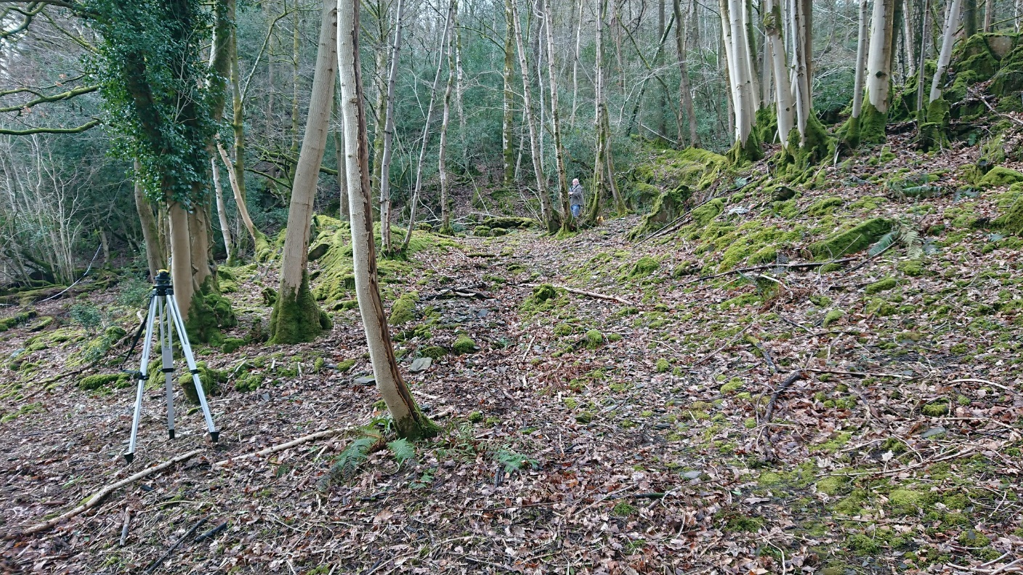

Section 3C View N
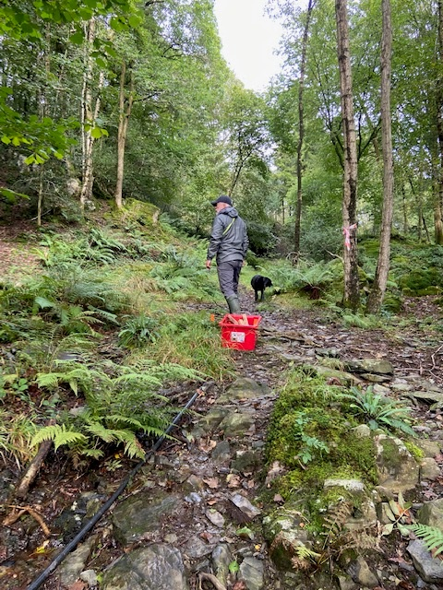

Section 3C – View N
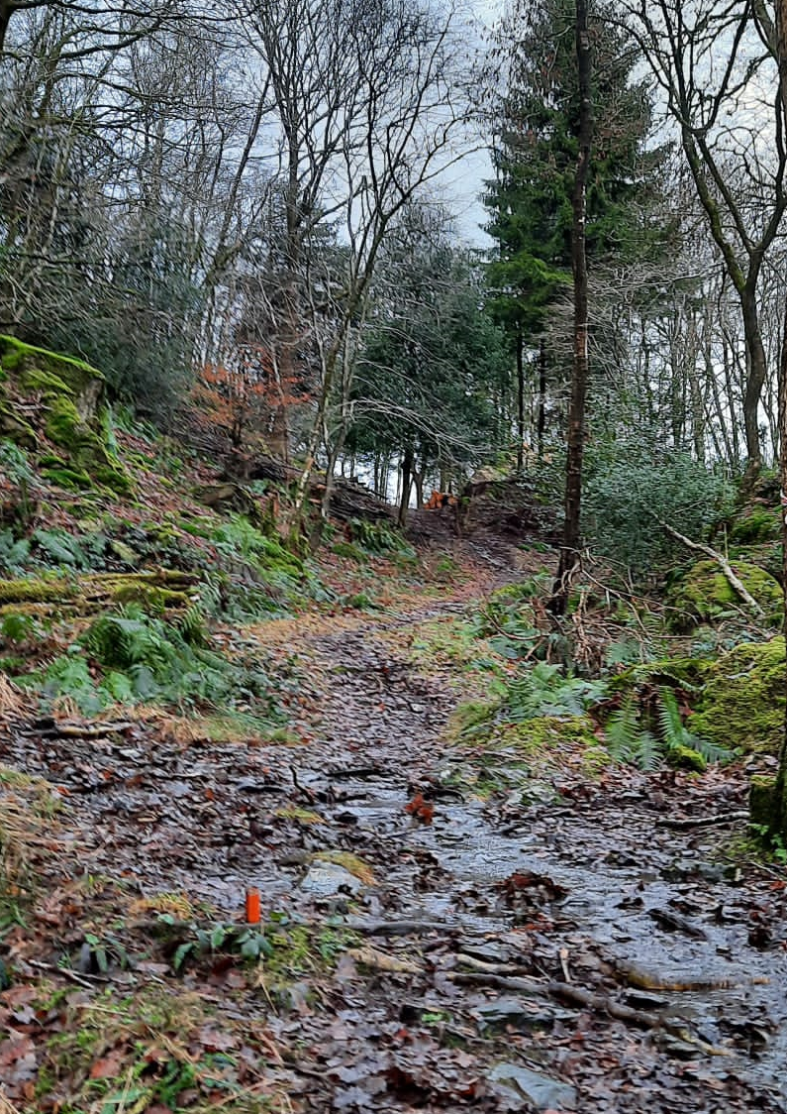
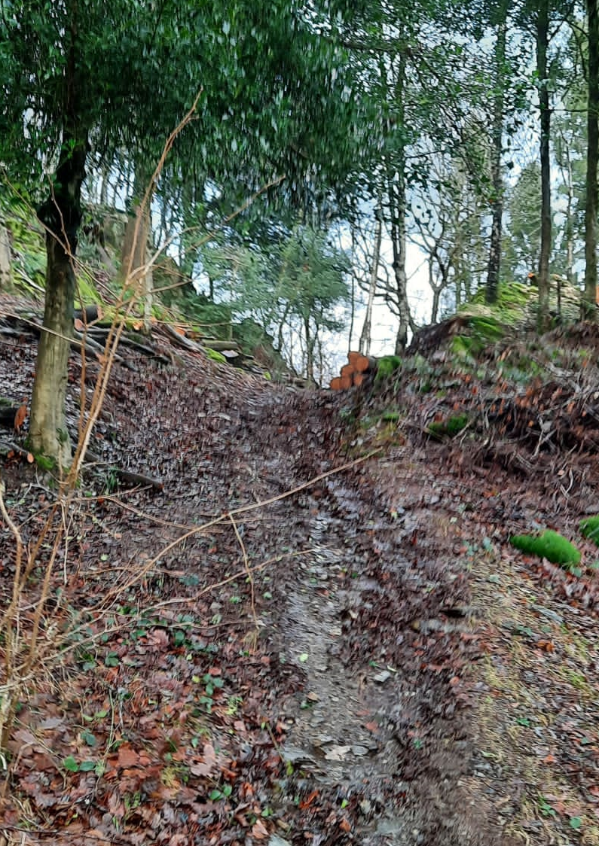

Section 3C – View N
