**Provision of a Dyfed Powys Independent Domestic Violence Advisory Service**

**June 2022**

# Introduction

The Dyfed-Powys region contains four Local Authorities; Carmarthenshire, Ceredigion, Pembrokeshire and Powys. It is a rural area with a population of 530,000 spread over 4,000 miles, about half the land mass of Wales.

Dyfed Powys Police and Crime Commissioner, along with the four Local Authorities within the Dyfed Powys region (the Commissioners), are tendering for Independent Domestic Violence Advisory (IDVA) services.

The Commissioners wish to procure a single IDVA service across the geography of Dyfed Powys. IDVAs work to address the safety of people at high risk of domestic violence and abuse from intimate partners, ex-partners and family members to secure their safety and the safety of their children. Operating as the primary point of contact, IDVAs typically work with their clients from the point of crisis to assess the risk, review options, and develop and implement plans to address their immediate safety, as well as longer-term solutions. Although the service will not work directly with children under the age of 16, it will make referrals to safeguard children at risk of harm and ensure appropriate signposting to specialist support services. The service will be available for all clients affected by domestic abuse, regardless of age, gender, sexuality, ethnicity or disability.

The successful Provider will be required to work in close partnership with other relevant services to support overall service delivery. The Commissioners are seeking an organisation that will effectively deliver this contract but also work as a developmental partner to help shape the future direction of addressing Violence Against Women, Domestic Abuse and Sexual Violence in Dyfed Powys. The provider will also be expected to work in partnership with Commissioners to seek and secure longer-term funding options to address the increasing volumes and complexity of demand facing the service.

The successful Provider will need to demonstrate that they are able to meet the requisite quality standards to deliver an Independent Domestic Violence Advisor service, their staff are appropriately trained (in accordance with IDVA qualifications and national training framework standards) and that they operate robust quality management frameworks.

The Commissioners intend to contract with a single provider, however subcontracting arrangements, partnership arrangements and/or a consortium approach to service delivery are welcomed.

# Partnership Funding

Police and Crime Commissioner for Dyfed Powys will lead on the procurement process.

The total contract value of the Dyfed Powys IDVA Service is a maximum of £400,000 per annum. The funding will be provided from two sources as follows:

Police and Crime Commissioner Dyfed Powys (PCCDP) £200,000

Carmarthenshire County Council (CCC) (acting as regional banker) £200,000

This is the maximum amount each party will fund on an annual basis

Carmarthenshire County Council hold the Welsh Government grant on behalf of the other Local Authorities in Dyfed Powys.

The Provider will be required to raise two invoices per quarter, of equal amounts one to PCCDP and one to CCC. The invoice should be to a maximum of £50,000 per party per quarter.

Mid and West Wales Violence Against Women, Domestic Abuse and Sexual Violence (VAWDASV) Executive Board will:

* Agree performance targets for the service (as recommended by the Strategic Group and Commissioners)
* Advise on the de-commissioning and re-commissioning of services
* Be accountable for the overall service delivery, including taking any required action to ensure performance issues are addressed

The Strategic Group and Commissioners will:

* Hold the relevant Service Level Agreements with the service Provider;
* Undertake quarterly monitoring and annual reviews of the Service Level Agreement, including recommending appropriate targets to be set and ensuring that delivery of service and expenditure is appropriately evidenced.

The Police and Crime Commissioner for Dyfed Powys will act as first point of contact for any queries in relation to the service provision by the Provider. Relevant queries will be discussed with the Strategic Group and Commissioners, and where necessary will be escalated to the VAWDASV Executive Board.

Additional Ministry Of Justice funding is currently in place and confirmed until the 31st March 2025:

* Critical Fund
  + 4 FTE IDVAs for Daily Discussion purposes. Total of £215,168 per annum
* National IDVA Fund
  + 3 FTE IDVAs totalling £137,735 per annum: 1 generic, 2 Male specific

# Contract

The contract will be for a period of 3 years with the option to extend for a further two 12 month periods.

The contract will be for a Dyfed Powys regional service to a maximum value of £400,000 annually.

The successful Provider will be required to offer a consistent service to best practice standards in all local authorities in the Dyfed Powys region according to the estimated local needs outlined in the Specification.

It shall be the responsibility of the successful Provider to consider whether the Transfer of Undertakings (Protection of Employment) Regulations 2006 (SI 2006/246) may apply to this contract.

# Background

In response to the Violence Against Women, Domestic Abuse and Sexual Violence Act (Wales) 2015, an Executive Board and Strategic Group have been established (under the Safeguarding agenda) to plan and implement the VAWDASV strategy across Dyfed Powys.

The first part of this strategy was to jointly commission the provision of IDVA services, in order to achieve the consistent and effective delivery of frontline services to high risk and repeat victims of domestic abuse. This was achieved in July 2018 and Commissioners are now in a position to tender for the future provision of this service.

The below provides information on the current demand and profile of domestic abuse across Dyfed Powys, to set the context in which the service will sit and the challenge which providers must meet.

## Data Sources

Data and information provided in this report has been extracted from:

* Dyfed Powys Police (DPP) Performance Dashboard (Qlikview). Extracted and correct as of 08/04/2022.
* MARAC central spreadsheets (Extracted 08/04/2022)
* Quarterly IDVA returns

The data period used for the report covers 1st April 2018 – 31st March 2022, unless otherwise stipulated. (Consideration to be made for the impact of Covid-19)

It is important to note that reliability of the data is subject to the relevant information being available and correctly recorded; therefore, discrepancies may occur in the data.

## Domestic Incidents

An increase in recorded domestic incidents can be seen, when looking over time from April 2018 to March 2022.

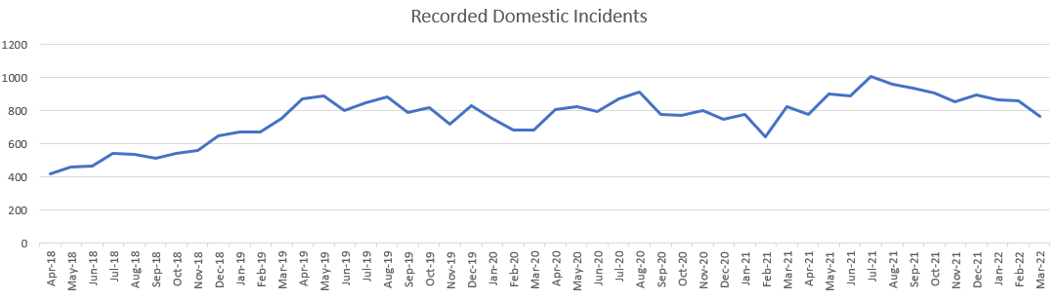

The increase in Domestic Abuse demand is expected to continue. Forecasting’s clearly show a predictable increasing trend, but the new Domestic Abuse Act 2021 undoubtedly brings with it a new dynamic which is set to impact on demand and additional processes. There is a national focus on Violence against Women and a political agenda for Public Space Safety, both of which increase awareness and greater understanding amongst the public; as a result, there is expected to be an increase in reporting and interest in DA and Stalking.

The ONS[1] report that during the Covid-9 pandemic Police crime data showed an increase in offences flagged as domestic abuse-related. However there has been a gradual increase in police recorded domestic abuse-related offences over recent years therefore it cannot be determined whether this increase can be directly attributed to the pandemic. Similarly, they report that there has been an increase in demand for domestic abuse victim services during the pandemic.

The table below outlines the number of recorded domestic incidents per financial year period, by division. A considerable increase can be seen in the number of recorded incidents, when comparing 2018/19 with 2021/22.

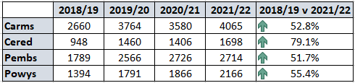

Reflecting on financial year period 2021/22 there were a total of 10,633 domestic incidents recorded. (36 of these records were cloaked). The table below provides the final risk gradings of the 10597 incidents.

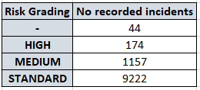

It is important to note that although an incident may not be graded as a high risk incident they may still meet MARAC threshold under another criteria.

## MARAC Repeat Escalation/Daily Discussion /Multi Agency Risk Assessment Conference

The Secondary Risk Assessment Unit (SRAU) was formed within Dyfed Powys on the 25th November 2020. The launch of the SRAU was in line with White Ribbon day and included in the force’s campaign #iflovehurts. This unit provides the infrastructure for the Daily Discussions. As described in the VAWDASV Journey and Evaluation Planning exercise, the Daily discussion is a framework introduced to discuss and address all domestic abuse incidents, meeting the MARAC criteria, in a shorter time frame that MARAC meetings, maximising opportunities to gain a comprehensive understanding and management of complex incidents.

As part of the COVID-19 contingency plan discussions were held between VAWDASV and senior Police for the agreement to introduce a MARAC Repeat / Escalation process (MRE). Following a 2-week consultation period with partner agencies the MRE process was implemented w/c 6th April 2020.

This process consists of the MARAC unit identifying the repeat and escalation cases, followed by the risk assessors reviewing and linking in with Goleudy and IDVA to determine if a multi-agency Daily Discussion is required. The chair of the Daily Discussion meetings (the Detective Sergeant within the Vulnerability Hub) also ratifies the rationale and makes the final decision if progression to a meeting is required. It is important to note that all cases that meet the repeat and escalation criteria are stored in a folder within the sharepoint for all agencies to view and review, should an agency feel at any stage that they have additional information that could affect the safeguarding plan then the case will progress to a Daily Discussion.

The charts below illustrate the number of cases discussed in MRE/DD/MARAC by division for financial years 2020/21 and 2021/22.

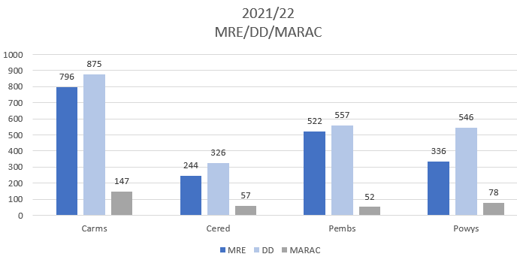

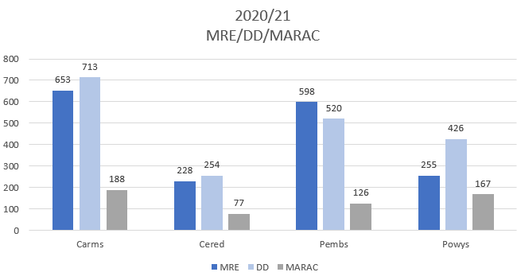

As part of the daily discussion meeting agreement is made to who the single point of contact (SPOC) will be for the victim in the discussed case. The chart below identifies how many cases the IDVA service was allocated as SPOC for the daily discussion meetings held 2021/22.

*There are numerous occasions where a joint SPOC is allocated between multiple agencies. The chart below includes all cases where IDVA has been recorded as a single agency SPOC or in conjunction with other agencies.

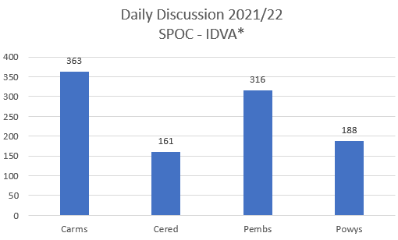

Victim profile data is captured for all full MARAC cases. The below chart illustrates selected characteristics for those full MARAC cases discussed 2021/22. This data is used to assist support allocation, whilst also demonstrating possible under reporting groups.

*\*To note this information is dependant on the information being available and recorded*

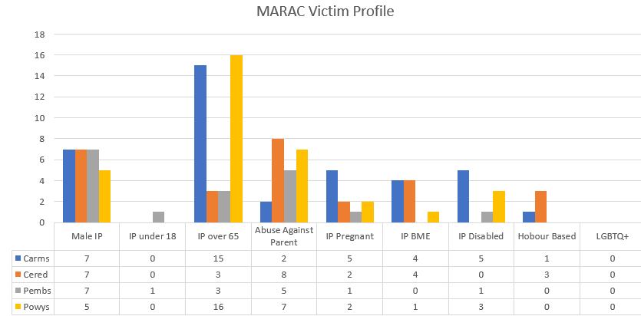

Safelives provide some recommended proportions. The table below illustrate that Dyfed Powys are considerably under these recommended guidelines.

To note data is only representative of those cases that progress to a full MARAC, and do not include any cases that meet threshold but not discussed in a full MARAC (i.e. MRE/DD).

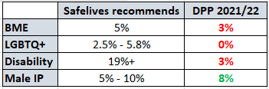

# 

## Safelives data

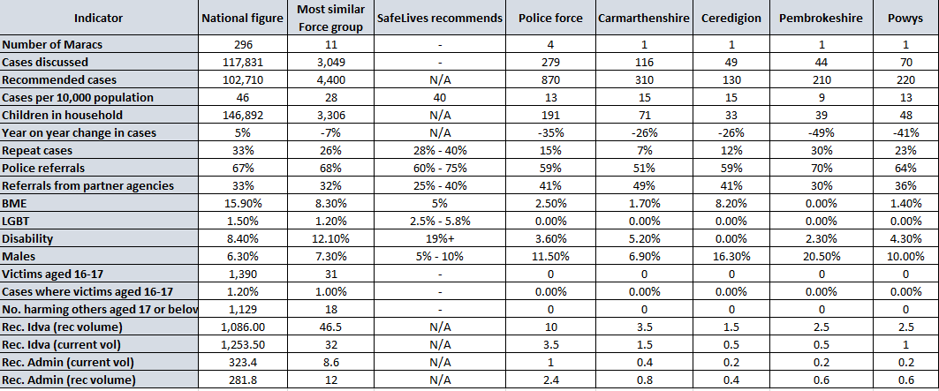Safelives collate regular data and provide year rolling statistics. The below table is in respect of period January 2021 – December 2021.

As previously stated, data is only representative of those cases that progress to a full MARAC, and do not include any cases that meet threshold but not discussed in a full MARAC (i.e. MRE/DD). This is important to consider as SafeLives calculates the required IDVA coverage for each individual MARAC as either an estimation based on the local female population at high risk of serious harm or murder or an estimation of the number of IDVAs needed to cover the cases heard at MARAC over a 12-month period, whichever number is greater. This means that their recommended IDVA coverage may change from year to year.

## IDVA service data

Quarterly data returns provided by Hafan Cymru included the number of New Referrals received and number of Repeat Referrals.

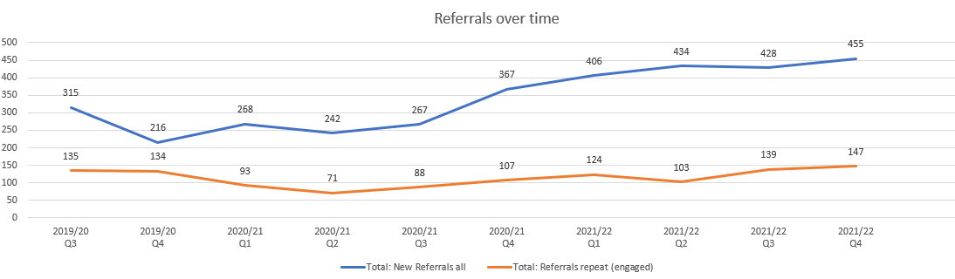

The chart above shows the referral numbers over time, a gradual increase can be seen. A 111% increase can be seen when comparing Q4 2019/20 with Q4 2021/22.

The charts below show the divisional referral breakdown for the 2021/22 quarters.

*\* New Referrals* = ALL (engaged or not) includes Daily Discussion referrals*

*\* Repeat Referrals* = ALL includes Daily Discussion referrals*

## Service User Demographics

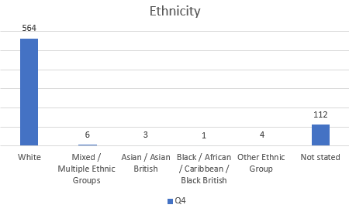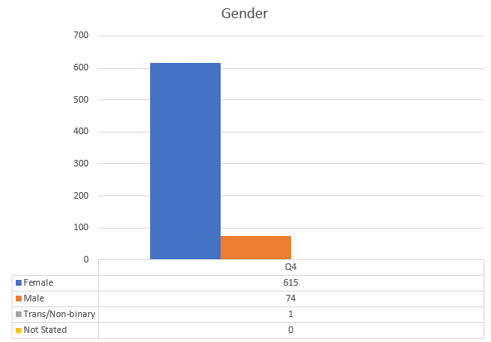The graphs below illustrate the service user deomgraphics for Q4 2021/22 – The information captured is correct as of the time the information was requested and recorded.

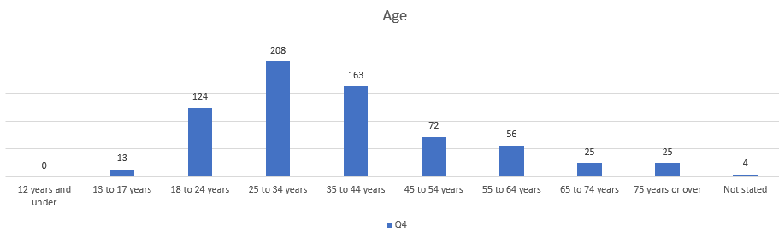The charts demonstrate that as of Q4, 89% of the service users identify as Female, with 82% identifying their ethnicity as being White.

At point of collecting the demographic data, the majority of service users (30%) were aged between 25-34.

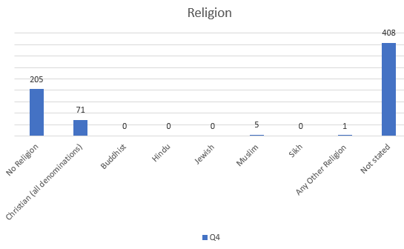The recorded religion and disability can be seen below, where 30% state they do not have a religion and 12% had a disability or were identified as disabled *As per The Equality Act 2010.

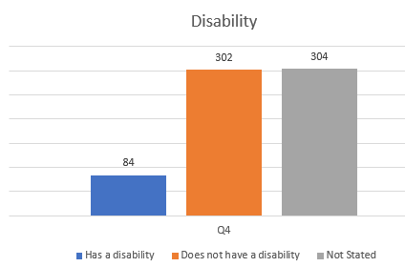

# Specification

## Summary of the Service

To provide an accredited, free of charge, high quality IDVA service, taking account of protected characteristics where relevant and without discrimination, and whether or not they have reported to police. t. The overarching objective is to reduce the risk level and increase the safety of victims of domestic abuse identified as at high risk of serious harm or homicide via the provision of an Independent Domestic Violence Advisory Service.

The main purpose of independent domestic violence advisors (IDVA) is to address the safety of victims at high riskof harm from intimate partners, ex-partners or family members to secure their safety and the safety of their children. In providing a service to adult victims, every care will be taken to ensure appropriate advice and referral is provided to safeguard any dependent children. Serving as a victim’s primary point of contact, IDVAs normally work with their service users from the point of crisisto assess the level of risk, discuss the range of suitable options and develop safety plans.

IDVAs are pro-activein implementing the plans, which address immediate safety, including practical steps to protect victims and their children, as well as longer-term solutions. These plans will include actions from the Multi Agency Risk Assessment Conference (MARAC) including Daily Discussion as well as sanctions and remedies available through the criminal and civil courts, housing options and services available through other organisations. However, the role of the IDVA is to deliver crisis management and coordination of the safety plan, not to deliver the required interventions directly. IDVAs should be working with other providers to ensure a smooth transition and transfer of clients between local services, covering both escalation and reduction in case risk, to maintain person focussed support in line with the individual support plan. IDVAs support and work over the short- to medium-term to put victims on the path to long-term safety.They receive specialist accredited training and hold a nationally recognised qualification.

Her Majesty’s Courts and Tribunals Service and the Judiciary welcome the presence of IDVAs at court to support victims through the criminal justice process. The service model should therefore include the provision of IDVAs at criminal or family court proceedings in order to advise and advocate appropriately for victims.

The practitioners delivering and manging the service must have, or be working towards, the nationally recognised IDVA qualification and be in accordance with Group 4 (for Practitioners) and Group 5 (for Managers) of the National Training Framework issued as statutory guidance under the Violence against Women Domestic Abuse and Sexual Violence (Wales) Act 2015(the Act).

## Eligibility for the Service

The service will provide an IDVA Service to victims of domestic abuse who are assessed as high risk in accordance with the recognised Safe Lives Domestic Abuse, Stalking and Harassment (DASH) risk assessment. High risk cases will include individuals subject to 3 incidents within 12 months that are agreed through the MARAC Repeat and Escalation process. Cases heard at Daily Discussion and MARAC will also require IDVA leadership and involvement. Clients who are assessed as standard or medium risk will be provided with information and support and signposted to the appropriate agencies and services.

# The service will be accessible to individuals who have reported domestic abuse and currently reside in the Dyfed Powys area, who are relocating to this area from elsewhere or who are reporting domestic abuse to agencies within this area.

Those individuals referred to the Dyfed Powys IDVA Service from outside of this area will be given initial advice but will be referred to appropriate services in their area and will be given emergency numbers for their area, including the national helpline number.

The Dyfed Powys IDVA Service will not provide services to perpetrators of domestic abuse. If, at any time during the intake or provision of service, a client is identified as a perpetrator of domestic abuse, he or she will be referred to an appropriate service for perpetrators of domestic abuse and the Regional IDVA Manager will be informed.

No client will be deemed inappropriate for service based on his or her age, ethnicity, religion, disability, sexuality, gender or immigration status.

There is no charge to clients for the IDVA Service.

## Specification for the Service

# The Provider will

* Ensure all service users are treated with respect, dignity and sensitivity, respect the diversity of the community and work to ensure all survivors have access to the services they need.
* Recognise the needs and concerns of a diverse range of survivors, and address them appropriately by working proactively to ensure that a non-discriminatory service is accessible to all eligible service users in full compliance with the duties under the Equalities Act 2010.

The Provider should ensure that the following standards are met as part of their service provision.

### Service Provision Standards

* The service provides clients with a specialist proactive, risk-led response that reflects clients’ individual risks and needs.
* The service provides effective and comprehensive safety and support planning work that reflects clients’ individual risks and needs.
* The service has a robust case management and supervision process in place ensuring effective practice and appropriate staff support from intake to closure.
* The service ensures that all aspects of casework and case file recording meet their legal and best practice duties to the client.
* The service encourages and supports clients to act for themselves and engage with services that can help them.
* The service is clear about to whom it offers a service and what that service provides.
* The service works proactively to ensure that a non-discriminatory service is equally accessible to all eligible clients.
* The service has clear and accessible referral pathways into and out of the service.
* The service regularly reviews its practice to ensure continuous improvement.

### Multi Agency Working Standards

* The service proactively engages with multi-agency responses to domestic abuse whilst ensuring that their primary role is to keep clients’ safety central.
* The service pro-actively engages with multi-agency responses to safeguarding and fulfils their legal duty in relation to this.
* The service engages with its local MARAC in line with its remit. This includes prior contact, attendance and engagement at the meeting, and continued client support.
* The service works with other agencies to promote, support and improve their response to adult and child victims of domestic abuse accessing those agencies.

### Human Resources Standards

* The service ensures that staff and volunteers are recruited, inducted, trained and supported appropriately for work with those who are experiencing domestic abuse.
* The service effectively manages the risks that caseworkers face through their work.
* The service is appropriately prepared to address the situation of employees as victims and as perpetrators.

### Governance Standards

* The service is based within a sustainable organisation with a clear strategy for maintaining its activities.
* The service is placed within a robust framework with clear lines of accountability between all staff and between the executive management and the board.
* The board identifies and manages key legal, financial and operational risks.
* The board monitors appropriate data to measure the performance and outcomes of the service, and ensures that corrective action is taken when required.
* The board takes responsibility for ensuring that the service meets its contractual requirements.
* The board receives regular information to ensure that a non-discriminatory service is being offered to all eligible clients.
* The board and management take account of stakeholder’s views in reviewing and developing the service.

### Operational Standards

The Provider shall comply fully with Safelives practice guidelines regarding the provision of this service.

The Provider shall deliver a service model that meets the following requirements as a minimum;

Contact within 1 working day of receipt of referral (preferably same day) unless risk is imminent;

* An information pack should be safely provided to the referred service user as soon as possible after referral to the service explaining what is being offered and what to expect;
* Agree a suitable and safe/secure method to deliver appointments in a manner deemed most appropriate for the needs and wishes of each referred individual;
* Conduct on-going agreed risk assessments through Case Management of the victim’s circumstances.
* Identify individual needs and develop an appropriate safety and support plan with the victim to reduce risk;
* Make appropriate referrals into other agencies e.g. Child Protection and Adult Safeguarding and other agencies to ensure specific interventions are offered and delivered.
* Equality analysis of service coverage throughout Dyfed-Powys and those victims that are classified as having a protected characteristic under the Equality Act 2010.

A risk assessment (standard as agreed with the Commissioners) and an initial safety plan must be completed within 1 working day, and one to one support must commence within 5 working days of referral date. A full assessment of the individual’s need and safety / support plan will be completed within 10 working days of one to one support starting. Safety plans should include provision of or access to safety equipment / target hardening where required.

The Provider will record all service users on appropriate information systems.

Safety Plans and risk assessments must be made available for onward sharing with other professionals and organisations where appropriate. Individual safety plans should follow a victim through the course of their support and should be updated every 6-8 weeks. Risk assessments should be reviewed every 4 weeks, after every new incident and before case closure. Information Sharing arrangements must be in place with all appropriate agencies to ensure there are no barriers to communication of safety plans between providers. Where possible, a standard template should be used for risk assessments and safety plans, to ensure consistency of approach.

## Service Delivery Model

The Commissioners have a budget of £400,000 per annum for the provision of this service.

In accordance with the instructions of the Commissioners, the Provider shall deliver a service with a delivery model including IDVAs trained to the nationally recognised qualification and in line with Group 4 of the Violence against Women, Domestic Abuse and Sexual Violence National Training Framework.

The Provider shall aim to maintain IDVA caseloads in line with Safelives standards.

The Provider will ensure that the IDVA service is independent of all statutory services and works closely with other organisations to ensure victims can access support appropriate to their individual needs. This should include witness care where victims are subject to a court process.

The IDVA service must act as the voice of the victim and ensure it advocates appropriately on behalf of the victim’s wishes.

All services to be confidential and follow professional codes of practice with appropriate information sharing protocols.

The Service shall achieve and maintain Safelives Leading Lights Accreditation programme, twelve months after the contract commencement date.

Dyfed-Powys is a large rural area; the Provider must as a minimum ensure that staff are based and available to the public in each county throughout the Force Region. The service must be accessible across all areas in the region and tenderers are encouraged to consider innovative and flexible service provision. The service must ensure the level of service provision is maintained through periods of annual leave, vacancies and sickness absence, with clear contingency plans in place.

The Service must be contactable 24 hours a day, 7 days a week. Out of hours arrangements must be made for high-risk cases where imminent harm is indicated; these arrangements must be agreed and notified to the Commissioners. Providers should propose a suitable delivery model with working hours based on the needs of victims. There should be no waiting list for service delivery.

The Provider must provide a single point of contact both during and out of office hours. .

A safe email address must be made available for all out of hours referrals and replied to within 24 hours.

Providers must specify the estate from which the service is to be delivered. This should include multi-agency co-location arrangements and outreach options for victims to be seen at the location considered the safest and most appropriate for their support.

## Referrals

The service must have clear and accessible referral pathways into and out of the service.

Referrals into the service shall be made by statutory, voluntary or community based organisations, professionals, self-referring individuals, family members, carers or friends.

The Provider will assess referrals (in accordance with the guidance on ‘Value and purpose in identifying who is doing what to whom’ contained in the Respect Toolkit for Work With Male Victims Of Domestic Violence) where it is suspected that a perpetrator may be presenting as a victim or to resolve counter allegations. If a referral is made as a result of cross-allegations, each case will be assigned to a different IDVA and assessment for the primary aggressor will take place. If a perpetrator is identified during this process they will be referred on to an appropriate service e.g. Perpetrator programmes, alcohol and drugs services, or in the case of mental health to their GP or the Respect Helpline and consideration will be given to sharing information with the Police and other relevant agencies in accordance with Information Sharing Protocols.

The Service must have effective processes for planned exit of service users, ensuring referral on to appropriate agencies to ensure achievement of support plan goals. An ‘Exit Plan’ must be completed on leaving the service. IDVAs are responsible for the crisis management of victims. This should be short term and intense in nature, with longer term and wider support needs and responsible organisations clearly identified within a support plan. This should include identification and awareness of additional needs and risks such as substance misuse, sexual exploitation etc.

The Service must ensure a smooth interface and transition between agencies where victims may escalate and de-escalate through the levels of risk and therefore move between organisations for support.

## Promoting the Service

The Provider will be responsible for promoting the service.

## Staff

The service must ensure that staff and volunteers are recruited, inducted, trained and supported appropriately for work with those who are experiencing domestic abuse.

The job description and person specification of the IDVA and any associated roles e.g. IDVA Manager must be based on the Safelives model and incorporate the requirements of the Welsh Government’s National Training Framework for Violence against Women, Domestic Abuse and Sexual Violence.

All staff involved in service delivery shall attend appropriate levels of Safeguarding training, or to evidence appropriate Safeguarding training accessed through their own service.

The Service will provide line management for all staff to ensure they:

* Review cases and resolve issues with complex cases;
* Supervise staff and facilitate team meetings;
* Ensure adherence to policies and procedures;
* Represent the service at Daily Discussion, MRE or MARAC processes or delegate to an alternative as necessary;
* Are responsible for the Health and Safety of staff and compliance with all appropriate safety risk assessments and Health and Safety legislation.

Safe working practices to include, as a minimum;

* Safe contact procedures
* Staff keeping themselves and others safe
* Training relating to safe working practices including lone working
* Annual safety audit
* Sharing “risk” and “threat” information
* What information to be kept on staff
* Professional boundaries

Where staff are lone working the Provider shall ensure that an effective assessment of risks is undertaken under the Health and Safety at Work Act and proper procedures are implemented.

The Provider shall ensure that every IDVAs is provided with clinical supervision, individually or in a group by an appropriately qualified and experienced individual every four weeks and clinical group supervision every twelve weeks as a minimum requirement. Full records shall be kept of these supervision sessions and these shall be made available to the Commissioners on request.

The Provider will adhere to safer recruitment practices.

Staff within the IDVA Service are required to work on duties involving access to vulnerable persons, children or other members of the public. The Provider must undertake comprehensive safeguarding and other appropriate checks in respect of all staff utilised in the provision of the service and shall ensure that all such persons have given their written permission for such checks to be made. Enhanced Disclosure and Barring checks (DBS checks) must be conducted at the offer of employment at the latest. Staff without an Enhanced DBS conducted by the agency must not work unsupervised at any time.

Where staff are to be based in police premises, or have access to police systems, individuals will be required to pass Non-Police Personnel Vetting Level 2.

It is desirable that the domestic abuse workforce reflects the diversity of the service user population, and the Provider must make every effort in recruitment to posts to attract diverse candidates. The Provider shall, in respect of all persons employed or seeking to be employed by it, comply with each and every aspect of the provisions of the law which prohibit discrimination in relation to employment on the grounds of age; disability; gender reassignment; marriage and civil partnership; pregnancy and maternity; race; religion or belief; sex; or sexual orientation.

All employment policies and practices must conform to the existing legislative requirement. The Provider must ensure that contingency planning for long-term staff absences is covered within salary budgets. Annual leave must be arranged in such a way as to ensure adequate cover of services.

In accordance with the Welsh Language Measures Act 2011 the Provider shall ensure that an active offer is made to provide the service in the medium of the Welsh language and that sufficient staff are able to offer such a service.

Tenderers are reminded that the services must be delivered in a manner which is compliant with the Welsh Language (Wales) Measure 2011 and with the Welsh Language Standards Scheme that the Commissioners are liable to comply with, as if the Provider was itself the authority. Providers must ensure that they are familiar with the Commissioners current Welsh Language Scheme which is available at

[The Welsh Language Standards | Dyfed-Powys Police](https://www.dyfed-powys.police.uk/police-forces/dyfed-powys-police/areas/about-us/about-us/the-welsh-language-standards/)

[Welsh Language (gov.wales)](http://www.carmarthenshire.gov.wales/home/council-democracy/welsh-language/)

[Welsh Language - Ceredigion County Council](https://www.ceredigion.gov.uk/your-council/strategies-plans-policies/welsh-language/)

[Welsh Language Standards - Pembrokeshire County Council](https://www.pembrokeshire.gov.uk/customer-service/welsh-language-standards)

[Welsh Language Standards - Powys County Council](https://en.powys.gov.uk/article/3268/Welsh-Language-Standards)

# Quality and Performance Management

Outcomes to which Commissioners expect the service to contribute:

* Increased access to and engagement with service provision
* Increased engagement of clients in the criminal justice process
* Reduction in risk levels for victims
* Increase in self-reported feelings of safety, confidence and wellbeing
* Improved quality of life for victims and their families
* A seamless multi-agency approach to provision of support for victims

The Provider will be expected to work with the Commissioners throughout the mobilisation phase to develop a framework of measurable outcomes for the service. As a minimum, Commissioners would expect to see both quantitative and qualitative indicators that measure the volume of activity and outcomes achieved by the service. The Provider will also need to consider how they intend to monitor the quality of the service provided and the impact on service users. The Provider will need to ensure that service user feedback is appropriately captured, reported and acted upon. A suite of Key Performance Indicators, agreed with Commissioners, must be in place and able to be reported on from point of commencement of contract.

The Provider shall ensure that it has appropriate systems and procedures in place in order to capture and report on compliance with KPIs as required. The Provider will make available, upon request from the Commissioners access to the software database. Where sub-contracted or consortium arrangements exist, the service must be reported upon as a holistic service, with one set of performance data reported to Commissioners.

The Provider shall be able to evidence continuous improvement in the quality and performance of the service. This shall include pro-actively seeking to make efficiency savings in service delivery.

The Provider shall carry out a service user satisfaction survey, at least annually for this service, the results shall be made available to the Commissioners.

The Provider will make available, upon request, case files for audit by the Commissioners for quality assurance purposes within agreed timescales. This will be included in service user consent forms. Any information made available under this clause shall be treated as Confidential Information.

Within 10 working days after the end of each Quarter, the Provider shall deliver to the Commissioners a management report detailing performance during that Quarter. Reports shall be in a format approved by the Commissioners and shall include narrative to highlight any performance issues, along with any steps that the Provider proposes to address areas of concern. The report should also contain other relevant performance information and any pertinent issues or areas requiring further discussion.

Monitoring will be undertaken via quarterly review meetings / visits. The quarterly reports submitted by the Provider will form the basis for discussion at these meetings. The meeting will afford both parties the opportunity to raise any issues for discussion or clarification.

# Equality and Diversity

The Provider shall comply with all anti-discrimination legislation. Where evidence of an under-representation of service users in terms of race, gender and disabilities exists measures shall be taken to address the issues highlighted.

The Provider shall ensure that the Service reflects the cultural diversity within Dyfed-Powys and be accessible to all eligible people regardless of their equality and diversity requirements. Services shall be delivered in a sensitive way which takes into account individual needs, including age, gender, ethnic origin, language, culture, faith, sexuality, gender identity, disability and any specific communication or lifestyle preferences.

The service shall monitor and record the ethnic background, gender and age of service users and compile a report annually including an analysis of the findings and proposed actions if access is seen to be unrepresentative. The demographic breakdown of Dyfed-Powys shall be used as a benchmark to assess performance. The report will be inspected during service reviews.

Where the service user’s first language is not English or Welsh, the Provider will be responsible for booking and arranging interpreting services through a recognised Provider. Family members or friends of the service users are not to be considered acceptable substitutes for interpreters. The costs must be funded from the contract price, and the quarterly cost of providing interpreting will be monitored to ensure this doesn’t place an excessive burden on the Provider.

The Provider must strive to support access to services for those with specific cultural needs.

1. <https://www.ons.gov.uk/peoplepopulationandcommunity/crimeandjustice/articles/domesticabuseduringthecoronaviruscovid19pandemicenglandandwales/november2020>