Dear Supplier

RE: CENTRO E-TENDERING PORTAL

Centro have embraced the environmentally friendly, efficient and secure electronic methodologies to facilitate the organisation’s tendering activities.

In order to view Centro opportunities, all that is required to participate is a valid email address and a reliable internet connection. The eTendering Portal is FREE to all suppliers and system requirements are minimal (PC, Internet Explorer 6+, Internet access).

We would like to invite you at this time to register your details within the eTendering portal at https://centro.bravosolution.co.uk. Please be advised that you must be registered and express an interest in a tender provision in order to access available documents on posted opportunities.

Benefits of the electronic tendering portal include:

- Having access to Centro tender opportunities
- Secure environment available 24x7
- Secure messaging facility
- Instant online publication
- Reduced printer and courier costs
- Reduced carbon footprint
- Fully auditable process

For assistance using/navigating Bravo Solutions, please telephone 0800.368.4850 or email to help@bravosolution.co.uk.

Yours faithfully,

Jennifer Mills
Head of Procurement

REGISTERING WITHIN BRAVO SOLUTION

URL: https://centro.bravosolution.co.uk

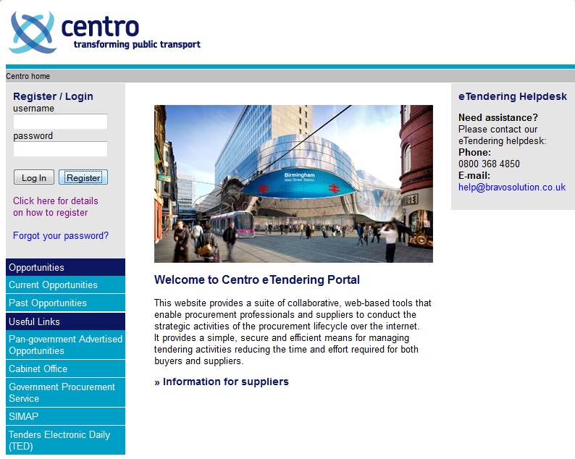
Click to register details

Help is available from Bravo Solutions

To register, click the button named Register. Fill out the fields then click Save. Your username and password will be emailed to the address within your registration. You will shortly receive an email from help@bravosolution.co.uk providing you with your user names and password details. Follow the link indicated within the email and login using the credentials (username and password) provided. You will be asked to change your password upon your first login.

NOTE: There is a video available to provide you with guidance on registering (linked called Click here for details on how to register)

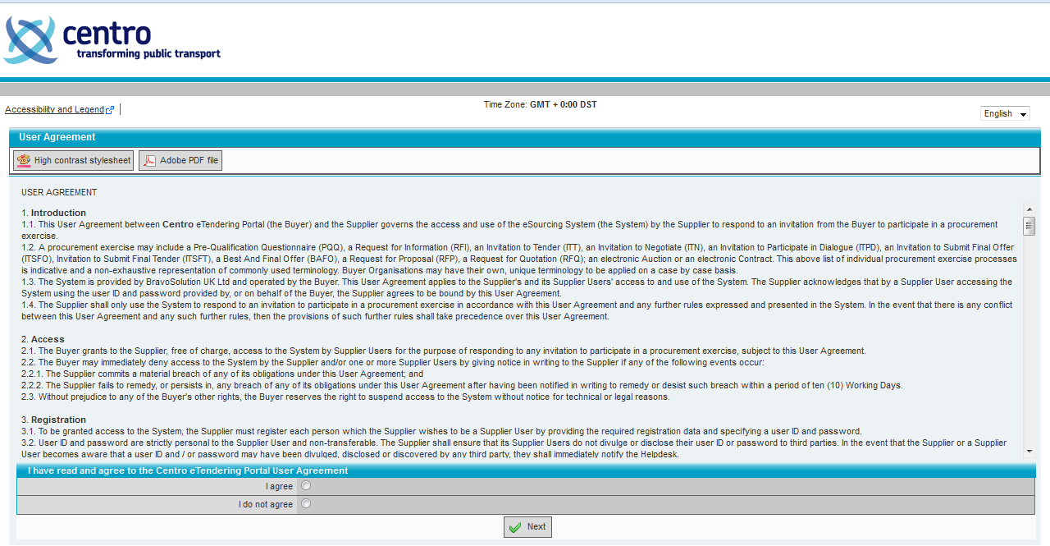

Agree to the user agreement. Click Next. The system will guide you through the setup of a basic profile in the first instance.

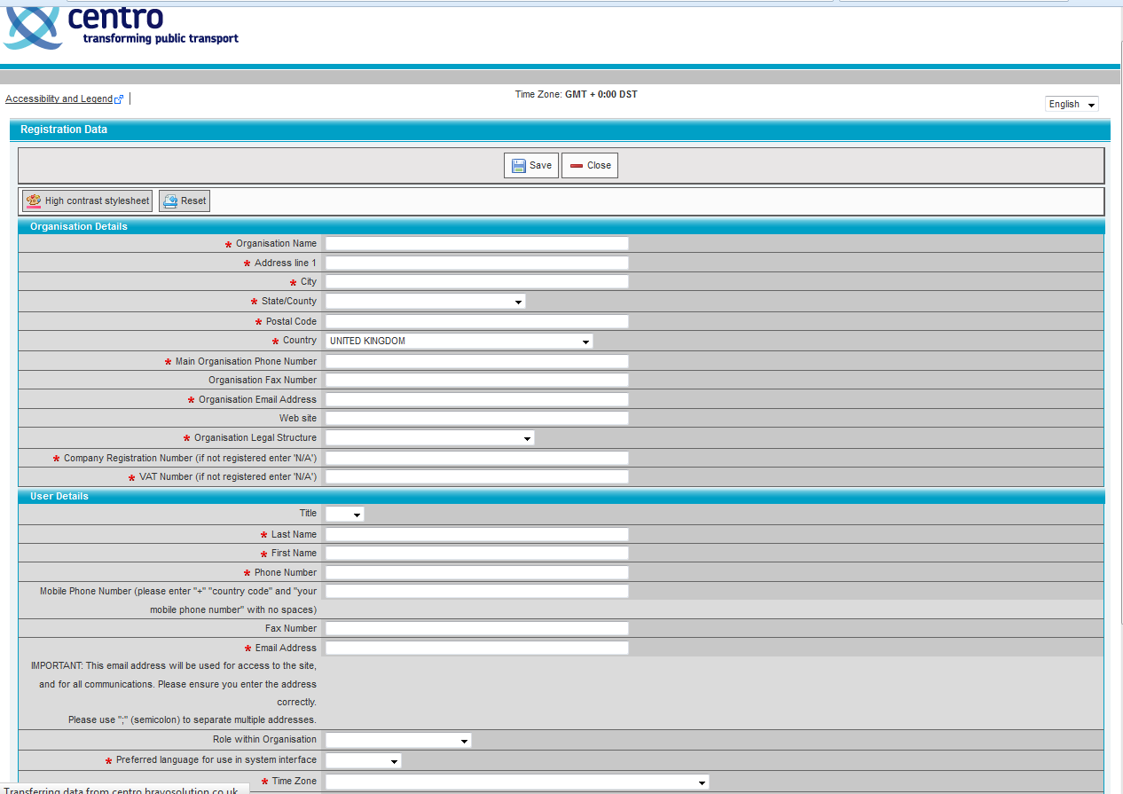

Enter Organisation Details and User Details as requested. Fields with a red asterisk are mandatory fields. Click Save. Once you complete your profile, you will then be able to go back and edit your profile at any time. Please ensure that your profile is kept up to date as the data within may form responses to pre-qualification questionnaires and invitation to tenders.

It is possible for a supplier to have a single registration to a given postal mailing address but have multiple email recipients within that one address and or users able to logon to Bravo. We encourage suppliers to keep registrations to a minimum where possible and use the new system functionality to enable correspondence to be sent to multiple recipients when deemed appropriate. Please see below for relevant instructions.

INSTRUCTIONS FOR SINGLE REGISTRATION; MULTIPLE RECIPIENTS
To add an additional email address to your account in order for the correspondence to be sent to multiple recipients, the Super User of the account should follow the instructions below:
- Log onto the e-tendering portal with your username and password.
- Click onto the link “Manage your profile” in the User Profile box on the left hand side of the screen.
- Click onto “Edit” at the top of the profile.
- Scroll down to the User Details section.
- After the existing email address enter a semi colon, then with no space type the next address.
- If more addresses are to be added, repeat the step above separating the addresses with a semi colon each time.

TO SET UP MULTI-USERS ON YOUR ACCOUNT (ability for multiple individuals to login to BravoSolutions)
- After logging in, click on to ‘Multi user’ or ‘Manage Users’ underneath “User Profile”
- Click on to [Create] at the top of the screen, fill in the relevant details for that user, and hit [Save] at the top or bottom of the page
- After creating the multi user you will then have to assign them user rights
- To assign user rights, click on to [View User Rights] at the bottom of the screen
- The user rights will all be default set to ‘No’ so click [Edit] at the top or bottom of the screen and change them accordingly then click [Save] at the top or bottom of the screen
- Each user will then be sent a username and password to log in.

THE FOLLOWING INSTRUCTIONS WILL ENABLE THE SUPER USER TO CHANGE YOUR USER RIGHTS (single administrator for your organisation with ability to change user rights of others within your organisation using BravoSolution)
1. Super User needs to log in to their account
2. Click on to ‘Manage Users’ underneath “User Profile” near the top left hand corner of the main
page
3. Click onto the sub user’s name
4. Underneath ‘User management’ on the left hand side of the screen click on to ‘User Rights’
5. Click on to [Edit] at the top or bottom of the screen
6. Change all relevant fields
- Click on to [Save] at the top or bottom of the screen

LOGGING IN
Enter username and password

PROFILE MANAGEMENT

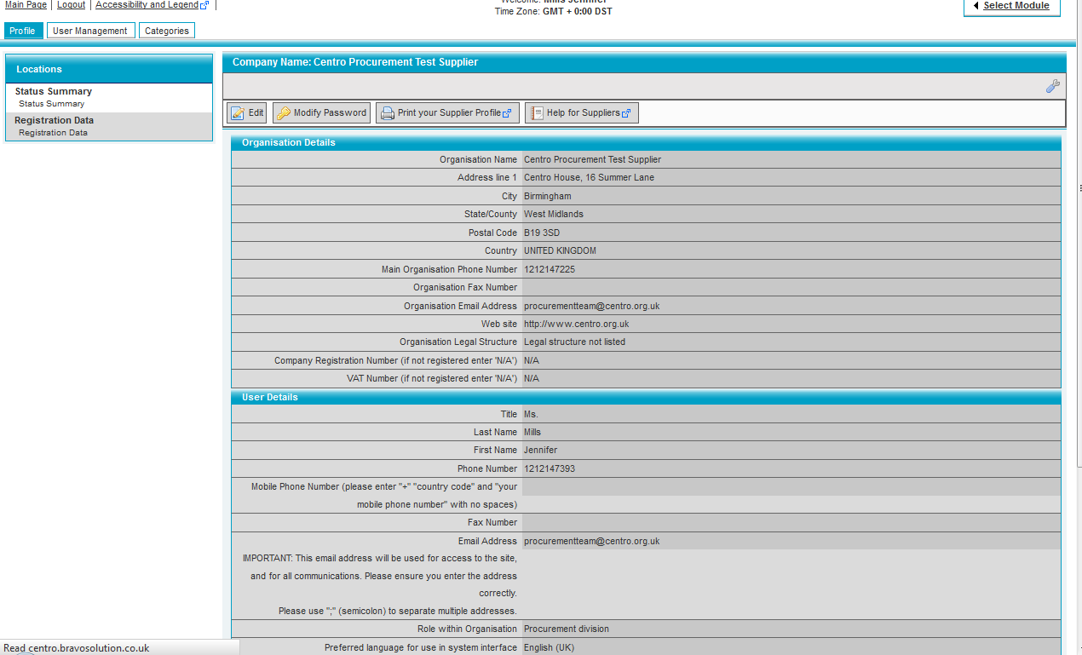
This is the supplier profile screen

If you have a few folks within your organisation that will work on tenders and wish to give varying access according to roles, you may define roles and divisions and then assign users to those.

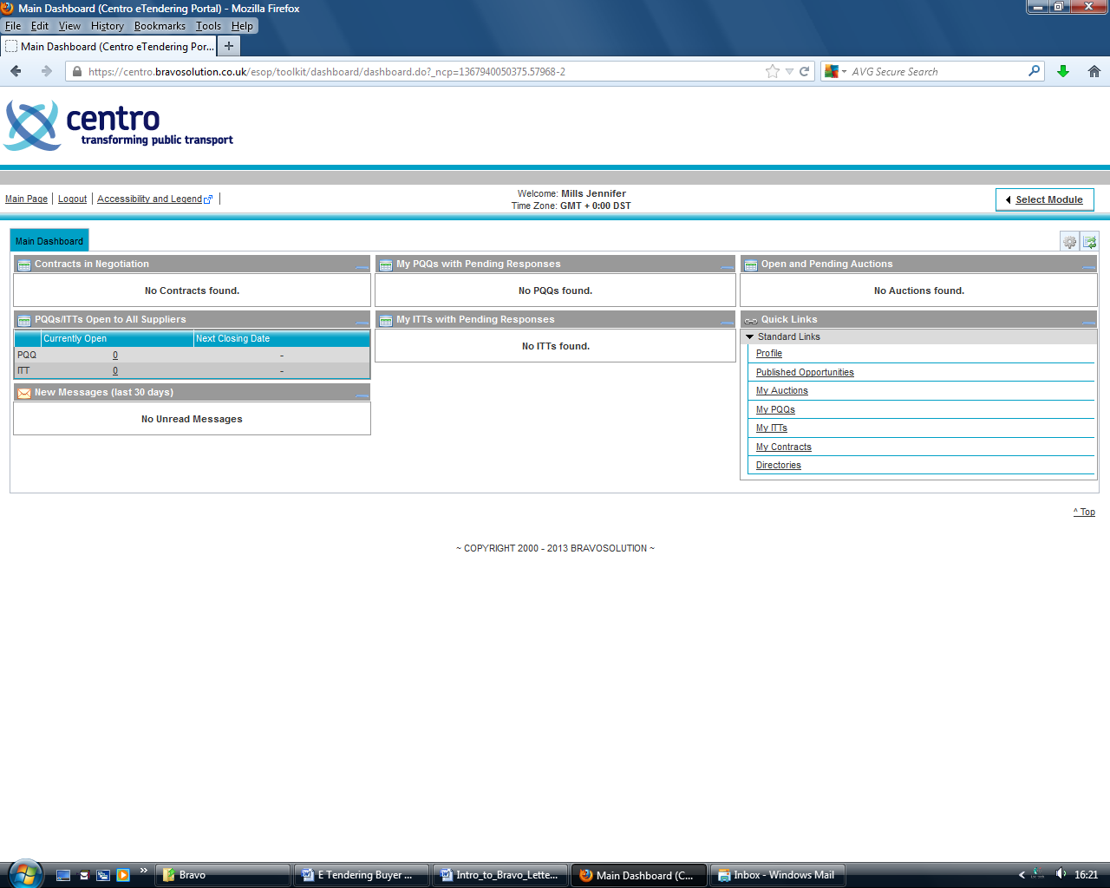
Click here to view published opportunities
Click here to make changes to your supplier profile

USER MANAGEMENT
Click Create

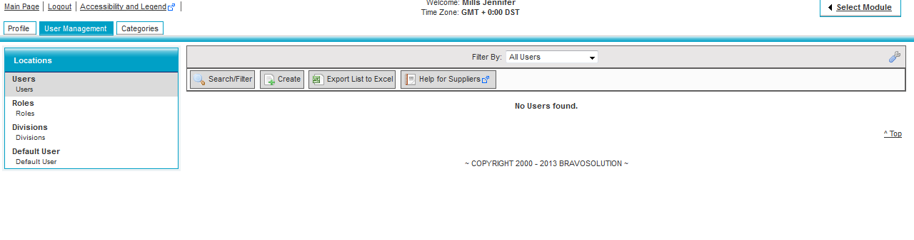
Add Users, Roles and Change Default Users
CATEGORY MANAGEMENT
Click Add Category

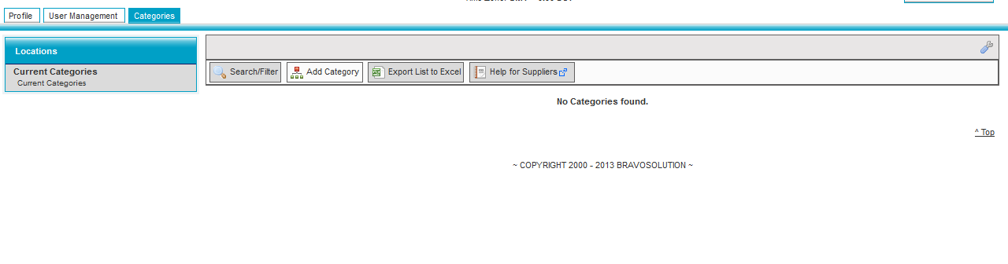
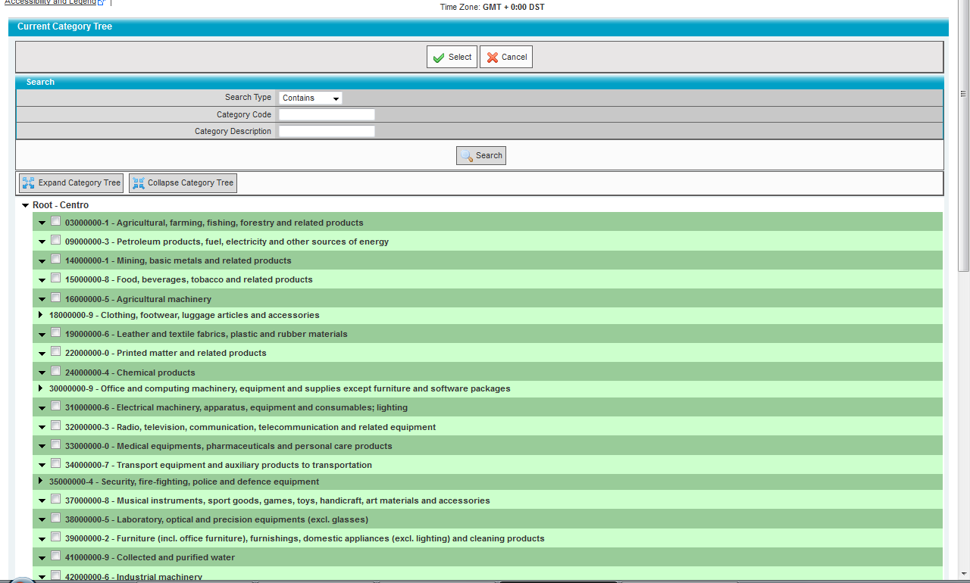

Choose a category that best represents the core or your business.

NOTE: Exceptions that require categorisation as follows:

Supplier Provides | Category you must use
Smartcard | 30162000-2 - Smart cards
Bus Operators | 60112000-6 - Public road transport services
Real Time Information | 48813200-2 - Real-time passenger information system
Taxi Services | 60171000-7 - Hire of passenger cars with driver
IT Consulting | Find the main category 72000000-5 and look below at the sub-categories to find the appropriate category your business provides
PPE | 18143000-3 - Protective gear
Business and Consulting Services | Find the main category 79400000-8 or 72220000-3 and look below at the sub-categories to find the appropriate category your business provides

EXPRESSING INTEREST

Check for Published Opportunities

If you wish to express an interest in a tender provision, the area where opportunities will be published. Click on any opportunity you have an interest in; you will then be able to express an interest. You will then have access to relevant documents related to the tender provision.

It is important to note that every tender provision has an end date and time (e.g., 12:00 18/01/2013). You may access documents and/or upload or remove documents as often as you like from the time you express an interest until the end date and time. However, you must click Submit by the end date and time in order for your tender submission to be considered. Any late submissions may not be considered.

