What is a Knowledge Library page?

Knowledge library (KL) pages are designed to communicate technical information and suggest best practices. It is an 'evidence base'; a reference for farmers and growers looking to find solutions to on-farm and business problems. It is not a space for news, opinions or campaigns.

Information should be presented as clearly as possible, so that the user is able to find what they need quickly and easily.

Knowledge library pages should:

* [Use plain English](https://teams.microsoft.com/l/file/E7F95E71-9A83-4ACA-888F-B8B69F236FA8?tenantId=a12ce54b-3d3d-4346-95ef-ff13ca5dd47d&fileType=docx&objectUrl=https%3A%2F%2Fahdbonline.sharepoint.com%2Fsites%2FWebContentworkshop-27.1.20%2FShared%20Documents%2FGeneral%2FWriting-web-content-BASICS.docx&baseUrl=https%3A%2F%2Fahdbonline.sharepoint.com%2Fsites%2FWebContentworkshop-27.1.20&serviceName=teams&threadId=19:75cd0c21d6e8430ba7838149b3758272@thread.skype&groupId=884fa1b8-d8b5-4065-958c-378281bbc361) and be easy to read
* Contain a brief introduction that outlines the purpose of the page
* Have a title that is searchable and contains any relevant keywords
* Use a combination of headers, short paragraphs and bullet points to make the page ‘scannable’
* Have an [active voice](https://www.grammarly.com/blog/active-vs-passive-voice/)
* Speak to the farmer/grower directly. E.g. “Planning ahead can help you to…” rather than, “Planning ahead can help farmers to…”
* Be easy to browse. E.g. subpages link back to landing page and related content linked to from the bottom of the page
* Have sound SEO throughout so users can find the content easily via search engines
* Only have images that support the user need. E.g. pictures of lesions that help illustrate the content
* Use language that aims to be accessible for all users, including those with disabilities.
* Use language that is impartial, open-minded and straightforward – this helps to create an inclusive tone of voice

Knowledge library pages should **not**:

* Use internal jargon
* Use puns
* Use idioms or figures of speech
* Have unnecessary images to ‘fill a space’
* Try to introduce too many topics on one page
* Have too many elements, leading to ‘overcrowding’ of the page
* Use ‘marketese’ or hyperbole
* Patronise the reader - plain English does not mean ‘dumbing down’

(cont.)

Don’t: Do:

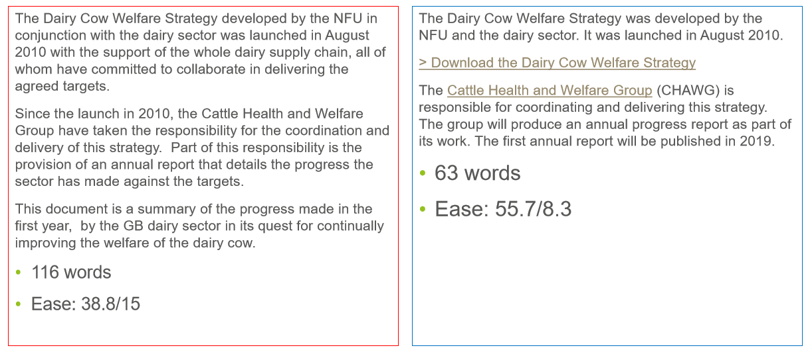

Examples of KL pages:

[Lameness in dairy cows](https://ahdb.org.uk/knowledge-library/lameness-in-dairy-cows)

Tomato brown rugose fruit virus