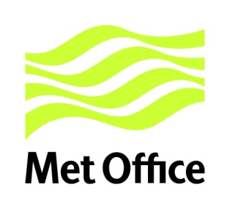

Notice of Contract Award

Between:

Met Office Procurement FitzRoy Road Exeter Devon EX1 3PB United Kingdom
Tel: 0870 900 **** Fax: 01133 36**** www.metoffice.gov.uk

Illuminas
183 Eversholt Street, London, NW1 1BU

13/08/2018

Contract Number: DN347901 – Market Research for Public Sector Information

The Met Office will engage Illuminas for the provision of Tender Number DN347901 dated 07/08/2018 for the supply of Market Research for Public Sector Information

Period of Contract

Contract Start Date: 13/08/2018
Contract End date: 13/08/2019
Contract Extension: N/A

Contract Value: £65,000

The Contract will be placed under:

- Met Office Amended Terms and Conditions for the provision of services

