

AUTHORITY: The Secretary of State for the Home Department
acting through Border Force

statement of requirements

PLANNED MAINTENANCE AND DRIVE LINE OVERHAUL TO CPV NIMROD

DECEMBER 2018

CONTENTS

Sect | Sub-heading
DEFINITIONS

Part 1: GENERAL

01 | Background
 | Part 2: REQUIREMENTS AND CONSTRAINTS
02 | Requirements
03 | Location
04 | Constraints
 | Part 3: PROVISION OF SERVICES
05 | General Requirements
06 | Part 4: WARRANTY  Warranty Requirements
 | Part 5: TRIALS, DOCUMENTATION & ACCEPTANCE
07 | Trials
08 | Documentation
09 | Acceptance
10 | Charges & Payment
Annex A Annual Maintenance & LSA
Annex B Machinery and Driveline Overhaul
Annex C Defects for Rectification

Annex D Vessel Drawings

Annex E Vessel Details

Annex F Handover Document

Annex G Acceptance Document

Annex H Reimbursable Expenses

DEFINITIONS:

Acceptance | The issuing of an acceptance document, signed by the Authority following the completion of an Annual Maintenance & Repair Period to the satisfaction of the Authority.
Additional Work | Unprogrammed work outside of the scope of planned or scheduled work, which is notified to the Supplier more than ten days prior to the commencement of any Maintenance & Repair Period.
Agreed Facility | A single phone number for the Supplier giving access to a point of contact able to give user friendly assistance to persons experiencing technical problems with any part or operation of the CPVs
Cardinal Date Plan (CDP) | A plan provided by the Supplier mapping out the significant dates for a project
Coastal Patrol Vessel (CPV) | The Vessel as detailed in Annexes D & E
Collar | RIB Collars (also known as RIB Tubes or Sponson) are the inflatable section of a Rigid Hull Inflatable OR A polyurethane coated closed cell foam cored buoyant Collar offering similar properties.
Defect Rectification | Work undertaken to resolve any kind of defect identified and listed in the work package.
Driveline | The CPV Driveline is the engines, water jets and drive shafts, and components used to connect these together
Emergent work | Any work that emerges from the Planned Maintenance, which is notified to the Supplier in this Statement of Requirements. Any repairs which are required as a direct result of defects found with during this package of works.
Highlight Reports | A report highlighting the details, cause and effect, of a deviation from the agreed Cardinal Date Plan.
Lloyd Register | Lloyd’s Register’s Rules and Regulations set standards for the design, construction and lifetime maintenance of ships, offshore units and land-based installations.
Machinery and Driveline Overhaul | The package of works as detailed at Annex B
Major Defect | Any defect or fault which reduces the performance of the CPV, so it is unable to perform its duties.
Milestone Payment Plan | A plan setting out the significant milestone payments process for each Maintenance and Repair period
Minor defect | Any defect or fault which reduces the performance of the CPV while allowing it to be safely operated for its duties.
Original Equipment Manufacturer (OEM) | The original manufacturer of a piece of equipment.
Planned Maintenance | The package of works as detailed at Annex A
Project Manager | A member of the Suppliers personnel who is responsible for the overall planning and execution of a project.
Progress Report | A report giving details of progress against the agreed CDP
Rectification Plan | A plan to rectify a specified defect, giving dates and reasons for relevant actions to effect full rectification of the defect.
Safe Working Load (SWL) | The maximum load a piece of equipment can safely lift.
Warranty | A guarantee, issued to the Authority by the Supplier, promising to repair or replace something if necessary within a specified period of time.
Working Location | The area in which the CPV is operational

Part 1:GENERAL

- Background

1.1 The Authority currently operates a fleet of eleven sea going patrol craft operating in both UK National and International waters. This consists of five Cutters and six Coastal Patrol Vessels (CPV).

1.2 The six CPV are equipped and certified to comply with Maritime Coastguard Agency (MCA) MGN 280 (M) Small Vessels in Commercial Use for Sport or Pleasure, Workboats and Pilot Boats – Alternative Construction Standards, Category 2, for service in waters up to 60 nautical miles from a safe haven.

  - The primary roles of the CPVs are: -

1.3.1 To provide a mobile, flexible seaborne force capable of maintaining an effective deterrent against illegal immigration, smuggling and other breaches of the law administered by Border Force both within and outside the territorial waters of the UK.

1.3.2 To increase maritime intelligence, undertake surveillance and improve international liaison in combating illegal immigration, the smuggling of drugs and movement of instruments of terrorism by sea;

    - To intercept suspect vessels in territorial and international waters; and

1.3.4 To provide mutual assistance to other EC countries, the Channel Isles, the Isle of Man and other partners on the UK border.

1.4 In addition to these primary responsibilities, Border Force also undertake tasks on behalf of the Ministry of Defence, Maritime and Coastguard Authority, National Crime Authority, Police and UK Fisheries Agencies.

1.5 The CPVs were originally built by Delta NP as Autonomous Rescue & Recovery Craft (“ARRC”), for use as Search & Rescue (SAR) assets for operation in the North Sea and were recommissioned by Border Force in 2017/18. The CPVs are built from a Fibre Reinforced Plastic (FRP) sandwich construction with hybrid buoyant foam / air filled Collar and an enclosed wheelhouse and mission space.

Part 2: REQUIREMENTS AND CONSTRAINTS

- Requirements

2.1 The objective of this specification is to provide requirements for:

- The annual Maintenance of equipment and machinery.
- The annual recertification of all safety equipment.
- The replacement of both drive shaft systems.
- Rectification of specified defects.

- Location

3.1 The work is to be carried out within the geographic navigable area from Lowestoft to Poole.

4.0 Constraints

  - All work carried out must be compliant to all applicable standards or regulations and in accordance with best industry standards.

  - All new parts and equipment fitted should be supportable for a period of five years following installation.

  - All new equipment shall be provided with relevant operator & maintenance documentation, and any applicable certification.

  - All work, including trials and the provision of all associated documentation or certification, is to be completed between 08 Jan 2019 and 29 Mar 2019.

4.5 The Supplier must have their own yard in which the works will be carried out or alternatively have a standing agreement in place with a yard capable of accepting CPV Nimrod immediately following award.

  - Annex B Item 6.1 (Removal of both main engines) is required to be carried out within one week of Contract award. The engines will be in overhaul for a maximum of 9 weeks from collection to delivery.

4.7 The removal of both main engines is to take place with the vessel securely supported out of the water, inside an environmentally controlled facility, to prevent damage due to unexpected movement of the CPV or ingress of weather.

4.8 An environmentally controlled undercover facility is to be provided to complete all work, with adjacent mechanical/electrical/fabrication workshops in the location.

3: PROVISION OF SERVICES

5.0 General Requirements

5.1 The Supplier will appoint a dedicated Project Manager, as a single point of contact, for the duration of the Project.

5.2 The Authority will delegate a Border Force Overseeing Officer (BFOO) for the duration of this contract, who shall be entitled to inspect any work or to have it inspected by his duly authorised representative.

5.3 On arrival at the supplier’s premises CPV Nimrod will be formally handed over to the Supplier using the formal handover document at Annex F. Thereafter, the Supplier will be formally approached for consent in respect of any Authority activity or the activity of any Authority designated / arranged contractor onboard.

5.4 The Supplier shall submit a draft CDP covering the completion of all planned work with the formal quotation for this work package, in an accessible Microsoft Office document format (word or excel), for approval by the Authority, once agreed by the Authority this will form the final CDP to be followed.

5.5 The Supplier is to provide Highlight Reports within twenty-four hours of all identified deviations from the CDP.

5.6 During the contract period the BFOO shall, during normal working hours, be given access to all premises of the yard or its suppliers where any parts are being manufactured, repaired or serviced.

5.7 During the contract period the Supplier shall provide reasonable office accommodation for use by the Authority at the site where the vessel is located for the work.

5.8 All tasks shall be completed by appropriately qualified, accredited and experienced personnel in relation to the equipment being worked upon.

5.9 The Supplier will be expected to clean the working area and remove and dispose of those component parts that are replaced and all waste created during this project.

5.10 All minor consumable fixings, sealants etc required to rectify defects to be provided by the Supplier.

5.11 The supplier is required to provide secure storage for the vessel’s equipment stored in the mission and bunk space as this requires removing to lift the deck to access the shaft line.

5.12 All bunk space soft furnishings, including mattresses are to be removed to a secure clean environment for the duration of the work, or covered to adequately protect them from dirt.

5.13. On completion of all work and prior to handback, the vessel shall be cleaned to an acceptable standard for operational use as accepted by the Authority.

Part 4: WARRANTY

6.0 Warranty Requirements

6.1 The Supplier shall provide an Agreed Facility for reporting faults and obtaining technical advice, covering the hours between 08:00 and 16:30, Monday to Friday, for the logging of faults or data. Response times for such service shall allow for all faults to be logged, given a reference number and rectification plan agreed between all parties within a maximum of forty-eight hours of the fault being logged.

6.2 The Supplier shall provide warranty repairs in the event that any of the supplied or repaired parts develops a fault during the parts warranty period. The severity of the repair will dictate where the repairs are carried out but will be as agreed with the Authority.

6.3 All work carried out by the Supplier during the period of this contract shall be covered by a one year Warranty.

6.4 All new parts supplied or fitted during the period of this contract shall be covered by a one year warranty or such other provided warranty if it is longer than the minimum one year.

6.5 In the event that a Warranty Major Defect is notified to the Supplier that will render a CPV non-operational. The Supplier shall provide services to ensure the CPV is restored to full working condition within forty-eight hours, calculated from the date and time on which the Authority agrees the Supplier personnel can gain access to the CPV. In the event a Major Defect cannot be rectified within the assigned period, a Rectification Plan must be agreed with the Authority within forty-eight hours of identification of the potential failure to meet the KPI.

6.6 In the event that a Warranty Minor Defect is notified to the Supplier, other than those that will render the CPV non-operational, the Supplier shall provide services to ensure the CPV is restored to full working condition, as quickly as possible, and in any event, within ten working days, calculated from the date and time on which the Authority agrees the Supplier personnel can gain access to the CPV. In the event a Minor Defect cannot be rectified within the assigned period, a Rectification Plan must be agreed with the Authority within forty-eight hours of identification of the potential failure to meet the KPI.

Part 5: TRIALS, DOCUMENTATION AND ACCEPTANCE

7.0 Trials

7.1 On completion of all work and once the Supplier has satisfied themselves that the CPV is seaworthy this will be demonstrated to the Authority who will provide an Acceptance Certificate and confirm the hand back of the CPV into the Authority’s custody and responsibility. This shall include propulsion and manoeuvring trials measured against original trials data for comparison.

7.2 Any trials required shall be to prove that the executed work has been carried out satisfactorily and that the various systems can be checked and confirmed as fully and effectively re-commissioned. Other than fuel, all costs related to the operations of test and trials will be the responsibility of the Supplier.

7.3 Because of the specialist nature of the vessel, the Authority will provide a crew member familiar with the navigational control and engineering systems of the CPV.

8.0 Documentation

8.1 All certification required for regulatory compliance or requested by the Authority shall be supplied enclosed in clear envelopes within four-ring binders complete with an index. An electronic copy shall be forwarded by e-mail to the Authority in an accessible Microsoft Word format.

8.2 All certificates and reports specified as required are to be provided before acceptance.

8.3 All certificates and reports specified as required are to be provided in a hard copy folder to the vessel before departure and electronically emailed to the Authority.

9.0 Acceptance

9.1 Final acceptance will be the issuing of a Final Acceptance document as at Annex G, signed by the Authority.

9.2 The Final Acceptance document will be issued after:

9.2.1 Successful completion of Sea Trials, complete with Final Sea Trials report.

9.2.2 Delivery of Certificates of Conformity for all new equipment fitted.

9.2.3 Delivery of all documentation and certificates as specified in part 5 of this Statement of Requirements.

10.0 Charges and Payment

10.1 On completion the Supplier shall provide the Authority with a completed schedule showing the individual cost breakdown for each item of Planned Work and Emerging Work for approval. Following approval of this schedule the Supplier will invoice the Authority for 90% of the total amount.

10.2 The remaining 10% shall be invoiced following a one calendar month snag free period in relation to the work completed

10.3 All travel and subsistence costs related to defect repairs shall be recharged at the Home Office reimbursable T&S rates as stipulated in Annex H

Annex A

PLANNED MAINTENANCE

Hull

1.1 Provide alongside berthing as required during LSA / Maintenance period.

1.2 Lift the CPV from the water, using safe process as appropriate to reduce the stresses on the GRP hull and prevent damage.

1.3 Pressure wash off the hull with fresh water and degrease.

1.4 Block off the hull, ensuring hull stresses are minimised.

1.5 Inspect the GRP hull for damage and advise the Authority of the results. Any work identified as a result will be Emergent Work.

1.6 Abrade the hull existing antifouling and apply two coats of International Interspeed 6400 Antifouling paint in accordance with International paint instructions and CPV paint scheme. Supplier to provide paint.

1.7 Renew all the hull zinc anodes (8 total) and undertake anode continuity check. Supplier to provide anodes in accordance with the supplied drawing.

1.8 Inspect superstructure and deck, providing a report on preservation condition and remedial work recommended.

1.9 Inspection to the satisfaction of the overseer to be conducted prior to launch and an antifouling certificate is to be supplied.

2.0 HULL VALVES

2.1 The following stainless-steel sea inlet valves are to be replaced with new ball valves to the same specification as existing, or the existing valves removed, refurbished, tested, refitted and certified. Supplier to provide valves or service kits.

2.1.1 2 Off 3” Ball valves main engine inlets.
2.1.2 1 Off 2” Ball valves Automatic Generator supply.
2.1.3 1 Off 2” Ball valve Black water discharge valve.

2.2 The main sea chest cover plate where the 3” and 2” hull valves are mounted is to be removed, sea chest cleaned out, the seal and 2 internal anodes replaced. (Supplier to provide anodes and seal).

2.3 Launch the CPV when required.

3.0 COLLARS

3.1 This section should be completed in accordance with MGN 280 section 4.5.3, Environmental controlled facility required.

3.2 Survey of the Collars, including anti slip, rubbing strakes and integrity of attachments.

3.3 Survey of the Collar attachment to GRP hull landing, soap tests to seams.

3.4 Carry out Collar air compartment air test to 120% of the 2.5 psi safe working pressure for 30 minutes.

3.5 Inflate all compartments to the safe working pressure, record ambient temperature. After 24 hours check safe working pressure has not dropped below 100% of the working pressure taking ambient temperature into account.

3.6 Survey all 9 Collar inflation valves.

3.7 A satisfactory inflation test certificate is required to be provided suitable for Class 2 use under MGN 280 4.5.3. Stating the above has been achieved.

3.8. If a satisfactory inflation test is initially not achieved a report of findings and costs to rectify / retest is to be provided to the Authority. Any work identified as a result will be Emergent Work.

4.0 ANNUAL MCA SURVEY AND CERTIFICATION

4.1 Arrange for a YDSA approved Class 2 surveyor in accordance with MGN 280M section 27 to undertake the following:

4.1.1 Conduct the requisite annual out of the water survey.
4.1.2 To provide a written survey report covering all points required by MGN 280M.
4.1.3 The survey must satisfy the requirements of the Mid Term examination as required by YDSA for continuation of certification.

5.0 LSA EQUIPMENT TESTS

5.1 Conduct 2 off Annual Life raft service by a MCA approved RFD service agent. (A pack 6 Man SURVIVA Life rafts). To include

5.1.1 Removal
5.1.2 Transport
5.1.3 Refitting
5.1.4 Replace Life raft Hydrostatic Release Units (HRU’s)
5.1.5 Certification

Note: Life rafts were new in Spring 2018

5.2 Service the following portable Fire extinguishers and fire blanket, identify with indelible service date marking and provide itemised annual certification.

5.2.1 CO2 Extinguishers
5.2.1a Wheelhouse portside
5.2.1b Wheelhouse starboard side
5.2.1c Wheelhouse Chart table
5.2.1d Top of Stairwell
5.2.1e Main Deck aft

5.2.2 6 Kg Dry Powder
5.2.2a Wheelhouse port
5.2.2b Mission space starboard side

5.2.3 6 litre Foam
5.2.3a O/S Engine room

5.2.4 Fire Blanket
5.2.4a Galley

5.3 Lay out the 18m fire hose and pressure test the hose to 4 Bar.

5.4 Undertake annual service and provide certification for McMurdo EPRIB unit.

5.5 Carry out annual service and provide certification for all sections of the Hadrian Safety rail and the 4 lifejackets to traveller rail lanyards. (Hadrian rail fitted around the upper deck to the superstructure at waist height and short sections on the wheelhouse roof, engine room roof and in front of wipers.

5.6 Carry out annual service for eight Crewsaver Seacrewsader 2010 275N inflatable lifejackets.

5.7 Approved fire safety contractor to undertake annual inspection and test of the fire detection system.

5.8. Itemised certification for all the above to be provided.

6.0 BLACK WATER SYSTEM

6.1 Flush and disinfect the system.

6.2 Carry out a functional test of system, including level indication system identifying any leaks or issues to the overseer.

7.0 LOAD TESTING AND STRUCTURAL INSPECTION

7.1 Conduct an annual inspection of the anchor windlass structure security, anchor and anchoring equipment, providing a report on the findings.

7.2 Load test the anchor windlass to 1.2 x the Safe Working Load (SWL) and provide certification.

7.4 Undertake inspection of Sampson post structure security and provide report on suitability for further use.

8.0 ELECTRICAL 240 AC & 24 DC

8.1 Carry out electrical system inspection, including conducting insulation tests on the following systems.

8.1.1 240-volt AC distribution.
8.1.2 24-volt DC distribution.
8.1.3 Shore power cable and connection system.
8.1.4 Undertake PAT testing on 10 items identified by the overseer.
8.1.5 Undertake battery capacity tests on all battery banks (Port, Starboard, emergency, Hamilton jet control and generator).
8.1.6 Provide report, test results and certification for all the above.

8.2 Carry out radiation test on the microwave oven and certify.

9.0 FRESH WATER & BILGES

9.1 Open and inspect fresh water tanks, clean as necessary, carry out super chlorination process of the fresh water system, including holding tanks, pipework, taps etc, flush and conduct biological test, providing potable water certification on completion. (total tank capacity 274 Litres). Water certification to include legionella bacteria test.

9.2 Check operation of bilge alarms and pumps (Manual and electric).

9.3 Engine room located calorifier
9.3.1 Carry out pressure test to 1.5 x the working pressure on the pressure vessel and provide certification.
9.3.2 Remove the safety valve, carry out a functional test and certify or replace with new certified valve.

10.0 NOVEC 1230 FIXED FIRE FIGHTING SYSTEM & FIRE PUMP

10.1 Approved fire safety contractor to carry out annual service of the fixed firefighting system, including
10.1.1 Pressure check.
10.1.2 Liquid Level check.
10.1.3 Remote pressure monitoring indicator check.
10.1.4 System Inspection report and certification required on completion.

11.0 EBERSHACER MODEL D4 AUTRONIC DIESEL OIL FIRED HEATER X 2

11.1 An annual service is to be carried out on the 2 Ebershacer Model D4 oil fired diesel heaters by a qualified Ebershacer service agent. Report of service / certification to be provided on completion.

12.0 SHORE POWER

12.1 The Supplier is to provide 240-volt 50 Hz, single phase shore power, for the Planned Maintenance and Driveshaft replacement whilst the CPV is ashore and alongside being commissioned up until acceptance.

Annex B

MACHINERY & DRIVELINE OVERHAUL

1.0 SUMMARY OF REQUIREMENTS

1.1 Removal and replacement of the complete drive shaft system and subsequent re-alignment with authority supplied:

1.1.1 Drive Shafts
    - Stub couplings
    - Cotton Reels
    - Cooper Bearings

1.2 Removal of both Water Jets to enable the drive shaft replacement to be undertaken.

1.3 Undertake 5000-hour service on the Hamilton 521 waterjets as detailed in Section 8.5/14 of the Hamilton 521 manual.

1.4 Re-installation of both Water Jets.

1.6 Replacement of Caterpillar Christie Grey engine mounts with new Authority supplied engine mounts.

1.7 Removal of the existing Caterpillar C18 engines for overhaul, to include:
1.7.1 Transportation cradles to be provided by the supplier for the duration of the task.
1.7.2 Preparation for transport to Messrs Finning at Poole

1.8 Installation of the overhauled Caterpillar C18 engines supplied by the Authority.

NB The Authority has made separate arrangements for the overhaul of both engines.

2.0 ELECTRICAL 240 AC & 24 DC

2.1 Removal of the 10 Off 12-volt batteries and provide storage.

2.2 Trickle charge the batteries whilst in storage.

2.3 Refit the batteries.

2.4 Test supplies at basin/sea trials.

3.0 PORT & STBD DRIVE SHAFT & COOPER BEARINGS

3.1 Remove both Port and Stbd Drive shafts, complete with all

3.1.1 Drive couplings
3.1.2 Cotton reels
3.1.3 Cooper Bearings

3.2 Install to manufacturer’s specification and tolerances, new: -

3.2.1 Drive Shafts
3.2.2 Cotton Reels
3.2.3 Cooper Bearings
3.2.4 Shaft fixings and connection bolts

Items 3.2.1 to 3.2.4 will be provided by the Authority

3.3 Initial alignment of the Cooper bearings to permit the overhaul driveline length to be determined in preparation of the engine installation.

3.4 Final alignment afloat of the Cooper bearings.

3.5 Install new remote grease lines and prove grease ways are clear.

3.6 All retaining fittings as provided by the Authority, are to be tightened to the correct torque values.

4.0. PORT & STBD HM521 HAMILTON JET UNITS

4.1 Complete removal of the Hamilton HM 521 waterjet units, to allow the installation of the new Drive driveshafts as provided by the Authority.

4.2 Complete re-installation of the Hamilton HM 521 waterjet units, to include seal face preparation, new sealant etc. All fixings to be torqued to OEM specified values.

4.3 Undertake a 5000-hour service of the Port and Stbd HM 521-A Hamilton Jet units in accordance with the manufacturers schedule including:
4.3.1 Renew Water seal
4.3.2 Renew Oil seal
4.3.3 Check Clearance of impeller blades
4.3.4 Check Impellor for wear/damage
4.3.5 Remove Reverse Duct; see section of manual 9.2.1
4.3.6 Disconnect Steering Linkages; see section manual 9.4
4.3.7 Remove Tailpipe, Steering Nozzle & Nozzle Housing: see section manual 9.2
4.3.8 Renew Marine Bearing
4.3.9 touch up casting duct paintwork
4.3.10 Clean and pressure test hydraulic oil cooler

4.4 Annual bearing oil change, annual hydraulic pack oil and filter change.

4.5 Exchange of Jet anodes in accordance with Supplied Hamilton Jets drawing (Total of 16 per jet). Supplier to provide.

4.6 Annual antifoul of Jets using Trilux 33 (Black).

4.7 Replace all hydraulic hoses with same specification as existing, providing test certification. (6 in total).

4.8 All junction box terminals are to be cleaned of all corrosion and a light application of waterproof grease applied upon re-connection.

4.9 All Hamilton jet solenoids, sensors and transducers to be inspected and tested. (Position x 2 + Oil temp and Pressure per jet).

4.10 Hamilton jets to be calibrated and commissioned on completion of service at basin trial prior to sea trial. It is the responsibility of the Supplier to engage a Hamilton Technician to oversee this.

4.11 All Hamilton waterjet servicing and installation work is to be undertaken by an approved Hamilton Jet agent suitably qualified and experienced to work on 521 waterjets. The Supplier shall submit details to the Authority of the Hamilton Jet agent who will carry out this work with the formal quotation.

4.12 Supplier to provide all material and spares required to undertake above tasks.

5.0 CATERPILLER C18 MAIN ENGINES (Type CKH)

5.1 Remove both port and stbd Caterpillar C18 engine units from the CPV: -

a. Mechanically
b. Electrically
c. Ancillary equipment
d. Provision of transportation cradles
e. Preparation for transportation to Messrs Finning at Poole
Note. Removal of the engines will require soft patch removal and supply of cranage.

5.2 Install the Border Force supplied Caterpillar C18 engines following overhaul to include;

5.2.1. Mechanically
5.2.2. Electrically
5.2.3. Ancillary equipment
5.2.4. Alignment
5.2.5. New Exhaust lagging on the hot sections
5.2.6. Replace engine mount retaining bolts
Note on replacement of engines, soft patch to be reinstalled and tested watertight.

NB The Authority will separately cover the engine overhaul costs

6.0 CHRISTIE GREY ENGINE MOUNTS

6.1 The existing 8 Off Christie Grey engine mounts are to be removed
6.2 New Christie Grey engine mounts as provided by the Authority are to be installed. Replacement fixings and lock washers to be provided by the supplier.

7.0 BASIN TRIALS

7.1 Carry out Basin trials

7.1.1 Final engine alignment
7.1.2 Cooper bearing final alignment
7.1.3 Commissioning of Caterpillar C18 engines, by a Finning engineer as arranged by the Authority.
7.1.4 Commissioning of Hamilton Water Jets by a Hamilton supplied Service Engineer.

NB The Authority will make the necessary arrangement for Messrs Finning attendance. It is the responsibility of the Supplier to arrange the Hamilton approved service engineer attendance.

8.2 Commissioning of auxiliary engine driven systems and testing

8.2.1 Battery Charging
8.2.2 Bilge pump
8.2.3 Fire Pump
8.2.4 Waterjet/Engine Controls

9.0 NOVEC 1230

9.1 The Novec 1230 Engine Room Fire Extinguishing system is to be set and locked in harbor mode prior to commencement of the work.
9.2 Upon completion, before basin trials the system is to be re-instated and a certificate of commissioning issued by an approved Seafire service engineer.

10.0 BILGE PAINTING

10.1 Whilst the waterjet units are removed.

11.1.1 Clean and degrease the Port and Starboard waterjet bilge areas.
11.1.2 Port and Starboard waterjet bilge areas to be painted with one coat of International Interguard 5000 grey bilge paint to be provided by the Supplier

Annex C

DEFECTS FOR RECTIFICATION

- Port main engine coolant valves to accommodation heating seized and stems broken. Valves to be replaced. Allow 2 hours of fitter time.

- Fire hydrant/shower sea cock seized and remote operating cable inoperative. Allow 2 hours fitter time.

- ZIP instant hot water boiler defective. Investigate and rectify. Allow 2 hours of electricians time.

- Black water overboard discharge valve inaccessible and obstructed preventing operation. Investigate cutting hand hole to access with cover and modifying handle. Allow 3 hours constructive time.

- Hand rail in mission space loose and not correctly secured to deckhead. Allow 2 hours of constructive time.

6. Intermittent fault on echo sounder resulting spurious low readings. Investigate and repair. Allow 2 hours of electrician time.

- Waterjet space large hatches x 2 allowing water ingress. Replace compressed foam seals. Allow 3 hours of constructive time.

- Window washer nozzles partially blocked and not functioning correctly. Investigate and rectify. Allow 2 hours fitter time.

- Fuel stripping pump not working, potential blockage. Investigate and repair. Allow 2 hours fitters time.

Note: All minor parts and consumables required to rectify are to be provided by the Supplier. If an item, such as a pump is required, approval is to be sought from the Authority and the Supplier will supply at additional cost.

Annex D: VESSEL DRAWINGS
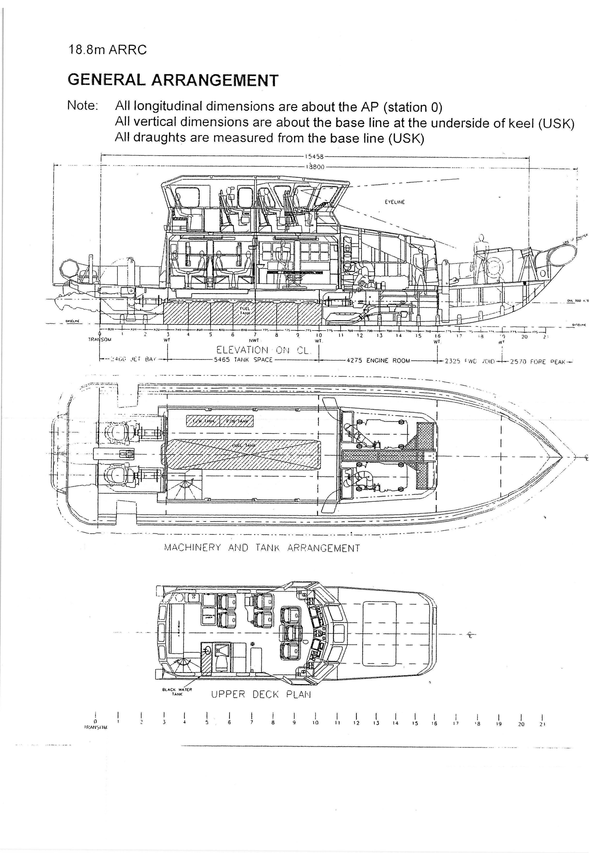

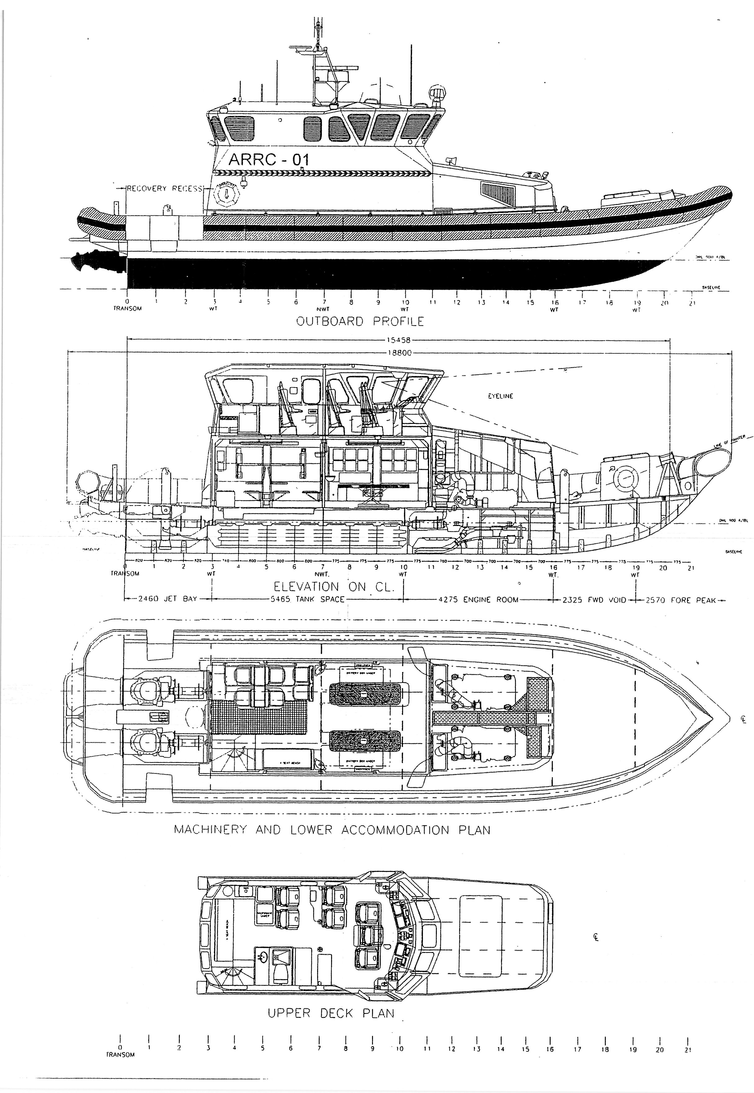

Eight vessels in the class: no pennant number are visually assigned, the f.r.p. (fibre reinforced plastic) mouldings were fabricated by Holyhead Marine Services and were fitted out by Delta in 2005-6. They were built and surveyed in accordance with Lloyd’s Rules for Special Service Craft to the classification 100 A1 SSC PATROL RIB HSC LDC G3 to report 10 status.
Annex E: Vessel Details

Name / Callsign | Name |  | MMSI | Callsign
 | CPV-01 EAGLE |  | 235118128 | 2JQP8
 | CPV-02 NIMROD |  | 235118129 | 2JQP9
Length overall (LOA) | 18.80 m including the Collar, waterjet and its guard
Length Rigid Hull | 16.75 m
Length waterline (LWL) | 15.49 m
Beam Overall | 5.60 m
Beam Moulded Hull | 5.22 m
Draught aft full load | 0.96 m
Ht Overall USK to mast | 7.42 m (approx.)
Displacement | c31.1 tonnes
Construction | FRP (fibre reinforced plastic)
Main Engines | Twin Caterpillar C18 Marine diesel engines, rated output 876 bhp / 644 kW @ 2,200 rpm each. (Total 1,752 bhp / 1,288 kW) Emergency rating 1,000 bhp (747 kW) @ 2,300 rpm
Gearbox | ZF 550 reduction ratio 1.5:1
Propulsion | Twin Hamilton HM 521A Waterjets
Speeds | 28 knots Cruising  34 knots emergency sprint speed in suitable seas
Manoeuvrability | Manoeuvrability at all speeds is good
Range / Endurance | (See Section 11: Fuel, Speed, Range.)
Fuel | Design fuel load 3,424 litres. Max Fuel capacity 3,750 litres.
Fuel Consumption | At Max rated power 195.6 litres / hour
Fresh water | 270 litres
Black Water | 71 litres
Accommodation | 4 berths FOC
Domestic Arrgts | Small Galley, Combined shower and heads (Wheelhouse deck IOC Main Deck FOC)
Crew Seating | 5 Wheelhouse seats
Mission Space | IOC. An open compartment accessed from the main deck level provides non-formatted mission space to accommodate up to 23 persons in addition to the crew. FOC separate compartment containing 4 x Bunk accommodation in Fwd. section of mission space.

ANNEX F

HANDOVER DOCUMENT

Name of vessel: CPV Nimrod

This Handover to Supplier Certificate is to be duly signed by a representative of the Authority and the Supplier upon the commencement of the contract for Planned Maintenance & Drive Line Overhaul.

Immediately upon signing this Handover Certificate by the Supplier, the responsibility and safe custody of CPV Nimrod is accepted by the Supplier and the responsibility and safe custody will thereafter remain at all times with the Supplier until completion of the contract and an Acceptance Certificate duly signed by the Authority and the Supplier representative.

Statement of Condition by the Authority

CPV Nimrod is in a safe and stable condition. All systems have been shut down, (except those as listed below, commensurate with the systems as required by the Supplier).

Tank Contents
Fuel |  |  | litres
Fresh water |  |  | litres
Black Water Tank |  |  | litres
Systems Still Operational

Signed:  ………………………………………….  For and on Behalf of the Supplier ……………………………….. | Signed:  ………………………………………………  For and on Behalf of the Authority
Name:  …………………………………………. | Name:  ………………………………………………
Position / Capacity:  …………………………………………. | Position / Capacity  ………………………………………………

ANNEX G: ACCEPTANCE DOCUMENT

PART 1: to be completed by Supplier
Vessel Name:CPV Nimrod

CPV Nimrod, having completed its Planned Maintenance & Drive Line Overhaul by…………………………………………….. to the satisfaction of the Authority and having successfully completed all trials and provided all documentation required under the Authority’s Contract No……….is this day offered for acceptance by the Border Force.

Signed:  ……………………………………………… |  | For and on Behalf of the Supplier  ……………………………………………………
- Print Name  - …………………………………………………. |  | Date: ……………………………
PART 2: to be completed by The Authority
By Vessel Commander:
I attended basin and sea trials of CPV Nimrod and have satisfied myself that all systems, machinery and equipment are working satisfactorily. I have inspected the CPV and consider she is in a condition suitable for return to operational service. Outstanding items are noted as attached.
Signed:  …………………………………………… |  | Print Name / Post  ……………………………………………………
By Border Force Overseeing Officer:
CPV Nimrod having completed its Planned Maintenance & Drive Line Overhaul to the satisfaction of the Authority and having completed all trials and documentation required under the Contract is hereby accepted at ..…......... hours.

Signed: …………………………………………… |  | Border Force Overseeing Officer
Print Name:  …………………………………………... |  | Date: …………………………….
Outstanding Items
Any outstanding items are to be noted, appended to this form and signed by both the Supplier and the Authority. Dates when these outstanding items are to be “completed by” are to be agreed and shown.

Distribution

Original - Retained by the Supplier
Copies to - Border Force Overseeing Officer; and
Cutter Chief Engineer (for Ships Book).

ANNEX H

REIMBURSIBLE EXPENSES

The Supplier may claim the following Reimbursable Expenses at the rates set out below:
1. Travel
Standard rate of allowance for private cars
Initial 10,000 miles 40p per mile
Additional miles over the initial 10,000 25p per mile
Public transport rate 23.8p per mile

2. Hotel rates
London £125 per night
All other locations other than London £90 per night

