 | My ref: | BC/apls2016
 | Date: | 19/02/2016
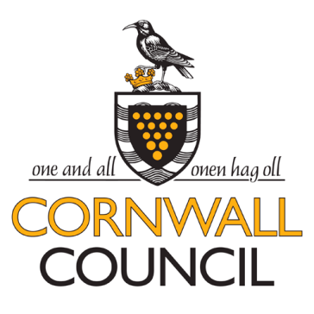
Dear Sir / Madame

REQUEST FOR QUOTATION (RFQ) – BUDE CANAL ACTIVTY PROVIDERS LICENCE SCHEME 2016

Cornwall Council would like to invite you to provide a request for activity provider licences on Bude Canal.

Specification
The fee for each licence has been set at £100, this covers the length of the Canal from Falcon Bridge to Whalesborough landing stage near Helebridge.
The Evaluation and Award Criteria for this RFQ is solely based on the Quality of the proposals submitted, on the basis that the provider is willing to accept the Licence fees proposed above and subject to license capacity and the provider’s ability to respond, as required, to the 5 quality based evaluation questions .

Return Date
Please respond to this request for quotation by Monday March 14th 3pm.

Terms and Conditions

In the event that we decide to move forward with your company an a draft copy of the licence agreement is attached to the RFQ document.

Please contact the undersigned if you have any questions or queries.

Thank you in anticipation.

Coralie Barrow Countryside Officer
Cornwall Council
Natural Environment Commissioning and Contracts
Room 102
Western Group Centre
Radnor Road
Scorrier
TR16 5EH
Telephone: 0300 1234 202
Email: Coralie.barrow@cornwall.gov.uk
www.cornwall.gov.uk

