Document No. 02

Invitation to Offer for:
NHS Framework Agreement for the supply of
Licensed Antiretroviral Therapy (ART) for the treatment of HIV (Lot 1)

&
For the provision of a service to supply over labelled Pre-Exposure Prophylaxis (PrEP) and Post-Exposure Prophylaxis (PEP) Packs for the prevention of HIV (Lot 2)

Offer reference number: CM/PHS/24/5709

Deadline for Tenders to be received:
22nd April 2024 13:00hrs

Table of Contents
- Notice to Bidders
- Summary of the Procurement
- Offer Documentation and Submission
- Award Methodology & Criteria
- Prices
- Legal and Contractual
- Governance & Administration

Notice to Bidders
  - This Invitation to offer document is being made available on the condition that the information contained within it is used solely in connection with the tender process to procure the Requirement (as defined hereinafter) on behalf of NHS England (the Authority) and for no other purpose.
  - Whilst reasonable care has been taken in preparing the ITT, neither the Authority nor any of its advisers accepts any liability or responsibility for the adequacy or completeness of any information or opinions stated in this ITT. No representation or warranty, express or implied, is or will be given by the Authority or any of its representatives, employees, agents, or advisers with respect to the ITT or to any information on which it is based. Any liability for such matters is expressly disclaimed.
  - In this ITT document, words such as “anticipates,” “expects,” “intends,” “plans,” “believes” and “will” (and words and terms of similar substance) indicate the Authority's present expectation of future events, which are subject to a number of factors and uncertainties that could cause actual requirements to differ materially from those described.
  - Neither the issue of this ITT nor any of the information presented in it should be regarded as a commitment or representation on the part of the Authority (or any other person) to enter into a contractual arrangement. If a Bidder proposes to enter into an agreement with the Authority, it must rely on its own enquiries and on the terms and conditions set out in the agreement(s) (as and when finally executed), subject to the limitations and restrictions specified in it.
  - In so far as it is compatible with any relevant laws, the Authority reserves the right, without prior notice, to change the basis of, or the procedures for, the process for the award of the contract or to reject any or all Tenders and to terminate discussions involving (directly or indirectly) Bidders at any time. In no circumstances will the Authority incur any liability in respect of the foregoing.

Summary of the Procurement

Introduction

The Authority is undertaking this procurement in accordance with the Public Contracts Regulations 2015 (as amended) and will use the Open process procedure.

Overview of the Procurement

2.2.1 This Procurement relates to the provision of:

2.2.1.1 Lot 1 - supply of licensed antiretroviral therapy (ART) for the treatment of HIV

(Adults and Children)
2.2.1.2 Lot 2 – a service to supply over labelled pre-exposure prophylaxis (PrEP) packs
And post-exposure prophylaxis (PEP) packs for the prevention of HIV.

2.2.2 Subject to receipt of compliant offers and its formal approval processes, the Authority intends to award framework agreements for:
Lot 1 - supply of antiretroviral therapy treatments and
Lot 2 - provision of a service to supply pre-exposure prophylaxis and post-exposure prophylaxis packs
that best satisfies the Authority’s Requirements.

2.2.3 process for this Procurement includes the following key steps:

Invitation to Offer

Evaluation of Offers

Contract award

Mobilisation

Contract Start

Timetable

The indicative timetable for the Procurement is set out below. Whilst the Authority does not intend to depart from the timetable, they reserve the right to do so at their sole discretion.

Activity | Target Date
Stage 1 – Invitation to Offer
Invitation to Offer Published (via Atamis) | 18th March 2024
Deadline for Submission Clarification Questions | 17th April 2024
ITT Submission Deadline | 22nd April 2024
ITT Evaluation Complete | 16th May 2024
Award Approval | 28th May 2024
Stage 2 – Contract award and Mobilisation
Contract Award Notifications Published  (via Atamis) | 31st May 2024
Standstill Period | 31st May 2024 - 10th June 2024
Contract Finalisation Completed | July 2024
Contract Mobilisation | June 2024 – October 2024
Contract Commencement | 1st November 2024
Table 1 – Procurement Timetable

2.4. Background
2.4.1 NHS England is responsible for the commissioning of all HIV and Preventative treatments, supported by the British Association for HIV for adults (BHIVA) and Children’s HIV Association (CHIVA), both national advisory bodies that provide a national platform for all HIV care.
2.4.2 NHS England are also responsible for the commissioning of HIV preventative treatments. PrEP (pre-exposure prophylaxis) and PEP (Post Exposure prophylaxis) are antiretroviral medicines that stops the transmission of HIV.
2.5 HIV
2.5.1 There were 94,397 people living with diagnosed HIV infection and accessing care in England in 2022, a rise of 3% from 91,368 in 2021. The number of HIV diagnoses in England rose by 22% from 3,118 in 2021 to 3,805 in 2022. Most of this increase is attributable to people previously diagnosed abroad, a 69% increase from 805 in 2021 to 1,361 in 2022. These infections were likely acquired abroad and therefore do not reflect a rise in transmission in England but highlights the increase in people accessing treatment in England.
2.5.2 BHIVA is accredited by the National Institute for Health and Clinical Excellence (NICE) to produce the UK national guidelines on best clinical practice for the treatment and management of adults with HIV infection on antiretroviral therapy (ART).
2.5.3 The Paediatric Network for the treatment of AIDS (Penta), a scientific organisation dedicated to paediatric research, remain the responsible organisation for producing the guidelines for children and adolescents in the European region.
2.5.4 Since 2019, NICE have been responsible for the technology appraisals of all HIV treatments.
2.5.5 Until the publication of national prescribing guidelines in 2022, choice of ART had been informed by national best practice guidelines or regional guidance where they existed.
2.5.6 There are currently 22 molecules in the HIV market which cover the 4 drug classes required to suppress the virus, they are combined in several ways to create different formulations. Over the years these molecules have been combined to create a number of different treatment regimens. The use of each regimen is determined by a number of ‘usability’ criteria, i.e. what regimen is suitable/preferred in patients with other conditions e.g. TB, Hep C, osteoporosis, mental health etc.
2.5.7 Children over the age of 12 can use the same treatment regimens as for adults where licensed/indicated. Infants and paediatrics have separate treatment regimens due to the need to administer a dose according to their age and weight.
2.5.8 Current treatment regimens for adults and adolescents include NHSE & BHIVA recommended treatments.
2.6 PrEP
2.6.1 Pre-Exposure Prophylaxis (PrEP) is a HIV medicine given to people who are HIV negative to reduce their risk of acquiring HIV if they are exposed to the virus.
2.6.2 The number of people who were identified as having a PrEP need increased from 79% (70,081) in 2021 to 83% (101,124) in 2022. Among people with PrEP need, the proportion of people who initiated or continued PrEP rose slightly from 70% (61,510) in 2021 to 71% (86,324) in 2022.
2.6.3 At present there are over 238 sexual health clinics and 110 detained settings delivering routine commissioning of PrEP across England.
2.6.4 PrEP is currently delivered to clinics in an over labelled pack ready for dispensing by practitioners through a national patient group directive (PGD).
2.6.5 Supporting the 2030 HIV agenda, the ambition within the next 12 months is to make PrEP more accessible in a number of settings and through various delivery models.
2.7 PEP
2.7.1 Post-Exposure Prophylaxis (PEP) involves two HIV medicines given to people who are HIV negative to reduce their risk of acquiring HIV if they are exposed to the virus.
2.7.2 PEP is a short course treatment following sexual exposures, occupational exposures and other non-occupational exposures in the community and is taken soon after a possible exposure to HIV to prevent the virus from taking hold.
2.7.3 PEP is used only in emergency situations. It is not meant for regular use by people who may be exposed to HIV frequently. It is envisaged that over time the requirement for PEP will reduce as more people access PrEP for prevention.
2.7.4 PEP is currently delivered to a number of settings, that include hospital accident and emergency departments and sexual assault and referral clinics in an over labelled pack ready for dispensing by practitioners.
2.7.5 In 2022, the Authority streamlined the number of different size packs to a standard 30-day pack. This was so that the licensed medicines could be packed in their original packaging and to align with the recommended BHIVA guidance of a minimum 28 - day course for people that may have been at risk of HIV transmission.
28 HIV Action plan
2.8.1 In January 2019, the government committed to an ambition to end new HIV transmissions, AIDS diagnoses, and HIV-related deaths within England by 2030.
2.8.2 The Department of Health and Social Care (DHSC) has published ‘Towards Zero – An action plan towards ending HIV transmission, AIDS and HIV-related deaths in England – 2022 to 2025’. The Plan supports the Government’s aims to achieve zero new HIV infections, AIDS, and HIV related deaths in England by 2030, and the work required to achieve ambitious interim targets by 2025:
- To reduce the number of people first diagnosed in England from 2,860 in 2019, to under 600 in 2025.
- To reduce the number of people diagnosed with AIDS within three months of HIV diagnosis from 219 to under 110.
- To reduce deaths from HIV/AIDS in England from 230 in 2019 to under 115.

2.8.3 The publication included the news on the expansion of opt-out HIV testing in Emergency Departments (A&E) in high prevalence areas, backed by an additional £20 million over three years.
2.8.4 The HIV Action Plan looks to build on the successes achieved in England over the past decade and to continue to strive to increase testing rates in populations most affected by HIV and raise awareness of HIV prevention.
2.8.5 To achieve this ambition, partners across the health system and beyond have been working around 4 core themes – Prevent, Test, Treat and Retain. This includes:
- preventing people from getting HIV;
- ensuring those who get HIV are diagnosed promptly;
- preventing onward transmission from those with diagnosed infection; and
- delivering interventions which aim to improve the health and quality of life of people with HIV and tackle stigma.

2.9 The Authority’s Requirement

2.9.1 Objectives
2.9.1.1 This Procurement seeks to support delivery of the HIV Action plan, through the following key objectives:
- Maintain clinical choice - Clinicians will continue to determine which HIV treatments are clinically appropriate for each patient and will be able to access all available treatments.
- Equity of access – to treatments for all people living with HIV
- Embed National Guidelines - encourage greater use of BHIVA and NHSE recommended treatments.
- Optimal portfolio – ensure plurality and surety of supply by buying each regimen component as effectively as possible, through standardising the construction of each regimen (number of tablets) whilst balancing the patients pill burden.
- Enhance access for prevention – to ensure that treatment is accessible for everyone as the population grows and service delivery models evolve.
- Value for Money - encourage uptake of the best value treatment(s) from those that are clinically appropriate for the patient.
- Data Capture – capture data on regimen use and criteria to help inform future procurements that will focus on patient outcomes that help improve quality of life for people living with HIV.
- Added Value - encourage the supply market to offer additional ‘value’ through Prevent, Test, Treat, and Retain initiatives that support the HIV Action Plan.
- Offer Documentation and Submission
  - The Products and Service Offered must be strictly in accordance with the requirements of this Invitation to Offer including the Conditions of Contract (Document No.03) and Contract Technical Specification (Document No.04).
  - Offers must comprise:
- Selection Questionnaire
- Documents No. 5a - Offer Schedule (Additional information) must be completed in full;
- Documents No. 5b - Offer Schedule (Quotation) must be completed in full;
- Document No. 06 - Form of Offer must be completed in full on the Atamis website;
- Document No. 08 – Confidentiality Undertaking
  - In addition, Offerors may include within their Offer one or more Prevent, Test, Treat, and Retain Initiative Proposals in accordance with the Prevent, Test, Treat, and Retain Initiative Proposal Template provided (Document No. 05c).

  - Prevent, Test, Treat, and Retain Initiatives
    - Offerors may propose, for consideration by the Authority, Prevent, Test, Treat, or Retain initiatives.
    - Proposals for Prevent, Test, Treat, or Retain initiatives may be submitted with the Offer or during the term of the Contract.
    - Proposals for Prevent, Test, Treat, or Retain initiatives must be treatment agnostic.
    - Such initiatives must seek to:

- ensure equitable access and uptake of HIV prevention programmes (Prevent); and/or
- scale up HIV testing (Test); and/or
- optimise rapid access to treatment and retention in care (Treat); and/or
- improve quality of life for people living with HIV and addressing stigma (Retain).

  - Prevent, Test, Treat, and Retain Investments
    - Offerors may include within the Offer Schedule, a financial commitment to fund Prevent, Test, Treat, or Retain initiatives.
    - Any financial commitment to fund Prevent, Test, Treat, or Retain initiatives may be expressed as an investment per Unit supplied.
    - Where a financial commitment to fund Prevent, Test, Treat, or Retain initiatives is made it will be a debt owed to the Authority.
    - The debt may be discharged through funding Prevent, Test, Treat, or Retain initiatives approved by the Authority or via a rebate to the Authority.
    - Proposals for Prevent, Test, Treat, or Retain initiatives must be submitted using Document No.05c – Prevent, Test, Treat, or Retain Initiative template
    - The Prevent, Test, Treat, or Retain initiatives will not be evaluated as part of the procurement process but, if approved by the Authority, will form part of any Contract subsequently awarded.
    - Outside of the procurement process and separate to it, the Authority will consider the Prevent, Test, Treat, or Retain initiatives proposed and confirm which are approved and if deployed will debit the committed Prevent, Test, Treat, and Retain investment.
  - Form of Offer
    - The Form of Offer must be authorised via the Authority’s electronic tendering system by an officer authorised by the Offeror.
    - The Form of Offer and other documents referred to in paragraph 3.2 above must be completed in full. Any Offer may be rejected which:
(a) contains gaps, omissions, or obvious errors; or
(b) is received after the closing time and date for the receipt of Offers.
    - Offerors must not submit with their Offer any documentation which has not been specifically requested by the Authority. If an Offeror does submit such additional documentation which has not been specifically requested by the Authority, this will be disregarded by the Authority.
    - For Lot 1, Offerors are required to submit an Offer that complies with the following requirements:
      - each Offer must include a price for each national product (NPC) line (in respect of which the Offeror is submitting an Offer) at which Participating Authorities can purchase such NPC product line under the Framework Agreement.
      - does not seek to alter or amend the stated terms and conditions of contract (including without limit the minimum pricing period and/or price variation clauses) issued with this invitation; or
      - does not seek a solus arrangement to exclude other NPC descriptions from other bidders from being appointed to the framework; or
      - does not seek a “basket deal” to include products that may be available from other sources (for example, parallel importers and wholesalers).
    - For Lot 2, Offerors are required to submit an Offer that includes a price for the delivery of the service.
  - Overview of the process to determine commissioning recommendations
    - The process the Authority may undertake to determine any commissioning recommendations regarding the use of HIV treatments is separate to and distinct from this Procurement process. Further details of this process are included in Section 11.

  - Deadline for submission of Offers
    - Offers and all documents relating to the Offers must be written in English and submitted to the Authority via the Authority’s electronic tendering system by 22nd April 2024 at 17:00hrs GMT.
  - Clarifications and Submission Date
    - Bidders can raise clarifications on the content of this ITT and the Requirement generally via the NHS England Atamis E-Tendering Portal and until the deadline specified therein.
    - Bidders must submit their response to the Invitation to Tender stage via the NHS England Atamis E-Tendering Portal no later than the deadline specified therein.

Please note that Bidder clarifications and / or submissions received after the closing deadlines may be rejected.
    - Please note that any queries raised by Offerors and the responses to those queries by the Authority may be published anonymously to all Offerors in order to ensure transparency, fairness, and equal treatment of Offerors throughout the procurement exercise. If you are concerned that your query and/or the response to it may disclose confidential information or information which is commercially damaging to you, then you may submit the query marked "Confidential" and setting out clearly the reasons why you believe that the query and/or the response are or will be confidential or commercially damaging. The Authority will consider your request and make its decision at its sole discretion. If the Authority determines that the query or response should not be disclosed to other Offerors, it will answer your query and not disclose it or the response (as appropriate) to the other Offerors. If the Authority determines that the query and/or the response should be disclosed to other Offerors, it will give you the chance either to withdraw your query or have it answered. If the latter, then the Authority will disclose the query and the response to all other Offerors.
  - Procurement Documents
    - Documents and information related to the Procurement are located in the Documents section of the NHS England Atamis E-Tendering Portal.
    - The Procurement Documents and information may be updated from time to time.
    - The Bidder's Authorised Representative will be notified via the Atamis portal if documents are added or updated.
    - Any difficulties or problems with access to the NHS England Atamis E-Tendering Portal or any of the documents or information contained therein should be reported by contacting the Atamis Helpdesk.
3.11 Selection Questionnaire

3.11.1 Offerors are required to submit information to support their Offers by completing the Response form on the Atamis website – found under “My Response,” which must be satisfactorily completed as indicated therein. The Authority reserves the right to reject an Offer where the Offeror has failed to complete the Selection Questionnaire satisfactorily.

3.11.2 Exclusion Grounds - Grounds for mandatory rejection: If the Offeror answers “yes” to any of the questions in this section they will be rejected except in the circumstances outlined in Regulation 57(6) and 57(7) of the Public Contracts Regulations 2015.

3.11.3 Exclusion Grounds - Grounds for discretionary rejection and Tax compliance: If the Offeror answers “yes” to any of the questions in this section, the Offeror must provide evidence of measures taken by the Offeror to demonstrate the reliability of their organisation despite the existence of a relevant ground for exclusion. If the Authority does not consider such evidence to be sufficient the Authority will reject the Offer.

3.11.4 Selection Questions (Part 3)
      - Economic and Financial Standing - if the Offeror answers “no” in this section, the Offeror must provide further explanation and assurances (such as a guarantee or performance bond in a form acceptable to the Authority in its absolute discretion) to the Authority’s satisfaction otherwise its Offer will be rejected. The Offeror’s Dun & Bradstreet failure score recorded in sid4gov should be 40 or greater. If the Offeror’s score is below 40 the Authority may reject its Offer unless the Offeror provides further explanation and assurances (such as a guarantee or performance bond in a form acceptable to the Authority in its absolute discretion) to the Authority’s satisfaction.
      - Modern Slavery Act 2015 - if the Offeror answers “no” in this section, the Offeror must provide further explanation and assurances to the Authority’s satisfaction otherwise its Offer will be rejected.
      - Prompt payment – an Offer may be rejected where the requirements detailed in this section are not met (only applicable to Offerors intending to use a supply chain). Successful Offerors(s) who have self-declared may be required to provide evidence of compliance prior to award.
      - Insurance requirements – an Offer may be rejected where the Offeror indicates in its response that it is unable to meet the insurance requirements.

3.12.1 Completing Document No. 5a, Offer Schedule (Additional Information)

3.12.2 Document No. 5a Offer Schedule contains the following:
      - Sheet 0: Instructions;
      - Sheet 1: Offeror Information;

3.12.2.3 Sheet 2: Licensed Product Information;
      - Sheet 3: Confidential Information;

3.12.2.5 Sheet 4: Subcontractor Information; and

3.12.2.6 Sheet 5: Supplier Assurance Assessment

3.12.3 Offerors must complete:
      - Sheet 1: Offeror Information;
      - Sheet 2: Licensed Product Information (not applicable for Lot 2);
      - Sheet 3: Confidential Information (if applicable);
      - Sheet 4: Subcontractor Information (if applicable); and
      - Sheet 5: Supplier Assurance Assessment (not applicable for Lot 2).

3.12.4 Within Sheet 1 – Offeror Information, Offerors must provide the required information;

3.12.5 Within Sheet 2 – Licensed Product Information, Offerors must provide the required details for each Product, licensed for use in the UK, that they have Offered (including any copy documents requested);
    - Within Sheet 3: Confidential Information, Offerors must specify what elements of their Offer they consider confidential and/or commercially sensitive;
    - Within Sheet 4: Subcontractor Information, Offerors must provide details of any proposed subcontractors;
    - Within Sheet 5: Supplier Assurance Assessment, Offerors must provide the additional information required.
    - Detailed instructions on how to complete Document No. 5a Offer Schedule are included in Sheet 0 (Instructions).
  - Completing Document No. 5b Offer Schedule (Quotation)
    - Document No. 5b Offer Schedule contains the following:
      - Sheet 0: Instructions;
      - Sheet 1: Offer Guidelines;
      - Sheet 2: Medication Catalogue; and
      - Sheet 3: PrEP and PEP packaging
    - Offerors for Lot 1 must complete:

(a) Sheet 2: Medication Catalogue.

(b) Within Sheet 2 – Medication Catalogue, Offerors must submit all information required

as described within Sheet 1 (Offer Guidelines) and as highlighted as ‘Supplier Input’

within Sheet 2 (Medication Catalogue).

Offerors for Lot 2 must complete:

(a) Within Sheet 3 – PrEP and PEP Packaging, Offerors must submit all information

required as described within Sheet 1 (Offer Guidelines)

3.13.3 Detailed instructions on how to complete Document No. 5b (Quotation) are included in Sheet 0 (Instructions) and Sheet 1 (Offer Guidelines).
  - Most Economically Advantageous Offer
    - The Authority does not intend to select the winning Offer based upon price alone. Any award will be made based upon the most economically advantageous Offer in accordance with the process set out in Section 4 of this Terms of Offer.
    - The Authority does not bind itself to accept the lowest or any Offer at all. Each Offer and each market share price within each Offer in Lot 1 being for this purpose treated as Offered separately.
    - The Authority reserves the right not to award any Lots, or to award only part of any Lot, or to cancel this procurement exercise without making any award(s). The Authority shall not be liable in any way whatsoever for the consequences of any such decision, including wasted costs or other costs or losses claimed to be incurred by any party.

  - Samples (Lot 1 Only)
    - Offerors may be required to submit samples of each item offered. Such samples shall be provided free of charge.
    - Samples should be despatched under separate cover as and when required by the Authority.
    - Any requested samples should be clearly marked with the name of the Offeror and the Offer reference number: CM/PHS/24/5709.

4. Award Methodology & Criteria
4.1 Introduction

4.1.1 Any contract awarded as a result of this procurement will be on the basis of the offer which is most economically advantageous to the Authority.

4.1.2 Bidders' Tender submissions will be evaluated by the Authority applying the evaluation criteria set out in this Section 4.
4.2 Award Process
4.2.1 The award process for Lot 1 and Lot 2 consists of the following key steps:
Compliance Gateway: Confirm that Offers comply with the requirements set out in the Invitation to Offer.
Evaluation: Evaluation of the Offers that have passed the Compliance Gateways in accordance with the methodology and criteria set out further below; and
Award Gateway: Approval to proceed to contract award (award notifications, standstill and contract signing).
4.2.2 The award process is summarised in Figure 1
Pass
Pass
Award
Gateway
Evaluation
methodology
Compliance
Gateway
Bids Received

Fail
Disqualified
Award and Standstill
Figure 1- Award Process

4.3 Gateway Requirements

4.3.1 Each Offer must satisfy the requirements of the Compliance Gateway or be disqualified.

4.3.2 To pass the Compliance Gateway, an Offer must:

(a) Pass the Selection Questionnaire; and

(b) Complete in full all information required for each Lot in Document No. 05a - Offer Schedule (Additional Information), in the format requested; and

(c) Complete in full all information required for each Lot in Document No. 05b - Offer Schedule (Quotation), in the format requested; and

(d) Satisfy any other requirements included in the Invitation to Offer.

4.4 Award Criteria

4.4.1 Lot 1 - The Award Criteria is set out in Table 2.
Evaluation Criteria | Scoring Methodology
Medication Presentation | Pass/Fail
Quality Assurance Assessment | Pass/Fail
Supply Assurance Assessment | Pass/Fail
Price | Equals the Offered Price per unit
Surety of Supply | Scored as detailed below
Intermediate and Active Pharmaceutical Ingredient (API) Supply | Where possible, when selecting multiple suppliers, avoiding common supplier combinations with Intermediate or API sources - See further detail below

Table 2 – Lot 1 - Award Criteria

4.4.2 Lot 2 – The Award Criteria is set out in Table 3.
Evaluation Criteria | Scoring Methodology
Price | Equals the Offered Price per over labelled pack

Table 3 – Lot 2 - Award Criteria

4.4.3 Medication Presentation: In order to achieve a pass for the Medication Presentation criteria, an Offer must include only a Product that is listed in Document No. 5b Sheet 2 Medication Catalogue. An Offer for a Product that is not listed in Document No. 5b Sheet 2 will fail the Medication Presentation criteria and be disqualified.

4.4.4 The following medication presentations are considered interchangeable and will therefore be considered as part of an Offer:
• Tablet/Capsule/Caplet

4.4.5 Quality Assurance Assessment: In order to achieve a pass for the Quality Assurance Assessment, an Offer must have products that are confirmed by the evaluation panel as “Low Risk” or “Medium Risk” according to the approach documented in Document No.04a – Quality Assurance Process. Beyond the Quality Assurance Assessment there is no distinction between “Low Risk” or Medium Risk” in the evaluation process. Any Product QC assessments that are confirmed by the evaluation panel as “High Risk” will only be awarded a Framework Agreement in the absence of any other qualifying tenders (and subject to satisfying all other award criteria).

4.4.7 Supply Assurance Assessment: In order to achieve a pass for the Supply Assurance Assessment, an Offer must provide the information requested in Document No 5a (Additional Information) sheet 5, Supply Assurance Information. The information provided will be assessed in accordance with the criterion detailed in Sheet 5, Supply Assurance Information. Each criterion may include a number of sub-criteria. The Offeror's response should address all the criteria and sub-criteria.
4.4.8 Price:
Lot 1 - Offerors will need to submit a Price per unit within Document No. 05b
(Quotation) sheet 2, medication catalogue for each product they wish to
submit an Offer; and
Lot 2 - Offerors will need to submit a Price per over labelled pack in Document No. 05b
(Quotation) sheet 3, PrEP and PEP packaging for the provision of a PrEP and PEP pack service.

4.4.9 Document No. 05b, Sheet 2, Medication Catalogue, specifies the minimum and maximum number of suppliers that the Authority intends to consider for the supply of each medicine. Where the Authority splits supply between 2 or 3 Suppliers, then to simplify supply arrangements, those suppliers will be awarded one or two of the regions set out below. These regions represent the seven NHS regional footprints across England.
4.4.10 The Authority intends to award only 1 Supplier for Lot 2 to deliver the over labelling PrEP and PEP pack service for all three regions listed below.
Region | Market Share Allocation
 | 3 Suppliers | 2 Suppliers | 1 Supplier
London | 50% | 70% | 100%
North East and Yorkshire, South West and South East | 20%
Midlands, East of England, and North West | 30% | 30%
Table 4 – Market share
4.4.11The indicative Market Shares are based on Public Health England’s, National HIV surveillance data tables, on all people living with HIV in the UK and accessing HIV care services within each region. Actual usage will be influenced by the needs of individual patients within each region and therefore the market shares are not guaranteed.
4.4.12 For medicines within Document No. 05b sheet 2, Medication Catalogue which are allocated a market share, Offerors will need to submit a Price for all market shares that they are considered for. In order to be considered for a particular market share, the quantity entered by the supplier in Maximum Possible Supply (Units per year) (Column Q) must be equal to or greater than the Minimum Current Demand required (Units per year) (Column E) multiplied by the respective market share. If the Maximum Possible Supply (Units per year) (Column Q) is not sufficient to cover the minimum required supply for a market share, then the respective cells for that market share will be crossed out and not taken into consideration.
4.4.13 For medicines within Document No. 05b, Sheet 2 – Medication Catalogue the Offeror must note that the “Maximum possible supply” provided will be used in-contract to manage any potential unexpected increases in demand. Specifically, the Offeror forfeits the exclusivity on the part of their awarded Share that corresponds to any increase beyond their quoted "Maximum possible supply" and the Authority may approach other awarded Suppliers (including the Reserve Supplier) to cover the excess demand at the Offered price.
4.4.14 Surety of Supply: Surety of Supply refers to the guarantee of medicine available for use by the NHS at contract commencement and over the lifetime of the contract. Offerors may offer either 3, 4, 5, 6, 7, or 8-months stock.
4.4.15 The minimum stock holding for a compliant bid is 3 months of which 1 month must be physically held in the UK. Physical stock can include stock at a wholesaler or over labeller. The remainder of stock (2 months) must be dedicated for UK use and/or capable of being physically in the UK and available for distribution to hospitals within 5 working days, otherwise the minimum physical stock level in the UK is 3 months.
4.4.16 The above is subject to the Supplier demonstrating robust supply arrangements and continue to satisfy the Key Performance Indicators set out in Document No. 03 Framework Agreement Terms and Conditions. If at any time the indicators fall to the red level, the Authority may require the minimum stock to be increased to 4 months and physically in the UK to be increased to 2 months.
4.4.17 Document No. 03 Framework agreement Terms and Conditions describe the requirements for the ramp up and ramp down periods at the beginning and end of the framework.
4.4.18 A stock holding longer than 3 months is preferred. As such the Surety of Supply Adjustment (as determined from Table 5 below) applied to the Offer Price decreases as the stock holding increases towards 8 months. The adjusted Offer Price (the Drug Level Comparison Price) equals the Offer Price + Surety of Supply Adjustment.
NB: The Surety of Supply Adjustment is purely for the purposes of evaluation and reflecting the Authority's preference in this procurement exercise. No actual adjustment will be added to the Offer Price and the Authority will purchase at the Offer Price without any adjustment.
Surety of Supply Adjustment = Offer price per unit x Surety of Supply Adjustment %

The Surety of Supply Adjustment % is determined from Table 5.

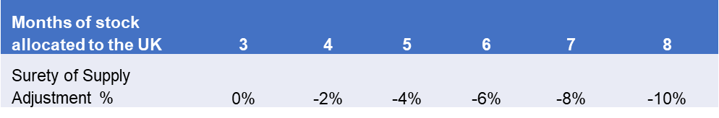
Table 5 –Surety of Supply Adjustment %

Example:
Offer price per unit = £10;
Months of stock allocated for the UK = 5 months
Surety of Supply Adjustment = £10 * (-4%) = -£0.4
This is then added to the Offer price per unit which is £10 - £0.4 = £9.60
£9.60 equals the Drug Level Comparison Price

4.4.19 Intermediate and API Supply: For medicines in Document No 05b, Sheet 2, Medication Catalogue where the Authority is considering splitting the award between multiple Suppliers, in addition to the evaluation described in 4.4.20 the Authority will seek further supply chain assurance by selecting the combination of Suppliers that have independent Intermediate and Active Pharmaceutical Ingredient (API) sources.
4.4.20 The Authority will determine the number of Suppliers awarded, based upon the following
Criteria:
(i) Triple Supplier Award:
The Authority will seek to award to 3 Suppliers where there is a minimum Allocated UK Stock of 3 months and the 3 Suppliers selected offer sufficiently independent (separate) Intermediate and API source as detailed in 4.6.2.

(ii) Dual Supplier Award:
The Authority will reduce the number of suppliers awarded to 2 if:
- the Allocated UK Stock from each Supplier increases to more than 5 months; AND
- the weighted average of Allocated UK Stock is greater than the weighted average of the Allocated UK Stock for 3 Suppliers; AND
- the 2 Suppliers selected have independent Intermediate and API sources; AND
- the weighted average Drug Level Comparison Price for 2 Suppliers is no more than for the 3 Suppliers.

(iii) Single Supplier Award:
The Authority will reduce the number of suppliers awarded to 1 if:
  - Document No. 05b, Sheet 2, Medication Catalogue, specifies the maximum number of suppliers that the Authority will award to is 1 (e.g. a Branded Supplier); OR
  - Only one compliant Offer is received; OR
  - Document No. 05b, Sheet 2, Medication Catalogue, specifies the minimum number of suppliers that the Authority will award to is 1 and the maximum number of suppliers that the Authority will award to is 3; AND
    - the Allocated UK Stock increases to more than 7 months; AND
    - the Allocated UK Stock is greater than the weighted average of the Allocated UK Stock for 3 Suppliers or for 2 Suppliers; AND
    - the Drug Level Comparison Price for 1 Supplier is no more than the weighted average Drug Level Comparison Price for 3 Suppliers or the weighted average Drug Level Comparison Price for 2 Suppliers, whichever allocation was preferred when comparing triple sourcing vs dual sourcing

4.4.21 For each medicine where the Authority has indicated multiple awards are permitted, the Authority will consider each option (i.e. a Triple Supplier Award; a Dual Supplier Award and where permitted a Single Supplier Award) and determine which option is selected based upon the above criteria.
4.4.22 The Authority will seek to award a Reserve Supplier for all medicines unless there is only 1 compliant Supplier available or unless the number of compliant Suppliers is equal to the number of shares awarded. The Reserve Supplier will be selected based on a) demonstrating independent Intermediate and API sources from the awarded supplier(s) and b) lowest Offer received.
4.4.23 The Reserve Supplier will not initially be awarded any supply volume/activity; however, this may change if an awarded Supplier does not meet its contractual obligations. See section 3 of Document No. 03 framework agreement for further details.
4.4.24 The Authority will award contracts for Medicines within Document No. 05b, Sheet 2, where there will be a requirement to purchase these in an Ad-hoc manner. This would be the case if there isn't sufficient supply available to cover the full current demand. Offerors will need to submit a Price in Column X to be considered. Suppliers will be selected based on lowest Offer received.
4.4.25 The price in Column X will also be used for patients who are unable to change Medicine for any clinical reason.
4.4.26 The minimum shelf life required is 12 months from the date the medicine is delivered to the Participating Authorities’ premises, any offers less than the required 12 months shelf life will not be considered.
4.4.27 Bidders will need to demonstrate that they can supply stock to the UK within 90 working days of a supply request being issued. Any offers that cannot demonstrate this requirement will not be considered.
4.4.28 For all medicines listed in Document No. 05b (Quotation), sheet 2, Medication Catalogue, Offerors must supply information on the Intermediate and API source for the products they are submitting an Offer. Details should be submitted in the following format:
Supplier Name, Address and Post Code

4.4.29 If only one source is used, Intermediate or API. Offerors must state this in the submission. Offerors that fail to submit this information will not be considered.
4.5 Award Principles:
4.5.1 Lot 1 - The Authority seeks to identify the optimum combination of Offers that:
      - Selects the best Price from Suppliers for each medicine presentation and combination presentation;
      - Maximises the optimum number of months stock Allocated to the UK; and
      - Ensures a robust supply chain.

4.5.2 Lot 2 - The Authority seeks to identify the Offer with:

(a) The lowest price; and

(b) Is MHRA (Medicines and Healthcare products Regulatory Agency) approved to deliver the service.

4.6 Award Approach – Lot 1

4.6.1 Each product Offered in the Offer Schedule, Document No. 05b, Sheet 2, Medication Catalogue will be checked by the Authority to ensure that the Offer meets the Authority’ requirements. Offers that pass the Compliance Gateway (“Qualifying Offers”) will be evaluated in accordance with the following methodology

4.6.2 Stage 1 – Optimisation of Suppliers (Best Supplier to provide specific medicine)

4.6.2.1 For medicines in Document No 05b, Sheet 2, Medication Catalogue, the Authority will use the optimisation software to:
- Apply the Drug Level comparison prices to all Offers across all possible market shares for each medicine. This means that any bonus due to Allocated UK Stock will be applied as described in 4.4.20 and shown in the example below.

Offer price
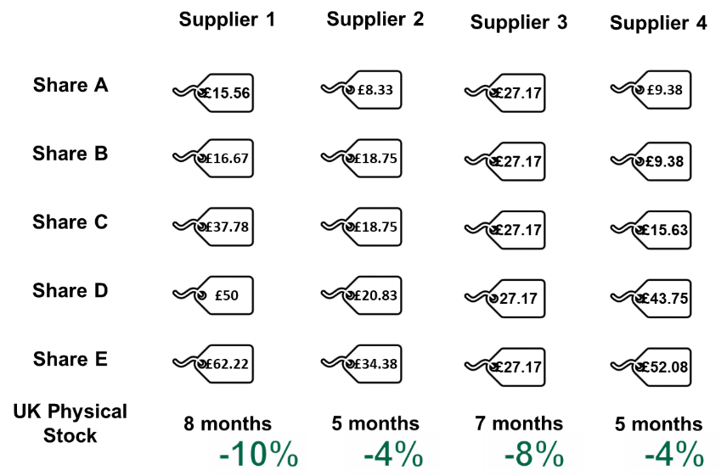

Drug Level Comparison Price
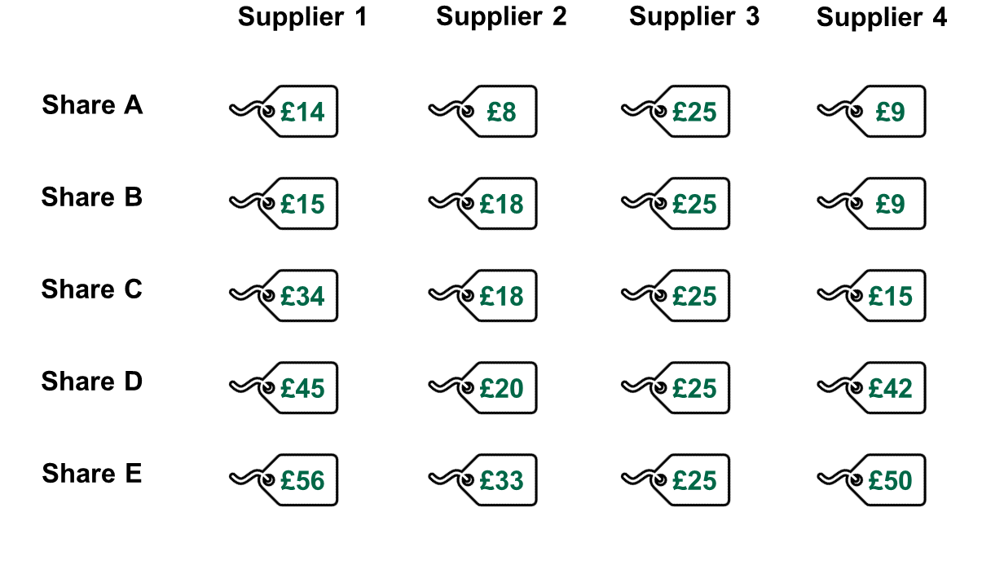
- The Allocated UK Stock commitment not only provides a bonus on Offered prices, but it will also be used to determine whether dual or single sourcing is possible.
- Dual sourcing: 5 months minimum for each Supplier and weighted average higher than the triple sourcing’s weighted average
- Single sourcing: 7 months minimum and higher than the triple and dual sourcing’s weighted average.
- To find the best allocation for triple, dual and single sourcing, i.e. the allocation that minimises the weighted average cost of the medicine the Authority will identify whether the Intermediate and API criteria has been met for all possible scenarios as per the examples below.

Triple sourcing Allocation
- In this example, Supplier 2 and Supplier 4 are not independent in terms of APIs, therefore any allocation with both of these suppliers (when one has a share of at least 55%) is not valid.
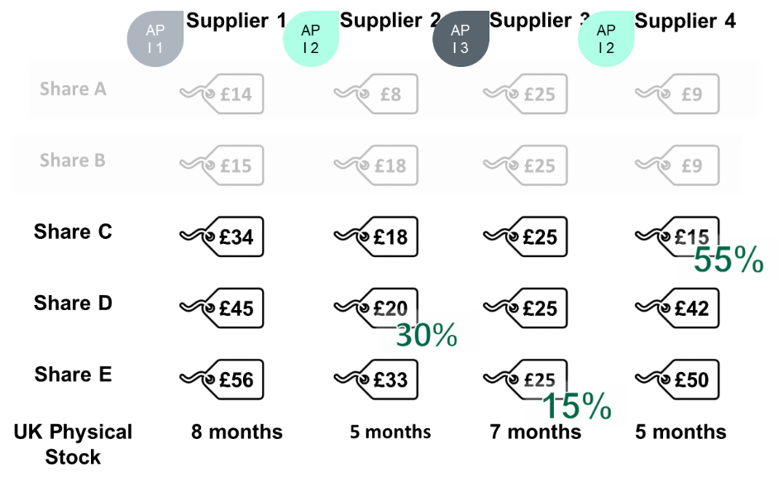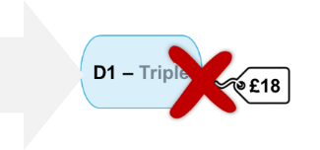

- The process of identifying the best allocation for triple sourcing will therefore continue until the next best option is presented as per example below. If for any reason the option below had the same issue for Intermediate and API, the next best option would be chosen etc.

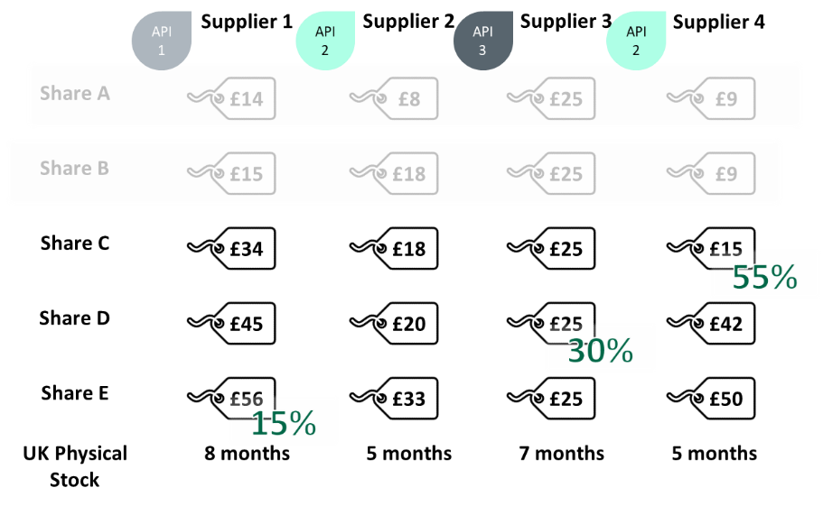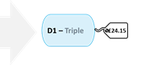

Dual Sourcing Allocation
- The Authority will then look to find the best allocation for dual sourcing with independent APIs and Intermediates and the average Allocated UK Stock being higher than the triple sourcing. In this example, the weighted average is 5.6 months of stock whereas the triple sourcing example above offers 6.05 months of stock. The Authority would therefore continue to find the next best allocation.

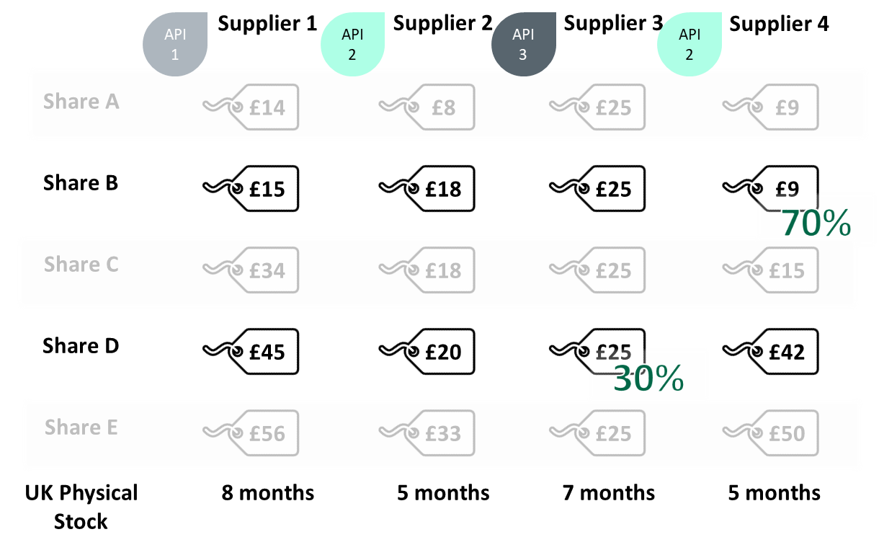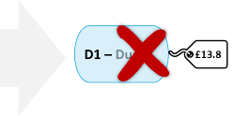

- The following allocation demonstrates that the sourcing fits all the criteria and therefore can be chosen for the dual sourcing. This sourcing allocation offers 7.1 months of stock, higher than the 6.05 months of the triple sourcing above.

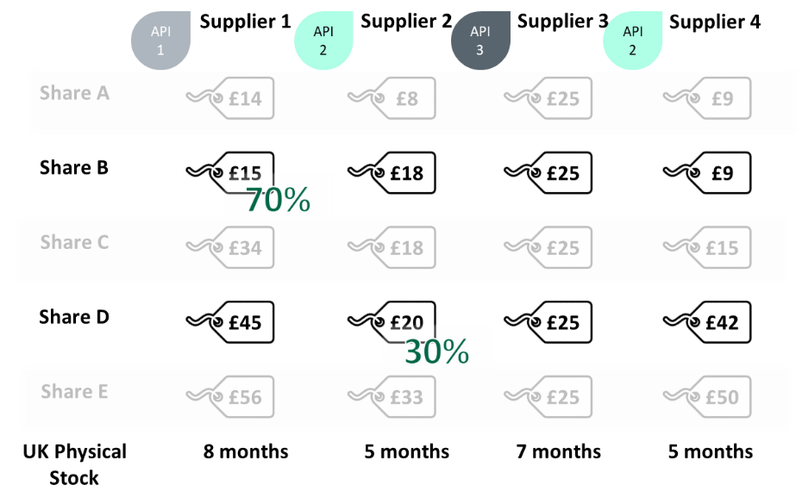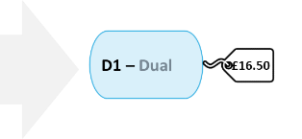
Single Sourcing Allocation
- Finally. the Authority will look to find the best allocation for single sourcing, choosing first the best allocation, whilst ensuring that the Allocated UK Stock minimum is met. For single sourcing, the Allocated UK Stock minimum is 7 months, so the allocation below does not fit the criteria.
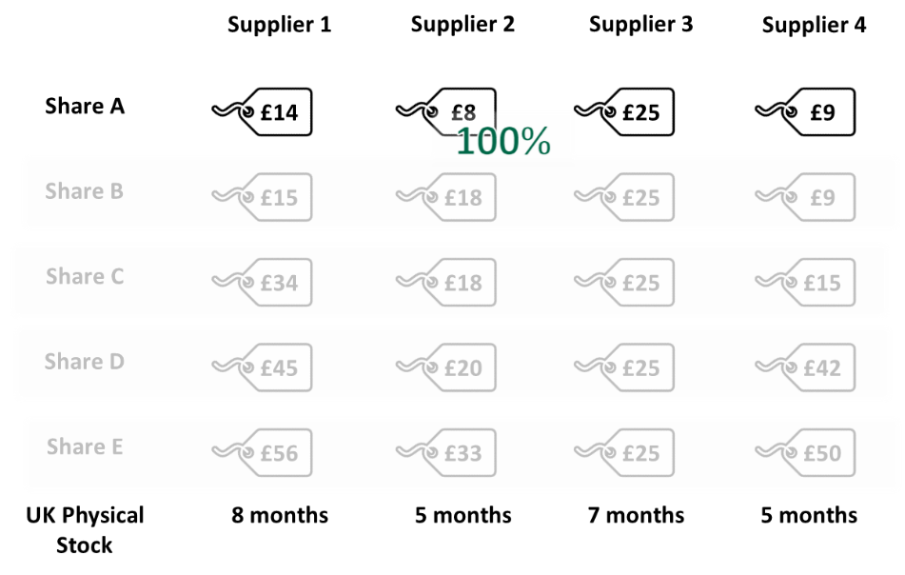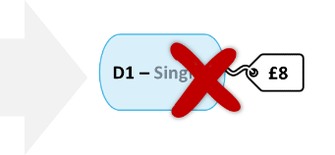
- The next best allocation also does not meet the criteria as it has less than the required Allocated UK Stock with only 5 months being offered. Therefore, the Authority will look at the next best allocation.
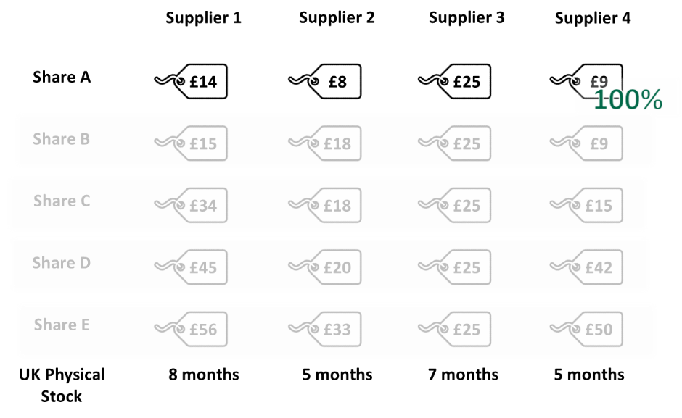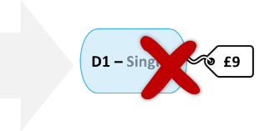
- In the final example, Supplier 1 offers 8 months of Allocated UK Stock, and all other requirements are met, therefore this is a valid choice.
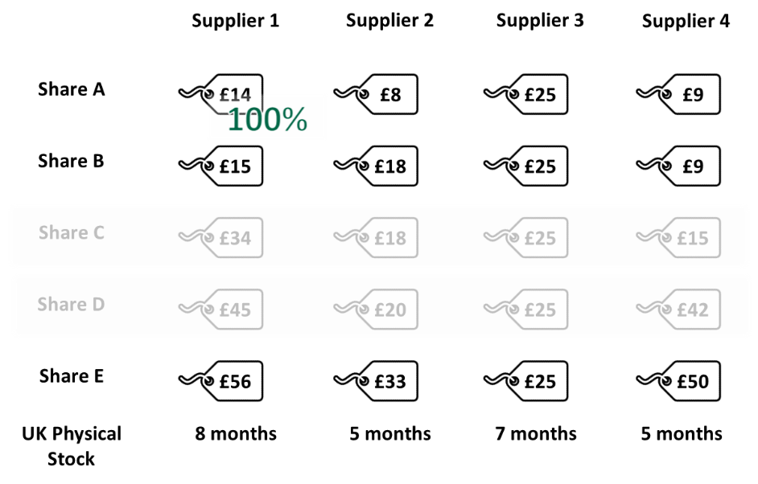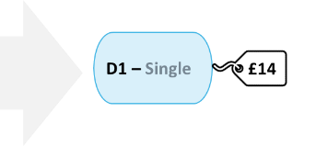
4.6.3 Once all the criteria have been met for all three types of sourcing, the best version in terms of Weighted Average Drug Level comparison price is picked.
Drug 1
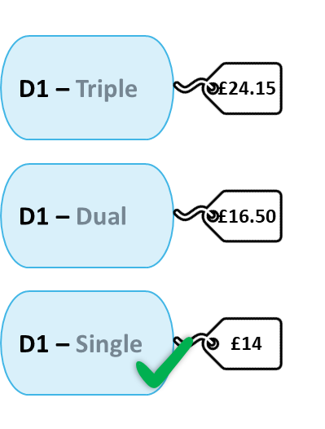
4.6.4 This process will be carried out for all medicines listed within Document No. 05b, Sheet 2, Mediciation Catalogue.

4.6.5 In the case of a branded medication, the medication is automatically assigned the single
sourcing at bid price.

4.7 Award Approach - Lot 2

4.7.1 Each Offer submitted in the Offer Schedule, Document No. 05b, Sheet 3, will be checked by the Authority to ensure that the Offer meets the Authority’ requirements. Offers that pass the Compliance Gateway (“Qualifying Offers”) will be evaluated in accordance with the following methodology.

4.7.2 The Supplier with the lowest price that demonstrate it is compliant with MHRA regulations will be awarded a contract for the PrEP and PEP over-labelling service.
4.8 PrEP
4.8.1 As detailed in Section 2, PrEP packs are currently supplied to clinics with the manufacturers’ original packs of licensed medicine, over labelled with instructions for use, ready for issue by healthcare professionals.
The medicine used is:

- Tenofovir disoproxil 245 mg + Emtricitabine 200 mg

4.8.2 Bidders wishing to provide an over labelled PrEP pack service, must submit a Price for the provision of the service within Document No. 05b, Sheet 3, PrEP Packaging.
4.8.3 Offerors Prices must be inclusive of all additional requirements to produce a pack, which includes the label, storage, and distribution to the nominated clinics in the allocated regions. Appendix A lists the current clinics commissioned to deliver a routine PrEP service. These may be subject to change during the contract period.
4.8.4 Volumes for over labelled PrEP packs have been included within Document No. 05b, Sheet 3, PrEP packaging.
4.8.5 The supplier will be responsible for the provision of the medicines to be incorporated into the pack, placing direct orders with the successful Suppliers from Lot 1 for the medication.
4.8.6 The PrEP accounts as listed in Appendix A and Schedule 8; Document No. 03 lists the participating authorities to the framework agreement that will be responsible for placing and payment of all orders for delivery of over-labelled packs. The minimum quantity being 30 packs, where possible. The participating authorities may be subject to change.
4.9 PEP
4.9.1 As detailed in Section 2, PEP packs are currently supplied to a number of settings in a 30-day pack with the manufacturers’ original packs of licensed medicine, over labelled with instructions for use, ready for issue by healthcare professionals.
The medicine used is:
- Tenofovir disoproxil 245 mg + Emtricitabine 200 mg; and
- Raltegravir 600mg
4.9.2 Bidders wishing to provide an over labelled PEP pack service, must submit a Price for the provision of the service within Document No. 05b, Sheet 3, PEP Packaging.
4.9.3 Offerors Prices must be inclusive of all additional requirements to produce a pack, which includes the label, storage, and distribution to the nominated sites. Appendix A and Schedule 8, Document No. 03 lists the participating authorities to the framework agreement, that will be responsible for placing and payment of all orders for delivery of over-labelled packs. The minimum quantity being 30 packs
4.9.4 Volumes for over labelled PEP packs have been included within Document No. 05b, Sheet 3, PEP packaging.
4.9.5 The supplier will be responsible for the provision of the medicines to be incorporated into the pack, placing direct orders with the successful Suppliers from Lot 1 for the medication.
4.9.6 The sites as listed in Appendix A and Schedule 8, Document No. 03, will be responsible for placing and payment of orders for delivery of the over-labelled packs. The minimum quantity being 30 packs, where possible. The participating authorities may be subject to change.

5. Prices
5.1 Prices must be stated in the Offer Schedule, Document No.05b (Quotation) and must remain open until 90 days from the closing date for the receipt of offers.
5.2 Prices must be fixed firm (i.e. not subject to variation) for the duration of any contract that may result from this procurement exercise subject only to any variation provisions contained in the Contract.
5.3 Prices must be quoted in sterling (GBP) and exclusive of Value Added Tax.
5.4 The pricing offered in an Offer must include commercial value to the NHS which is at least equivalent to current pricing arrangements, therefore the pricing proposed in an Offer must not exceed the weighted average price available to the NHS from that Offeror via current framework agreements.
5.5 If the Authority considers that any pricing proposed by an Offeror as part of any Offer is abnormally low, the Authority may require the Offeror to provide further information to explain and justify its pricing proposals (or any aspect of these). If after assessment of any information, explanation or evidence provided by the Offeror, the Offeror does not, in the opinion of the Authority, satisfactorily account for the low level of prices proposed and so leads the Authority to the conclusion that the Offer is abnormally low (so as to put the sustainability and satisfactory delivery of any contract over its term at risk), the Authority reserves the right to reject such Offer.

Legal and Contractual
6.1 The Authority and Participating Authorities
6.1.1 The Authority is conducting this procurement exercise as a central purchasing body to establish the Framework Agreement) for and on behalf of itself and the Participating Authorities with whom the suppliers appointed to the Framework Agreement ("Successful Offerors") will ultimately enter into contracts under the Framework Agreement for the supply of the goods and/or services.
6.1.2 The Authority is not responsible or accountable for and shall have no liability whatsoever in relation to:
6.1.2.1 the conduct of Participating Authorities in relation to the Framework Agreement;
6.1.2.2 the acts or omissions of a Participating Authority in connection with a contract between a Successful Offeror and a Participating Authority entered into pursuant to the Framework Agreement; or
6.1.2.3 the performance or non-performance of a contract between a Successful Offeror and a Participating Authority entered into pursuant to the Framework Agreement.

6.1.3 Offerors taking part in this competition consent to the terms set out in this Invitation to Offer as part of the competition process.
6.2 The Framework Agreement
6.2.1 This Procurement exercise concerns the conclusion of a Framework Agreement under which successful Offerors will be appointed to supply Goods and/or Services to Participating Authorities who may place orders for such Goods and/or Services from time to time and in accordance with the call-off terms set out in the Framework Agreement.
6.2.2 The Authority cannot mandate the Participating Authorities to place any orders or any level of orders, nor can it require them to place orders with particular successful Offerors. It follows that the Authority can give no warranty that any successful Offeror will receive any business or any level of business under the Framework Agreement.
6.2.3 Any volume estimates provided to Offerors by the Authority are statements of opinion, provided in good faith and based on experience and market knowledge, but they should not be relied upon by Offerors in formulating their Offers.
6.2.4 By submitting an Offer, an Offeror is deemed to acknowledge and agree that:
6.2.4.1 the supply of goods and/or services under any Framework Agreement resulting from this procurement exercise is not an exclusive arrangement;

6.2.4.2 notwithstanding the establishment of any Framework Agreement pursuant to this procurement exercise, the Authority and/or any of the Participating Authorities may at any time purchase goods and/or services from (and/or enter into other contracts and framework agreements with) any third party that are the same as, or similar to, the goods and/or services described in Offer Schedule 5b;
6.2.5 The Framework Agreement prices will supersede any previous pricing arrangements Offerors may have with the Authority for medicines in Document No 05b, Sheet 2, Medication Catalogue and Sheet 3, PrEP, and PEP packaging; and
6.2.6 Where the Authority and/or any of the Participating Authorities receives an Offer for a drug already included on framework agreement (either for its existing or additional indications), then the Authority and/ all of the Participating Authorities shall be entitled to use the lower price for all indications.

Contract Duration

6.3.1 As a result of this procurement the Framework Agreements will be entered into with the successful Bidders for an initial period of eighteen (24) months (with an option to extend the contract by mutual agreement for a period or periods up to twelve) (24) months.

Contract Award and Signature

Within one month of the Authority notifying the Supplier of the Authority’s decision to proceed to award of contract, the Supplier must:

enter into the Contract with the Authority.

enter into all necessary contractual arrangements to put in place the sub-contracting arrangements and/or consortium arrangements which formed part of the Bidder’s Tender submission, including forming any legal entity and provide evidence of this to the satisfaction of the Authority.

The Authority may abandon the procurement if the Bidder does not meet the requirements of paragraph 6.4.1 above or where the Authority enters into the Contract with the Supplier but terminates this Contract due to failure by the Supplier to meet the mobilisation requirements and /or conditions precedent set out in the Contract.

No offer or bid is deemed accepted until the relevant contractual documents have been duly signed on behalf of the Authority, the Supplier and all other relevant parties and declared unconditional. No dialogue or communication with the Authority whether prior to, during or subsequent to the submission of any bid implies acceptance of any offer or constitutes an indication that the Bidder will be awarded the contract. Only the express terms of any written contract(s) which is finally agreed and signed for and on behalf of the relevant parties and which is duly declared unconditional shall have any contractual effect.

Mobilisation

Mobilisation will commence, subject to agreement, following execution of the Contract and will end at contract commencement. The Supplier(s) may commence mobilisation prior to the contract execution date but this will be at their risk and cost.

Contract Commencement

The Authority anticipates that contract commencement will be 1st November 2024, or such other date as agreed between the Authority and the Supplier.

Conditions of Offer

A response to the Invitation to tender is an irrevocable offer by the Bidder and the Bidder separately undertakes with the Authority that the Tender submission will remain open for acceptance by the Authority for up to 90 days from the ITT submission deadline.

In submitting its ITT submission, the Bidder warrants, represents and undertakes to the Authority that:

All information and representations made to the Authority by the Bidder, its staff, or agents in connection with or arising out of the selection questionnaire (SQ), ITT and/or associated documents, are true, complete, and accurate;

It has made its own investigations and undertaken its own research and due diligence and has satisfied itself in respect of all matters (whether actual or contingent) relating to the SQ, ITT and associated documents and that it has not submitted its Bid Submission in reliance upon any information, representation or assumption which may have been made by or on behalf of the Authority (save in respect of any information which is expressly warranted by the Authority); and

Where there is a change to the information provided to the Authority at any time the Bidder must advise the Authority as soon as practicable, even if this is prior to the date of submitting the Tender / Final Tender submission and disclose such changes in full.

The Authority reserves the right to retain all and any of the information supplied to it by the Bidder(s).

Contract Monitoring and Management

Monitoring & Reporting:
Supplier Monthly Reporting

Lot 1 - The Supplier shall provide to the Authority by (day to be agreed), a report setting out, as a minimum, the quantity of each medicine (by NPC) delivered to each Purchasing Authority and the delivery date together with any other information reasonably requested by the Authority.

Lot 2 - The Supplier shall provide to the Authority by the (day to be agreed), a report setting out, as a minimum, the quantity of each Over labelled pack delivered to each Purchasing Authority and the delivery date together with any other information reasonably requested by the Authority.

Supplier Quarterly Reporting

The Supplier will provide a quarterly report by (day to be agreed) of the month after the quarter, detailing its performance, together with supporting evidence, against each of the performance criteria.
Contract Management

The Authority anticipates undertaking contract review meetings with Suppliers at least quarterly, with monthly meetings during the initial six (6) month period of the Contract.

The contract management arrangements will be discussed during dialogue; however, the quarterly review meetings will include validating the Suppliers performance against the performance criteria in the previous quarter.
- Commissioning Recommendations
Note to Bidders: this Section 7 does not form part of the criteria or the Procurement and is for information only.
  - The process the Authority may undertake to determine any commissioning recommendations regarding the use of HIV treatments the ("Commissioning Process") is separate to and distinct from this Procurement process.
  - The Commissioning Process will be conducted following completion of the Procurement and may be informed by the outcome of the Procurement and the Offers received.
  - The Commissioning Process may consider a number of factors, including but not limited to:
a) the objectives of the Procurement;
b) the Offers received;
c) the overall value offered to the Authority;
d) implications for patients;
e) implications for local commissioners
f) if the value offered is greater than that offered by current arrangements;
g) an assessment of the cost versus benefit to the Authority;
h) an assessment of the risk versus benefit to the Authority; and/or
i) an assessment of deliverability (e.g. the operational and administrative requirements to implement Offers)
  - As part of the Commissioning Process, the Authority may seek feedback from stakeholders including but not limited to:
      - Clinicians;
      - HIV Clinical Reference Group
      - Blood and Infection programme of Care

  - Provided, in the opinion of the Authority, there is a clear rationale for doing so, the Authority may issue one or more commissioning recommendations covering topics, including but not limited to:
      - Access to treatments;
      - Clinical choice;
      - Use of any preferred treatment options (from the clinically appropriate options available);
      - Switching patients between treatments where clinically appropriate;
      - NHSE policy;
      - BHIVA guidelines;
      - Improvement opportunities (i.e. Invest to save schemes); and/or
      - Prevent, Test, Treat, and Retain Investments Initiatives.

  - If the Authority decides to issue any commissioning recommendations, then the Authority will provide the commissioning recommendations to Offerors but will not provide any further details regarding the Commissioning Process.

Governance & Administration

Definitions

For the purposes of this ITT the capitalised words and expressions that follow have the meanings hereby assigned to them unless the context specifically requires otherwise.
Agreement  Allocated UK stock |  |  | the agreement to be entered into between the Authority and the winning Bidders in respect of the Requirement  Stock that is allocated to the UK as part of the contractual requirements of the framework agreement for minimum stock levels
Authorised Representative |  |  | the nominated person authorised on behalf of the Bidder
Authority and / or Contracting Authority |  |  | the NHS Commissioning Board, referred to as “NHS England”
Bidder |  |  | the person, firm, company, or consortium that has responded to this ITT
Compliant Offer |  |  | an Offer which (following Pharmaceutical Quality Assessment in accordance with Document No.07b) is assessed as being "Low Risk" or “Medium Risk”;
Contract or Draft Contract |  |  | the draft terms and conditions of contract and associated schedules set out in Document No. 03
Drug Level Comparison Price |  |  | surety of Supply Adjustment added to the Offer price per unit
Goods and/or Services |  |  | the goods and/or services specified in the Offer Schedule (Document No. 05b)
Framework Agreement |  |  | the framework agreement to be awarded pursuant to this procurement exercise;
FOIA |  |  | the Freedom of Information Act 2000, the Environmental Information Regulations 2004, any regulations, guidance, or codes of practice made or issued pursuant to the foregoing, decisions of the Information Commissioner and by courts and tribunals of competent jurisdiction concerning the foregoing;
NPC |  |  | national product code
Offer |  |  | an offer submitted by an Offeror in response to this Invitation to Offer;
Offeror |  |  | an economic operator which submits an offer in response to this Invitation to Offer or which considers doing so or otherwise expresses interest or participates in this procurement process;
Open Procedure |  |  | a procedure, pursuant to the Public Contracts Regulations 2015 as amended (the “Regulations”) by which the Authority will, with the aim of meeting its Requirements, conduct the procurement of the Requirement
Participating Authorities |  |  | the organisations specified in Schedule 8 of Document No. 03 (Framework Agreement and Terms and Conditions); and
Procurement |  |  | this procurement process relating to NHS Framework Agreement for the supply of Licensed Antiretroviral Therapy (ART) for the treatment of HIV (Lot 1) & For the provision of a service to supply over labelled Pre-Exposure Prophylaxis (PrEP) and Post-Exposure Prophylaxis (PEP) Packs for the prevention of HIV (Lot 2)
Procurement Documents” |  |  | the documents referred to in this ITT and all associated Appendices, Annexes or other documents referred to therein
Usability Criteria |  |  | Defines set of criteria used to ascertain the regimens that are clinically appropriate
Recommended |  |  | HIV treatments that are recommended as the preferred treatments by BHIVA & NHSE
Regulations |  |  | the Public Contracts Regulations 2015 (as amended)
Requirement |  |  | The licensed antiretroviral therapy (ART), pre-exposure prophylaxis (PrEP) and post-exposure prophylaxis (PEP) which the Authority wishes to procure, information and details of which are set out in 2.8 of this ITT documents and “Requirements” shall be construed accordingly
 | Sub – Contract | any sub - contract entered into by the Supplier or by any Sub - Contractor of any level for the purpose of the performance of any obligation on the part of the Supplier under this Contract
 | Sub – Contractor | any sub - contractor, whether of the Supplier itself or at any further level of sub - contracting, under any Sub – Contract
 | Supplier(s) | the Bidders that have entered into a Contract with the Authority to supply and deliver Licensed Antiretroviral Therapy (ART) for the treatment of HIV (Lot 1) & For the provision of a service to supply over labelled Pre-Exposure Prophylaxis (PrEP) and Post-Exposure Prophylaxis (PEP) Packs for the prevention of HIV (Lot 2)
 | Tender |  |  | the responses submitted by Bidders in accordance with the terms of this ITT issued by the Authority during the course of this Open Tender process
 | Total Comparison Cost  Price |  |  | equal to the sum of the Drug Level Comparison  Price multiplied by the relevant Market Share
 | Update |  |  | a written notification by the Authority the  Bidders. Updates may be issued during  the tender period to amend or to provide  further clarification to any part of the ITT

General

By signing/submitting a Tender, the Bidder and each Relevant Organisations warrants that, save as disclosed in writing to the Authority with the Tender, any information supplied by it remains true and that it has:

Not passed a resolution, nor is it the subject of an order by the court, for the company’s winding-up otherwise than for the purposes of bona fide reconstruction or amalgamation, nor has it had a receiver, manager or administrator on behalf of a creditor appointed in respect of its business or any part thereof, nor is it the subject of proceedings for any of the above procedures, nor is it the subject of similar procedures under the law of any other states;

Not been convicted of a criminal offence relating to the conduct of its business or profession;

Not been convicted of any of the offences listed in Regulation 57 “Mandatory exclusions” of the Public Contracts Regulations 2015;

Not been in in any of situations listed in Regulation 57 “Mandatory and discretionary exclusions for non-payment of taxes etc” or “Discretionary exclusions” of the Public Contracts Regulations 2015, subject to the exercise of Discretion, or acceptance of evidence of Self-Cleaning, on behalf of the Authority, as provided for under Regulation 57.

Not made any material misrepresentation in providing any of the information required in relation to the or ITT and;

Not disclosed, copied, reproduced, or distributed and will not disclose, copy, reproduce or distribute any information contained in the Procurement Documents or supplied by the Authority to any third party at any time except for the purpose of enabling a response to the ITT or to be prepared.

The Authority may its own absolute discretion extend the closing date and time for receipt of ITT and/or responses. Any extension granted will apply to all Bidders.

Guidance and Compliance

Bidders should read these instructions carefully before submitting a response to this the ITT. Failure to comply with these requirements for completion and submission of the Tender response may result in the rejection of the Tender response. Bidders are therefore advised to acquaint themselves fully with the instructions and conditions set out in this ITT.

All Tenders received by the Authority will be checked for compliance with the submission requirements set out in this ITT. If a Tender is not considered compliant, the Authority will not be obliged to carry out any further evaluation and the Bidder may be eliminated from the procurement. During this period, clarification on any aspect of the Tender may be sought.

A compliant Tender is defined as one that meets the following criteria (as defined in this ITT) (i) it is delivered before the Tender submission deadline and (ii) it meets the Tender response requirements;

The Authority requires adherence to all instructions and conditions within this ITT from each of the Bidders and the participation in the tender process by each Bidder shall be construed as unqualified acceptance of such obligations by and on behalf of that Bidder.

Enquiries

Any enquiries must be submitted in writing via the Atamis e-tendering portal.

Except where the response to an enquiry relates to commercially confidential matters, the Authority's will copy their responses to all Bidders in accordance with paragraph 8 below in the form of a clarification via the Atamis e-tendering portal.

Tender Validity

All Tenders submitted by Bidders must remain open for acceptance up to 90 Days from the ITT submission deadline. Offer Prices must be firm (i.e. not subject to variation) for the period of the contract subject only to any variation provisions contained in the contract documents.

Language

All documentation and communication shall be in English.

Tender Preparation Costs

Each Bidder shall be solely responsible for all the costs it incurs in the preparation and submission of its Tender up to and including the award of any contract by the Authority. This shall also be deemed to cover the cost of attending any pre or post Tender meetings and dialogue and, should a Bidder be successful, the preparation of contract documents. The Authority shall in no event be responsible or liable for any such costs regardless of the conduct or outcome of the bidding process, and in this respect, the Bidder shall have no recourse to the Authority.

Variant Bids

Variant bids are NOT permitted.

Bidder's Authorised Representative

All communication relating to this Procurement will be sent via the NHS England Atamis E-Tendering Portal for the attention of the Bidder's Authorised Representative. The Authorised Representative must have full authority to represent the Bidder and attend any meetings on the Bidder's behalf. The Authority may, at any time, request documentary proof of such authority. Bidders shall notify the Authority of any changes to the Authorised Representative's contact details as soon as practicable.

Confidential Information

Confidential information means all information which is supplied by the Authority to a Bidder whether in writing, orally or in any other form, directly or indirectly from or pursuant to discussions with such Bidder or which is obtained through observations made by such Bidder which is designated by the Authority as confidential or which is otherwise of a confidential nature. Each Bidder shall hold in confidence any confidential information, provided that such Bidder shall not be restricted from passing such information to its professional advisers, or its proposed sub-contractors (subject to obtaining appropriate confidentiality undertakings) but only to the extent necessary to enable it to prepare its Tender and participate in this procurement.

The Authority may disclose detailed information relating to Bidders’ Tender responses to the Authority's officers, employees, agents or advisers and they may make Bidders’ Tender responses available for private inspection by the Authority's officers, employees, agents, or advisers.

The Authority also reserve the right to disseminate information that is materially relevant to all Bidders, even if the information has only been requested by one Bidder, subject to the duty to protect any Bidder's commercial confidence in its responses.

Should Bidders wish to avoid such disclosure (for example, on the basis that the request or response contains commercially confidential information or may give another Bidder a commercial advantage) the request must be clearly marked “In Confidence - not to be circulated to other Bidders” and the Bidder must set out the reason(s) for the request for non-disclosure to other Bidders.

If the Authority considers that, in the interests of open and fair competition, it is unable to respond to the question or request for clarification or further information on a confidential basis, it will inform the Bidder who has submitted it. The Bidder must as soon as practicable thereafter respond in writing requesting that either the query be withdrawn or treated as not confidential. The Authority will deem that the question or request for clarification or further information has been withdrawn if the Authority is not contacted in writing via the Atamis e-tendering portal within 2 working days following the Bidder being so informed.

The Authority will act reasonably as regards the protection of commercially sensitive information relating to the Bidder, subject always to the Authority's duties under the Freedom of Information Act 2000 (see paragraph 7.12 below).

No Inducement or Incentive

The Procurement Documents are issued on the basis that nothing contained in them shall constitute an inducement or incentive nor shall have in any other way persuaded a Bidder or Relevant Organisation to submit a Bid or enter into any contractual agreement.

Freedom of Information

Bidders are reminded that the Authority is subject to the requirements of the Freedom of Information Act 2000 ("FoIA") and the Environmental Information Regulations 2004 ("EIR"). Accordingly, the Authority may be required to disclose, on request, information submitted to it by Bidders in connection with the ITT. Information may be exempt from disclosure under FoIA where its disclosure would breach confidentiality or be likely to prejudice the commercial interests of any person, but the Authority can give no assurances as to whether or not information received from Bidders in connection with the ITT or would be disclosed in response to a request made under FoIA. In the event that such a request is received by the Authority, the Authority shall, in accordance with its obligations under the Code of Practice made under section 45 FOIA, consult with any party whose interests are likely to be affected by disclosure and take their views into account. However, the Authority shall be responsible for determining at its absolute discretion whether any such information is exempt from disclosure in accordance with the provisions of the FoIA or the EIR and whether any such information is to be disclosed in response to an information request. Even if the Authority initially refuses to disclose requested information, Bidders should be aware that disclosure may be enforced by the Information Commissioner or the Courts

Right to publish – Transparency agenda

8.13.1 By submitting an Offer, an Offeror is deemed to acknowledge and agree that, except for any information which is exempt from disclosure in accordance with the provisions of the FOIA, this Invitation to Offer and the content of any framework agreement resulting from this procurement exercise will be published in accordance with the Government's policies on transparency as expounded in the Guidance published by the Cabinet Office. Further information on transparency can be found at:

https://www.gov.uk/government/policies/buying-and-managing-government-goods-and-services-more-efficiently-and-effectively

8.13.2 The Authority shall be ultimately and solely responsible for determining whether any of the content of this Invitation to Offer and any Framework Agreement that is concluded as a result of this procurement exercise is exempt from disclosure in accordance with the provisions of the FOIA.

Copyright

Bidders are reminded that the copyright to this ITT rests with the Authority and its appointed advisors. This ITT may not either in whole or in part be copied, reproduced, distributed, or otherwise made available to any other third party without the prior written consent of the Authority except in relation to the preparation of a Tender. All documentation supplied by the Authority in relation to this ITT is and shall remain the property of the Authority and must be returned on demand, without any copies being retained.

Canvassing

Any Bidder who directly or indirectly canvasses any member of the Authority or any of its officials or representatives concerning the contract award process for Requirement may be disqualified.

Collusive Submissions

Any Bidder who:

Fixes or adjusts the Tender rates and prices quoted by it under or in accordance with any agreement or arrangement with any other person; or

Communicates to any person other than the Authority the amount or approximate amount of its proposed Tender (except where such disclosure is made in confidence in order to obtain quotations necessary for the preparation of the Tender for insurance or similar activity); or

Offers or agrees to pay or give, or does pay or give any sum of money inducement or valuable consideration directly or indirectly to any person for doing or having done or causing or having caused to be done in relation to this or any other Tender or proposed Tender, any act or omission; will be (without prejudice to any other civil remedies available to the Authority and without prejudice to any criminal liability which such conduct by a Bidder may attract) disqualified. The Bidder warrants that its Tender shall be bona fide and shall be intended to be competitive and that it has not done and will not do at any time any of the acts set out in paragraph 7.16.1 above.

Bidder Membership and Eligibility

The Authority must be notified in writing of any change in the control, composition or membership of a Bidder that has taken place subsequent to the Bidder’s ITT submission and of any other material change to the Bidder's response to the SQ, particularly any material changes in the financial position of a Bidder. The Authority reserves the absolute right to withhold approval to any such changes and to disqualify the Bidder concerned from any further participation in the procurement process.

Bidders are reminded of the eligibility requirements that apply to the procurement process at all times. In particular, these include the provisions set out in Regulation 57 of the Public Contracts Regulations 2016. Any change in the eligibility of a Bidder must be notified immediately to the Authority in writing and may result in such Bidder being disqualified from any further participation in the procurement process.

Authority's Advisors

Bidders should note that the advisers currently appointed on behalf of the Authority in relation to this procurement are:
Legal - Blake Morgan LLP

The Authority may, at their sole discretion, appoint additional advisors.

Each Bidder acknowledges that by virtue of submitting a Tender in response to the ITT it waives any right of objection which it has or may have in relation to the Authority's appointment of professional advisers. The Authority reserves the right to disqualify any Bidder which refuses to provide such a waiver.

Publicity

No publicity regarding the procurement of the Requirement or the award of any contract will be permitted unless and until the Authority has given express written consent to the relevant communication.

Conflict of Interest

Bidders are instructed to ensure that their potential appointment as the service provider to the Authority for the provision of the Requirement has not and will not create any conflict of interest or any situation that might compromise or prejudice the Authority's duty to manage an open, fair, non-discriminatory, and competitive procurement process. In the event of a conflict (or potential conflict) arising at any time during the procurement process, the affected Bidder must report the occurrence of an actual or potential conflict and the means for resolving it to the Authority as soon as reasonably practicable.

Failure to declare any actual or potential conflict and/or failure to address such conflict to the reasonable satisfaction of the Authority may result in a Bidder being disqualified from this procurement.

Right to Reject Bidder Responses

The Authority reserves the right to reject or disqualify a Bidder where:

A Tender response is submitted late, is completed incorrectly, is materially incomplete or fails to meet the Authority's Requirements which have been notified to Bidders;

the Bidder and/or a member(s) of its supply chain are unable to satisfy the terms of Regulation 57 of the Public Contracts Regulations 2015 (as amended) at any stage during the tender process;

the Bidder and/or a member(s) of its supply chain are guilty of material misrepresentation in relation to information provided by the Bidder during the selection stage and/or in connection with any Tender response;

the Bidder and/or a member(s) of its supply chain contravene any of the terms and conditions of this ITT or other document issued by the Authority or

there is a change in identity, control, financial standing, or other factor impacting on the selection and/or evaluation process affecting the Bidder and/or a member(s) of its supply chain.

The Authority's Rights

Although it is intended that the remainder of this procurement will take place in accordance with this ITT the Authority reserves the right to:

waive the requirements of this ITT;

disqualify any Bidder that does not submit a compliant Tender response in accordance with the instructions in this ITT;

annul the Tender process in its entirety;

withdraw this ITT at any time, or to re-invite Tender responses on the same or any alternative basis;

choose not to award any contract as a result of the current procurement process; and

make whatever changes it sees fit to the timetable, structure or content of the procurement process and this ITT from time to time without prior (or any) notice being given by the Authority.

Interpretation

In the Procurement Documents, except where the context otherwise requires:

Words importing one gender include all other genders and words importing the singular include the plural and vice versa.

Enactment means any statute or statutory provision (whether of the United Kingdom or elsewhere), subordinate legislation (as defined by s.21 (1) Interpretation Act 1978) and any other subordinate legislation made under any such statute or statutory provision.

A reference to any enactment shall be construed as including a reference to:
  - any enactment which that enactment has directly or indirectly replaced (whether with or without modification); and
  - that enactment as re-enacted, replaced or modified from time to time, whether before, on or after the date of the Procurement Documents.

the Definitions (7.1), any abbreviations, the headings to the sections of the Procurement Documents and the Annexes thereto are for ease of reference only and shall not affect the construction of the Procurement Documents;

any Appendices or Annexes to the Procurement Documents form part of the Procurement Documents and will have the same force and effect as if expressly set out in the body of the Procurement Documents;

in the event of any inconsistency between the provisions of the Procurement Documents and any previously issued documents, the provisions of the Procurement Documents shall prevail
8.24 Amendments to Invitation to offer
8.24.1 At any time prior to the closing time and date for the return of offers, the Authority may modify the documents comprising the Invitation to Offer by notifying Offerors of the same in writing.
8.24.2 The Authority may extend the closing time and date for the return of Offers to allow for significant amendments made by the Authority to be fully assessed and taken into account by Offerors.

  - Governing Law
8.25.1 The laws of England and Wales and the exclusive jurisdiction of the Courts of England and Wales; shall apply to this Procurement, ITT, the Open Process procedure, the Requirement and, subject to applicable law, any dispute, including any non-contractual dispute arising there from.

