**Document No 11 - LSD Patient distribution**

Illustration Only - Information provided from data collected in summer 2022

Information correct as of summer 2018

**QUIPP Patient Status Key**

FNS – Full Nurse Support  
SI – Semi-Independent  
FI – Fully Independent  
Oral – Oral Treatment Only

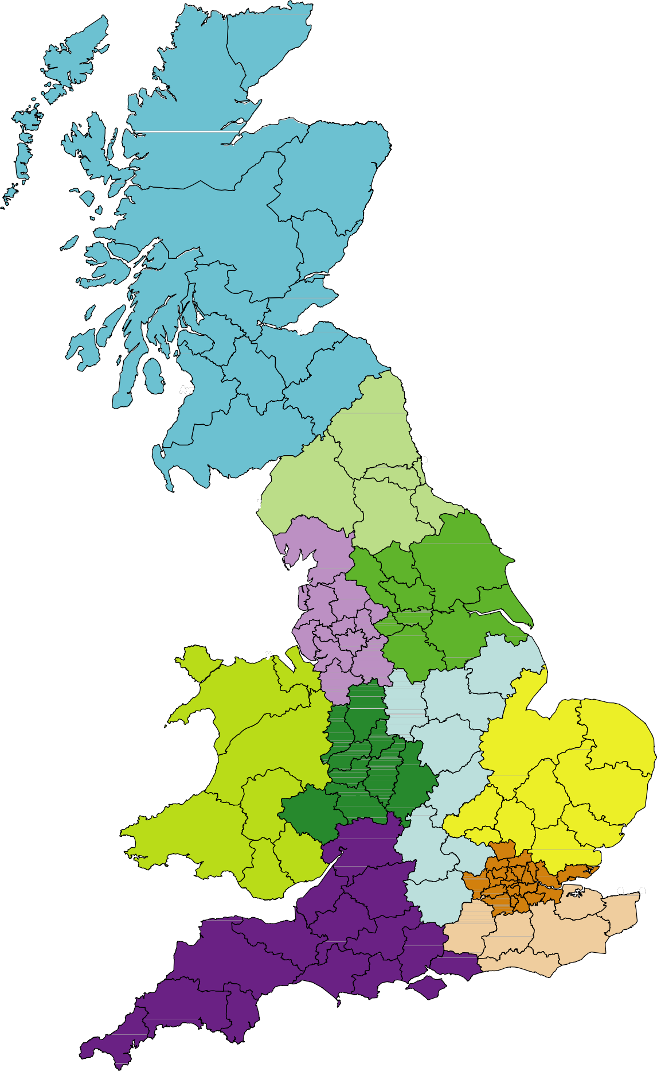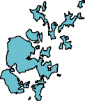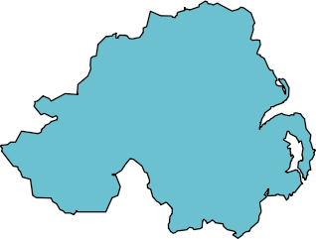

IV

North Scotland   
2 FNS/SI  
4 FI/Oral

AB

NHS Scotland (Directly Commissioned)

FNS – 46  
FI/Oral – 13

Scotland  
55 FNS/SI 18 FI/Oral

KY

FK

G

EH

ML

PA

North East  
48 FNS/SI  
37 FI/ORAL

NE

DE

Northern Ireland   
1 FNS/SI  
1 -FI/ORAL

BT

CA

DH

DL

North West  
80 FNS/SI  
79 FI/ORAL

Yorkshire and Humber  
64 FNS/SI  
58 FI/ORAL

YO

LA

BD

HG

BB

HU

LS

FY PR

Wales  
8 FNS/SI  
9 FI/ORAL

HD

OL

DN

BL

L

M

s

East Midlands  
57 FNS/SI  
34 FI/ORAL

SK

LN

East of England  
48 FNS/SI  
56 FI/ORAL

CH

CW

NG

LL

DE

West Midlands  
90 FNS/SI  
51 FI/ORAL

SY

PE

LE

NR

DY

NN

IP

CV

B

Midlands  
30 FNS/SI  
18 FI/ORAL

CB

MK

HR

CO

OX

LU

**London areas**

**118 FNS/SI  
82 FI/ORAL**

SA

AL

GL

HP

CM

EN

CF

HA

E

RG

DA

BS

South West  
118 FNS/SI  
56 FI/ORAL

ME

KT

BR

GU

BA

CT

CR

EX

South East  
69 FNS/SI  
52 FI/ORAL

PO

BHJ

DT

BN

Jersey & Guernsey  
FI/ORAL <5

PL