**Atamis Supplier User Guide**

For assistance with responding to this tender in the health Family (Atamis) System please refer to the Health Family User Guide which can be found via this link

[Supplier Portal User Guide - Health Commercial System - Supplier Portal User Guide (refined.site)](https://sp-user-guide.refined.site/space/SPUG)

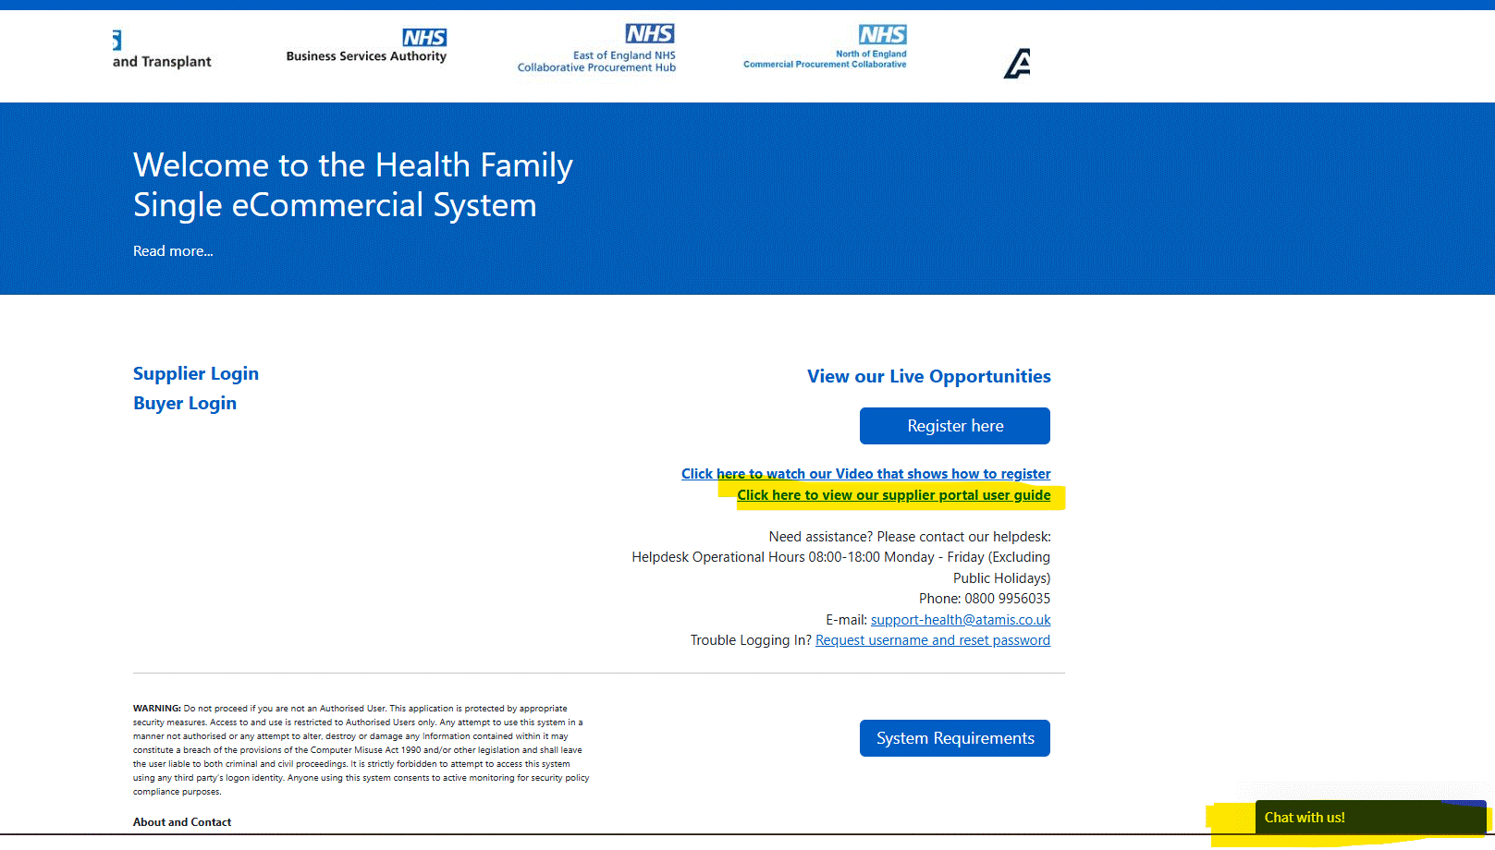

**Please see below how the page should look like when they open the user guide link.**

