Dear Supplier,

Please see the guide below on how to register an interest to the Medical Gases and Nitric Oxide - Prior Information Notice (PIN).

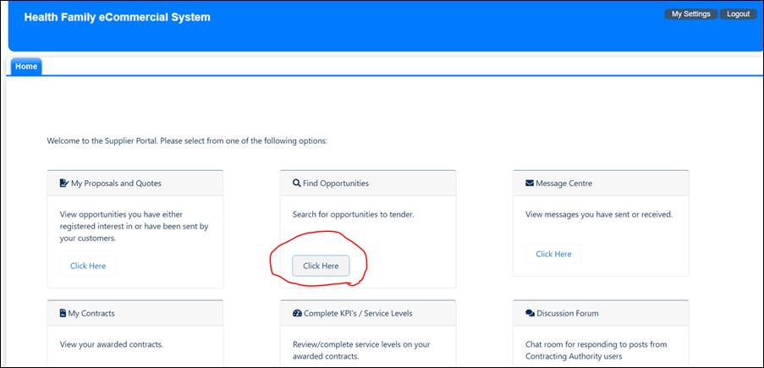

Please click the button under Find Opportunities.

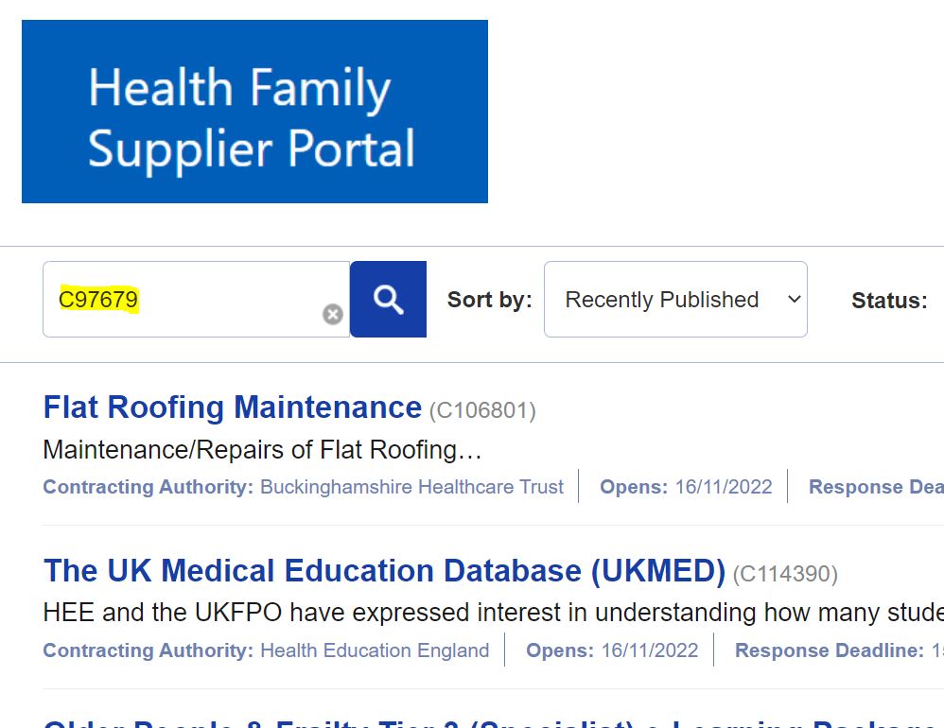

Input the Project number into the search box: The Project number for this PIN is **C97679**

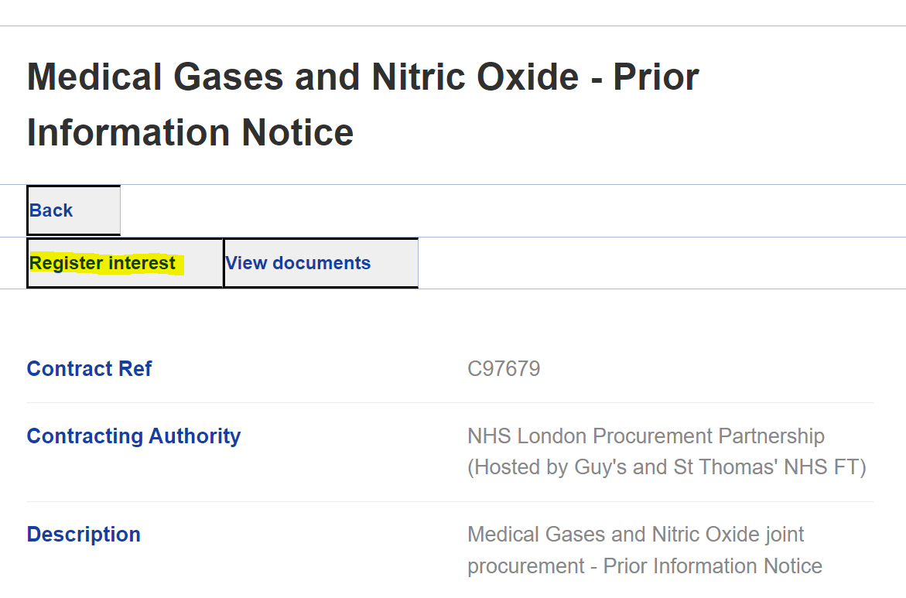

Click on Register interest, and confirm on the next page.

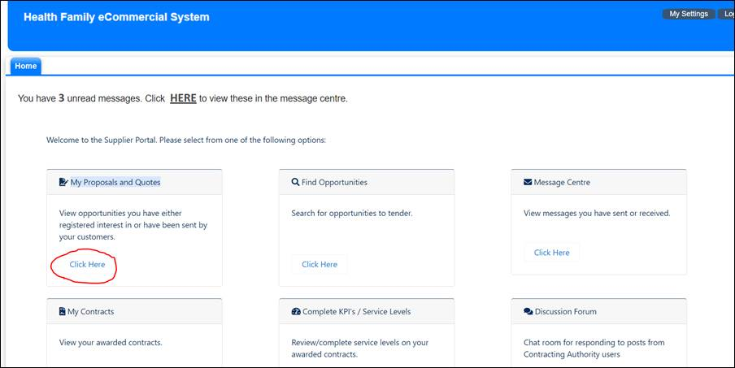

Return to the Home Page, and click on the button under My Proposals and Quotes.

Click on the project titled C97679 (Medical Gases and Nitric Oxide - Prior Information Notice)

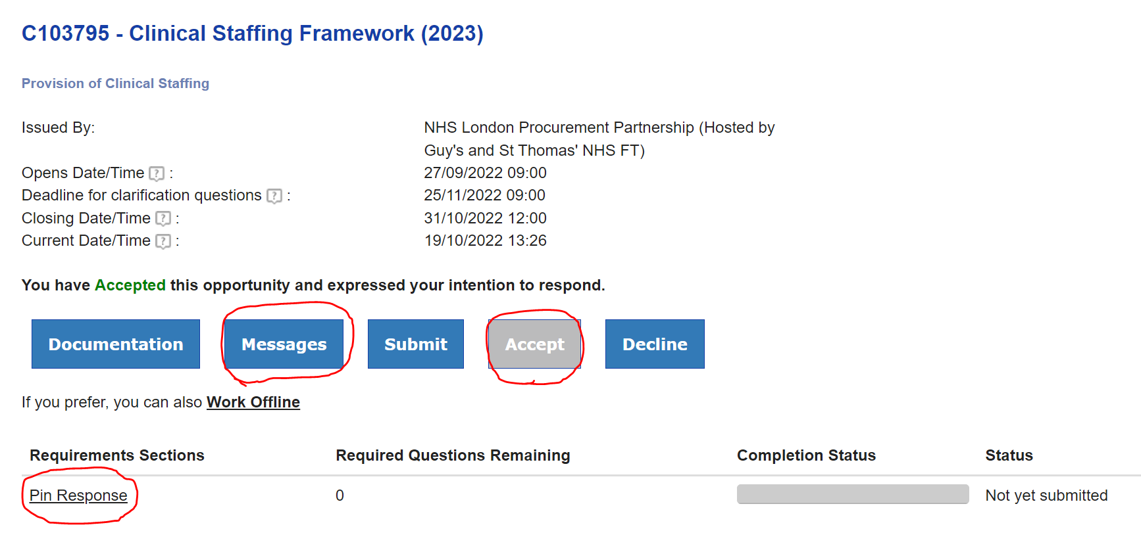

Click on the ‘Accept’ button in order to confirm Registration.

Click on the ‘Pin Response’ link to view the PIN guidance and questions.

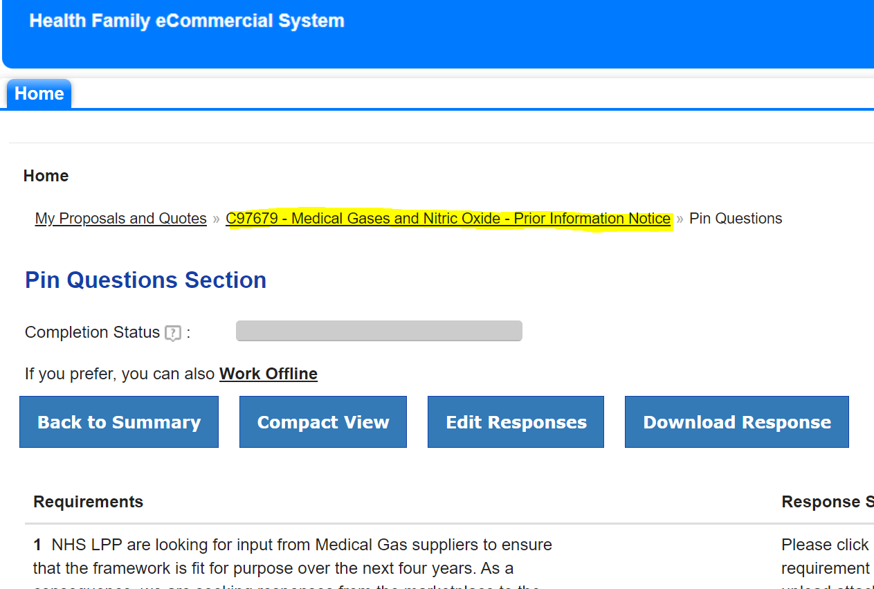

Once you have reviewed the questions, click on the link highlighted in Yellow, which will return to the previous page, Click on the Messages button.

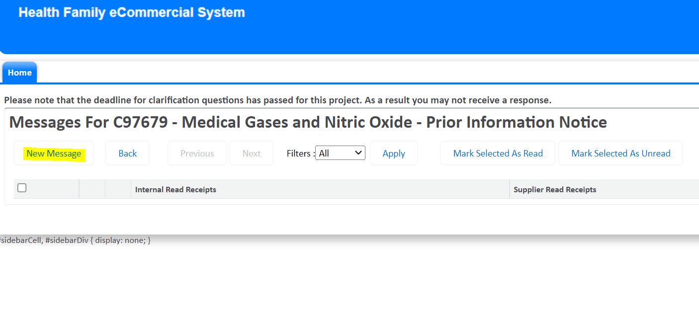

Click ‘New Messages’ in order to submit your response to the questions or you can simply respond to this message.