Supply of Rock for the Southease Flood Alleviation Scheme (Tidal Ouse North of Newhaven to the A27) 2

Ref: 20154

Background
The Environment Agency requires natural stone aggregate for embankment repairs to the tidal River Ouse embankments in East Sussex between Newhaven and the A27 (near Lewes).

Requirement
The specification requires the supply and delivery to site of an estimated 2,000 tonnes of aggregate annually. All aggregate supplied under the framework will be suitable for the intended purpose (as a tidal riverbank revetment or gabion stone) and meet the specification as detailed. The average annual quantity of aggregate is likely to be around 2,000 tonnes, however this figure could vary from year to year. Work is typically restricted to between April and September to coincide with the favourable ground conditions (although emergency repairs may be required outside of this period). The Environment Agency therefore cannot provide a guarantee on the level of business that will be placed under this framework.

The aggregate supplied for the framework will need to match with the existing natural stone aggregate already in place along the tidal River Ouse embankments which is Kentish Ragstone, a sandy limestone aggregate. All material supplied under the framework must be suitable for the intended purpose (as a tidal riverbank revetment or gabion stone). The material shall be hard quarried rock, extremely durable, frost proof and non-degradable and meet the specification below.

Aggregate size (mm): 100 - 200
Colour: Medium Grey on BRE Colour Chart, Grey on Munsell Rock Colour chart, or equivalent
Compressive Strength: Strong – Very Strong (50MPa-250MPa)
Durability: Resistance to weathering, and low frost susceptibility

Expressions of Interest
An Expression of Interest will only be considered to be valid if:
- it is submitted via the https://defra.bravosolution.co.uk/web/login.html portal before the submission deadline of 3pm Thursday 15 December 2016,
- a sample of the proposed material is received by 20 December 2016, together with supporting documented evidence of compliance with the above criteria, and
- the sample meets with the Environment Agency engineer’s approval.

Up to 3 different material samples may be submitted for this purpose.

Please send your material sample to:
Christopher Venus
Environment Agency
Seaford Storage Depot
Marine Parade
Seaford
East Sussex
BN25 2QR

Supporting documented evidence should include test reports of particle size distribution, compressive strength, and other characteristics as appropriate.
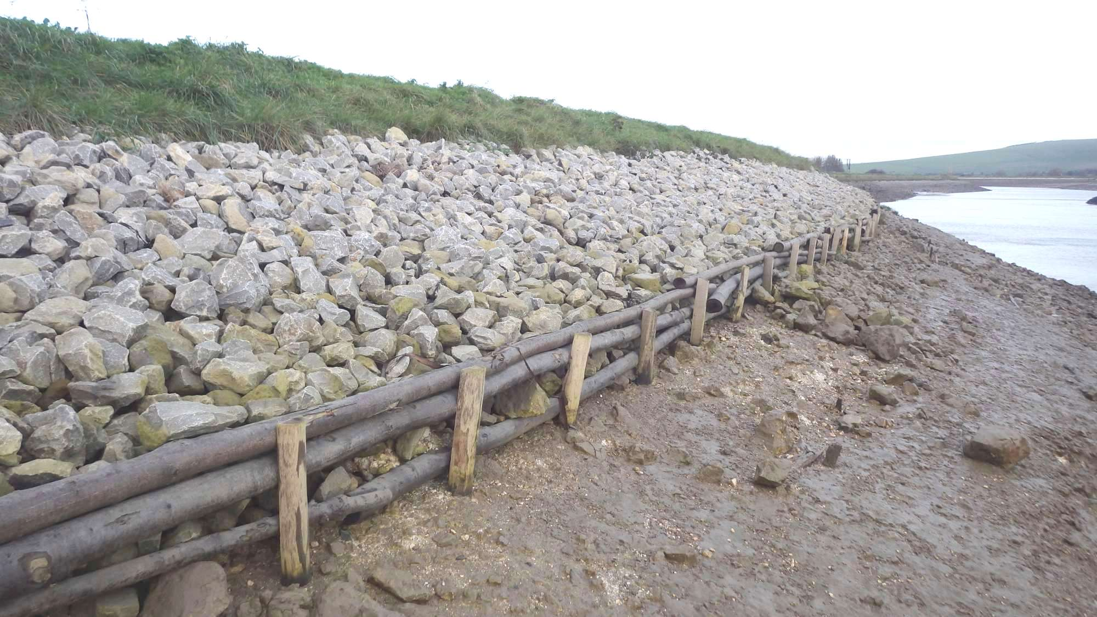
Figure 1: Completed pole-wharfing repair to tidal River Ouse embankment using Kentish Ragstone.

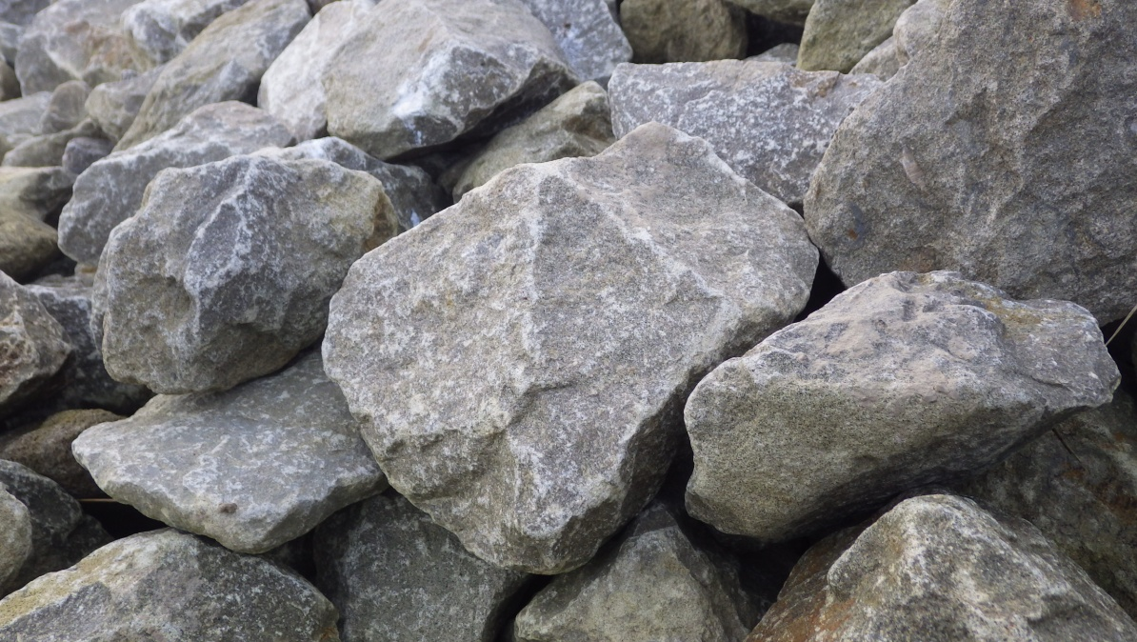
Figure 2: Kentish Ragstone used in previous embankment repairs on the tidal River Ouse.

Please note:

This exercise shall be conducted using the Environment Agency’s eSourcing portal Bravo.

Candidates shall only be considered by registering their expression of interest on our portal at https://defra.bravosolution.co.uk/web/login.html

Click on the ‘Register Now’ link and then Register Free on the portal. Login to the portal with the username/password then find this opportunity using the reference project_20154.
If you have any queries then please contact the eSourcing helpdesk by phone: 0800 368 4850, or by email: help@bravosolution.co.uk

Right to Cancel: The Environment Agency reserves the right to discontinue the procurement process at any time, which shall include the right not to award a framework or contract, and does not bind itself to accept the lowest tender, or any tender received, and reserves the right to award the framework or contract in part, or to call for new tenders should it consider this necessary.

The Environment Agency shall not be liable for any costs or expenses incurred by any candidate or tenderer in connection with the completion and return of the information requested in this Contract Notice, or in the completion or submission of any tender.

