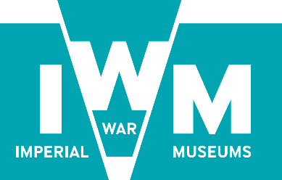

Tender Documentation

Contract No.
IWM/DE/1792

Partner Agency: Digital Transformation Strategy Implementation Plan

Tender Submission Return Date:

14.00 on 12 September 2017

1.0 Introduction

1.1 Imperial War Museums (IWM) is a global authority on conflict and its impact on people’s lives. We collect objects and stories that give an insight into people’s experiences of war, we preserve them for future generations, and we bring them to today’s audience in the most powerful way possible at our five branches (IWM London, IWM Duxford, IWM North, Churchill War Rooms and HMS Belfast) and across our digital channels. By giving a platform to these stories, we aim to help people understand why we go to war and the effect that conflict has on people’s lives.

1.2 IWM is a non–departmental public body (NDPB) overseen by a Board of Trustees and its Chairman. Its sponsor department is the Department for Culture, Media & Sport (DCMS). The museum’s records are public records.

1.3 Further information about IWM and all of our branches can be obtained from our website on www.iwm.org.uk.

1.4 IWM is an exempt charity under the terms of the Charities Act 1993 Schedule 2 (u) and (w). As such we do not have a Charity Registration Number.

2.0 Project Introduction

2.1 IWM is seeking a partner agency with which to collaborate to devise a three-year roadmap and investment plan for our customer-facing digital development and internal transformation.

2.2 This plan will ensure the Digital Transformation Strategy is turned into practical reality.

2.3 We are looking for an experienced and confident partner that can rapidly understand our digital ambitions, analyse our current state of development and then co-create a practical and costed roadmap for delivering those ambitions and transforming the organisation.

3.0 Project Summary

3.1 Background

3.1.1 IWM is lagging in its digital development in a sector that itself is generally behind the curve. We have many teams across the organisation contributing digital value, with some digital functions and services relatively highly developed and others poorly or not developed. However, until now there has not been a unifying vision or roadmap for our digital development, with the result that our work is unco-ordinated and our performance patchy.

3.1.2 Against this background, IWM has committed to an ambitious digital transformation strategy that aims not only to build digital capability, but also to make digital activity part of the normal business of the whole organisation.

3.1.3 This strategy has been approved by our Board of Trustees, with the recognition that its execution will require a sustained period of significant investment and internal change. Our next step is to deliver a practicable and costed plan for our digital development, to present back to the organisation for approval, before moving into a three-year implementation phase.

3.1.4 In 2020, IWM London launches the second phase of its transformation with the opening of new Second World War and Holocaust galleries. These are being devised now and offer an unmissable opportunity to fully integrate a digital dimension in a way that sets the standard not only for IWM, but across our sector.

3.2 IWM’s Digital Transformation Strategy

Through our strategy, IWM is committed to placing itself in the top tier of UK cultural institutions for:

- the integration of digital as a normal part of all our curatorial and public programme work
- the quality and consistency of our digitally-delivered customer experience
- the collection and use of customer data to deepen engagement and generate income.

To obtain a full copy of the strategy document you must complete the Confidentiality Agreement (see Appendix 1) and forward to sbourne@iwm.org.uk, and a copy of the strategy will be issued.

3.2.1 Customer Focus

A key result of this strategic approach is to focus our digital activity and development on our customers (by which we mean anyone with whom IWM exchanges value, both commercially and in our free offer). In this next stage of our strategy development we need to move the way IWM thinks of digital from a focus on internal teams, digital products and systems, to start instead with the customer experience and customer journeys.

Specifically as part of this project we will map the customer experience and journeys we want to deliver, accompanied by the necessary programme of change in order to do that.

3.2.2 Organisational Change

A second key aspect of the strategy is to commit IWM to internal transformation. The value we hold in trust and contribute to the United Kingdom and the world lies in our unique collection and in our curatorial and historical expertise. We must therefore move from digital outputs and activity being a peripheral activity performed by standalone digital teams, to become a normal part of business for our core functions.

Therefore as part of this project we will examine our current skills, processes and organisation and devise a plan to transform these, so that teams and staff across IWM contribute digital value not in addition to their work, but as a standard part of it.

3.2.3 Commercial Drive

As a proportion of our income, public funding is reducing and we anticipate this trend will continue. At the same time, digital technologies open new commercial opportunities, to transform our brand perception, reach new audiences, through new products and modes of delivery, and via the collection and exploitation of customer data.

Therefore this project must produce a costed plan that is achievable within our means, which meets our commercial aims and in which every aspect is able to demonstrate the expected commercial benefit of our planned investment.

3.3 Objectives of this partnership

3.3.1 We must deliver a costed implementation plan early in the fourth quarter of this financial year (January-March 2018) in order for that investment to be factored into our financial planning for the three year period commencing in the 2018 financial year. In order for this planned investment to be taken into account in our corporate planning process this work will also need to produce and indicative framework for a plan and indicative costs during the third quarter of this year (October-December 2017).

3.3.2 This plan must map out the customer experience we want to achieve, throughout the span of a customer’s relationship with IWM. It will:

- Illustrate our key customer journeys and identify the necessary digital touchpoints online, via mobile and in gallery.
- Identify where we need to overhaul services or products we currently supply, or build new services or products, for instance in mobile.
- Identify the technical and process changes we need to effect to deliver that customer experiences, identifying platforms, technical integration and skills we will invest in.
- Map the internal change we need to bring about to build a digital-first organisation.

3.3.3 The plan must inspire IWM to believe in this approach and justify itself commercially to secure the required investment.

3.4 Our outline roadmap

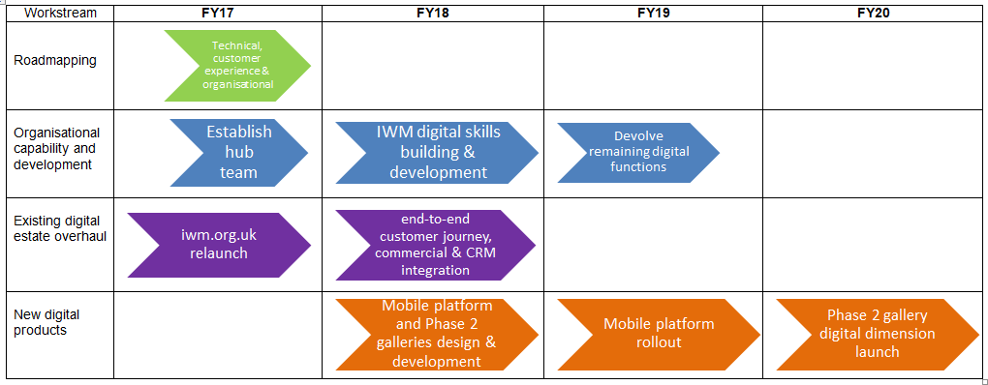

3.5 The Partner organisation we are looking for

3.5.1 IWM cannot create an implementation plan for our digital strategy alone: we lack the necessary mind-set, skills and capacity to do so. We are therefore looking for a partner agency that brings the outlook, skills and capacity that we lack, and which can work with us in a collaborative fashion to produce a three-year costed investment plan.

3.5.2 We are not looking for an audit or state-of-digital report, nor for top-level recommendations and we need a partner who can work very closely with us and bring stakeholders with us, as we begin our transformation.

3.5.3 You will need to immerse yourself in how we work not only digitally but in areas such as curation and the creation of galleries and exhibitions to understand and recommend how these will be transformed to produce digital value. You will work with stakeholders across the organisation to create customer journeys that fit our audiences and commercial objectives. You will work intensively with our IT and CRM project teams to create a full picture of our current digital platforms. You must also be able to drive cultural change yourself, by creating buy in for your recommendations, not just when they are presented but throughout this process.

3.5.4 To win this Contract you must be able to demonstrate to us:

- Relevant experience: working in the cultural sector or with visitor attractions and with similar organisational, technical and commercial challenges.
- Collaborative working: the ability to work in an integrated fashion with clients, with frequent face-to-face interaction and with your staff embedded onsite for periods when required.
- Customer focus: the ability to map customer journeys and design great digital customer experience across web, mobile, apps and in-gallery.
- Commercial focus: the ability to create investment and business plans for digital products and projects.
- Technical expertise: the ability to understand fractured digital, technical and IT infrastructures and plan the evolution and development of these to support CX and commercial objectives.
- Platform and integration expertise: a thorough understanding of relevant customer-facing and back end technical systems and the work required to introduce and integrate these.
- Planning expertise: the ability to turn overall goals into staged implementation plans to include low investment quick wins and interim steps as well as substantial longer term investments.
- Organisational development expertise: the ability to both recommend internal process and roles change to deliver digital plans, and to recommend and map wider organisational change.
- Stakeholder management: exceptional stakeholder skills, especially the ability to consult in a fashion that builds confidence; ability to create and convey plans that generate understanding and buy in and drive forward a focus on customer experience.
- Implementation ability: though this tender extends only to the creation of an implementation plan, you must be able to show the skills and capacity to collaboratively deliver the type of digital transformation we are aiming for, should we wish to continue to work with you during the next, implementation phase.

3.6 Anticipated Activities and Outputs

The following is not an exhaustive list, but we expect the agency involved to undertake some of the following activities and others as we decide during this process and in discussion with the successful agency:

- Business and stakeholder consultation: collaborative working with key stakeholders with externally-facing audience responsibility and internal delivery responsibility to understand business objectives and constraints and factor these into the projected plans. Creation of plans that demonstrably deliver to stakeholder objectives.

- CX and projects review and summary: the review and summary of both our current digital CX and its acute pain points and assessment of projected developments across the organisation in the next three years to map our current and emerging landscape.

- Audience and user experience: research and evidence-based mapping of our target audiences’ digital behaviours and end-to-end digital needs and expectations; creation of end-to-end user journey maps based on user needs, business objectives and projects in train.

- Organisational delivery and process: assessment of current state of digital and relevant non-digital roles, capabilities and supplier relationships and capabilities; roadmap of necessary organisational change across these to achieve our digital strategy and aims.

- Technical delivery: close collaboration with technical roles and in particular IT and audit and assessment of the current technical architecture responsible for delivering our digital touchpoints; roadmap for technical and platform change and development necessary to achieve our digital strategy and aims.

- KPIs: create a top level dashboard of KPIs against which progress on this strategy can be tracked and evaluated.

- Full three year plan: delivery of a full three-year costed plan for IWM’s digital transformation to meet the objectives of the Digital Transformation Strategy. The plan will include not only the ‘what’ of must happen, but the ‘how’ including implementable recommendations for delivery methods and teams and costed requirements for ongoing external involvement to deliver the plan and blend of in-house and external members in a designated Digital Transformation Team.

The plan must also be delivered in at least two formats, to include as a minimum a heavyweight, full detail version, and a lay person’s lightweight version that highlights key changes and business benefit.

4.0 Timetable

Activity | Planned date
Place notice on Contracts Finder | 21 August 2017
Closing date for submissions | 12 September 2017
Assessment of tenders and shortlisting | 13 - 22 September 2017
Notification of Interview | 25 September 2017
Interviews | 3 or 4 October 2017
Appointment Date | 5 October 2017
Project commencement | 1 November 2017
Project completion | 31 January 2018

5.0 Budget

We anticipate this work will cost between £55k and £65k and request bidding agencies to break their cost estimates down to a high-level menu to enable us to understand the costs and benefits of the work you recommend and to consider the advantages of allocating additional budget should your estimate exceed £65k.

6.0 Response to the Brief

Tenderers are required to submit a written response to the brief, outlining:

- basic details of your organisation including your company name, address, website and VAT, company registration and or charity number plus dates of registration
- examples of similar projects undertaken with indicative costs for both planning and implementation phases and outline of project impact and benefits for your client
- examples to substantiate your fit for the criteria in section 2.5
- confirmation of who will undertake the review and their individual experience
- proposed methodology and approach and in particular how you will ensure this is a collaborative exercise and one that brings key stakeholders with the project
- proposed activities to create a digital implementation plan for IWM
- costs and resources required to deliver a transformation plan, presented on a scale and/or in a menu fashion identifying all costs associated with the delivery of the plan
- your proposal payment schedule
- you may be required to work with IWM with additional work with the implementation of the plan (or parts thereof). Please indicate your experience in this area of work; how you would go about this work; who within the team would be responsible for the delivery; and the day rates chargeable for such services
- identification of the support required from IWM
- proposed outputs and deliverables
- the overall vision and objectives of your company
- how you will work with IWM to identify project KPI’s and monitor and report on progress against all deliverables

7.0 Selection Criteria

Written tender responses will be evaluated against the following criteria:

  - Experience: experience of similar projects and assessment of delivery team (4)
  - Approach: your proposed programme of work and approach (5)
  - Value for money: cost/resource allocation (5)
  - UX focus: evidence of user experience focus and expertise (4)
  - KPIs: assessment of the proposed KPI’s and monitor and reporting processes (3)
  - Stakeholder focus: proposals to involve stakeholders, assimilate their needs and bring them on board with the programme (2)

Following the evaluation, a shortlisted selection of tenderers may be invited to an informal discussion of their tender, which will be held at an IWM London office on either 3 or 4 October 2017.

Following appointment, IWM will issue a formal contract based upon the terms as shown in Appendix 2.

8.0 Contacts

If you would like an informal discussion around the information contained in this brief, please call Charles Bodsworth, Head of Digital Engagement on 020 7091 3117 or on cbodsworth@iwm.org.uk, after 29 August 2017.

9.0 Tender Returns

You are required to submit two hard copies of your tender, and one on memory stick by 14.00 on 12 September 2017 to:

Simon Bourne
Head of Procurement
IWM London
Lambeth Road
London
SE1 6HZ

Please ensure that the tender envelope is marked ‘Tender Documents – Contract No: IWM/DE/1792’.

Appendix 1

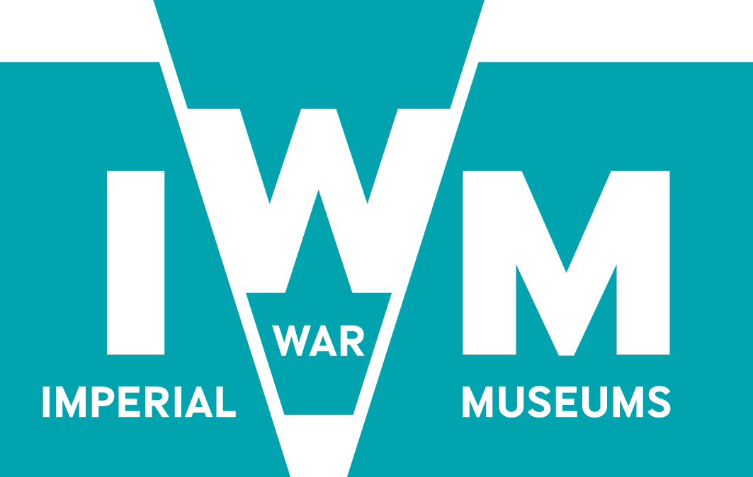
Confidentiality Agreement

Contract No | IWM/DE/1792
Contract Title: | Partner Agency: Digital Transformation Strategy Implementation Plan

- In consideration of IWM supplying information relating to Partner Agency: Digital Transformation Strategy Implementation Plan (“the Confidential Information”) solely for the purpose of enabling us to develop a Contract (“the Permitted Use”), we hereby confirm to you that we will exercise all reasonable skill and care (without prejudice to any rights which we may have at law in connections with the Confidential Information) that we agree that:

  - we will hold the Confidential Information at all times in strict confidence and under conditions of secrecy, and we will take all necessary steps to preserve confidentiality;
  - we will disclose the Confidential Information only to our directors, officers and employees as is strictly necessary for evaluating the Confidential Information and we will procure that such persons are aware of and shall comply with the terms of this Confidentiality Agreement and we shall be responsible for any breaches by such persons;
  - we will not use the Confidential Information for any purpose other than the Permitted Use;
  - we may only disclose the Confidential Information, without prior consent, to any third party, to enable the facilitation of the scope of works of this Confidentiality Agreement (including for the purposes of consulting legal/insurance advisors);
  - we shall not mix, add, merge, combine, store or amalgamate (including without limitation store on or add to hard or soft disk) any of the Confidential Information with any other information, material or intellectual property except for the Permitted Use. In the event of any mixture, merger, addition, combination, storage or amalgamation of the Confidential Information contrary to the terms of this Confidentiality Agreement, then the product of such process shall become your exclusive property;
  - we will upon your oral or written request at any time return to you forthwith by such means as you may specify all Confidential Information supplied to us, all material prepared by us which uses or incorporates any of the Confidential Information, any material on which any such information is recorded or stored and all copies thereof and all such information on hard disk upon shall be irretrievably and permanently erased and any soft disk upon which such information is stored or recorded shall be delivered and become your property;
  - we will not make any statement or announcement to any customers, representatives of the Press, competitors or any third parties about any arrangements contemplated between us without your prior written consent; and
  - we confirm that the expression “Confidential Information” includes all such information (if any) relating to the idea described above as we may have disclosed to you already.
  - in the case of any Personal Data supplied, we will additionally ensure that it is held in accordance with the terms of the Data Protection Act 1998.

- Subject to paragraph 3 below, the above limitations on use and disclosures shall not apply to information which is known to us before receipt thereof from you (unless such information was then disclosed in confidence);

  - is learned from a third party entitled to disclose it;
  - becomes known publicly other than through disclosures by us;
  - is authorised in writing by you to be released.

- Nothing in this Confidentiality Agreement shall be constructed as a grant of rights to us in the confidential information nor as placing you under any obligations to grant us future rights in the Confidential Information in any subsequent agreement.

- Our obligations under this Agreement shall survive any termination of any existing or future agreement between us whether or not that agreement relates in any way to the Confidential Information.

- Without prejudice to any other rights or remedies that you may have, we acknowledge and agree that damages alone would not be an adequate remedy for any breach by us of the provisions of this Confidentiality Agreement and, accordingly, you shall be entitled without proof of special damage to the remedies of injunction, specific performance and other equitable relief for any threatened or actual breach of the provisions hereof by us.

- Any notice or other communication under this Confidentiality Agreement shall (unless otherwise specified in this Confidentiality Agreement) be in writing and may be sent by post. A notice sent by post shall be deemed to have been delivered on the third day after posting and in proving service it shall be sufficient to prove that the envelope containing the notice was properly addressed, prepaid and posted.

- In the event that it is determined in any legal proceedings before a competent tribunal, that any paragraph, or part of any paragraph of this Confidentiality Agreement is invalid, illegal, or unenforceable, such paragraph or part thereof shall be deemed to be severed from this Confidentiality Agreement and the remainder of this Confidentiality Agreement shall continue in full force and effect.

- No failure or delay by either party in exercising any right, power or privilege available under this Confidentiality Agreement shall operate as a waiver thereof.

- This Confidentiality Agreement is personal only to the parties to it, and shall be governed in all respects by the laws of England and may only be amended with the written consent of both parties and each party submits to the non-exclusive jurisdiction of the English courts

Signed on behalf of (insert company name):

Signed by:
Print Name (in Block Capitals)
In capacity of:
Date

Appendix 2 – Terms & Conditions

The following represent the terms and conditions that will apply to this Contract.

1.0 Definitions

1.1 In these terms "the Contract" means the agreement concluded between IWM and the Agency including all specifications, plans, drawings and other documents which are relevant to the Contract and also such of these terms as are included in these terms and conditions of the Contract.

1.2 The following provisions shall have effect with respect to the interpretation of the Contract except where the context otherwise requires:

- "Contract fee" means the fee exclusive of Value Added Tax, payable to the Agency by IWM;
- “Deliverables” refers to any materials produced as a result of this Contract;
- “Force Majeure” means any event or occurrence which is outside the control of the party concerned and which is not attributable to any act or failure to take preventive action by the party concerned, but shall not include industrial action occurring within the Agency’s organisation or within any sub-contractor’s organisation.
- "Services" mean all services which the Agency is required under the Contract to supply;
- "Sub-contractor" means any person, firm or company under contract to the Agency to perform work or provide professional services and/or supply goods and includes any other person or persons taken as a partner or director by such person, firm or company during the currency of the Contract and the surviving member or members of any such firm or company;
- “Intellectual Property Rights” means patents, Trade Marks, trade names, design rights, copyright (including rights in computer software and moral rights), performers’ rights, database rights, and other Intellectual Property Rights, in each case whether registered or unregistered and including applications for the grant of any of the foregoing and all rights or forms of protection having equivalent or similar effect to any of the foregoing which may subsist anywhere in the world.
- “Background IPR” means all Intellectual Property Rights excluding Foreground IPR, owned by either IWM or the Agency prior to their accession to this Contract, as well as any Intellectual Property Rights pertaining to such information, the application for which has been filed before their accession to this Contract, and which is needed for creating the Deliverables or for using Foreground IPR in accordance with this Contract.
- “Foreground IPR” means all Intellectual Property Rights in the Deliverables arising as a direct result of and in the performance of this Contract.
- “Third Party IPR” means Intellectual Property Rights, not owned by the Parties subject to this Contract.

1.3 The headings to these terms shall not affect the interpretation thereof.

1.4 Any notice or other communication whatsoever which IWM are required or authorised by the Contract to give or make to the Agency shall be seen to be given if sent by post in a prepaid letter addressed to the last known address of the Agency and that the letter is not returned undelivered by the Royal Mail shall be deemed for the purposes of the Contract to have given or made at the time at which the letter would in the ordinary course of post be delivered.

1.5 The masculine includes the feminine, and the singular includes the plural and vice versa.

2.0 Non-Disclosure

2.1 Except with the consent in writing of IWM, the Agency shall not disclose the Contract or any provision thereof to any person other than a person employed by the Agency in the carrying out of the Contract or any other person concerned with the same. Such disclosure shall be made in confidence and extend so far as may be necessary for the purposes of the Contract.

2.2 Except with the consent in writing of IWM, the Agency shall not make use of the Contract or any information issued or furnished by or on behalf of IWM otherwise than for the purpose of the Contract.

3.0 Intellectual Property Rights

3.1 IWM retains the ownership rights in any specification, plans, drawings, or any other documents issued by or on behalf of IWM to the Agency, and IWM retains the ownership rights in any Deliverables arising from this Contract.

3.2 Each Party shall grant the other Party a non-exclusive royalty free worldwide licence to use any Background IPR within the context of creating the Deliverables and for granting any rights and permissions relating to the foreground IPR.

3.3 The Agency shall be credited in association with the Deliverables where reasonably practical.

3.4 The Agency warrants that all Intellectual Property Rights are owned by the Agency, or in the case of Third Party IPR are licensed to the Agency for use in the Deliverables, and that the Deliverables do not infringe the Intellectual Property Rights of any third party.

3.5 The Agency agrees that IWM shall have no liability and the Agency shall indemnify, defend and hold IWM harmless against any and all damages, liabilities, claims, causes of action, legal fees and costs relating to any third-party claim of Intellectual Property Rights infringements or threats of claims thereof with respect of IWM’s use of the Deliverables, provided that:

- the use of the Deliverables has been in full compliance with the terms and conditions of this Contract;
- IWM provides the Agency with prompt notice of any such claim or threat of claim;
- the Agency has sole and complete control over the defence or settlement of such claim.
4.0 Anti-Bribery Act

4.1 The Agency is aware of IWM’s obligation to comply with the anti-bribery rules relevant to the contracting parties, and represents that it will not use money or other consideration, paid by IWM for unlawful purposes, including purposes violating anti-bribery laws including the Bribery Act 2010, such as make or cause to be made direct or indirect payments to any public official in order to assist IWM or any group member organisation or anyone acting on their behalf in obtaining or retaining business with, or directing business to, any person, or securing any improper advantage.

4.2 The Agency hereby declares that:

- its members, officers, owners or employees are not public officials;
- it does not and will not employ or otherwise compensate any public officials or make or cause another to make any direct or indirect offers of payments to any public officials, for the purpose of influencing or inducing any decision for the benefit of IWM and it will not employ any sub-contractor, consultant, agent or representative in connection with this Contract without a documented examination of his person, reputation and integrity, and;
- it will not employ any sub-contractor, consultant, agent or representative who does not comply with the anti-corruption rules and if such a violation comes to its attention to inform IWM immediately.

4.3 IWM will immediately terminate this Contract if the Agency violates any of the anti-corruption laws and the provisions as defined in this clause.

4.4 The Agency agrees to comply fully with all applicable anti-bribery laws, including those in the jurisdiction where they are registered and the jurisdiction where the relevant contract will be performed (if different), and to comply with IWM’s Anti-Bribery Policy.

4.5 The Agency represents that:

- he or she or, as the case may be, the authorised representatives of the Agency presently is/are not, and during the life of the Contract will not become, an official or employee of the relevant country’s government or of a political party in the country;
- he/she/they will disclose any such appointment immediately to IWM, and;
- such appointment may result in the termination of the Contract.

4.6 The Agency agrees to keep accurate books, accounts, records and invoices and agrees that IWM is entitled, with the help of outside auditors if it deems necessary, to audit all books, accounts, records and invoices and accompanying documentation of the Agency for compliance with any applicable anti-bribery laws and that the Agency will cooperate fully in any such audit.

4.7 The Agency’s failure to comply with all applicable anti-bribery laws or IWM’s Anti-bribery Policy will be deemed to be a material breach of the Contract entitling IWM to terminate the Contract. In the event the Agency will surrender any claim for payment under the Contract including payment for savvies previously performed.

4.9 IWM may also terminate the Contract or suspend or withhold payment if it has a good faith belief that the Agency has violated, intends to violate, or has caused a violation of any anti-bribery laws. IWM will not be liable for any claims, losses or damages arising from or related to failure by the Agency of the Contract under this clause, and the Agency will indemnify and hold IWM harmless against any such claims, losses or damages.

5.0 Break

5.1 If either Party is in breach of its obligations and/or the terms of this Contract which is capable of remedy, the Party suffering the breach may at any time give the Party in breach written notice specifying details of the breach and requiring it to be remedied, or a solution to remedy to be submitted to them within 5 working days of their notification of the breach. If after the specified time given, the breach has not been remedied, or a solution to remedy has not been agreed, this Contract may be terminated by the Party suffering the breach, on giving not less than one week’s notice in writing to the other Party.

5.2 Upon the end or early termination of this Contract, the Intellectual Property Rights clause, clause 3, survives the termination of the Contract.

6.0 Agency's Organisation

The Agency shall provide and maintain an organisation having the necessary facilities and employees of appropriate qualifications and experience to undertake the tasks identified in the specification.

7.0 Contract Documents

7.1 In any case of discrepancy between these terms and other documents forming part of the Contract, these terms shall prevail unless the inconsistent provision of such document is expressed to be, or if the context indicates it to be, an amendment of these terms and the same, shall have been effected in accordance with clause 7.2.

7.2 Any variation of any provision of this Contract must be effected in writing between the Parties, and no purported variation by any other means shall bind the Parties.

8.0 Freedom of Information Act 2000

8.1 IWM is subject to the provisions of the Freedom of Information Act 2000 (“FoIA”). FoIA obliges IWM to release certain information to third parties upon written request, unless subject to one of the exemptions under FoIA.

8.2 The Parties agree that all information pertaining to the Contract shall be released to third parties upon request.

8.3 Under the terms of FoIA IWM may be ordered by the Information Commissioner to release information to a third party.

9.0 General Clauses

9.1 IWM shall pay to the Agency, in addition to the Contract Fee, a sum equal to the Value Added Tax chargeable on the value of the supply of services provided in accordance with the Contract.

9.2 The Agency shall not give, bargain, sell, assign, sub-let, sub-contract or otherwise dispose of the Contract or any part thereof of the benefit or advantage of the Contract or any part thereof without the prior written consent of IWM.

9.3 The Contract shall be considered as a Contract made in England and subject to the law of England.

9.4 All disputes, differences or questions between the parties to the Contract with respect to any matter or thing arising out of or relating to the Contract, other than a matter or thing as to which the decision of IWM is under the Contract to be final and conclusive and except to the extent to which special provision for arbitration is made elsewhere in the Contract, shall be referred to the arbitration of 2 persons, one to be appointed by IWM and one by the Agency, or their Umpire, in accordance with the provisions of the Arbitration Acts 1950, 1975 and 1979, or any statutory modification or re-enactment thereof for the time being in force.

9.5 In the event that a different organisation is required to take on the Contract due to the early termination of the Contract, the Agency shall co-operate in the transfer under arrangements to be notified to him by IWM.

The transfer shall be arranged between IWM and the Agency so as to reduce to a minimum any interruption to the Services

9.6 No whole or partial waiver of any breach of this Contract shall be held to be a waiver of any other or any subsequent breach. The whole or partial failure of either party to enforce at any time the provisions within this Contract shall no way be construed to be a waiver of such provisions nor in any way affect the validity of this Contract or any part of it, or the right of either party to enforce subsequently each and every provision.

9.7 Neither Party shall be liable to the other Party by reason of any failure or delay in performing its obligations under the Contract which is due to Force Majeure, where there is no practicable means available to the Party concerned to avoid such failure or delay.

If either Party becomes aware of any circumstances of Force Majeure which give rise to any such failure or delay, or which appear likely to do so, that Party shall promptly give notice of those circumstances as soon as practicable after becoming aware of them and shall inform the other party of the period for which it estimates that the failure or delay will continue.

Any failure or delay by the Agency in performing his obligations under the Contract which results from any failure or delay by an agent, sub-contractor or supplier shall be regarded as due to Force Majeure only if that agent, sub-contractor or supplier is itself impeded in complying with an obligation to the Agency by Force Majeure.

9.8 If any part of this Contract, is found by a court of competent jurisdiction or other competent authority to be invalid, unlawful or unenforceable then such part will be severed from the remainder of this Contract, which will continue to be valid and enforceable to the fullest extent permitted by law. In the event of a holding of invalidity so fundamental as to prevent the accomplishment of the purpose of the Contract, the Parties shall promptly commence good faith negotiations to remedy such invalidity.

9.9 Neither Party may assign any rights under this Contract without the written consent of the other Party, which is not be unreasonably withheld, and any attempt to do without that consent shall be void.

9.10 This Contract is the complete and exclusive statement of the Contract between the Parties relating to the subject matter of this Contract which supersedes all previous communications, contracts and other arrangements, written or oral.

The Parties hereto are independent organisations, and nothing herein contained shall constitute to create a partnership, agency or joint venture between the Parties.

