**Office of Rail and Road**

**Chief Executive Officer**

**Senior Civil Service pay band 3**

**[ ] 2018**

**Deadline for applications: 5pm, Friday [ ] 2018**





Table of Contents

Introduction 3

About ORR 5

About the role 6

Person specification 8

Terms of appointment 9

Appointment Process 10

How to apply 11

Further information 11

Equality and Diversity 11

Data Protection Act, 1998 12

Complaints 12

Annex A: Equality and Diversity Monitoring Form 13

Annex B: Candidate Summary Form 15

# Introduction

ORR is seeking a Chief Executive Officer (CEO) with the leadership capability and credibility to deliver effective independent regulation in rail and strategic roads, protecting the interests of rail and road users, and improving the safety, value and performance of railways and roads today and in the future.

Transport networks that are affordable, safe and reliable are the backbone of a thriving economy and are vital to bringing our country together. They are also thriving as record numbers of passengers use our railways and with a strong Government commitment to major programmes of transformational investment. However, this growth also creates challenges – around achieving value for money, about ensuring delivery and of continually ensuring that the needs of passengers are met safely. ORR plays a key role in meeting these challenges.

Our five yearly review of Network Rail’s financial settlement (PR18 – published on 31 October 2018) set the funding and requirements for Network Rail for the following five years. ORR’s initial assessment of Network Rail’s five year plans shows that the transition from a centrally run company to one structured round eight geographic routes has improved the quality of the plans but we want to see £1bn more spent on renewing the railway to improve reliability and boost safety. A key role for ORR during Control Period 6, which starts on 1 April 2019, will be monitoring and enforcing delivery by each of the routes, so that passengers and freight customers will be able to rely on the railway for the essential service it provides.

ORR must also hold the railways to account for continued improvement in health and safety: to continue to drive for a safer railway through compliance with the law and striving for excellence.

In the highways sector, ORR must make sure Highways England manages the strategic highways network effectively and efficiently delivers the investment programme set out in the Government’s £15bn road investment strategy to 2021.

This programme of work means that the appointment of ORR’s CEO comes at a critical time for our regulated industries - and for the Government. The successful appointee will have a major role to play in realising significant benefits to the national economy.

I look forward to receiving your application.



**Chair, Office of Rail and Road**

# About ORR

The Office of Rail and Road (ORR) is here to:

* protect the people who use, interact or work on the railway. This work is both to ensure continuous improvement in health and safety and, on the economic side, to temper the monopoly power of Network Rail;
* ensure fair access to a rail network which is becoming increasingly congested;
* ensure Highways England implements its £15 billion investment programme on England’s strategic road network. It is our job to report on Highways England’s progress in delivering this investment, on budget and to time;
* protect the interests of future users by working with the industry and funders as they develop the network of tomorrow; and
* ensure that the public’s money is well spent.

Effective and efficient transport networks matter to all of us: they feed the economy and wider society by contributing to productivity and economic growth. Our rail and road networks exist for the benefit of those who use them: rail passengers freight customers, and road users. Britain’s roads and railways are attracting increasing traveller numbers which means, more than ever, that passengers’ interests need to be protected.

Network Rail, as the National monopoly network rail operator, and Highways England as the sole strategic highways authority, therefore need to be monitored accordingly. Everyone also wants roads and railways which are safe, reliable and efficient. Our job is to ensure the industry delivers this.

Decisions on the structure and funding of the rail industry are matters for government and rail regulation needs to adapt regularly to a changing industry, and the changing needs of customers and wider society. Over time, the roads industry must do the same and our role will be to report on this. Important changes to the structure of the railways, such as the reclassification of Network Rail as a public track and stations owner, mean we must play a vital role in holding the rail industry to account for public benefit. It also falls to us to make often tough choices about operator access.

Continued growth presents big challenges and has increased the importance of our role in protecting the interests of users. A primary role for us is to enforce consumer law and compliance with the conditions contained in Network Rail’s and train operators’ licences, to help ensure that all rail users get the service to which they are entitled.

The very success which has seen rail passenger numbers double in the past 20 years, to over 1.6 billion train journeys a year also tests our vital role of ensuring that the railway is safe for passengers, workers and the general public. Increased train traffic also places greater strain on tracks, stations and signalling systems, demanding more maintenance, even as the funding available to conduct the work is constrained.

As a data-driven and evidence-based organisation, we lead the collection, validation, analysis and dissemination of data from across the rail industry. We are the main provider of railway industry statistics in Britain and provide commentary and interpretation of the trends across rail themes.

# About the role

The CEO must have a strategic outlook - able to identify and implement long term plans while being alert to short-term pressures. They should also demonstrate an objective approach to sensitive or complex issues, a commitment to evidence based decision making and an ability to work effectively in a complex stakeholder environment. Whilst maintaining the ORR’s independence, the CEO must work closely with the Government, including Scottish and Welsh Governments and other devolved administrations, to deliver effective leadership and regulation. Through the board, ORR takes important regulatory decisions for which the CEO must account publicly and to Parliament.

The CEO carries overall responsibility and discretion for the management and delivery of the entire organisation, and is accountable to the ORR statutory board for delivery of the ORR’s strategic objectives and annual business plan. The CEO controls the management and delivery of the organisation’s 300 staff (FTE) and is responsible for a budget of £32.1 million.

The key responsibilities of the CEO are to:

* provide strong, visible, inspiring and dynamic leadership to ORR;
* lead the executive team to deliver the objectives and priorities set by the Board;
* ensure ORR has the capability and credibility to be a highly professional, decisive and well respected independent regulator;
* represent ORR publicly, including at parliamentary select committees, and maintain strong, professional and productive relationships with ORR’s key stakeholders;
* create an empowered, open and inclusive culture and business environment that will attract and retain the best staff as part of a high quality team; and
* as Accounting Officer for ORR appointed by HM Treasury, ensure that there are effective disciplines of resource and performance management, risk management, audit and compliance.

The CEO (a Senior Civil Service pay band 3 appointment) has direct management responsibility for 7 executive directors, all at Senior Civil Service pay band 2: the senior structure of the executive organisation is shown below.

ORR Senior Structure:

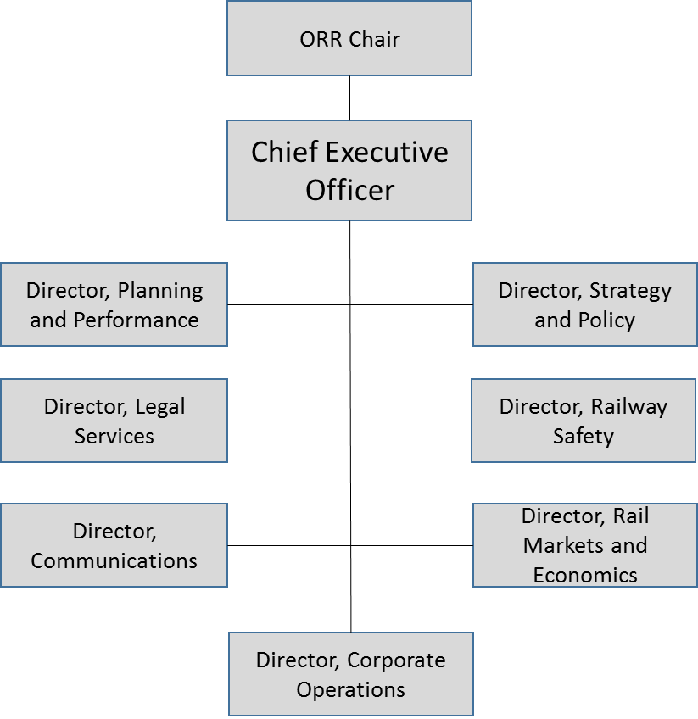

# Person specification

**Part 1**

To be successful, you will have to demonstrate in your application:

* a track record of senior leadership experience in a complex, challenging environment, ideally with experience in both public and commercial sectors;
* significant senior leadership experience (including working at board level) in building, leading and inspiring a strong senior team to deliver organisational success;
* managing a highly skilled and capable organisation to achieve high levels of staff engagement and performance;
* experience of working in a regulated environment, or working as a regulator, to drive significant organisational and industry change;
* significant experience of working with and influencing national organisations, governments, and other stakeholders;
* an understanding of the development, management and operation of national infrastructure; and
* a history of quickly establishing credibility with industry or stakeholder groups.

**Part 2**

During the selection process, we will be assessing the following skills and capabilities:

* outstanding strategic thinking and analytical abilities, and sound judgement;
* the ability to deal with complex economic, corporate finance and technical issues, as well as safety risks of national importance;
* collaborative and persuasive communication and influencing skills, with the competence to address the media and other major public stakeholders on controversial transport issues of national importance and interest;
* appreciation of the challenges and commercial requirements of service delivery that face ORR’s sectors;
* political astuteness with the ability to manage complex high-level stakeholder relationships;
* ability to identify and then drive organisational and process improvement;
* honesty, openness and respect for people, and a public service ethos; and
* ambition and drive, allied with a long term approach to the achievement of strategic goals.

# Terms of appointment

The role carries an attractive salary of c.£150,000. The CEO will be a Senior Civil Service pay band 3 appointment.

For existing Civil Servants, we will apply the normal Civil Service rules for internal promotions and associated salary increases.

The successful candidate will be appointed for a term of five years.

ORR is required to consult the Secretary of State for Transport on the appointment of its Chief Executive, and to obtain approval of the Treasury on the terms of appointment.

We expect the successful candidate to be appointed to the ORR Board, and will invite the Secretary of State for Transport to make this appointment when the new Chief Executive takes up post.

We will also invite HM Treasury to appoint the successful candidate as ORR’s Accounting Officer.

Annual pay increases and non-consolidated bonuses are determined annually by the ORR Board, following guidance from the Cabinet Office.

All employees are eligible to join the Service Pension scheme. Employer contributions are currently 24.3% for this role. Employee contributions are 7.35% from 1 April 2015.

The appointee will entitled to 25 days annual leave, rising to 30 days after 5 years (existing Civil Servants retain their current entitlement), plus public holidays and one civil service privilege day.

Location

The ORR’s London HQ, which is currently at Kemble Street, WC2B. You will be expected to travel to around the UK.

ORR’s current London office location may not be available to us after 2019, and we are therefore looking at options for relocating to new London premises in zones 1 or 2.

Conflicts of interest

It is important that the Chief Executive not only is, but is also seen to be, free from proximity to vested interests. The successful candidate will therefore be required to have declared fully anything which is believed could present an actual or potential conflict of interest between their work, their background or their financial interests on the one hand, and their role as Chief Executive, on the other.

# Appointment Process

This appointment will be made on the basis of fair and open competition established in the Civil Service Commission’s recruitment principles.

A Civil Service Commissioner will chair and oversee the selection process.

The Civil Service Commission has two key functions, as set out in the Constitutional Reform and Governance Act 2010:

The commission is responsible for upholding the principle that selection to appointments in the Civil Service must be on merit on the basis of fair and open competition; and the commission can hear and determine complaints raised by civil servants under the Civil Service Code, the ethical code which forms part of the terms and conditions of every civil servant.

The Commission also work with departments to help them promote the Code and the core values of the Civil Service that is describes. Further information on the Civil Service Code can be found at:

[**http://civilservicecommission.independent.gov.uk/civil-service-code/**](http://civilservicecommission.independent.gov.uk/civil-service-code/)

The selection panel will be Chaired by [ ] (Civil Service Commissioner), and will also comprise Declan Collier (ORR Chair designate), [ ] (ORR non-executive board member) and an independent panel member.

All applications will be considered by the selection panel.

Please see the timetable below for indicative dates:

Closing date 5pm, Friday [ ] 2018

Long-listing Meeting w/c [ ] 2018

Preliminary interviews post longlisting

Short-listing Meeting w/c [ ] 2018

References taken and psychometric assessments conducted

Informal discussions with ORR post shortlisting

Final panel interviews with ORR w/c [ ] 2018

As these dates are indicative, they may be subject to change.

It is expected that final panel interviews will be held in London

# How to apply

The deadline for receipt of applications is 5pm, [ ] 2018.

If you wish to apply for this role, please email your application to: [ ] supply the following:

* A full CV including educational and professional qualifications, a full employment history showing the more significant positions, responsibilities held, relevant achievements, budgetary responsibilities, and staff managed.
* A Supporting Statement (around two sides of A4), outlining how you meet the criteria in PART 1 of the Person Specification as far as you are able to. You do not need to respond to PART 2 of the Person Specification - the criteria listed here will be tested if you are invited to preliminary interview and, for those selected, at final panel interview with ORR.
* Please also complete the Equal Opportunities Monitoring Form (see Annex A) and Candidate Summary Form (see Annex B).

# Further information

If you have any questions or wish to discuss the role or the process further, please contact:

[ ]

Tel. [ ]

# Equality and Diversity

The Office of Rail and Road is committed to equality and diversity amongst its employees. Our aim is to ensure that no job applicant or employee receives less favourable treatment on the grounds of ethnicity, gender, sexual orientation, age, marital or civil partnership status, disability, religion, gender reassignment, or family and other caring responsibilities.

# Data Protection Act, 1998

Information provided by you as part of your application to the Office of Rail and Road will be used in the recruitment process. Any data about you will be held securely by ORR with access restricted to those involved in dealing with your application and in the recruitment process. Once this process is completed the data relating to unsuccessful applicants will be stored for a maximum of 12 months and then destroyed by ORR. If you are the successful candidate, your application form will be retained and form the basis of your personal record. Any equal opportunities information provided by you will be used to monitor ORR's diversity policies and practices. By submitting your completed application you are giving your consent to ORR for your data being stored and processed for the purpose of the recruitment process, equal opportunities monitoring and your personal record if you are the successful candidate.

# Complaints

ORR’s recruitment processes are underpinned by the principle of selection for appointment on merit on the basis of fair and open competition as outlined in the Civil Service Commission's recruitment principles, which can be found at [**http://www.civilservicecommission.org.uk/**](http://www.civilservicecommission.org.uk/).   
  
If you feel your application has not been treated in accordance with the Code and you wish to make a complaint, you should contact the head of human resources in the first instance at [**david.chapman@orr.gsi.gov.uk**](mailto:HR.generalenquiries@orr.gsi.gov.uk). If you are not satisfied with the response you receive from ORR, you can contact the Civil Service Commission.

# Annex A: Equality and Diversity Monitoring Form

The intention of monitoring and analysis is to establish if there are different success rates between genders, people of different sexual orientation, ages, different ethnic backgrounds or faiths, and people with disabilities. If there are differences in success rates it will enable action to be taken to ensure that no group is treated unfairly. Your answers will be treated confidentially and will not affect your application in any way.

**Personal Details:**

|  |  |
| --- | --- |
| Title | Mr / Mrs / Miss / Ms / Dr / Other |
| Surname: |  |
| First name: |  |
| Age: | 16-24  25-34  35-44  45-54  55-64  65+ |
| Gender: | Male  Female  Prefer not to say |
| Gender Identity (if appropriate) | If you identify as transsexual, transgender (in that you have effected a permanent change of gender identity) or as intersex which group do you identify with?  Transsexual  Transgender  Intersex |
| Working Pattern: | Part time  Full time  Job Share  Other............................. |

**Ethnic origin: Please tick against one of the following:**

|  |  |  |  |
| --- | --- | --- | --- |
| **Asian or Asian British**  Bangladeshi  Indian  Pakistani  Any other Asian background  Please specify below if you wish.......  ........................................................... |  | **Mixed**  White and Black Caribbean  White and Black African  Asian and White  Any other mixed background  Please specify below if you wish.......  ......................................................... |  |
| **Black or Black British**  African  Caribbean  Any other Black background  Please specify below if you wish.......  ........................................................... |  | **White**  British  English  Irish  Scottish  Welsh  Any other White background  Please specify below if you wish.......  ........................................................... |  |
| **Chinese or Other ethnic group**  Chinese  Any other  Please specify below if you wish.................................................................. |  | Prefer not to say |  |

**Disability: Please tick against one of the following:**

|  |
| --- |
| Do you consider yourself to have a disability under the Equality Act 2010?  In the Act, a person has a disability if:  they have a physical or mental impairment  the impairment has a substantial and long-term adverse effect on their ability to perform normal day-to-day activities  For the purposes of the Act, these words have the following meanings:  'substantial' means more than minor or trivial  'long-term' means that the effect of the impairment has lasted or is likely to last for at least twelve months (there are special rules covering recurring or fluctuating conditions)  'normal day-to-day activities' include everyday things like eating, washing, walking and going shopping  Yes  No  Prefer not to say  Please describe the nature of your disability  *This information is provided for monitoring purposes only – if you need any reasonable adjustments you should arrange these separately.* |

**Religion or belief: Please tick against one of the following**

|  |  |  |  |
| --- | --- | --- | --- |
| No religion  Baha’i  Buddhist  Christian  Hindu  Jain |  | Jewish  Muslim  Sikh  Other  Please specify below if you wish…………………………  Prefer not to say |  |

**Sexual Orientation: Please tick against one of the following**

|  |  |  |  |
| --- | --- | --- | --- |
| Bisexual  Gay Woman/Lesbian  Prefer not to say |  | Gay Man/Homosexual  Heterosexual/straight |  |

# Annex B: Candidate Summary Form

|  |  |  |  |  |  |  |
| --- | --- | --- | --- | --- | --- | --- |
| **POSITION APPLIED FOR:** | | | | | | |
|  | | | | | | |
| **REFERENCE NO:** |  | | | | | |
| **SURNAME** |  | | | | | |
| **FIRST NAME** |  | | **INITIAL(S):** |  | **TITLE:** |  |
| **ADDRESS FOR CORRESPONDENCE:** | |  | | | | |
| **CONTACT TELEPHONE NUMBER(S):** | |  | | | | |
| **EMAIL ADDRESS:** | |  | | | | |
| **MOST RECENT EMPLOYER (ORGANISATION):** | |  | | | | |
| **MOST RECENT JOB TITLE:** | |  | | | | |
| **REMUNERATION:** | |  | | | | |

**Please indicate where you saw this position advertised, i.e.**

**Office or Rail and Road website:**

**Civil Service Jobs website:**

**Sunday Times online website:**

**Other (please state):**