Technology Services 2 Agreement RM3804
Framework Schedule 4 - Annex 1

Order Form

In this Order Form, capitalised expressions shall have the meanings set out in Call Off Schedule 1 (Definitions), Framework Schedule 1 or the relevant Call Off Schedule in which that capitalised expression appears.

The Supplier shall provide the Services specified in this Order Form to the Customer on and subject to the terms of the Call Off Contract for the duration of the Call Off Period.

This Order Form should be used by Customers ordering Services under the Technology Services 2 Framework Agreement ref. RM3804 in accordance with the provisions of Framework Schedule 5.

The Call Off Terms, referred to throughout this document, are available from the Crown Commercial Service website http://ccs-agreements.cabinetoffice.gov.uk/contracts/rm3804

The Customer must provide a draft Order Form as part of the Further Competition Procedure.

Section A
General information

This Order Form is issued in accordance with the provisions of the Technology Services 2 Framework Agreement RM3804.

Customer details
Customer organisation name
Ministry of Defence

Billing address
Your organisation’s billing address - please ensure you include a postcode
Jago Road, HM Naval Base, Portsmouth, PO1 3LU

Customer representative name
The name of your point of contact for this Order
Lydia Irving

Customer representative contact details
Email and telephone contact details for the Customer’s representative
Lydia.irving104@mod.gov.uk

Supplier details
Supplier name
The Supplier organisation name, as it appears in the Framework Agreement
Centreprise International Ltd

Supplier address
Supplier’s registered address
Centerprise International Ltd, Lime Tree Way, Hampshire International Business Park, Basingstoke, RG24 8GQ

Supplier representative name
The name of the Supplier point of contact for this Order
Tim Eagle

Supplier representative contact details
Email and telephone contact details of the supplier’s representative
tim.eagle@centerprise.co.uk

Order reference number or the Supplier’s Catalogue Service Offer Reference Number
A unique number provided by the supplier at the time of the Further Competition Procedure
Please provide the order reference number, this will be used in management information provided by suppliers to assist CCS with framework management. If a Direct Award, please refer to the Supplier’s Catalogue Service Offer Reference Number

700913368

Section B
Overview of the requirement

Framework Lot under which this Order is being placed  Tick one box below as applicable (unless a cross-Lot Further Competition) |  | Customer project reference  Please provide the customer project reference number.
- TECHNOLOGY STRATEGY & SERVICES DESIGN | ☐ | Click here to enter text.
- TRANSITION & TRANSFORMATION | ☐ | Call Off Commencement Date
- OPERATIONAL SERVICES |  | The date on which the Call Off Contract is formed – this should be the date of the last signature on Section E of this Order Form  16/09/2020
a: End User Services | ☐
b: Operational Management | ☐
c: Technical Management | ☒
d: Application and Data Management | ☐
- PROGRAMMES & LARGE PROJECTS
- OFFICIAL | ☐
- SECRET (& above) | ☐

Call Off Contract Period (Term)
A period which does not exceed the maximum durations specified per Lot below:
Lot | Maximum Initial Term – Months (Years) | Extension Options – Months (Years) | Maximum permissible overall duration – Years (composition)
1 | 24 (2) | - | 2
2 | 36 (3) | - | 3
3 | 60 (5) | - | 5
4 | 60 (5) * | 12 + 12 = 24 (1 + 1 = 2) | 7 (5+1+1) *

* There is a minimum 5 year term for this Lot  Call Off Initial Period Months  3 months | Call Off Extension Period (Optional) Months  Click here to enter text.
Minimum Notice Period for exercise of Termination Without Cause  (Calendar days) Insert right (see Call Off Clause 30.7) |  | 30 days

Additional specific standards or compliance requirements
Include any conformance or compliance requirements over and above the Standards (including those listed at paragraph 2.3 of Framework Schedule 2) which the Services must meet.
List below if applicable
As detailed in requirement.
Customer’s ICT and Security Policy
Where the Supplier is required to comply with the Customer’s ICT Policy and Security Policy then append to this Order Form as a clearly marked document
Security Management Plan
Where the Supplier is required to provide the Customer with the Security Management Plan then append to this Order Form as a clearly marked document

Section C
Customer Core Services Requirements

Please provide details of all Services required including the locations where the Supplier is required to provide the Services Ordered.

Services
List below or append as a clearly marked document to confirm the Services which the Supplier shall provide to the Customer (which could include the Customer’s requirement and the Supplier’s response to the Further Competition Procedure). If a Direct Award, please append the Supplier’s Catalogue Service Offer.
As per Statement of Requirement.

Location/Site(s) for provision of the Services
As per Statement of Requirement.

Additional Clauses (see Annex 3 of Framework Schedule 4)
This Annex can be found on the RM3804 CCS webpage. The document is titled RM3804 Alternative and additional t&c’s v4.
Those Additional Clauses selected below shall be incorporated into this Call Off Contract
Applicable Call Off Contract Terms  Additional Clauses and Schedules |  | Optional Clauses  Can be selected to apply to any Order
Tick any applicable boxes below |  | Tick any applicable boxes below
A: SERVICES – Mandatory  The following clauses will automatically apply where Lot 3 services are provided (this includes Lot 4a & 4b where Lot 3 services are included).  A3: Staff Transfer  A4: Exit Management | ☐ | C: Call Off Guarantee | ☐
 | ☐ | D: Relevant Convictions | ☐
 | ☐ | E: Security Requirements | ☐
 | ☐ | F: Collaboration Agreement  Where required please complete and append to this Order Form as a clearly marked document (see Call Off Schedule F) | ☐
A: PROJECTS - Optional |  |  | ☐
A1: Testing | ☐ |  | ☐
A2: Key Personnel | ☐ | G: Security Measures | ☐
B: SERVICES - Optional  Only applies to Lots 3 and 4a and 4b |  | G: Security Measures | ☐
B1: Business Continuity and Disaster Recovery | ☐ | H: MOD Additional Clauses | ☐
B2: Continuous Improvement & Benchmarking | ☐ | Alternative Clauses
B3: Supplier Equipment | ☐ | To replace default English & Welsh Law, Crown Body and FOIA subject base Call Off Clauses
B4: Maintenance of the ICT Environment | ☐ | Tick any applicable boxes below
B5: Supplier Request for Increase of the Call Off Contract Charges | ☐ | Scots Law  Or | ☐
B6: Indexation | ☐ | Northern Ireland Law | ☐
B7: Additional Performance Monitoring Requirements | ☐ | Non-Crown Bodies | ☐
 |  | Non-FOIA Public Bodies | ☐

Collaboration Agreement (see Call Off Schedule F) This Schedule can be found on the RM3804 CCS webpage. The document is titled RM3804 Collaboration agreement call off schedule F v1.

Organisations required to collaborate (Collaboration Suppliers)  Click here to enter text. | An executed Collaboration Agreement shall be delivered from the Supplier to the Customer within the stated number of Working Days from the Call Off Commencement Date insert right  OR |  |  |  |  |  |  | Click here to enter text.
 | An executed Collaboration Agreement from the Supplier has been provided to the Customer and is attached to this Order Form.  tick box (right) and append as a clearly marked complete document |  |  |  |  |  |  | ☐
Licensed Software Where Software owned by a party other than the Customer is used in the delivery of the Services list product details under each relevant heading below
Supplier Software  Click here to enter text. | Third Party Software  Click here to enter text.

Customer Property (see Call Off Clause 21)
Items licensed by the Customer to the Supplier (including any Customer Software, Customer Assets, Customer System, Customer Background IPR and Customer Data)
List below if applicable
Click here to enter text.
Call Off Contract Charges and Payment Profile (see Call Off Schedule 2)
Include Charges payable by the Customer to the Supplier (including any applicable Milestone Payments and/or discount(s), but excluding VAT) and payment terms/profile including method of payment (e.g. Government Procurement Card (GPC) or BACS)
List below or append as a clearly marked document. If a Direct Award, please append the Price Card attached to the Supplier’s Catalogue Service Offer.
£8,711.83 to be paid on completion of work via CP&F/Exostar
Undisputed Sums Limit (£)  Insert right (see Call Off Clause 31.1.1) |  |  |  |  | Click here to enter text.
Delay Period Limit (calendar days)  Insert right (see Call Off Clause 5.4.1(b)(ii)) |  |  |  |  | Click here to enter text.
Estimated Year 1 Call Off Contract Charges (£)  For Call Off Contract Periods of over 12 Months |  |  |  |  | £8,711.83
Enhanced Insurance Cover
Where a specific Call Off Contract requires a higher level of insurance cover than the £1m default in Framework Schedule 14 please specify below
Third Party Public Liability Insurance (£) |  |  |  |  | £5m
Professional Indemnity Insurance (£) |  |  |  |  | Click here to enter text.
Transparency Reports (see Call Off Schedule 6)
If required by the Customer populate the table below to describe the detail (titles are suggested examples)
Title | Content | Format | Frequency
[Performance]
[Call Off Contract Charges]
[Key Sub-Contractors]
[Technical]
[Performance management]

Quality Plans (see Call Off Clause 7.2)
Time frame for delivery of draft Quality Plans from the Supplier to the Customer – from the Call Off Commencement Date (Working Days)  Where applicable insert right |  |  |  |  |  |  | Click here to enter text.
Implementation Plan (see Call Off Clause 5.1.1)
Time frame for delivery of a draft Implementation Plan from the Supplier to the Customer – from the Call Off Commencement Date (Working Days)  Where applicable insert right. If a Direct Award, please append the Implementation Plan attached to the Supplier’s Catalogue Service Offer. |  |  |  |  |  |  | Click here to enter text.
BCDR (see Call Off Schedule B1)  This can be found on the CCS RM3804 webpage. The document is titled RM3804 Alternative and additional t&c’s v4.  An executed BCDR Plan from the Supplier is required prior to entry into the Call Off Contract tick box (right) and append as a clearly marked complete document  OR |  |  |  |  |  |  |  |  | ☐
Time frame for delivery of a BCDR Plan from the Supplier to the Customer – from the Call Off Commencement Date (Working Days)  Where applicable insert right |  |  |  |  |  |  | Click here to enter text.
Disaster Period (calendar days) |  |  |  |  |  |  | Click here to enter text.
GDPR (see Call Off Clause 23.6)
Where a specific Call Off Contract requires the inclusion of GDPR data processing provisions, please complete and append Call Off Schedule 7 to this order form. This Schedule can be found in the Call Off Contract on the RM3804 CCS webpage
____________________________________________________________________________

Supplier Equipment (see Call Off Clause B3)
This can be found on the RM3804 CCS webpage. The document is titled RM3804 Alternative and additional t&c’s v4.

X - Service Failures (number)  Where applicable insert right |  | Click here to enter text. |  | Y – Period (Months)  Where applicable insert right |  | Click here to enter text.
Key Personnel & Customer Responsibilities (see Call Off Clause A2)
List below or append as a clearly marked document to include Key Roles
Key Personnel  List below or append as a clearly marked document to include Key Roles |  |  | Customer Responsibilities  List below or append as a clearly marked document
Click here to enter text. |  |  | Click here to enter text.
Relevant Conviction(s)
Where applicable the Customer to include details of Conviction(s) it considers relevant to the nature of the Services.
List below or append as a clearly marked document (see Call Off Clause D where used)
Click here to enter text.
Appointment as Agent (see Call Off Clause 19.5.4)
Insert details below or append as a clearly marked document
Specific requirement and its relation to the Services |  |  |  | Other CCS framework agreement(s) to be used
Click here to enter text. |  |  |  | Click here to enter text.

Section D
Supplier response

Suppliers - use this section to provide any details that may be relevant in the fulfilment of the Customer Order

Commercially Sensitive information
Any information that the Supplier considers sensitive for the duration of an awarded Call Off Contract
Click here to enter text.

Total contract value
Please provide the total contract value (for the Call Off Initial Period) as detailed in your response to the Customer’s statement of requirements. If a Direct Award, please refer to the Price Card as attached to the Supplier’s Catalogue Service Offer.
Click here to enter text.

Section E
Call Off Contract award

This Call Off Contract is awarded in accordance with the provisions of the Technology Services 2 Framework Agreement RM3804.

The Supplier shall provide the Services specified in this Order Form to the Customer on and subject to the terms of this Order Form and the Call Off Terms (together referred to as “the Call Off Contract”) for the duration of the Call Off Contract Period.

SIGNATURES

For and on behalf of the Supplier
Name | Tim Eagle
Job role/title | Account Manager
Signature
Date | 16.9.2020

For and on behalf of the Customer
Name | Lee Culshaw
Job role/title | Commercial Manager
Signature
Date | 16/09/20

07 Apr 2020 STATEMENT OF REQUIREMENT

TP1132- S-19/S-20 Lewin building fibre and copper network uplift

- This Statement of Requirement (SoR) covers the network infrastructure installations in Lewin Building, rooms S-19 and S-20 to support 10 Training Local Area Network PC’s (T-LAN) and 1 T-LAN networked printer and 10 Secret Local Area Network (S-LAN) PC positions

- The rooms will be networked onto-LAN and S-LAN , consisting of 11 T-LAN ports and 10 S-LAN fibre ports. Strict adherence to Joint Service publication (JSP) 440 and JSP 604 Part 2 Volume 2 must be followed. The onsite IT Specialist (ATLAS) will be responsible for the Engineering Change Request (ECR) process forms 2 and 4, and act as the design authority for the Installation of the Local Area Networks (LAN’s) and associated equipment.

- The contractors are reminded that an ECR 3 from Site Coordinating Installation Design Authority (SCIDA) is required before commencing any IT infrastructure installations associated with this project. The installation is not to commence until the authority to proceed is obtained from the Training Equipment Project Management Team (TEPMT) Project Manager (PM).

Cables and materials for MOD installations are to be Cat 6 Low Halogen Smoke Free (LHSF) and used only if they comply with Euro Class Standard 305/2011. From 1st July 2017, all cables will be marked with the CE mark and the “Euro Class category for the cable marked on the cable sheath. Contractors shall make available a Declaration of Performance (DOP) certificate available to the ATLAS ISPM on request.

- To maintain change/configuration control, all changes/modifications/deviations to the agreed design must first be authorised by the PM prior to the changes taking place. The Change Request Form (CRF), Annex A, can be used to formally record changes.

- The outline of this requirement is as follows and should be read against the accompanying drawing:

- Reposition cabinet in S-19 from floor to wall position
- Install new fibre link to main server cabinet
- Supply and install infrastructure to 11 x TLAN and 10 x SLAN ports in S-19 and S-20 as per design solutions
- Test and provide certificated results on completion of installation

Full specifications of the requirement are detailed in the tables below.

- Quote must include a scheme of works which must detail installation time frames.

- Work to be undertaken in rooms S-19, S-20 and S-3.

Req. No | Requirement | Remarks
1 | Cabinet installation works
1.1 | Repositioning of S-19 cabinet from floor to wall mounted. | Location and position to be determined
1.2 | Upgrade of S-3, S-19 and S-20 cabinets to the latest JSP standards | Upgrade to be IAW JSP 440 and JSP 604
2 | Fibre Installation Works
2.1 | Installation of a new 12 core single mode fibre optic link between the existing cabinets in S-3 and S-19 | As per design solution at Annex B. New fibre link to use current containment and tray work where possible
2.2 | Installation of 10 x SLAN ports in S-19 with fibre links to the existing cabinet in S-20 | Fibre LAN ports to be positioned as per design solution at annex C  A mandatory 100mm is always to be kept between Power and LAN cable runs
2.3 | Installation of 10 x SLAN ports in S-20 with fibre links to the existing cabinet in the same room. | Fibre LAN ports to be positioned as per design solution at Annex C  A mandatory 100mm is always to be kept between Power and LAN cable runs
3 | Copper installation works
3.1 | Installation of 11 x TLAN ports in S-19 with copper links to the existing cabinet in the same room. | Copper LAN ports to be positioned as per design solution at annex C  A mandatory 100mm is always to be kept between Power and LAN cable runs
3.2 | Installation of 11 x TLAN ports in S-20 with copper links to the existing cabinet in S19. | Copper LAN ports to be positioned as per design solution at annex C  A mandatory 100mm is always to be kept between Power and LAN cable runs
4 | Testing and certification
 | Testing and certification to be carried out on fibre and copper installations | Test certification to be emailed to the following the Project manager and IT senior Project manager on completion of works
 | Electrical and LAN certification must be provided on completion iaw current regulations | All certification will be emailed to the PM and Atlas PM on completion of testing. This is to ensure minimum delay in submission of ECR4

- Additional requirements

  - Contractor shall have both ISO 9001 and NICEIC accreditations, or equivalent, with a suitable scope for the work required.

  - All work shall be carried out in accordance with current regulations & standards appertaining to the type of work undertaken.

  - The Contractors Electrical staff must be certified by the Establishment Electrical Approved Person (AP), to obtain this certification individual electricians / electrical fitters shall:
(1) Prove their competence by showing original indentures, I.E.E. course certification etc.
(2) Hold a current Basic First Aid certificate.
(3) Hold a current Basic Fire Awareness certificate.
(4) Be in possession of approved test equipment, personal locks and signs.

  - The contractor shall supply all tools and lifting equipment (with current certification) and any other equipment as necessary to complete this task.

  - The whole of the work covered by this specification shall be undertaken without MoD assistance unless otherwise stated.

  - All materials required to carry out the task shall be supplied by the contractor unless otherwise stated.

  - Where a Computer Information System (CIS) is being installed the contractor is to comply with the Navy Command Engineering Change Request (ECR) process.

  - A contractor representative is to be available at installation inspections that are conducted by external authorities, (e.g. SCIDA, MCTA). Installation inspections will be carried out at the end of the project by the relevant authorities prior to payment being made.

  - Contractors are to be able to work unescorted within the establishment either through having the appropriate security clearance or providing their own escorts that have the appropriate security clearance.

  - Prior to commencement of any work by contractors on site they must conduct a site induction brief (4Cs) with the Training Equipment Installation Coordinator (TEIC). The safety brief is site generic and the brief is valid for a period of up to 12 months. The contractor must carry the 4Cs card that is issued by TEIC at all times when working on site and be able to produce the card upon request. A site (building) specific brief must be obtained from the building manager or TU prior to work commencing.

  - TEPMT TEIC and contractors shall consult the onsite asbestos register to identify any possible issues with the proposed work schedule and on asbestos materials in the vicinity of the work to be undertaken.

Health and safety

- 48 hours prior to starting work, the contractor will be required to forward the following,

- Risk Assessment that includes:

(1) The tasks should be identified.
(2) All hazards should be identified.
(3) Hazards should be eliminated where possible.
(4) Persons at risk should be identified.
(5) All risks should be evaluated.
(6) Controls should be developed for these risks.
(7) The Assessment should be recorded.
(8) Controls should be implemented.
(9) The Assessment should be reviewed and monitored as necessary.
(10) Certification and tests of plant equipment being employed.
(11) COSHH assessments for any hazardous materials being brought and used on site.
(12) RAMS to cover current COVID-19 Health and safety regulations and processes

- Proposed Safe System of Work / Method Statement that should include:

(1) Details of work to be done.
(2) Method of doing this work.
(3) Location of the worksite.
(4) Project timing and phasing.
(5) Details of personnel, their skills, training and competence.
(6) Details of equipment to be used including maintenance procedures and records.

- Prior to tender companies must provide the following information,

  - Copy of the company’s Health and Safety Policy.

- History of the Company’s safety performance.

- Waste management certification as required.

- The company shall provide evidence that they have current 3rd party liability insurance with a minimum value of £5M.

Working hours

- The contractor will normally be required to contain work within the normal working hours of the Establishment i.e. 0800 – 1600 Monday to Thurs, 0800 – 15.30 Fri. Work outside of normal working hours must be agreed and authorised with the TEPMT Senior Project Manager (SPM) minimum of 24hrs in advance.

Project Number | Project Name |  | Date
Change Required, (include why needed)

Submitted By
(name/organisation)

Program Manager (PM) Comments

Change in cost to original project is, (inc nil cost) |  | £
Agreed / Not agreed as above, (delete as required).

PM ID | PM Signature |  | Date
Annex A
CHANGE REQUEST FORM (CRF)

Annex B

ATLAS Desgin Solution

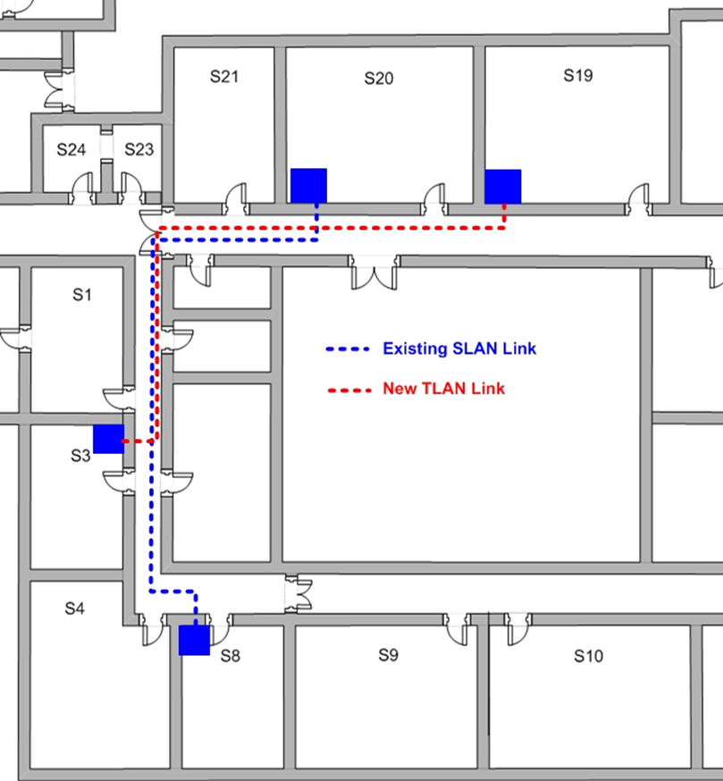

Annex C

S-19 and S20 Lewin Building

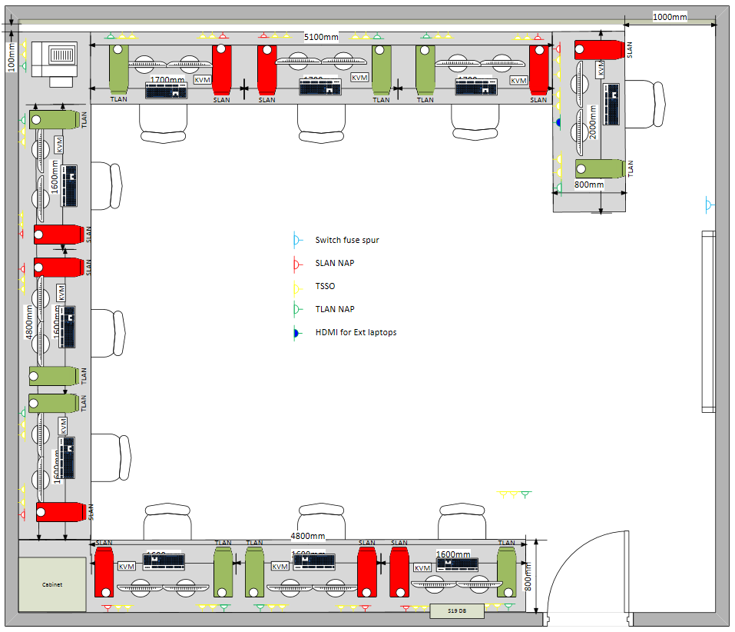

Annex D

Work Station Configuration

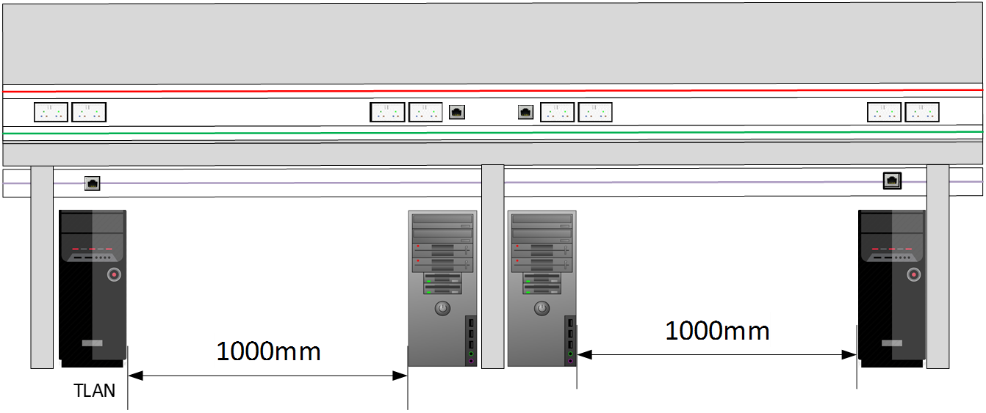

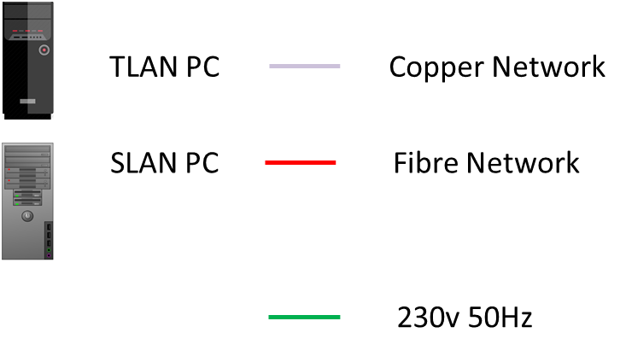

ANNEX E
Example ECR Form 2

 |  | CO-ORDINATING INSTALLATION DESIGN AUTHORITY  ENGINEERING CHANGE REQUEST  Part 2  CHANGE PROPOSAL & REQUEST FOR DESIGN ENDORSEMENT
Project Title:
Originators Ref No: |  |  |  |  | CIDA Ref No:
Proposed Start Date: |  |  |  | Anticipated End Date:

Location of Proposed Change:
Main Site: |  |  |  | Sub-site:
Building Name: |  |  |  | Room Names:
Building No: |  |  |  | Room Nos:
CIDA: |  | TSCIDA: |  |  |  | SCIDA:

SCIDA Details:
Name: |  | Post:
Address: |  | Telephone:
Address: |  | Fax:
Address: |  | e-mail:

Inventory of all supporting documentation:
 | Document Reference: |  | Document Title:
If proposed change is temporary, date due for removal:
PTO

ADATS Form 468 ‘MOD Radio Site Clearance Request’
iaw JSP 846 MOD Radio Site Clearance and Protection-UK  a completed F 468 is included with this proposal |  | Yes | No | Not  Applicable
If NO, state the reference relating to an earlier
submission or the reason for non inclusion
Cable Duct Route Approval:
An approval request for provision of, or change to, a duct or cable route is included with this proposal |  | Yes | No | Not  Applicable
If NO, state the reference relating to an earlier
submission or the reason for non inclusion
The on-site Duct Manager has been involved in this proposal |  | Yes | No | Not  Applicable
If NO, state reason for non involvement
Siting Board Findings:
The findings of the Siting Board associated with this ‘change’ are included with this proposal |  |  |  |  | Yes | No | Not  Applicable
If NO, state the reference relating to an earlier
submission or the reason for non inclusion
Associated Design Restrictions:
 | Equipment Involved: |  | Associated Restriction:
Change Designers Details & Statement of Conformance:
Name: |  | Post:
Address: |  | Telephone:
Address: |  | Fax:
Address: |  | e-mail:
This proposal conforms with the requirements of JSP 440 & JSP 480 as amended by any specific CIDA requirements established in response to Part 1.
Other Designers with a vested interest, as notified by CIDA, are content with this proposal.
Signature:
Signature: |  | Date:
### REVIEW PROTECTIVE MARKING REQUIREMENT ###
## BEFORE DISPATCH TO THE APPROPRIATE INSTALLATION CO-ORDINATOR ##

ANNEX F
Example ECR Form 3
 |  | DESIGN ENDORSEMENT of a  CHANGE PROPOSAL  issued on behalf of The Defence CIDA  RAF Henlow & Blandford Camp
 |  | Issued: |  |  | Valid For:
Main Town/Base: |  |  |  |  | CIDA Change Serial No::
Unit/Site: |  |  |  |  | Local Change Serial No::
Location:
Rooms: |  |  |  |  | System:
Proposed Change:
References: | - JSP 480 ‘Manual of Regulations for Installation of Communication & Information Systems’.  - Design Documentation Ref:  - JSP 440 ‘The Defence Manual of Security’.  - SDIP 29 ‘Facility Design Criteria and Installation of Equipment for the Processing of Classified Information’.
- In accordance with the requirements of Chapter 04 of Reference A, the change proposal detailed at Reference B has been assessed against the standards and mandates of References A, C and D.
- This design is Endorsed as fully compliant with all relevant regulations. [This statement OR following statement]
This design is NOT fully compliant with all relevant regulations. It is Endorsed on the basis of the Risk Management Statement identified below.
- Any deviation or amendment to that detailed in the design documentation at Reference B or the subject facility detailed above, subsequent to the issue of this Design Endorsement of a Change Proposal, is to be the subject of a re-submitted Change Proposal.
- This document is issued to the Change Designer and the Facility Owner as confirmation that the proposed change and its implementation will not breach any standards or requirements that are applicable to the facility. It has no contractual standing and is not to be construed as an Authority To Proceed (ATP). ATP may only be conferred by the Facility Owner in conjunction with the relevant Budget Holder.
- The CIDA requires written confirmation of the implementation of this Design Proposal.
Risk Management Statement Reference and Owner:
Issuing Authority  Post: |  |  | Name:  Signature:  Date:
THIS ENDORSEMENT IS TO BE AVAILABLE FOR INSPECTION BY  THE FACILITY OWNER |  |  |  |  |  | Version 16  Jan 11
### REVIEW PROTECTIVE MARKING REQUIREMENT BEFORE DISPATCH ###

ANNEX G
Example ECR Form 4

 | CO-ORDINATING INSTALLATION DESIGN AUTHORITY  ENGINEERING CHANGE REQUEST  Part 4  INSTALLATION COMPLETION STATEMENT
Project Title:
Originators Ref No: |  |  |  | CIDA Ref No:
Actual Start Date: |  |  | Completion Date:

Location of Change:
Main Site: |  |  |  | Sub-site:
Building Name: |  |  |  | Room Names:
Building No: |  |  |  | Room Nos:
CIDA: |  | TSCIDA: |  |  |  | SCIDA:
CIDA/SCIDA Details:
Name: |  | Post:
Address: |  | Telephone:
Address: |  | Fax:
Address: |  | e-mail:
Change Implementers Details & Certificate of Completion:
Name: |  | Post:
Address: |  | Telephone:
Address: |  | Fax:
Address: |  | e-mail:
Except for this Risk Management Statement, the proposal at Part 2 of this ECR has been completed in conformance with the requirements of JSP 440 & JSP 480.
Date by which ‘As Fitted’ drawings will be lodged with CIDA:
Signature:
Signature: |  | Date:
### REVIEW PROTECTIVE MARKING REQUIREMENT ###
## BEFORE DISPATCH TO THE APPROPRIATE INSTALLATION CO-ORDINATOR ##

