Isles of Scilly operational services team electric panel van
Specification for goods
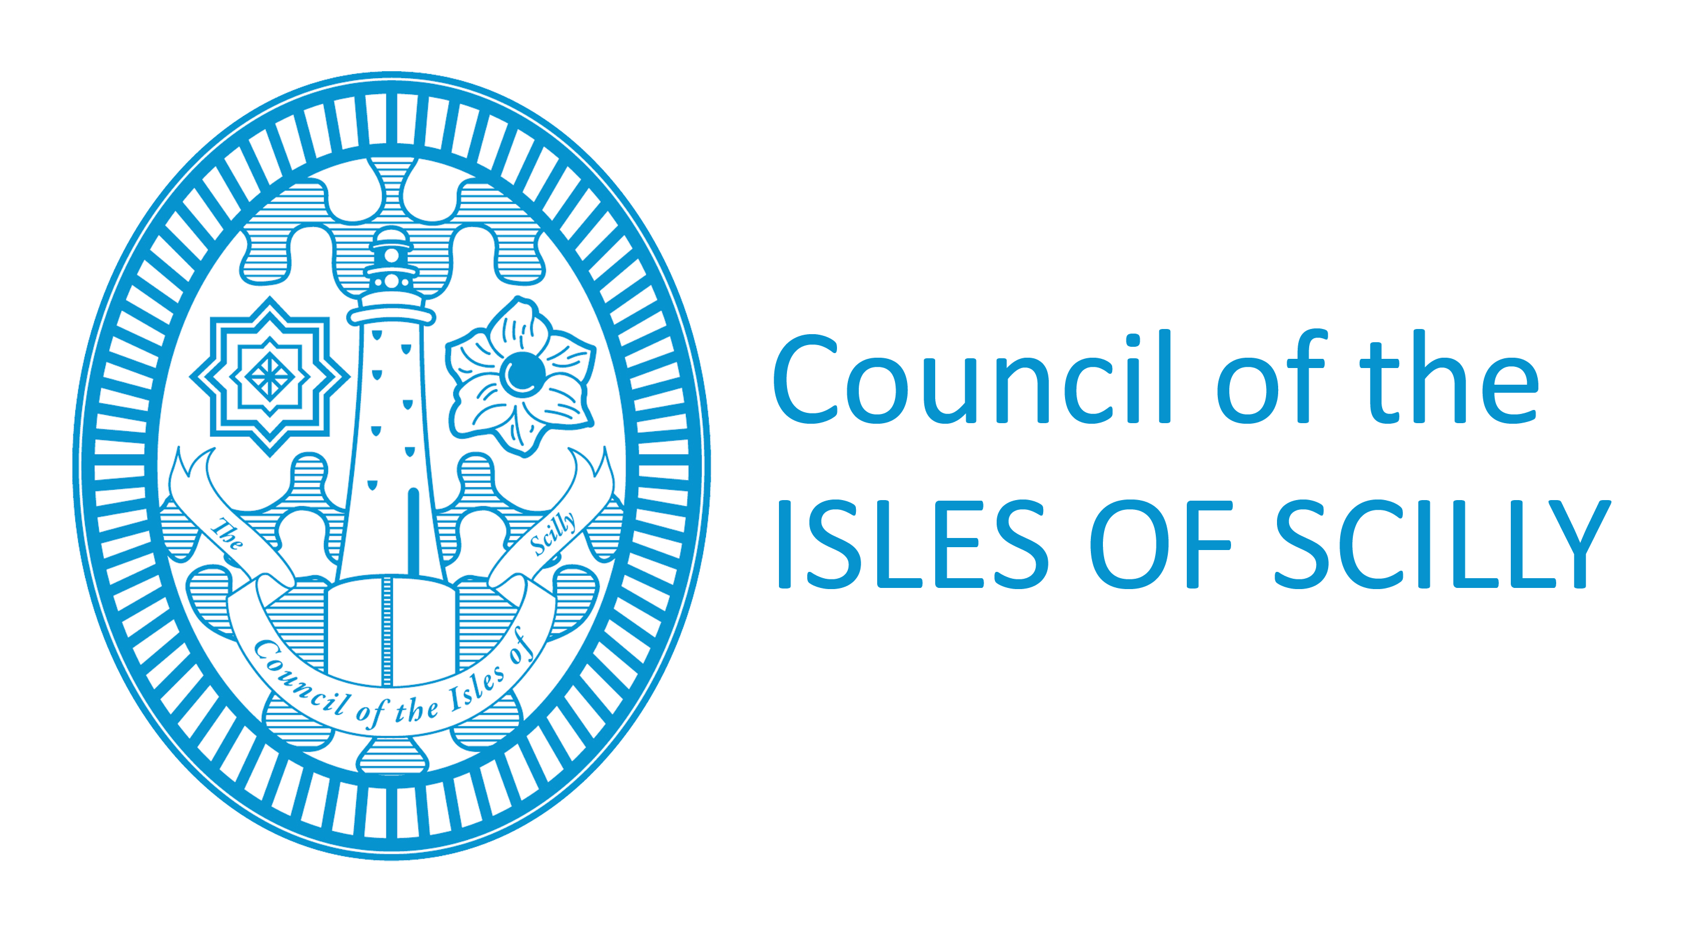
July 2026

Contents

- List of Drawings and Reference Materials
- Specification of goods
- Variations from specification (Variant bids)

1. List of Drawings and Reference Materials

Background

In line with the Council’s ambitions to be net zero by 2030 we are looking to procure an ex-demo electric panel van to be used by our Operational Services team on the Islands

2. Specification
We are seeking quotes for 1 (one)
Panel van
Short wheelbase of 2725mm
2020 or later model year
Less than 2500 miles
Fully electric battery power (40 Kwh battery capacity)
Possible 150 mile + range on single full charge
All charging cables
2 seats
Fully automatic gearbox
Rear view camera
Spare wheel
Tyre pressure monitoring system
Front & side airbags
Colour: White
Delivery to Penzance included

End of Specification

3. Variations from the Specification (Variant Bids)

The Council will not accept variant bids relating to this procurement.
Where variants are allowed, the participants will need to identify how the solution proposed provides an equivalent result to the materials, items, processes, methods or other aspects outlined in this specification (and any accompanying documents) for each and every variation from the specification. The participant shall also identify the means by which the equivalence can be verified (independently) by the Contracting Authority.

