**Appendix 16 to ITPD v1 20th October 2023**

**SME Guidance Document: Low Carbon Procurement Policy**

*Partnering with our Suppliers to reduce our carbon impacts*

* ***Why do we need the Policy?***

The eight local authorities in West London – Brent, Ealing, Hammersmith & Fulham, Harrow, Hillingdon, Hounslow, Richmond upon Thames, and Wandsworth – and West London Waste (the West London Authorities) have declared their climate emergency and set out their targets and goals in this regard. To reduce the impact on the environment though our procurement activity and mitigate climate change, we are being proactive in embedding low carbon considerations in our process.

* ***What is it about?***

The Procurement Policy, and the Toolkit that sits behind it, provides advice and guidance to procurers in the local authorities to reduce carbon emissions in the procurement cycle – planning, sourcing, and managing – to help them achieve the targets, set out in the climate action plans for each individual local authority. The toolkit aims to drive a coordinated and consistent approach across the Participating Authorities to Net Zero objectives, thereby reducing administrative burden and duplication of effort in trying to achieve a common goal.

* ***Where do I fit in?***

If each local authority is going to achieve its aims and targets on net zero carbon, they need the supply chain to collaborate – the overwhelming majority of our carbon impacts comes from the products and services we procure and use. We need your support.

* ***What should I expect as part of the tender process?***

As part of the procurement process, the local authorities will be including questions within the Supplier Questionnaire (SQ) and Invitation to Tender (ITT) on carbon-related topics such as embodied carbon, air quality and greenhouse gas emissions in the various stages of the manufacture, delivery, installation, use, and end-of-life for goods, works and services that you may provide. The questions have been made relevant to the nature, size of the organisation and the works, services and goods being offered.

* ***How do I respond?***

You will be expected to provide information on what you are doing to reduce carbon from your organisation and from the products and services you offer, both in general terms and specifically for the contract opportunity you are tendering for. For example, providing copies of your environmental / sustainability policy or strategy, action plans for reducing carbon emissions, resource efficiency and waste management plans, evidence of having delivered low carbon solutions for previous clients, and a willingness to works towards and supporting the local authorities in achieving their objectives in addressing climate change.

* ***Where do I get the right information and related documents relating to the low carbon toolkit?***

Please sign up to the WLA Low Carbon Procurement Charter – your signing of this document is a clear commitment to supporting any of the West London Authorities with whom you work, on initiatives to tackle climate change. You can also contact the authority to whom you are tendering.

**Examples of where and how lower carbon outcomes can be achieved, using the Carbon Hierarchy**

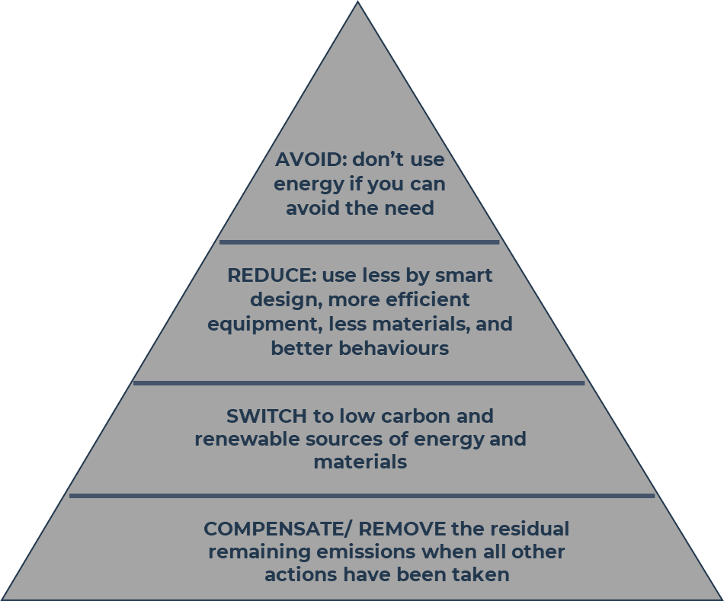

* **More efficient equipment and transport, e.g.**
  + Invest in energy-efficient equipment, e.g., lighting, plant & equipment, HVAC, IT
  + Upgrade vehicles and fleet to Euro 6 engines and plant to NRMM Stage V.
  + Go further to electric / hybrid powered vehicles.
  + Considered the associated air quality benefits
* **Consider the materials you are using, e.g.**
  + Use less materials in absolute terms – work with design and procurement teams to ‘lightweight’ the product.
  + Use Lean techniques to be more efficient and create less waste
  + Take an eco-design approach to enable easier maintenance, repair, upgrade and ultimately recycling of the products
  + Switch to alternative materials that have lower embodied carbon impacts, including greater recycled content. Enable innovation in design
  + Increase the reusability of the material or product – move away of single-use and disposable options, where possible
* **Improve behaviours and systems, e.g.**
  + Use Energy / Buildings Management Systems to monitor and automatically adjust for energy consumption
  + Install automatic switches and sensors to reduce use – make sure to check them periodically
  + Train colleagues and suppliers in how to use equipment efficiently, e.g.,
    - Choose the right equipment for the job – don’t over specify
    - Use correct power modes including in low / eco power modes
    - Turn off equipment that’s not being used. Avoid machine idling
* **Different ways of working**
  + Pursue different ways of reaching the same outcome that can lead to lower environmental impacts, greater output efficiency, and reduced safety risks.
    - Is there something in existence already that could be reused, retrofitted?
    - Can you use passive techniques such as natural light and heating?
    - Can it be achieved through a service instead of buying a product?
    - Can the service it be delivered remotely, rather than in person?
    - Can the components be manufactured offsite?