**Invitation to Quote for Stand Build**

**AHDB Exports Stand**

***Annual Meat Conference, Dallas, Texas, USA***

**Contact Name:** Event Lead: Katrina Thompson **Email:** [Katrina.thompson@ahdb.org.uk](mailto:Katrina.thompson@ahdb.org.uk)

Technical Lead: Susana Morris

**Company Name:** AHDB **Website:** [www.ahdb.org.uk](http://www.ahdb.org.uk)

**Address**: Stoneleigh Park **Tel:** 07773 167 523

Kenilworth

Warwickshire

CV8 2TL

United Kingdom

**Show Name:** Annual Meat Conference **Show Dates:** 6th – 8th March 2023 (exhibition opens 12:30pm on Tuesday 7th March until 5pm)

**Stand Number:** 1223

**Stand Size:** 10ft x 24ft (240sqf) **Open Sides:** 3

**Budget:** £35000-£40000

**Show Venue:** Hilton Anatole – [Show website](https://www.meatconference.com/content/exhibits)

**Deadlines:** Latest date forquestions/clarifications – 3rd January 2023

Quotation to be received by 10th January 2023

Award notification date – 13th January 2023

**Contract Period:** 13th January – 7th March 2023

1. **Introduction**

This document outlines the requirements for the AHDB Exports stand at Annual Meat Conference, Texas.

AHDB Exports are part of AHDB (the Agriculture, Horticulture Development Board) and based in Warwickshire, England. We are a non-departmental Government public body working to promote (Beef, Lamb & Pork) both at home and abroad.

For more information about our work visit [www.ahdb.org.uk](http://www.ahdb.org.uk) or <https://meattheukexporters.com/>

**2. Event Objectives**

To provide a platform for levy and/or non-levypaying meat producers to create new business relationships with international meat buyers and promote Beef, Lamb and Pork in the US market. UK exporters will utilise the stand for meetings and discussion opportunities. The overall stand design should maximise footfall in the exhibition hall, encouraging show visitors to engage with exporters and sample UK products.

**3. Stand Build Requirements**

The AHDB stand measures 10ft by 24ft, a total floor-space of 240sqf and is open on 3 sides. Full guidelines for event stand build are also attached.

The look and feel of the stand are important and must portray the quality of British meat (Beef, Lamb and Pork) and be clearly British. The stand should be open and inviting, encouraging visitors to engage and experience British products.

The stand will need to be seen from a distance and be visually appealing - high level branding should reflect GREAT branding, guidance in Section 5 below illustrates.

The objectives of the stand are to:

• Provide an impactful, visible platform promoting British meat.

Solutions incorporating sustainability and energy efficiency are encouraged in your response – note that all lighting should be low heat creating.

Stand build /breakdown timings are as follows:

* Exhibitor Move In
* Saturday, March 4 – 1:00 – 6:00 PM
* Sunday, March 5 – 8:00 AM – 5:00 PM
* Monday, March 6 – 8:00 AM – 5:00 PM
* Tuesday, March 7 – 8:00 AM – 11:00 AM
* Show Hours
* Tuesday, March 7 – 12:30 PM – 5:00 PM
* Exhibitor Move Out
* Tuesday, March 7 – 5:00 PM – 10:00 PM
* Wednesday, March 8 – 8:00 AM – 10:00 AM

The stand needs to have the following elements and provisions (to be used by AHDB staff and exporters)

* 1 x retail style chiller with display (all electrical installations can be ordered via GES [lfesby@ges.com](mailto:lfesby@ges.com))
* Welcome/ reception desk with lockable storage underneath - Hospitality package (soft drinks, tea and coffee, water cooler)
* Cooking station/ butchery demonstration space (“kitchen”) – please use induction hobs, the hotel cannot support open flames or deep fryers
* Plasma TV on the rear wall, with space for branding around the TV
* 2x Poser tables and 6x chairs
* Bin
* Electrical sockets for charging items

**Other –** the successful contractor will be responsible for arranging stand cleaning and waste removal pre/post show. There are communal wash and waste areas in the exhibition hall.

**4. Graphics**

AHDB will provide full and print ready artwork for all graphics.   
Top level branding (i.e. lampshade or banner) needs to be seen from a distance in all directions and draw people to our stand. This should be co-branded with GREAT (as per the below) – however GREAT branding can only feature at a right angle to other branding. See Section 5 below for more information on GREAT branding principles.

**AHDB graphic panels**

The theme will be based on Great British Beef, Lamb and pork using landscape images with livestock and/or food images. Our key message “Quality Meat from Britain” – will need to be shown in a prominent position.

Our unique selling point is based around a quality product and so graphics design needs to reinforce this message.

**5. GREAT Branding**

AHDB have agreed the following overarching principles for use of the GREAT brand at international events.

* Where the stand design does not incorporate a lampshade, AHDB will design a column or back wall which mirrors the agreed logo and brand hierarchy with GREAT as the primary brand.
* In this instance the GREAT header fascia must be clearly separated from the AHDB panels. Ideally there should be a physical gap no less than the same dimension as the height of the header fascia.
* Where this is not achievable the GREAT header fascia must be a definite different colour. If the AHDB background colour is blue, then the GREAT header must be white (or vice versa).
* The use of the GREAT Union Jack can be used within the AHDB stand design as a low- level way finder
* The use of product imagery is a key feature on AHDB stands but must not include a superimposed GREAT logo or be close to a GREAT logo.

The only permissible messaging referencing British produce within AHDB branded panels is as follows:

Quality Meat from Britain

It is possible to use implied messaging, particularly in images, where the prominence of ‘Britain’ and the provenance of the food is more ‘loudly’ stated.

* The Union jack can only be used in the following places (only one option per stand):
  + On a header panel, with the GREAT logo, with a clearly separate design to our panels
  + A small bus stop sign in an aisle (a separate panel)
  + On the front of a counter (when none of the above options are possible)

Branding hierarchy:

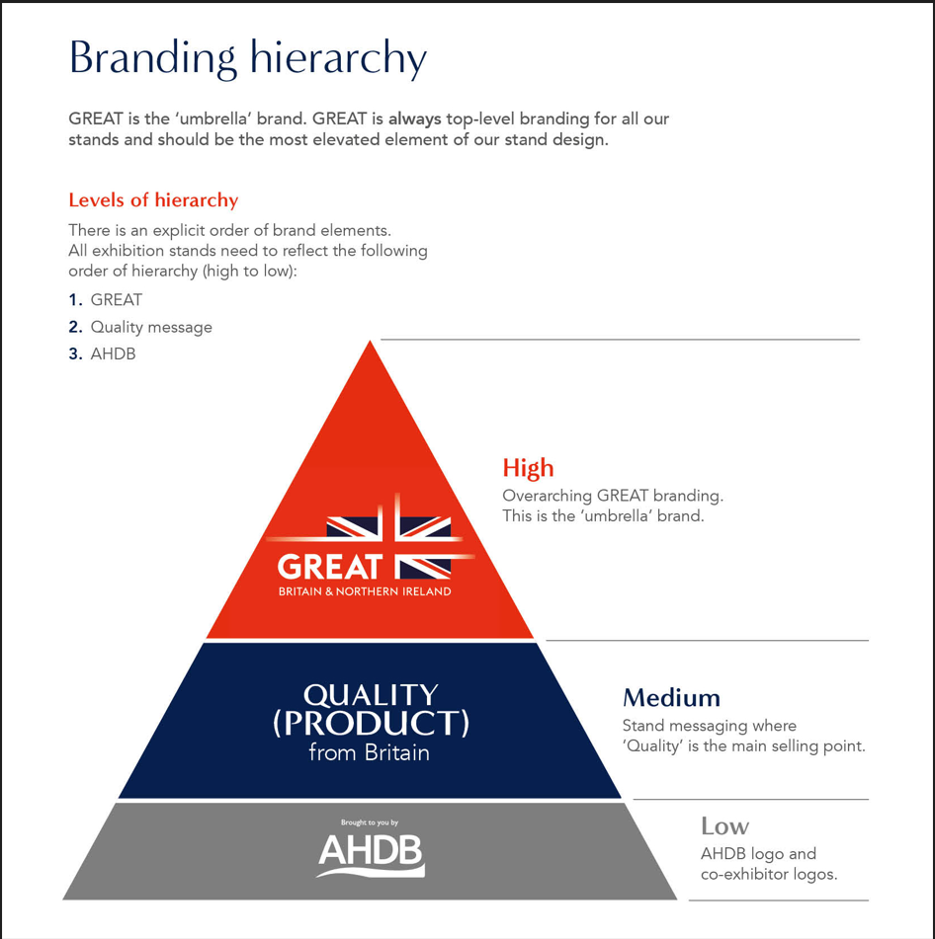

**6. Venue & Hall Plan**

AHDB’s stand indicated in red

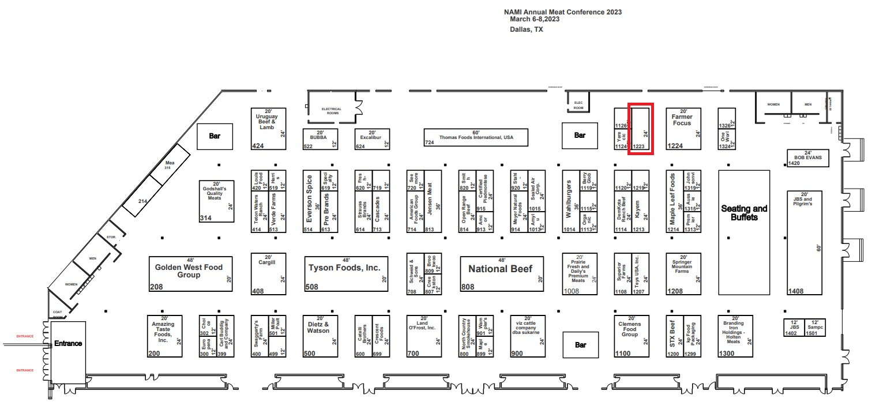

**7. Stand Layout & Design**

The visual below illustrates a previous stand of a similar size, effectively combining multiple elements i.e. info counter, chiller area, networking area and branding. Note that GREAT branding and graphic panel styles shown have been updated, ensuring you refer to Section 5 when considering your design.

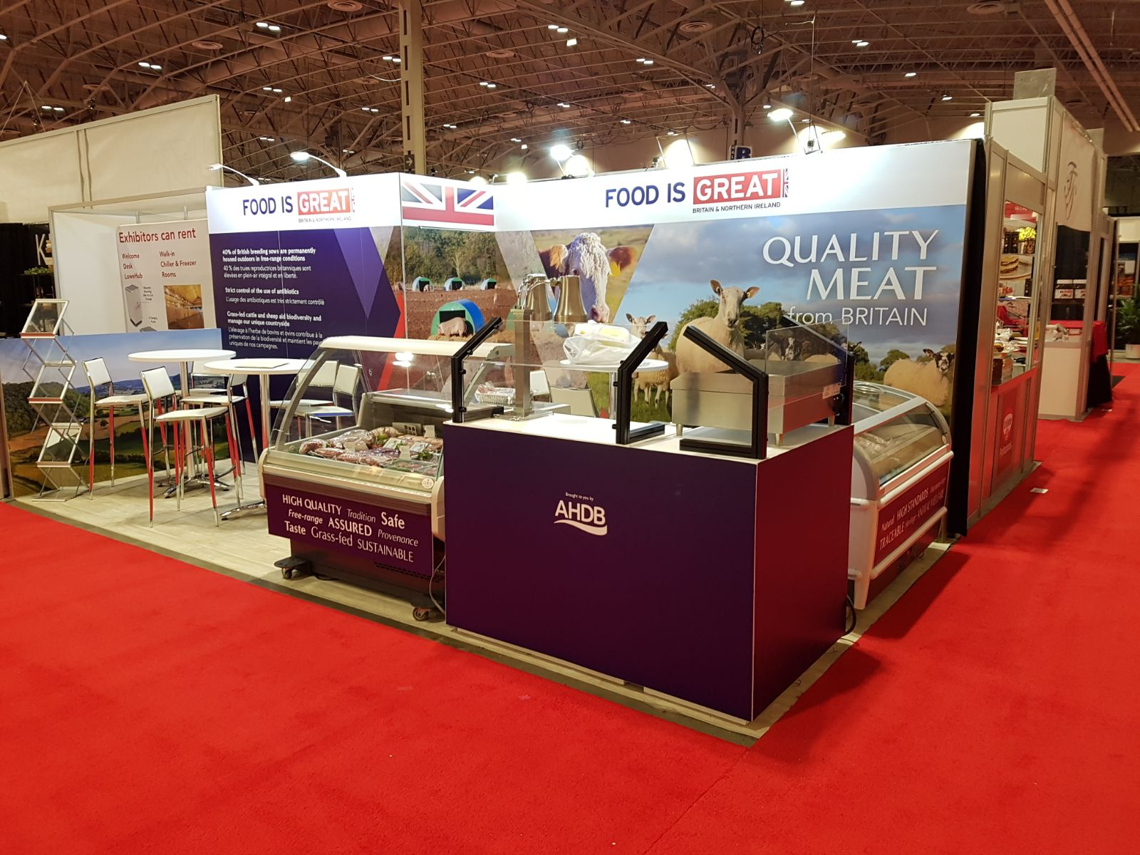

**8. Useful information**

The contractor will be responsible for completion and submission of organisers forms relating to the design and construction of the stand, including organiser design approval. A login for the exhibitor portal will be provided after the contract is awarded, and a copy of the exhibitor manual sent electronically.

**9. Tender Process**

The contractor shall deliver the whole of the services, complete in all parts and furnished with every necessary detail, notwithstanding any omission or inconsistency in the specification.

The quote should include ‘to scale’ visuals of your design and be clearly itemised for all services and provision; where possible split by area (cooking area, storeroom, partner areas etc.) stating if any sub-contractors will be used; graphic dimensions and artwork deadline.

Except as otherwise stipulated in the specific conditions of service required, the contract shall remain at the fixed price and rates shall not be revised.

AHDB’s Event Manager can order reasonable additions to, or reduce from, the service specified. These amendments shall be requested in writing and agreed by both parties.

**10. Evaluation of Tenders**

Our award criteria are:

* Understanding of the brief **20%**
* Price **25%**
* Design, creative impression and equipment **40%**
* Ability to meet event timelines, build-up and break-down **15%**

Please email your design proposals to Katrina Thompson [Katrina.thompson@ahdb.org.uk](mailto:Katrina.thompson@ahdb.org.uk) by Tuesday 10 January.

**11. Payment Terms**

Please note that all invoices submitted to AHDB require a purchase order number to enter onto our payment system. Our payment terms are 30 days from receipt of the invoice.