Invitation to Tender

Bowgie Inn, Crantock Newquay Cornwall, Extension to Existing Solar Panels

Ref: NZ752_1

1. About Bowgie Inn Limited

Perfectly perched on the West Pentire Headland, overlooking the golden sands of Crantock Beach, near the popular surfing and family destination of Newquay.
The Bowgie is the place where you can momentarily escape to a slower pace of life with mind-blowing views and an enviable cliff-top location.

The panoramic coastal views of the unspoiled beach of Crantock, Polly Joke, the Gannel and the dramatic headlands nearby, help to inspire and regenerate the soul.

The ‘Bowgie’ which is Cornish for ‘cowshed’ is one of Cornwall’s most well-known and loved pubs, and has one of the most incredible beer gardens in the whole country. Andy Pickles has proudly owned the pub for 50 years, and back in the 1970s, he used to grow potatoes in the field on the cliff edge to make the pub chips! You can still see some of the original features of the old farm building which The Bowgie once was up until the 1950s, and hidden gems and traditional charm can still be seen throughout the pub.

2. Background and Context

This procurement specification is part of the work to set out the requirements for a lower carbon, cost effective energy generation and monitoring system for the kitchen, bar and restaurant areas of the Inn.
The purchase of this system is part of a grant funded application process and therefore procurement will be subject to grant approval of the project. We will assess tenders received on a Most Economically Advantageous Tender.

3. Tender requirements

The successful tenderer will be expected to undertake the following activities:

  - General

    - Location: Bowgie Inn, West Pentire, Crantock, Newquay Cornwall TR8 5SE

3.1.2 Existing System and Load

The building currently has 68 units of 320 W panels (22 kW existing capacity) which are distributed into 3 arrays. The associated inverters are 2 kW (single phase), 4 kW (single phase) and 12 kW (three- phase). The highest electrical demand from the grid recorded on site is 37 kW.
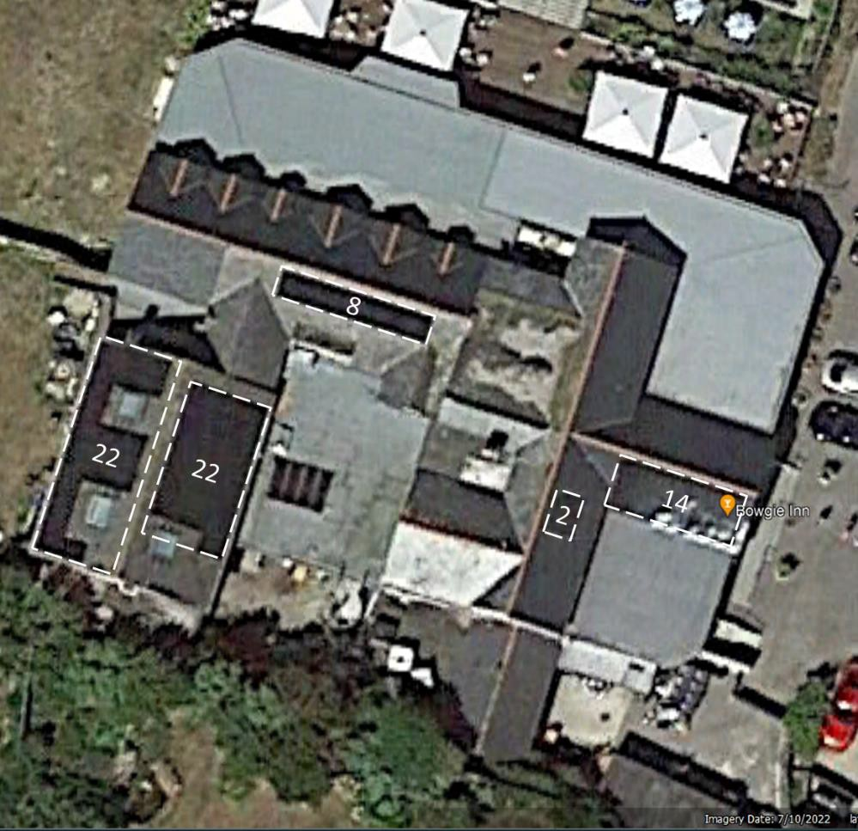

Arial view of Bowgie Inn with existing PV system
The number of panels are labelled in each region in the figure above.

The existing 3 systems are to be left as they are to avoid disruption to the FIT arrangements unless it can be shown there is an optimisation advantage to consolidation. Monitoring is proposed for installation in September.

  - New Additional System

    - The number of panels and dimensions are indicative, subject to detailed design and choice of PV module. P and L stand for portrait and landscape respectively. We assume the orange and blue arrays consists of different sized PV modules: 1.7 m x 1 m and 1.8 m x 1.1 m respectively, due to space limitation. The flat roofs were built in 2019 with a steel structure and are deemed suitable for PV installation. Contractors will be asked to provide their own structural assessment.

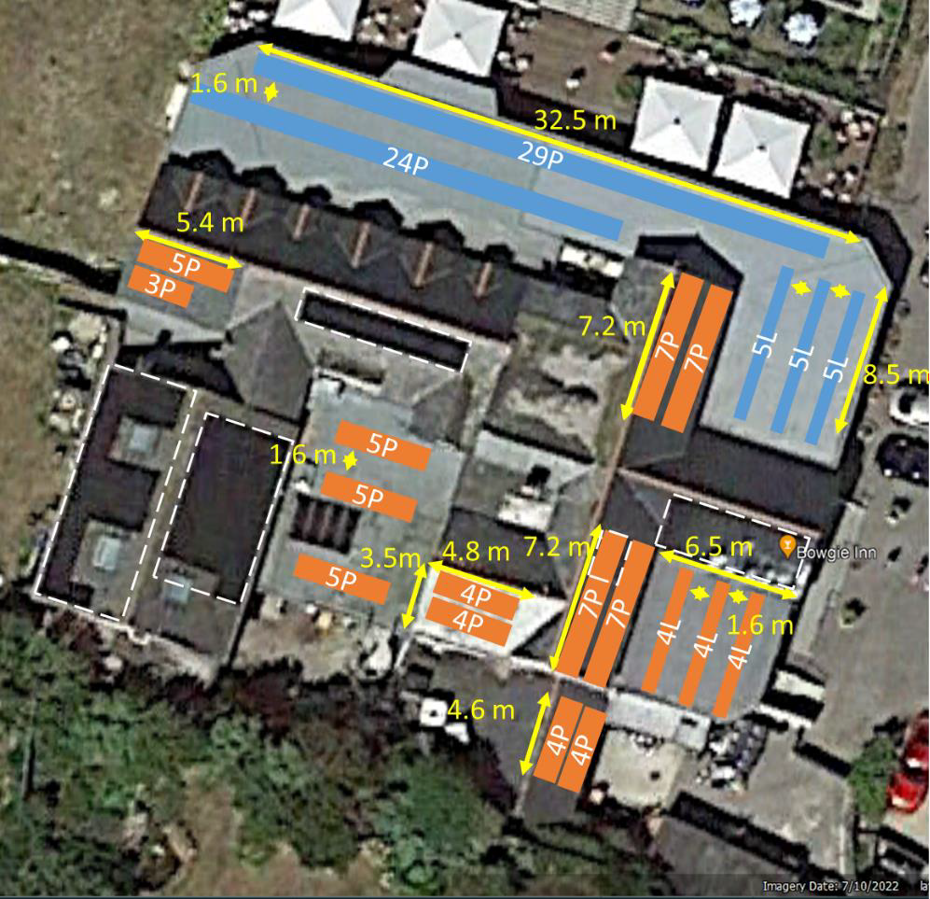

Arial view of Bowgie Inn with new PV system

    - An energy monitoring system which is being installed by Planet A independently and does not form part of this request.

  - Site Visit A site visit and structural assessment is strongly recommended to be conducted. This is be arranged as per Section 5.

  - Specific Requirements

3.4.1 Installation at our premises (3.1.1) and integration to our 3 phase electrical supply and existing solar panels

    - Maximum installed capacity of at least 40kWp

    - Maximum export capacity of at least 35 kWh/year

    - Preferred system but suppliers can provide alternatives providing they meet or exceed the specification and warranties.
- Trina 425W black frame modules
- SolarEdge inverter
- Solar Edge optimizers
- MCS Compliant On-roof mounting kit
- Electrical equipment system including cabling, connectors, AC and DC Isolators

    - Battery storage. 94.5kWh Battery storage with Tesla power wall: 7 x 13.5kWh

    - EV Charges. 2 x 22kW EV chargers.

    - All work to include:
- To design new arrays on the pitched roofs where feasible
- A new PV system including the PV modules and three phase inverters or (and) micro-inverters utilising the flat roof area.
- To configure the three phase inverter system(s) to the most cost-effective outcome
- Structural Assessment and Building Regulations Compliance
- District Network Operator Consent. To conduct the necessary G99 checks and application process with the DNO.
- System design
- Scaffolding and safe access system
- Compound and welfare facilities
- Mechanical handling of materials
- Waste Management; waste certificates to be provided as evidence the waste has been disposed of in accordance with any regulatory requirements
- Supply, installation and commissioning of solar PV system
- On site client training, instruction and handover

3.5 Warranties:
- PV units minimum 15 year product workmanship and 25 year power performance
- Inverters with minimum 12 year warranty
- Optimizers with minimum of25 year warranty
- Workmanship minimum warranty of 5 years
- Other equipment employed as part of the installation should clearly specify the length and type of warranties included

3.6 Service Contract with annual cost proposal
This will not form part of the tender assessment.

4. Budget

The total maximum budget available for this commission is £110,000.00 (ex VAT) but inclusive of all expenses.

Tenders that exceed the total budget will not be considered.

The budget will be reviewed as part of the tender evaluation detailed in Section 10 and will reflect the degree to which there is a saving on the maximum budget.

5. Tender and commission timetable

The timescale of the programme is from the date of signing the contract until acceptance by Bowgie Inn Limited authorised representative. The timetable for submission of the Tender, completion of the programme is set out below:

Milestone | Date
Date ITT available on Contracts Finder | 16 April 2024
Site Visit to be arranged with Sally Pickles sally@bowgie.com | 23 April 2024
Last date for raising queries | 1700: 30 April 2024
Last date for clarifications to queries | 1700: 1 May 2024
Deadline to return ITT | 1700: 15 May 2024
Evaluation of ITT | 16 May 2024
Preferred supplier notified | 20 May 2024
Award of Contract | This is subject to successfully obtaining grant funding and will normally be no later than 60 days from contract evaluation

6. Tender submission requirements

Please include the following information in your Tender submission.

6.1 Covering letter (two sides of A4 maximum) to include:

- A single point of contact for all contact between the tenderer and Bowgie Inn Limited during the tender selection process, and for further correspondence.
- Confirmation that the tenderer has the resources available to meet the requirements outlined in this brief.
- Confirmation that the tenderer holds current valid insurance policies as set out below and, if successful, supporting documentation will be provided as evidence:
- Professional Indemnity Insurance with a limit of indemnity of not less than two million (£ 2,000,000),
- Employers Liability Insurance with a limit of indemnity of not less than ten million (£10,000,000)
- Public Liability Insurance with a limit of indemnity of not less than ten million (£10,000,000).
- Products Liability Insurance with a limit of indemnity of not less than ten million (£10,000,000).
- Conflict of interest statement

6.2 Method statement to include the following:
- Supply, installation and commissioning of the new system/components, following all legal requirements and trade association codes.
- PV system design practices.
- Proposed illustrative layout of PV panels on roof.
- DNO application for grid connection. Responsibility for securing G99 agreement, and G100 if required.
- Installation of any additional sensors required to meet best practice.
- Supply of electrical installation drawings to integrate with existing system/3 phase supply.
- Manufacturer and parts of PV Panels and Inverter. (Section 3)
- Confirm terms of guarantee for parts and installation. (Section 3)
- How waste is going to be responsible and legally compliant.
- Evidence that you are a registered member of both MCS and RECC.
- Include structural report to confirm roof load capacity.
- The CV of the HS responsible person.
- Gantt chart or equivalent demonstrating the project timescales and any payment plan with associated milestones.

6.3 Previous work examples. Two examples of previous contracts of a similar size. Maximum of one side of A4 (pictures can be supplied separately but must contain no other text than labels; website links will not be viewed).

6.4 Budget

6.5 Service Contract with annual cost proposal

7. Sub-contracting

Tenderers should note that a consortia can submit a tender but the sub-contracting of aspects of this commission after appointment will only be allowed by prior agreement with Bowgie Inn Limited.

8. Conflicts of Interest

Tenderers must provide a clear statement with regard to potential conflicts of interests. Therefore, please confirm within your tender submission whether, to the best of your knowledge, there is any conflict of interest between your organisation and Bowgie Inn Limited or its programme team that is likely to influence the outcome of this procurement either directly or indirectly through financial, economic or other personal interest which might be perceived to compromise the impartiality and independence of any party in the context of this procurement procedure.

Receipt of this statement will permit Bowgie Inn Limited to ensure that, in the event of a conflict of interest being notified or noticed, appropriate steps are taken to ensure that the evaluation of any submission will be undertaken by an independent and impartial panel.

9. Tender clarifications

Any clarification queries arising from this Invitation to Tender which may have a bearing on the offer should be raised by email to:

sally@bowgie.com.

in accordance with the Tender and Commission Timetable in section 5.

Responses to clarifications will be anonymised and uploaded by Bowgie Inn Limited to Contracts Finder and will be viewable to all tenderers.

No representation by way of explanation or otherwise to persons or corporations tendering or desirous of tendering as to the meaning of the tender, contract or other tender documents or as to any other matter or thing to be done under the proposed contract shall bind Bowgie Inn Limited unless such representation is in writing and duly signed by a Director/Partner of the tenderer. All such correspondence shall be returned with the Tender Documents and shall form part of the contract.

10. Tender evaluation methodology

Each Tender will be checked for completeness and compliance with all requirements of the ITT. Tenders will be evaluated to determine the most economically advantageous offer taking into consideration the award criteria.
Tender returns will be assessed based on the following tender award criteria.
Ref 6.1 Covering Letter
Acceptable covering letter including confirmation of the requirements detailed at 6.1 | Pass/ Fail
Ref 6.2 Method Statement | 20
a. Supply, installation and commissioning of the new system/components, following all legal requirements and trade association codes.
b. PV system design practices.
c. Proposed illustrative layout of PV panels on roof.
d. DNO application for grid connection. Responsibility for securing G99 agreement, and G100 if required.
e. Installation of any additional sensors required to meet best practice.
f. Supply of electrical installation drawings to integrate with existing system/3 phase supply.
g. Manufacturer and parts of PV Panels and Inverter. (Section 3)
h. Confirm terms of guarantee for parts and installation. (Section 3)
i. How waste is going to be responsible and legally compliant.
j. Evidence that you are a registered member of both MCS and RECC.
k. Include structural report to confirm roof load capacity.
l. The CV of the HS responsible person.
m. Gantt chart or equivalent demonstrating the project timescales and any payment plan with associated milestones.

Ref 6.3 Previous work examples | 20
Two examples of previous contracts of a similar size. Maximum of one side of A4 (pictures can be supplied separately but must contain no other text than labels; website links will not be viewed).
Ref 6.4 Budget | 60
A fixed fee for this work (ex VAT) including travel and other expenses.

The lowest bid will be awarded the full 60 marks. Other bids will be awarded a mark that is proportionate to the level of their bid in comparison to the lowest bid i.e. Marks awarded = 60 x lowest bid / bid

11. Assessment of the Tender
The reviewer will award the marks depending upon their assessment of the applicant’s tender submission using the following scoring to assess the response:
Scoring Matrix for Award Criteria
Score | Judgement | Interpretation
100% | Excellent | Exceptional demonstration of the relevant ability, understanding, experience, skills, resource and/or quality measures required to provide the goods/works/services. Full evidence provided where required to support the response.
80% | Good | Above average demonstration of the relevant ability, understanding, experience, skills, resource and/or quality measures required to provide the goods/works/services. Majority evidence provided to support the response.
60% | Acceptable | Demonstration of the relevant ability, understanding, experience, skills, resource and/or quality measures required to provide the goods/works/services, with some evidence to support the response.
40% | Minor Reservations | Some minor reservations of the relevant ability, understanding, experience, skills, resource and/or quality measures required to provide the goods/works/services, with little or no evidence to support the response.
20% | Serious Reservations | Considerable reservations of the relevant ability, understanding, experience, skills, resource and/or quality measures required to provide the goods/works/services, with little or no evidence to support the response.
0% | Unacceptable | Does not comply and/or insufficient information provided to demonstrate that there is the ability, understanding, experience, skills, resource and/or quality measures required to provide the goods/works/services, with little or no evidence to support the response.

During the tender assessment period, Bowgie Inn Limited reserves the right to seek clarification in writing from the tenderers, to assist it in its consideration of the tender. Tenders will be evaluated to determine the most economically advantageous offer taking into consideration the award criteria weightings in the table above.

Bowgie Inn Limited is not bound to accept the lowest price or any tender. Bowgie Inn Limited will not reimburse any expense incurred in preparing tender responses. Any contract award will be conditional on the Contract being approved in accordance with Bowgie Inn Limited’s internal procedures and Bowgie Inn Limited being able to proceed.

12. Tender Award
Any contract awarded as a result of this tender process will be in accordance with this tender and supplier’s response.

13. Tender returns

Tenders are to be returned by email.

Tenders are to be returned in accordance with Section 5
Latest date to be returned: As per Section 5
Latest time to be returned: 17:00

Emailed tenders should be sent electronically to:

sally@bowgie.com

with the following message clearly noted in the Subject box;

‘Bowgie Inn, Crantock Newquay Cornwall, Extension to Existing Solar Panels’

Tenderers are advised to request an acknowledgement of receipt of their email.

14. Disclaimer

The issue of this documentation does not commit Bowgie Inn Limited to award any contract pursuant to the tender process or enter into a contractual relationship with any provider of the service. Nothing in the documentation or in any other communications made between Bowgie Inn Limited or its agents and any other party, or any part thereof, shall be taken as constituting a contract, agreement or representation between Bowgie Inn Limited and any other party (save for a formal award of contract made in writing by Bowgie Inn Limited or on behalf of Bowgie Inn Limited).

Tenderers must obtain for themselves, at their own responsibility and expense, all information necessary for the preparation of their tender responses. Information supplied to the tenderers by Bowgie Inn Limited, or any information contained in Bowgie Inn Limited’s publications is supplied only for general guidance in the preparation of the tender response. Tenderers must satisfy themselves by their own investigations as to the accuracy of any such information and no responsibility is accepted by Bowgie Inn Limited for any loss or damage of whatever kind and howsoever caused arising from the use by tenderers of such information.

Bowgie Inn Limited reserves the right to vary or change all or any part of the basis of the procedures for the procurement process at any time or not to proceed with the proposed procurement at all.

Cancellation of the procurement process (at any time) under any circumstances will not render Bowgie Inn Limited liable for any costs or expenses incurred by tenderers during the procurement process.

15. Enclosures

- Any supporting documents

