KITELANDS RECREATION GROUND GUIDANCE
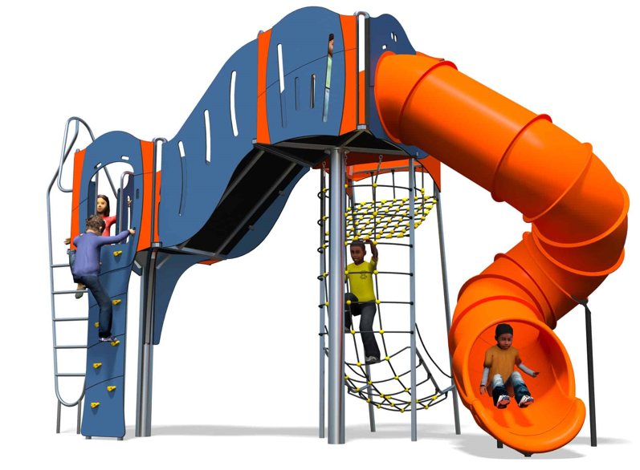 |  | 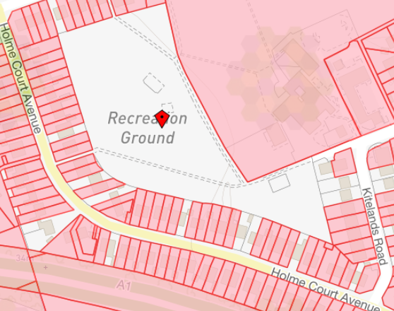 |  | 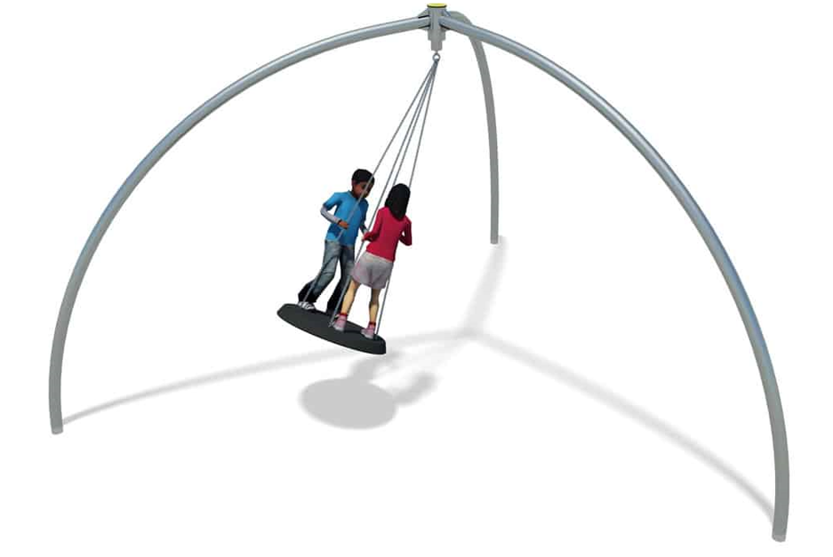
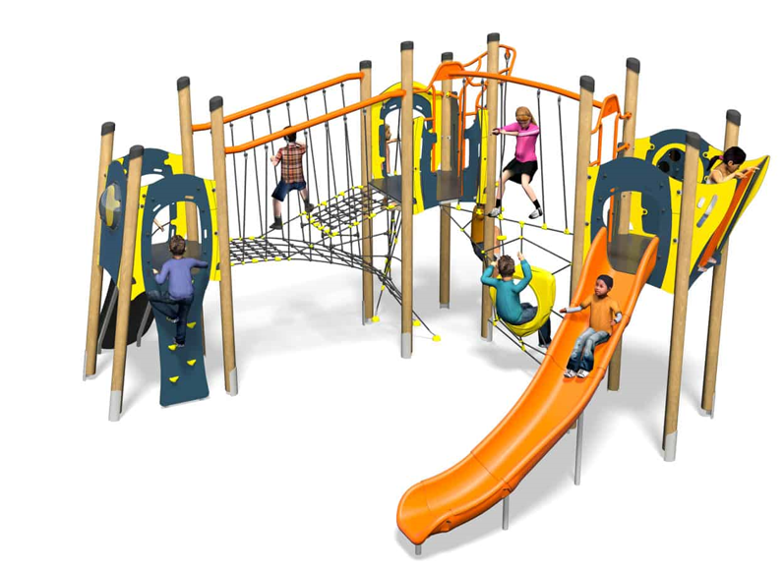 |  | 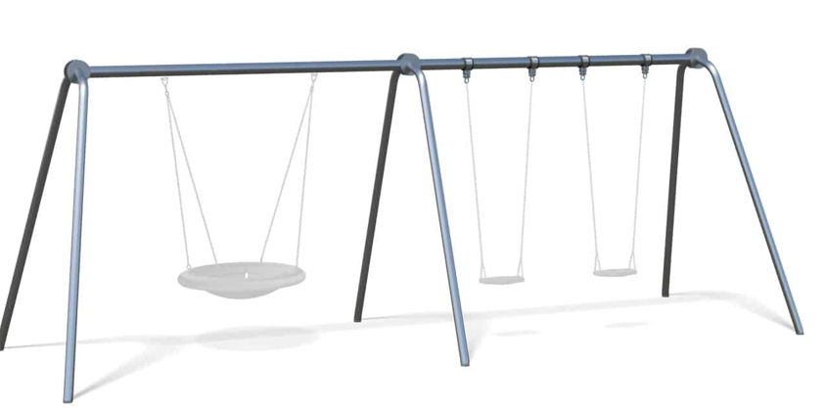 |  | 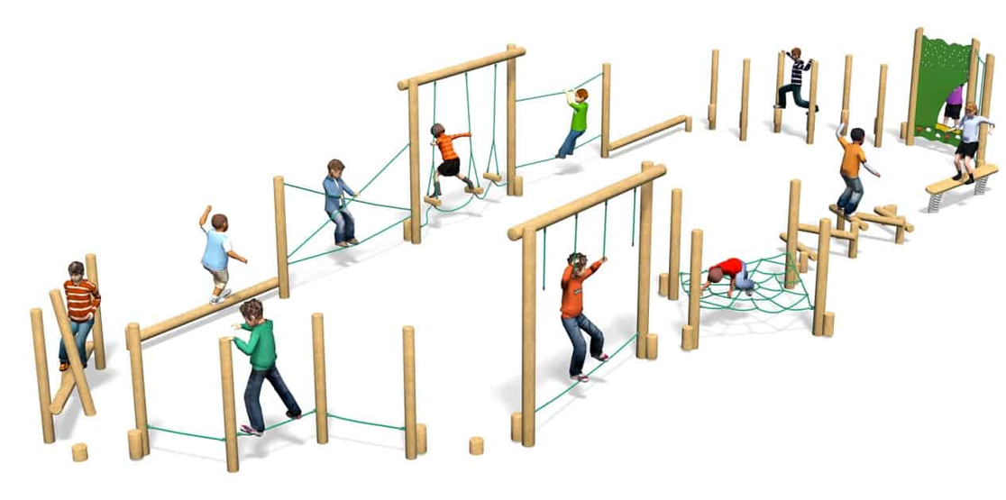

KITELANDS RECREATION GROUND
This large and pleasant green open space of circa 7 acres is a major focal point in Biggleswade and attracts heavy footfall, including from a neighbouring school. It is one of the largest recreation grounds in town. The grounds include distinct play areas, each catering to specific age groups from infant to teenager. The equipment in these areas has been recently inspected and is safety compliant.
The Toddlers’ Play Area includes some aged play equipment such as a Multiplay unit, Swings, Springers and Turnstile.
The Recreation Ground includes a MUGA area, Basketball Hoop, Goalpost, Multiplay unit, Double Zig Zag Twisters, Cableway, Swings, Space Net, Freeride, Hip Hop, Aeroskate, Supernova, Roundabout, Seesaw and Slide.
All of the existing play equipment is standing on mixed materials ground surfaces (wet pour) which due to age and wear and tear need replacing, preferably via installing new sustainable grass matting.

The Town Council has worked on a single project plan for the entire Kitelands Recreation Ground, to be delivered in two separate phases. For clarity, the tender includes both phases in a single project and is intended to provide some planning clarity to interested bidders. Each phase will need to be individually agreed with the successful bidder and two separate contractual agreements will be drawn up.
Bidders will need to provide a simple drawing and plan of Kitelands, setting out the proposed new equipment, surfacing and location and will provide an overall cost estimate for each phase of the project. The Town Council prioritises consideration of new play equipment which is inclusive of all abilities and ages.

Phase 1: The Toddlers’ play area equipment and surfacing will all need to be replaced in phase 1 of the project. The installation work can commence as soon as the successful bidder has been announced. The new play area will be relocated to the other side of the footpath where the main section of play equipment is. This is due to improving line of sight between play areas and thus overall safety.
Phase 2: The remaining play equipment in Kitelands will need to be replaced along with new grass matting installed, which will commence at a later date (TBC). Some existing play equipment (such as the zip wire) will remain in place due to its good condition, please ask for further details. Bidders should recommend new play equipment to complement the retained play equipment to achieve the greatest possible positive effect.

For any queries about this project, please get in touch with Mr Jonathan Woolley (Public Realm Manager) at Jonathan.woolley@biggleswadetowncouncil.gov.uk or on 01767313134.
Please see the following link for some photos of current play equipment at Kitelands Recreation Ground which will be remaining in place Recreation grounds and open spaces | Biggleswade Town Council

