Dawdon Cricket Club Invitation to tender. 4-bay changing room facilities

Seaham, Durham, SR7 7XL
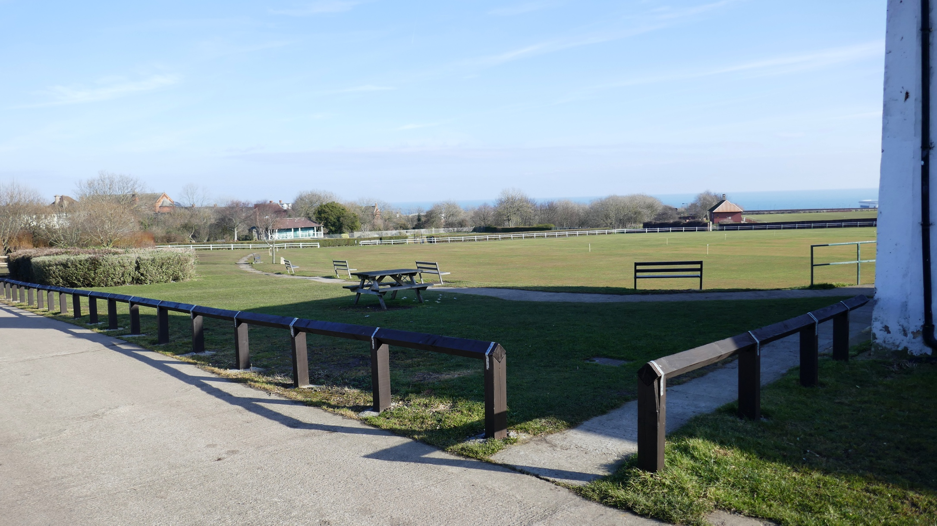
Appearance of area to receive prefab building. Table is loose.
Seaham Town Council (the client) wish to purchase a prefabricated modular building consisting of four 6m x 2.4m (20' x 8') bays, to be supplied and erected to SR7 7XL on or around 16/4/2018.

The new prefab will be 2.8m away from an existing club house as per the enclosed drawings pack.

- A local contractor (GC) shall prepare foundations and services ready for connection, also opening up the site for vehicular access.
- Hot water for showers and heating will be supplied via insulated PEX or similar pipes by GC.
- The drawings pack shows a provisional layout for your modular building. Other layouts are acceptable subject to compliance with Building Regulations.
- All loose equipment to be supplied by client.
- The client does not bind itself to accept the lowest or any tender.

Any queries:

Roger Vila

Address: Simulations Ltd., The Old Forge, Seaton Lane, Seaham SR7 0LS, UK

Email: rv@simulations.plus.com

tel: 0191 513 0077

