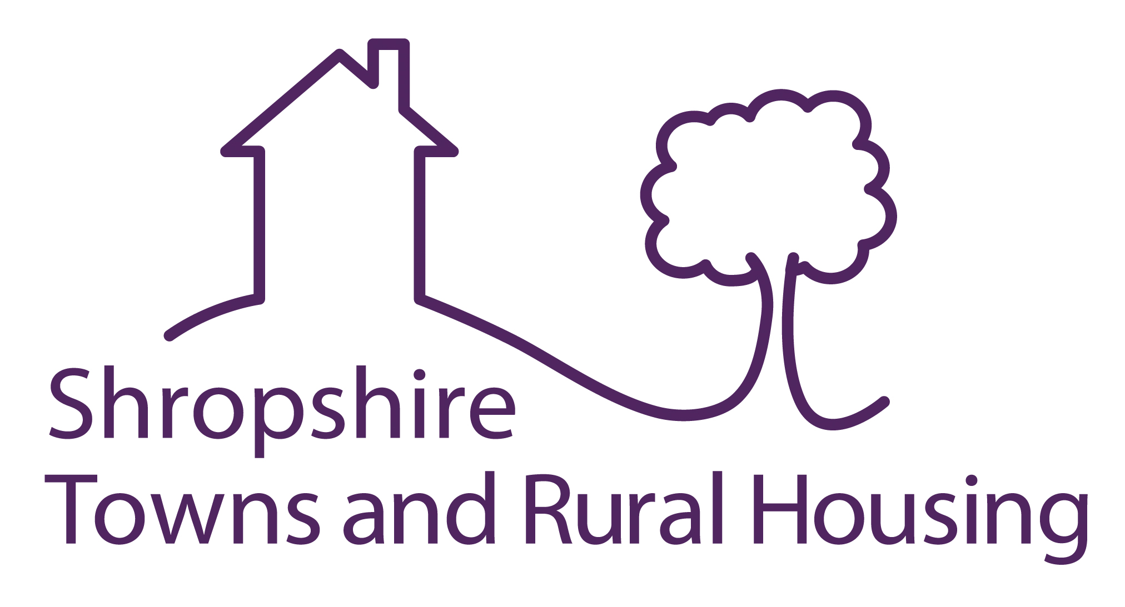

Shropshire Towns & Rural Housing Ltd

**INVITATION TO TENDER FOR EXTERNAL AUDIT SERVICES**

**Audit of Company Accounts for**

**Financial years April 2023 to March 2026**

**1. COMPANY OVERVIEW**

* 1. **OVERVIEW**

Shropshire Towns and Rural Housing Ltd is an Arms-Length Management Organisation that was formed on the 1st April 2013 as a Private Company Limited by Guarantee wholly owned by Shropshire Council to manage and maintain the Council’s retained housing stock.

We manage approximately 4,000 homes across the Oswestry, Shrewsbury and Bridgnorth areas on behalf of Shropshire Council under a 10-year Management Agreement. This includes general needs and supported housing properties.

Main services undertaken by the Company under the Management Agreement include:

Responsive repairs

Income collection

Asset management

Neighbourhood management

Supported Housing

Management of the HRA capital programme including new homes building and planned repairs.

Our annual turnover is in the region of £23.3m with income comprising of the Management Fee (£9m), Supporting People Grant (£0.3m), charges for services (£0.4m) and the works fee in respect of commissioning the Council’s HRA capital programme (£13.6m). We currently employ around 150 staff.

The Company has an in-house Finance Team, an IT Support Team and an HR function a number of other support service functions are currently provided by Shropshire Council under a number of Service Level Agreements (SLA).

The Company manages the Housing Revenue Account Capital Programme on behalf of the Council which includes all decent homes works, planned repairs and a new build programme.

The Company is governed by a Board of Directors of 10 members comprising of:

3 Tenant representatives

3 Shropshire Council appointees (Elected Members and/or Officers)

3 Independent members

1 Staff member

* 1. **BUSINESS PLAN & STRATEGY DEVELOPMENT**

Following the renewal of the 10-year Management Agreement in April 2023 a new Executive Team has been appointed. The Executive Team is currently working with Shropshire council to produce a new forward thinking, customer focussed Corporate Plan as well as a detailed Self-financing 30 year business plan for the HRA and a financial plan for STAR Housing in alignment with the HRA plan. These plans will be available during Q4 of the current financial year. The new plans will enable STAR Housing to better serve its tenants and communities as well as effectively meet the requirements of the Social Housing (Regulation) Act 2023. They will also ensure that the future for STAR housing and the Housing Revenue Account is financially sustainable.

The approved budget for STAR housing for 2023/24 is attached at Appendix 1. It should be noted that this is currently being restructured to reflect changes in operational structure and practices.

**1.2 COMPANY SENIOR MANAGEMENT & FINANCE TEAM STRUCTURE**

The Company’s Senior Management and Finance teams are all based centrally in Shrewsbury and a structure chart is attached as Appendix 2.

Regional teams are based in Bridgnorth and Oswestry to undertake customer facing services such as and neighbourhoods and tenancy management and responsive repairs.

**1.3 FINANCIAL SYSTEMS**

The Company’s Financial Year runs from the 1st April to 31st March. A detailed budget is prepared on an annual basis and is approved at service summary level by the Board in February each year.

STAR housing uses Unit 4s ERP as its primary finance system and Monthly Management Accounts are produced from May onwards each year and are circulated to budget holders and senior managers. Quarterly management accounts are reported to the Finance, Audit & Risk Sub-Committee.

The Executive team has recently put in place a finance improvement plan to ensure that levels of financial literacy and the quality of finance and performance reporting are heightened throughout the business.

**1.4 INFORMATION AND COMMUNICATION (ICT) SYSTEMS**

The Company directly employs a small IT Team to provide system support and administration for the Open Housing system and management and support of devices and software to enable mobile working. Other aspects of the ICT function are currently procured via an SLA with Shropshire Council.

Some of our key systems are:

* ERP (Unit 4 - general ledger, purchase and sales ledgers, payroll & HR)
* Open Housing (CAPITA – Housing Management System)
* Dynamic Resource Scheduler (Repairs Scheduling)
* InfoSuite and InSight (Reporting Systems)
* MobileIron (Mobile Device Management platform)

**1.5 RISK MANAGEMENT**

Risks that may prevent the Company from achieving its objectives are considered and reviewed by the senior management team as part of the business planning process. These risks are assessed in terms of their probability and impact and appropriate controls identified. The subsequent Strategic Risk Register is reviewed quarterly by the senior management team and reported to the Finance, Audit & Risk Committee and the Board.

**2.0 EXTERNAL AUDIT TENDER SPECIFICATION**

**2.0 CONTRACT TERM**

The contract for the provision of external audit services will officially commence on the 1st December 2023 and the appointment of the auditor will be confirmed at the STAR Board to be held on 27th November 2023.

The initial contract will run from 1st December 2023 to 30th November 2026 and will provide for audit of the Company accounts for three financial years from April 2023 to March 2026.

The external audit service will be subject to an annual performance review by the Finance, Audit & Risk Committee. The external auditor will be appointed for an initial term of three years but, subject to satisfactory performance, may be re-appointed for a maximum period of up to five years by mutual agreement.

**2.1 SCOPE OF AUDIT SERVICE**

The scope of this tender covers the statutory audit of the financial statements of Shropshire Towns and Rural Housing Ltd.

The external audit will consist of both an interim and final audit.

The external auditor will be required to attend meetings of the Finance, Audit & Risk Committee to present on the following audit work:

- Proposed Annual Audit Plan (anticipated in April)

- Final Audit Completion Report / Management Letter (anticipated in June)

All Board and Committee meetings are typically held in normal office hours, although there may be a requirement to attend evening meetings if necessary.

The external audit team will need to work closely with the Company’s Finance Team and the Company’s Internal Auditors to review and plan the scope of the audit and to meet as and when required.

**2.2 LIAISON WITH INTERNAL AND GROUP AUDITORS**

The Company has appointed Shropshire Council as its internal auditor working to an audit plan driven by the Company’s risk assessment and approved annually by the Finance, Audit & Risk Committee.

The external auditor will be required to co-ordinate and plan the external audit work after taking account of work undertaken by the Company’s internal auditor. The external auditor will also be required to work with Shropshire Council’s auditors in relation to Group Accounts audit requirements.

**2.3 AUDIT METHODOLOGY**

The audit methodology should be detailed annually in the Audit Plan and agreed with the Finance, Audit & Risk Committee. The external auditor should adopt a methodology that ensures an efficient and robust approach to auditing and be able to demonstrate a process of continuous improvement and the ability to produce quality reports to a high standard and on time.

**2.4 AUDIT EXPERIENCE AND SECTOR COVERAGE**

The composition of the external audit team should include staff at all levels with suitable knowledge and experience of the social housing sector and organisations of a similar nature to Shropshire Towns and Rural Housing Ltd.

Your tender submission should highlight any relevant experience your firm has with auditing social housing or similar accounts.

The external audit team should be of a sufficient size to effectively manage the audit of the Company in a timely manner, in particular the completion of the final audit process. We would welcome suggestions as to how the audit process can be managed and the number of days on site to ensure the minimum disruption to the on-going financial management of the organisation.

Your tender submission should include details of the audit team that you would propose using on this audit, including as a minimum the lead partner and audit managers/seniors.

**2.5 INTERNATIONAL FINANCIAL REPORTING STANDARDS (IFRS)**

Your tender document should detail the approach you would take to working with the Company’s Finance Team on the implementation of Finance Reporting Standards. This should include your view on the key areas to be covered, and how you would report new and emerging issues to the Finance, Audit & Risk Committee.

**2.6 REFERENCES**

As part of your tender submission we would like you to provide contact details for two referees that you would be happy for us to contact as part of the tender evaluation process

**2.7 INSURANCE COVER**

The external auditor should have suitable cover in place for professional indemnity, employers and public liability cover. Your tender should include details of the level of cover currently in place within your firm.

**2.8 GENERAL DATA PROTECTION REGULATION (GDPR)**

Your tender submission should identify how you will ensure compliance with GDPR in respect of information and data relating to Shropshire Towns and Rural Housing Ltd.

**3.0 TENDER PRICE**

Your tender submission should clearly indicate the audit fee for the first year (the base price). Your tender submission must clearly indicate any proposed annual increase, if any, that will be applied to the first year base price.

Your tender submission should provide clarity and transparency on the fee that you are proposing to undertake this service. It should therefore include details on the following:

- Number of audit days allowed for within the tender price broken down by audit team and how you would propose this be allocated

- The number of audit days that you would envisage being on site for the interim and final audits

- Details on which staff would attend Finance, Audit & Risk Committee and, Managements Board of meetings

- Time allowed within your tender price, for meetings with the finance team staff and Board members outside of the interim and final audits

Prices agreed following tender award shall remain firm and fixed for twelve months from the date the contract is awarded and must not be subject to any variation

**4.0 EVALUATION OF TENDERS**

Shropshire Towns & Rural Housing Ltd will evaluate tenders based on a combination of the quality of the submissions received in respect of the specification identified above and overall pricing.

The successful firm will be notified in writing following our Board Meeting on 27th November2023.

**5.0 DEADLINE FOR SUBMISSION**

Your completed tender must be received no later than **midday on Friday 10th November 2023**.

Tenders should be marked **Private & Confidential – Tender Documents DO NOT OPEN** and submitted by post to:

Corporate Director

Shropshire Towns and Rural Housing Ltd

Mount McKinley

Anchorage Avenue

Shrewsbury Business Park

Shrewsbury

Shropshire

SY2 6FG