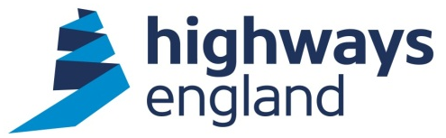  Our ref: HE/CCSRM3745/4  Your ref:  HKA Global LTD  FAO Harry Colledge  Via Email | Cat Bensley  1st Floor  Woodlands  Manton Lane  Bedford MK41 7LW  Direct Line: 0300 470 4766  Date: 15 December 2020

OFFICAL – SENSITIVE

Award Letter - CCS RM3745 – Complex Infrastructure Programme Independent Commercial Review

Dear Harry

On behalf of Highways England, I am writing to accept your recent offer to carry out the above-mentioned Package Contract within the terms of the Crown Commercial Services RM3745, Lot 7.

The commencement date is stated in the attached Call Off Order Form. This Package Contract will be operated on a cost reimbursable basis and will be paid in line with the Framework daily rates of your key people.

You should note that we will not pay for any work unless it has been specifically authorised in writing within the terms of the Agreement.

This award is subject to confirmation that the Key People you have offered in your tender will be available to start the project.

Invoices should be sent as a PDF file to FS Payments at Highways England via invoices@highwaysengland.co.uk. The invoice should quote the Project Manager’s name and Purchase Order number, which will be obtainable from the Project Manager.

Please note you must not make any public announcements and all media enquiries should be directed to the Highways England Press Office.

Please acknowledge receipt of this letter via email.

Yours faithfully,

Cat Bensley
Procurement Partner

Redacted under section 40 FOIA 2000 exemptions: personal information.

