
Redimo2 Supplier Guidance – Education & Children’s Social Care Framework (ECSC) membership The Dynamic Purchasing System
February 2016
Contents
1 Introduction 3
2 Accessing the ECSC framework 4
2.1 Registering your interest 5
2.2 Raising an enquiry 5
2.3 Withdrawing your interest 6
3 Viewing your ECSC application form 7
4 Completing your application 8
4.1 Downloading the documentation 8
4.2 Classifications 8
4.3 Mandatory Questions 9
4.4 Submitting your application 9
5 Reviewing/Updating your category codes 10

1 Introduction
The ECSC Framework is a platform within Redimo2 for the Department for Education to procure associates with specialist skills specific to Educational & Children’s Social Care Services. Membership to the framework allows associates to receive invitations to bid for opportunities against the skill sets (referred to as categories) they have applied for. The ECSC Framework will expire in March 2020.
This Framework allows the Department for Education to effectively engage with a range of professionals across a variety categories including: Assessors, Brokers, Coaches, Children's services commissioners, Children's social care intervention advisers, Development of practitioner networks, Evaluators, Facilitators, Mentors, Practitioners, Programme design and development, Quality assurance, Researchers, Speakers, Operational development and delivery, Trainers and Writers.

2 Accessing the ECSC framework
Please log onto the supplier self service area of Redimo2 via the following link:
https://supplierlive.proactisp2p.com/Account/Login/?cid=DFE
NOTE: If you have yet to register on Redimo2, please find guidance on how to do this on the GOV.UK website
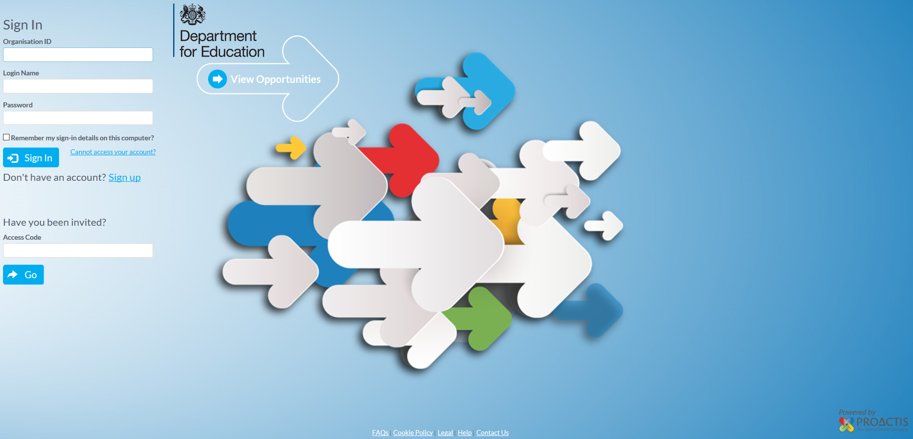
Once on the main homepage, please navigate to the opportunities section, either by selecting the button in the centre of the screen or selecting the option on the vertical toolbar.
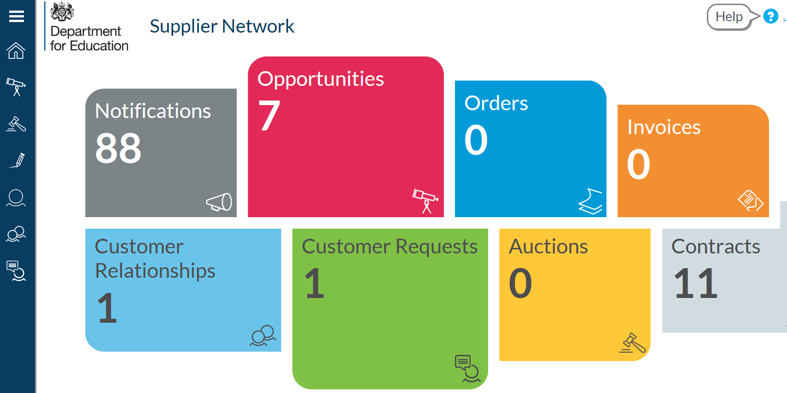
To view all departmental opportunities, please search for ‘Department for Education’ in the search facility provided. This will include the ‘Education and Children’s Social Care (ECSC)’ advertisement.
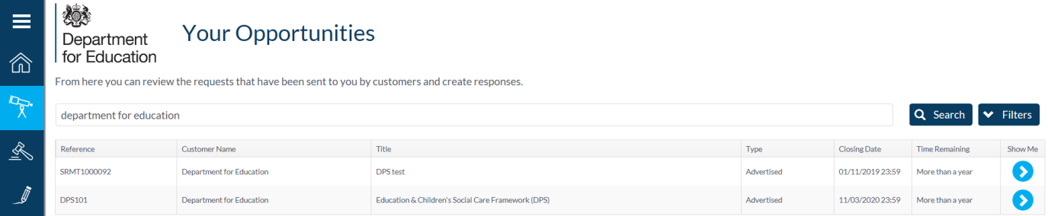
To read more about this opportunity, please click the corresponding ‘Show Me’ arrow in the far right column.

2.1 Registering your interest
To register your interest, simply access the full notification (as directed in section 2) and click the ‘Register Interest’ button.
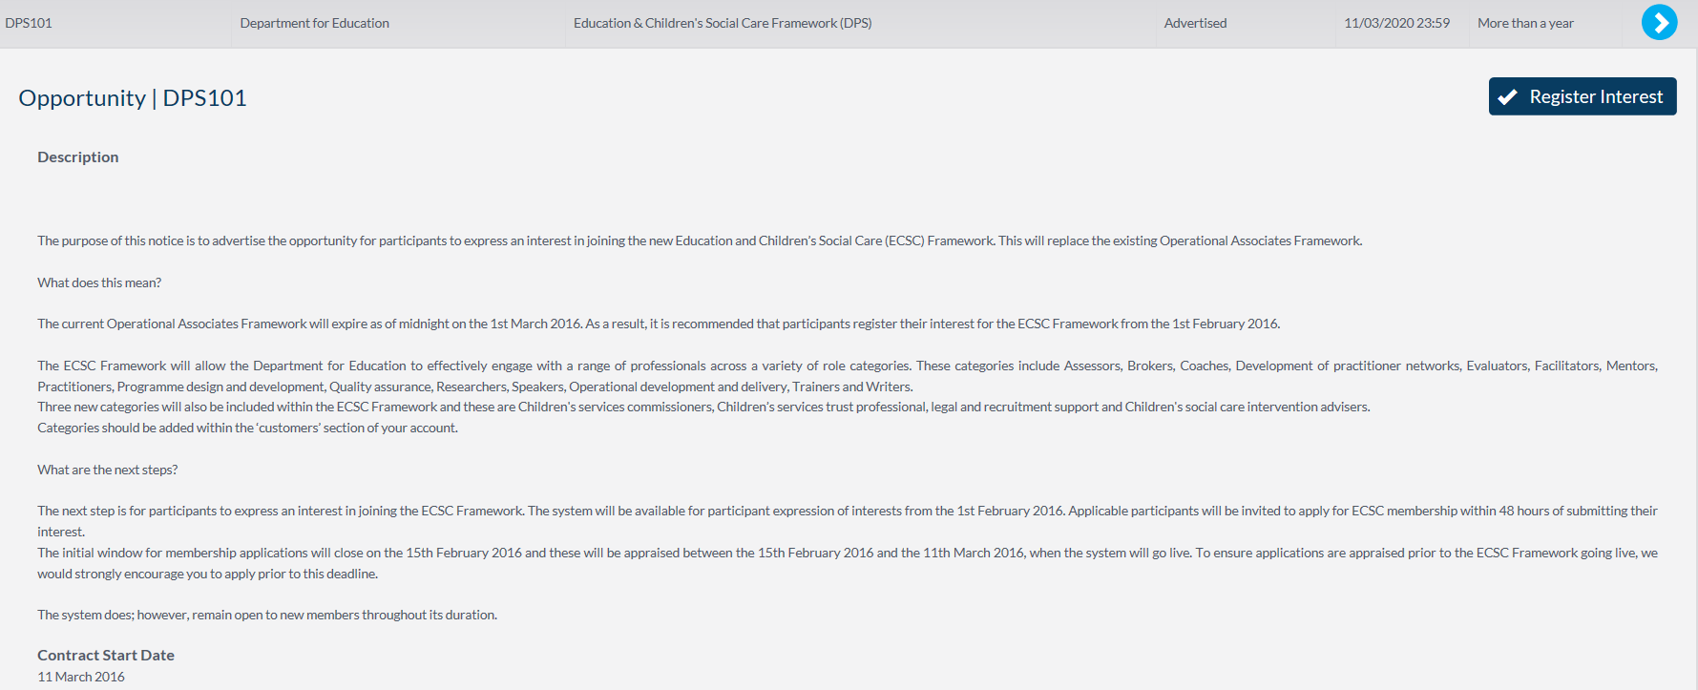
This will notify the system administrators of your interest in becoming a member of the framework. The administrator will then send you an invitation to apply for membership via a system generated e-mail.
The SLA for extending this invitation is 3 working days. If you fail to receive this invitation within this window, please contact commercial.contactpoint@education.gsi.gov.uk .

2.2 Raising an enquiry
Once you have registered your interest (see 2.1), you are able to raise enquiries via the system relating to this DPS. This can be done by clicking the ‘new message’ button.
It is however advisable on this occasion that you contact the commercial contact point directly (see above) as this mailbox is monitored daily.

2.3 Withdrawing your interest
Once you have registered your interest (see 2.1), you may withdraw your interest at any time by clicking that replaces it called ‘withdraw interest’.
Please note that once you have withdrawn interest, you cannot re-register your interest without contacting the system administrator to request re-instatement.

3 Viewing your ECSC application form
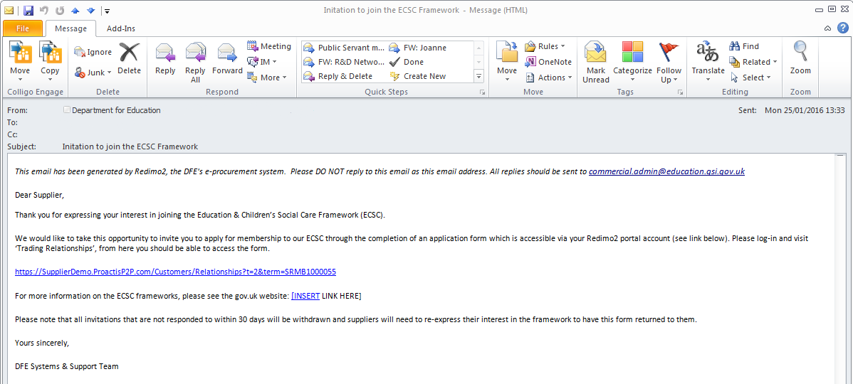
Upon receipt of your invitation, please follow the link in the e-mail to the ‘Requests & Relationships’ section of your self-service account:
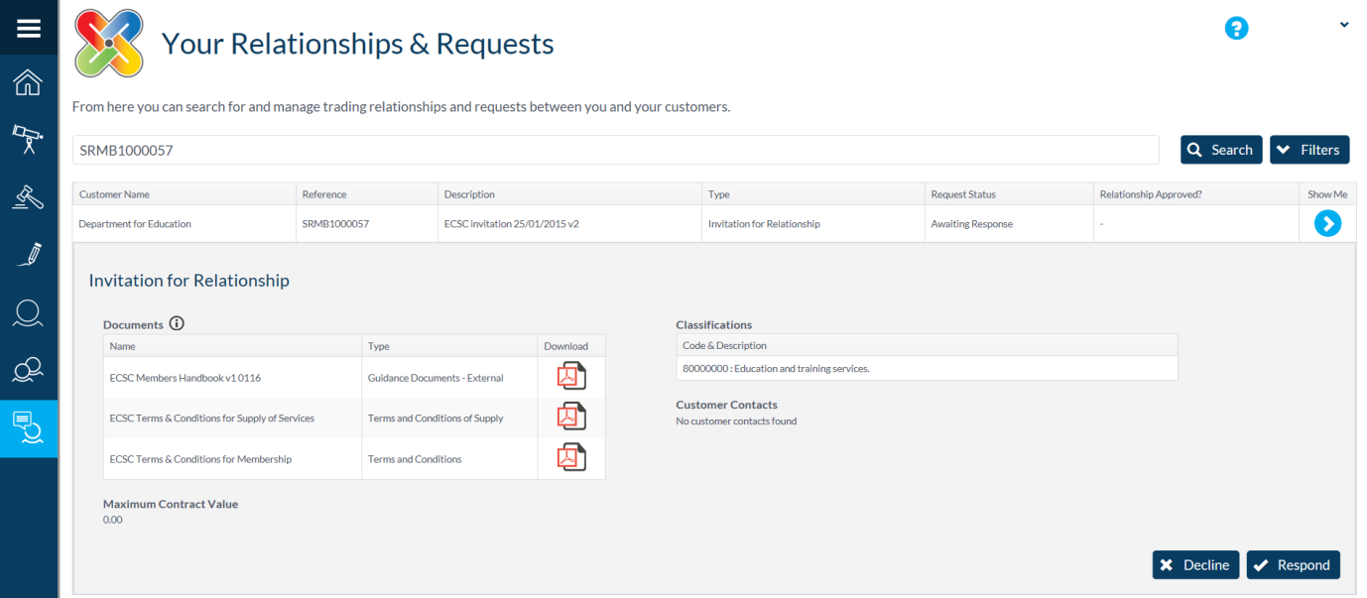
NOTE: The link you receive is unique to your account and should not be shared. You will need to be signed into the portal for the link to work.
On this page you will be able to obtain further information around the framework and decide whether you wish to apply to be a member.

4 Completing your application
It is essential that you read all available documentation prior to deciding to whether or not to apply.
To apply, please click  in response to the invitation received.
Conversely, should you decide you no longer wish to be considered for this framework, please click .

4.1 Downloading the documentation
There are two places where you can download the documents relating to both the framework and the application process:
On the main Relationships & Requests page – You will find all documentation listed in the invitation summary. To download each document, please click on the corresponding file icon, such as .
Within the application form – If you have already begun your application (by clicking respond), the documents can be found on the ‘General’ tab. Directly below the tabs, you will find a collapsed section called ‘documents’, please click the arrow to expand the section and then download the documents by clicking on their corresponding file icons, such as .
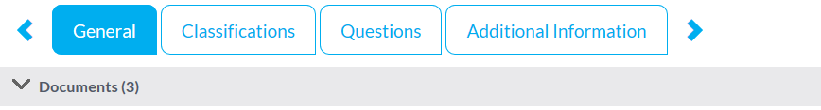

4.2 Classifications
As part of your application, you will be required to declare that you are able to deliver against one of the two CPV classification codes to which this framework is based upon. They are:
- 80000000: Education & Training Services
- 85300000: Social work and related services
To declare you can deliver one or more of these types of services, please ensure you tick the corresponding declaration boxes on the right hand side of the ‘classifications’ tab.
NOTE: Failure to successfully declare against one of these codes will lead to the rejection of your membership application.

4.3 Mandatory Questions
The next tab is the questions tab, which contains all the remaining actions required to obtain membership onto the framework. The 5 questions are split into two parts: ECSC Terms & Conditions & ECSC Declarations. In this area you are require to do the following in order for your application to be approved:
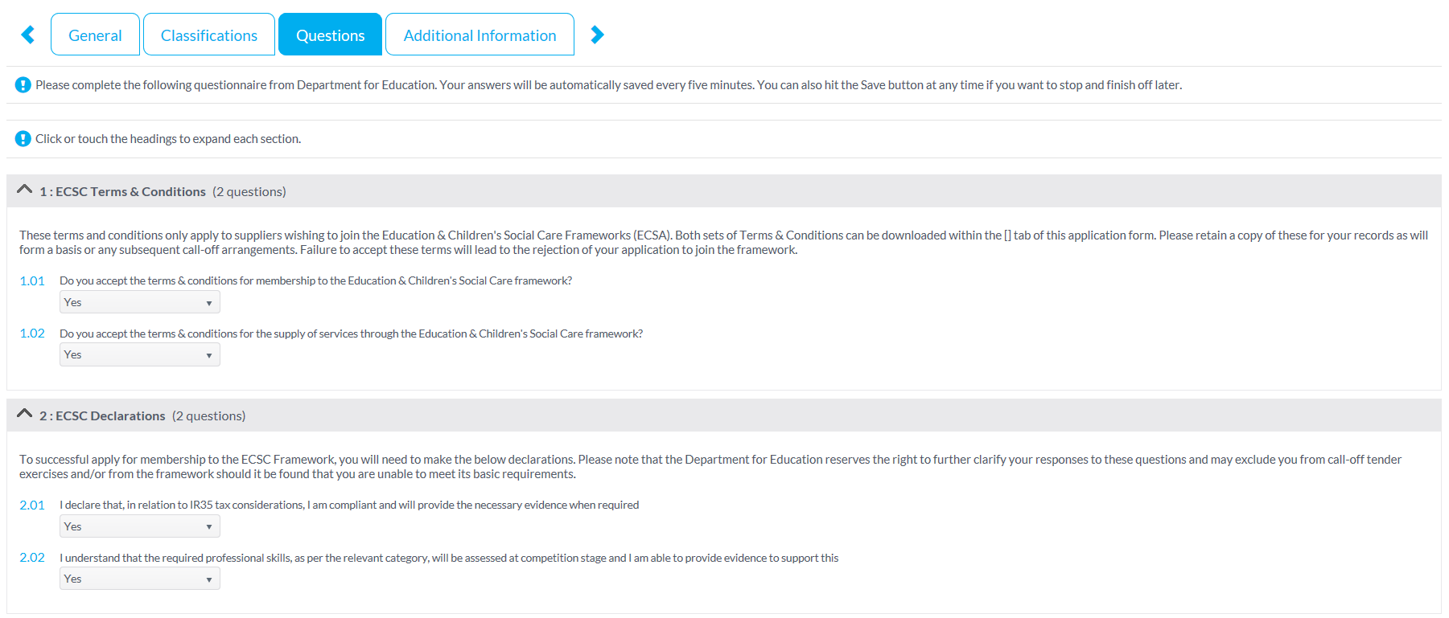
- Accept the Terms & Conditions for use of the Dynamic Purchasing System (DPS)
- Confirm your willingness for your eligibility to deliver against framework categories to be assessed at any time.
- Confirm your adherence to IR35 regulations and confirm your willingness to provide documentation to support this when requested.
NOTE: Failure complete this section will result in the rejection of your application.

4.4 Submitting your application
Once you have completed both the Classification & Question tabs, you are in a position to submit your application for assessment. To do this, simply click the  button.

5 Reviewing/Updating your category codes
NOTE: This step can be completed at any time, regardless of your current framework status.
To access your category codes, please go to the ‘customers’ section of your self-service account. This can be found by selecting the option on the vertical toolbar.
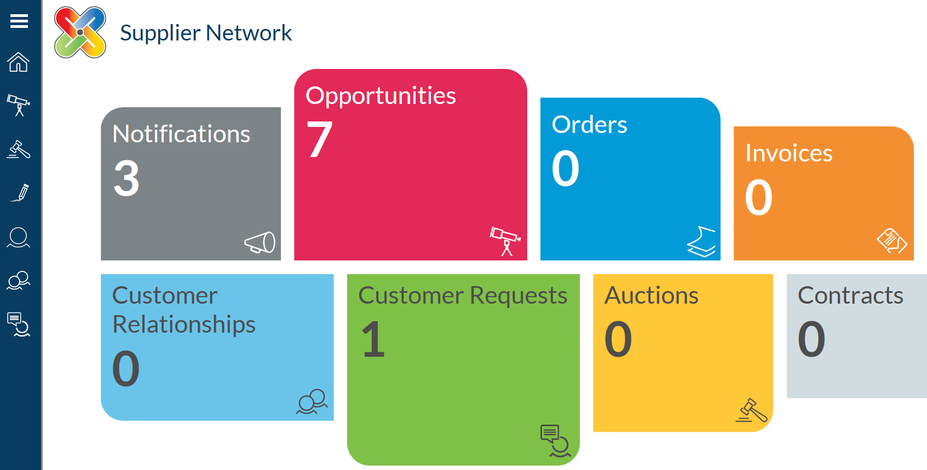
You will then find a list of all your established customers on the wider proactis portal. Select ‘Department for Education’ and under the full notice, please click ‘edit’.
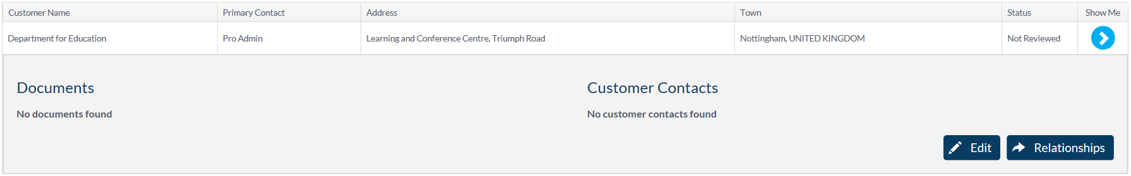
Go to the ‘Category Codes’ tab (this may be called ‘Geographies’ depending on whether you are on the DFE specific link or not).
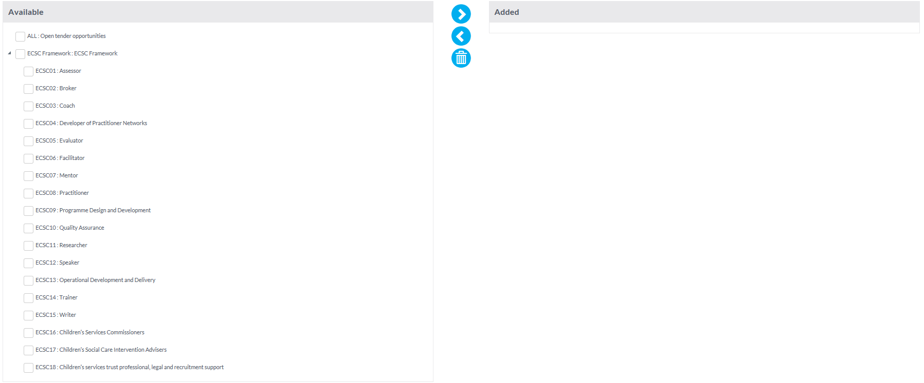
Down the left hand side you will see a full list of categories under the ECSC framework, use the tick boxes on the left hand side of each category you wish to select and press the  arrow. This will transfer these categories into the added section on the right side of the screen.
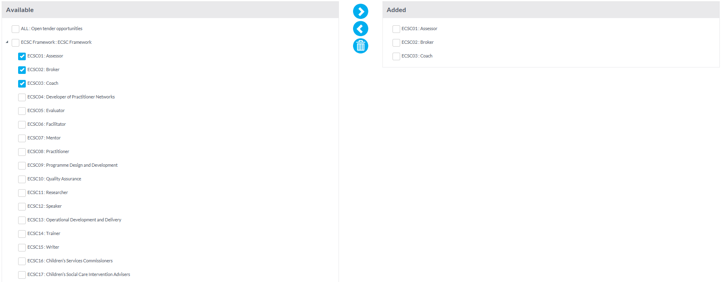
Click ‘Save’.

© Crown copyright 2016
This publication (not including logos) is licensed under the terms of the Open Government Licence v3.0 except where otherwise stated. Where we have identified any third party copyright information you will need to obtain permission from the copyright holders concerned.
To view this licence:
visit www.nationalarchives.gov.uk/doc/open-government-licence/version/3
email psi@nationalarchives.gsi.gov.uk
write to Information Policy Team, The National Archives, Kew, London, TW9 4DU
About this publication:
enquiries www.education.gov.uk/contactus
download www.gov.uk/government/publications
Reference: [000-000-000]
 | Follow us on Twitter: @educationgovuk |  | Like us on Facebook:  facebook.com/educationgovuk

