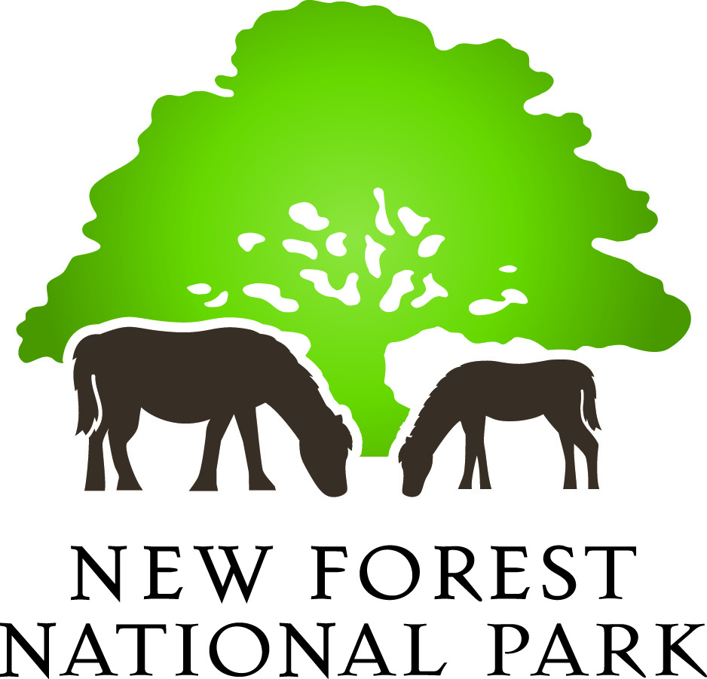

**Sustainability Appraisal / SEA**

**Project Brief and Invitation to Quote (NFNPA – 0028)**

**February 2016**

1. **Introduction** 
   1. The New Forest National Park Authority invites tenders from suitably experienced consultants to undertake a Sustainability Appraisal (SA) and Strategic Environmental Assessment (SEA) which will shape and support the review of the Authority’s Local Plan. These assessments are required by the *Planning & Compulsory Purchase Act 2004* and the European Directive 2001/42/EC (the Strategic Environmental Assessment or SEA Directive).

1.2 The project brief outlines what the National Park Authority expects of its Sustainability Appraisal / SEA and the requirements for Tender proposals.

1. **Background** 
   1. The New Forest National Park Authority adopted its first set of Park-wide planning policies in the *Core Strategy & Development Management Policies DPD* in December 2010. The planning system plays a key role in the delivery of the two statutory National Park purposes (and related socio-economic duty) and the adopted Core Strategy has provided a clear planning policy framework for the New Forest National Park over the last 5 years.
   2. The publication of the National Planning Policy Framework (NPPF) in 2012, allied to changes in national Permitted Development Rights and the experiences of apply the adopted planning policies over the last 5 years, means that now is an opportune time to review the planning policies for the Park.
   3. A Strategic Housing Market Area Assessment for the New Forest National Park (and surrounding areas within New Forest District Council’s planning remit) was completed in 2014; as was a Gypsy & Traveller Accommodation Assessment covering the National Park in 2013. Further evidence base studies are currently being undertaken and we have recently started working with our neighbouring planning authority New Forest District Council and Land Use Consultants (LUC) on a Habitats Regulations Assessment (HRA). The findings of the emerging HRA will need to be incorporated into the Sustainability Appraisal process.
   4. We undertook an initial high-level Regulation 18 consultation on the scope of the Local Plan Review in late 2015 and continue to liaise with our local communities and interest groups on the range of issues to be addressed through the review. We intend to publish a consultation ‘draft’ of the emerging Local Plan in October 2016, prior to the publication of the Submission draft Local Plan in Summer 2017 and submission to the Secretary of State for independent examination in Autumn 2017.

**3. The Study Area**

3.1 The study area is the whole of the New Forest National Park. The 220 square mile National Park was designated in 2005 and includes land within the counties of Hampshire and Wiltshire. As with all of the English and Welsh National Parks, the New Forest has two statutory purposes:

* To conserve and enhance the natural beauty, wildlife and cultural heritage of the Park; and
* To promote opportunities for the understanding and enjoyment of the special qualities of the Park by the public

3.2 Working in partnership with other organisations, it is also the Authority's duty to seek to foster the economic and social well-being of the local communities within the New Forest. National Parks are recognised within the NPPF as having the highest level of protection in relation to landscape and scenic beauty (paragraph 115) and are identified as areas of restraint within paragraph 14 of the NPPF. Since the designation of the National Park in 2005, an average of 20 new dwellings (net) per annum have been completed within the National Park, with housing and employment development currently delivered through positively worded enabling policies, rather than land allocations.

3.3 56% of the New Forest National Park is designated as being of national or international importance for nature conservation – the highest proportion of any local planning authority’s area in the country. It is also a living-working landscape, with a resident population of 35,000 which makes it one of the most densely populated National Parks in the country. The New Forest has a variety of settlements, with no villages larger than 3,500 people, and the National Park is home to around 2,300 local businesses. The Authority deals with around 1,000 planning applications per annum.

3.4 With the reforms to national planning policy, the review of the Authority’s local planning policies will consider the allocation of land within the New Forest for specific uses for the first time since the National Park was designated in 2005. The Authority has recently undertaken a ‘call for sites’ process and the results of this will feed into the review of the Local Plan.

**4. Project Description**

4.1 The National Park Authority is looking to engage consultants to undertake stages A, B, C and D of the Sustainability Appraisal and Strategic Environmental Assessment of the revised Local Plan in accordance with the latest Government guidance and best practice (including the National Planning Practice Guidance (NPPG) resource). This involves the following key stages.

|  |
| --- |
| **Stage A: Setting the context and objectives, establishing the baseline and deciding on the scope**   1. Identify other relevant policies, plans & programmes & sustainability objectives 2. Collect baseline information 3. Identify sustainability issues and problems 4. Develop the sustainability appraisal framework 5. Consult the consultation bodies on the scope of the sustainability appraisal |

4.2 The **Sustainability Appraisal Scoping Report** will need to be consulted on with the three statutory consultation bodies (and any other organisations considered necessary). After consultation, any comments received will need to be reviewed and the Scoping Report amended accordingly.

|  |
| --- |
| **Stage B: Developing and refining alternatives and assessing effects**   1. Test the Local Plan objectives against the sustainability appraisal framework 2. Develop the Local Plan options including reasonable alternatives 3. Evaluate the likely effects of the Local Plan and alternatives 4. Consider ways of mitigating adverse effects and maximising beneficial effects 5. Propose measures to monitor the significant effects of implementing the Local Plan |

4.3 The National Park Authority intends to publish a non-statutory version of the draft Local Plan in October 2016 for public consultation and a **draft Sustainability Appraisal Report** will be published alongside it. This will include an assessment of the alternative policy options.

|  |
| --- |
| **Stage C: Prepare the Sustainability Appraisal Report** |

4.4 In line with Government guidance in the NPPG, the **Sustainability Appraisal Report** should focus on the likely significant effects of the Local Plan and focus on the policies that require a more detailed analysis. The Sustainability Appraisal Report should be accompanied by a Non-Technical Summary.

|  |
| --- |
| **Stage D: Seek representations on the sustainability appraisal report from consultation bodies and the public** |

4.5 The Authority intends to publish its Submission draft Local Plan in Summer 2017 and at this stage the **Sustainability Appraisal Report** of the Plan must also be published (including a Non-Technical Summary) and ultimately then submitted for independent examination.

**5. Relevant Studies**

5.1 There are several published documents which will be of relevance and assistance to the production of the Sustainability Appraisal for the revised Local Plan. We have undertaken Sustainability Appraisal work for the last ten years and relevant existing assessments and reports include:

* New Forest National Park Core Strategy Sustainability Appraisal Report (Scott Wilson, 2010)
* [New Forest National Park Management Plan Update Sustainability Appraisal 2015-2020](http://www.newforestnpa.gov.uk/downloads/file/1195/sustainability_appraisal_of_management_plan_update) (2015)
* [The New Forest National Park State of the Park Report (](http://www.newforestnpa.gov.uk/info/20016/our_work/80/state_of_the_park)NFNPA, 2015)

**6. Notes on the format and status of the data**

6.1 The report should be provided in a format that can be uploaded onto the National Park Authority’s website, preferably in PDF.

6.2 The use of the Authority’s Ordnance Survey mapping, or data derived from it, will be subject to the signing of a Contractor’s Licence as provided under the Public Sector Mapping Agreement.

**7. Final Reports**

7.1 At each stage of the process a draft version of the relevant report should be submitted in confidence to the Authority prior to completion of the final report. Once the final draft has been approved the Authority will require:

* 2 paper copies of each final report, including any Executive Summary or Non-Technical Summary; and
* Electronic copies, in Word and PDF format.

7.2 The appointed consultants may also be required to give evidence on behalf of the National Park Authority at the Local Plan Examination in Public.

**8. Timescales**

8.1 The Authority must produce the Sustainability Appraisal to ensure the timely delivery of the Local Plan. The proposed project timetable is set out below.

|  |  |  |
| --- | --- | --- |
| **Date / Deadline** | **Stage** | **Who by** |
| Noon 14 March 2016 | Deadline for tenders to be submitted | Consultants |
| 18 March 2016 | Consultants appointed | NFNPA |
| 23 or 24 March 2016 | Inception meeting held at NFNPA offices, Lymington | NFNPA / Consultant |
| April 2016 | Stage A work – Production of SA Scoping Report | Consultant |
| May 2016 | SA Scoping Report published for consultation (5 weeks) | NFNPA |
| June 2016 | Review SA Scoping Report comments and amend report | Consultant |
| Summer 2016 | Assess policy options against agreed SA Objectives and produce Stage B SA Report | Consultant |
| October 2016 | Draft Local Plan and Stage B SA Report published for consultation | NFNPA/Consultant |
| July 2017 | Publication of Submission draft Local Plan and Stage C SA Report | NFNPA/Consultant |
| Autumn 2017 | Submission of Local Plan to the Secretary of State (with Stage D final SA Report) | NFNPA/Consultant |
| Winter 2017 | Local Plan Examination hearings |  |
| March 2018 | Target for adoption of Local Plan |  |

8.2 It is expected that at least two update meetings will be held during the course of the Sustainability Appraisal preparation. It will also be necessary to provide regular updates on the Assessment’s progress either by phone or email. The Sustainability Appraisal / SEA is an iterative process and will require on-going communication with the Authority throughout this process.

8.3 The final timetable for the project will be reviewed if necessary and agreed between the Authority and the successful consultant.

**9. The Tender Proposal**

9.1 Consultants tendering for this contract should include in their proposals:

* An outline of their approach to the work which should meet the requirements of the relevant guidance, including the NPPG;
* A programme and timetable for the undertaking of the assessment reflecting the target dates listed above;
* Details of the consultancy’s experience in the area of Sustainability Appraisal / SEA, together with two contacts for references relevant to the study;
* Details of the qualifications and experience of the team who would be undertaking the project;
* Confirmation that undertaking this project would not give rise to conflicts of interest;
* Full details of the pricing structure to be applied to the work. The pricing structure should show costs for each of the major elements in this study, including expected time spent on the work, personnel involved, rates charged and limits applied to expenses; and
* Particulars of public liability and professional indemnity insurances. Public Liability Insurance is required, with a limit of indemnity of not less than £1,000,000 (one million pounds) per claim or series of claims. In addition, the National Park Authority require the appointed consultants to have Professional Indemnity Insurance with a limit of indemnity of not less than £500,000 (five hundred thousand pounds) per claim or series of claims

9.2 Fixed price tenders should be all inclusive with VAT charges show separately. Please note that the anticipated budget from this work is in the region of £9,000 - £12,000.

9.3 All submissions must be made via our e-Procurement portal [In-tend](https://in-tendhost.co.uk/newforestnpa/aspx/Home) and must be submitted by **12 noon on Monday 14 March 2016.**

9.4 The contract will be awarded on the basis of the criteria including (i) price; (ii) relevant experience; (iii) understanding of the brief. While cost is obviously an important consideration for the Authority, the contract will not necessarily be awarded to the lowest price. The overall objective will be to appoint the consultant that offers the best overall value for money.

**10. Contract**

10.1 The contract will be let on a fixed price basis including all appropriate expenses and costs.

10.2 All submissions are required to comply with the New Forest National Park Authority ‘Standard Conditions of Contract for Services’ (attached) which will be used to draw up the contract with the winning contractor.



10.3 Payment will be made in five stages: 20% on receipt of the final report at each of Stages A to D and the final 20% upon the completion of the Post Adoption Statement, each to the satisfaction of the National Park Authority.

10.4 The copyright of the final reports and any appendices or other supporting information / outputs (including associated databases) will reside with the New Forest National Park Authority.

10.5 The Authority reserves the right to withdraw this contract opportunity without notice and will not be liable for any costs incurred by suppliers during any stage of the process

**11. Project Management**

11.1 Initial contact should be made with:

David Illsley

Planning Policy Manager

New Forest NPA

Lymington Town Hall

Avenue Road

Lymington

SO41 9ZG

[david.illsley@newforestnpa.gov.uk](mailto:david.illsley@newforestnpa.gov.uk)

01590 646672

Tony Spence

Policy Officer

New Forest NPA

Lymington Town Hall

Avenue Road

Lymington

SO41 9ZG

[tony.spence@newforestnpa.gov.uk](mailto:tony.spence@newforestnpa.gov.uk)

01590 646687

11.2 Please note that to ensure fair and open competition, all substantive responses to any questions raised by interested suppliers will be made available to all other suppliers where appropriate. Any such clarifications will be posted on our In-tend portal and you will receive email notification to make you aware of this (you must be registered on the site in order to receive these).