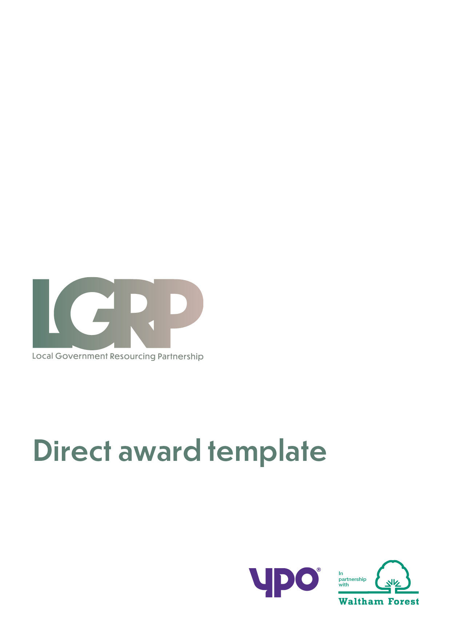

**LGRP Framework   
Direct Award**

|  |  |
| --- | --- |
| Organisation name | Defence Nuclear Organisation, Ministry of Defence |
| Organisation contact | [Redacted-Personal] |
| Email address | [Redacted-Personal] |
| Phone number | N/A |
| LGRP lot (required) | Lot 4 |
| Timescales (if applicable) | [Redacted-Commercial] |
| How would you like the provider to contact you in response to the direct award? | Email |

**Project requirements**

|  |
| --- |
| [Redacted-Commercial] |

**Direct award pricing**

|  |
| --- |
| £277,937.00 |

All direct awards will be in-line with the framework terms and conditions and the call off terms and conditions.

**If you have any amends to the call-off terms and conditions, please state here:**

|  |
| --- |
| Additional MOD DEFCONS included in attachment. |