Request for Expressions of Interest.

Project LAND TO THE REAR OF 11 HOLME AVENUE, DALTON, HUDDERSFIELD, HD5 8DP

Client Stonewater Developments Ltd.

Employers Agents Innovate Associates Ltd.

Architect Vaughan Architecture Ltd

We kindly request you to read the following description of the proposed works and to formally request you to participate in a tender process for the construction contract.

Anticipated Timescales

Return of EOI 20th December 2023

Return of Pre-Qualification Questions 20th December 2023

Issue of tender Mid-January 2024

Tender Period 6 Weeks.

Return of tender Late February 2024

Scheme Overview

The site is located as shown below.

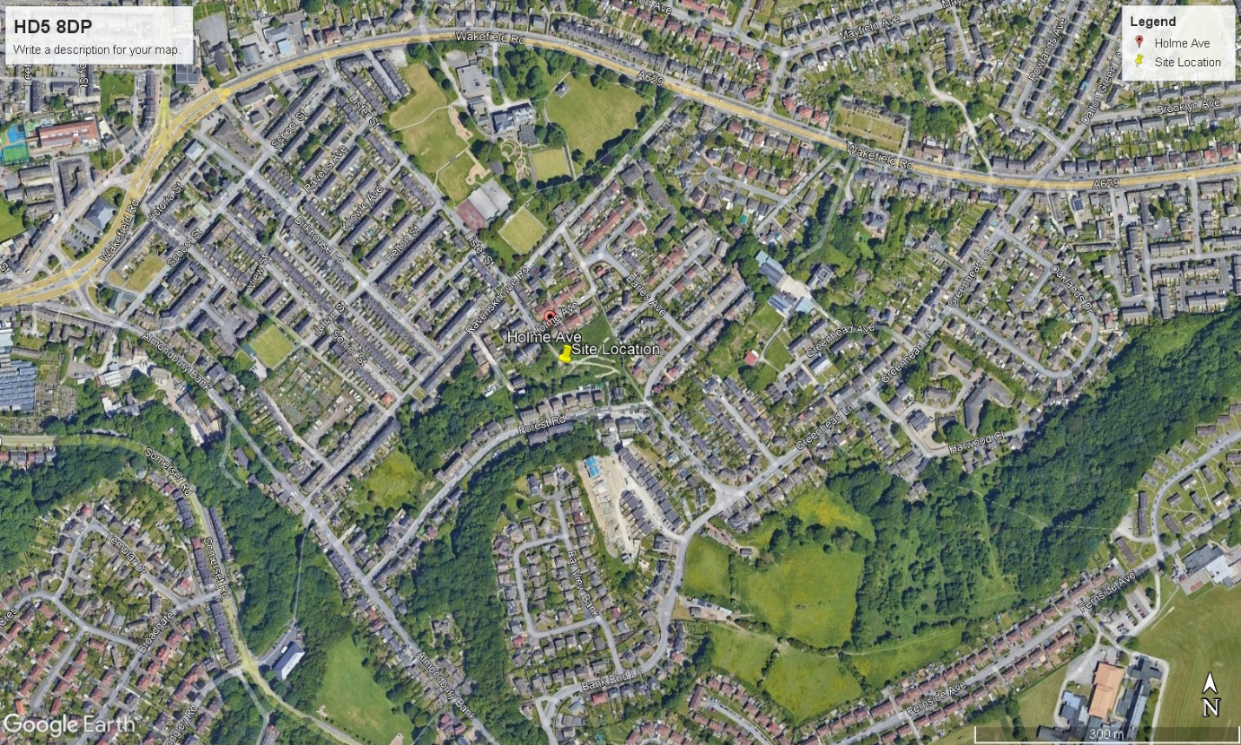

The scheme is an inherited design for 22 new build houses and the refurbishment of 1 semidetached bungalow at the above location.

The original scheme has been updated for Stonewater Developments Limited to suit their mix of housing needs.
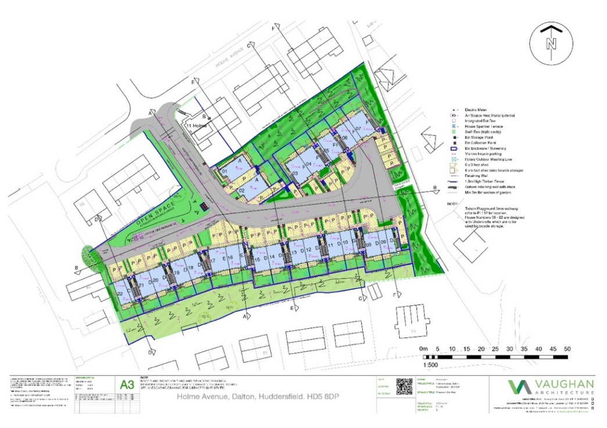

The updated scheme has been subject to a section 73 planning application and details of this including the house types can be found on line at https://www.kirklees.gov.uk/beta/planning-applications/search-for-planning-applications/detail.aspx?id=2023/92187

The scheme Is on a sloping site with retaining structures within the line of the houses. Retaining structures are also needed within the gardens and part of the entrance to the site as part of the section 38 highway works.

The buildings are a mix of detached, and semi-detached properties with 2 and 3 storey houses, some within split levels from front entrance to garden access.

The houses are to be designed to an increased thermal performance together with PV cells to the roof and potential for battery backup. The heating systems are primarily air source heat pumps.

The site comes with a bungalow at nr 11 Holme Avenue which is available for the full duration of the contract and is to be refurbished and delivered at completion of the project.

The project is to be delivered as a Design & Build contract through a single main contractor. The architecture and structural designs have been completed to RIBA stage 4 and both consultants are to be appointed by the contractor for completion of the stage 5 design.

Consultants to be retained by the client are the Employers Agent and Principal Designer under the CDM regulations.

Building Regulations and Warranty approvals are the responsibility of the Main contractor.

The project is to be delivered in a single phase with all plots contractually required to be delivered at the contract completion date, although advance handover will be considered subject to the section 38 road works be completed and handed over in its entirety.

