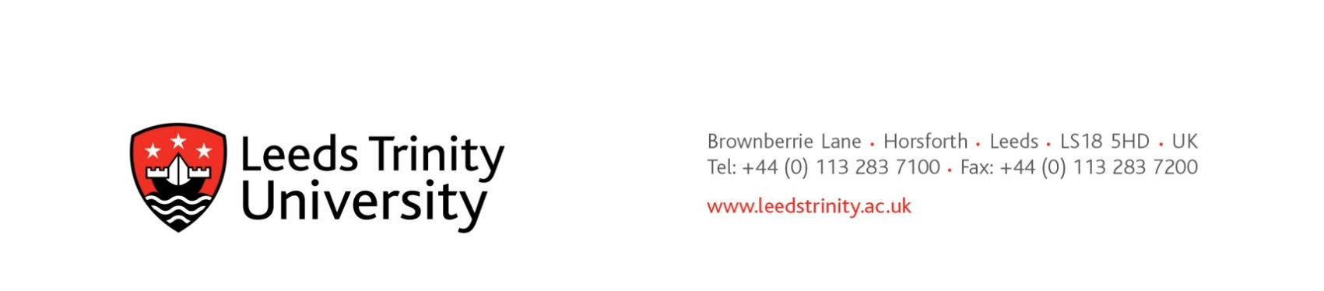

Dear potential supplier

RE: Preliminary market consultation: Replacement Library website and user comms. tools

Leeds Trinity University is seeking market engagement for solutions that deliver the following services:

- Library website/CMS (we are currently using INFOR’s Iguana product – see https://lib.leedstrinity.ac.uk for our current website)
- Chat service to provide Library support to users, potentially with screen sharing functionality (not currently offered as a service)
- FAQs functionality, with ability to populate these from chat (not currently offered as a service)

Solutions will be
- tailored to deliver services in an academic Library context
- have an existing customer base in the Higher and/or Further Education sector
- outstanding value for money

Please provide details of the following:
- Costs over a 4 year period, including any initial set up costs, and recurrent costs. Please indicate whether the costs stated are inclusive or exclusive of VAT.
- Names of academic Libraries that use your solutions
- Training and support provided including at initial set up and on an ongoing basis
- Information on authentication and security
- A statement on how your solutions comply with GDPR
- Information on the process by which your products are developed and enhanced

Correspondence
via Mark Hayter, Head of Procurement by e-mail to m.hayter@leedstrinity.ac.uk

Closing date for lodging interest in the market consultation midnight at the end of 27/09/2020

The Public Contracts Regulations 2015
In respect of the above Leeds Trinity University seeks advice from independent experts/authorities/market participants with a view to developing the scope and specifications needed to plan and conduct its procurement procedures. For the avoidance of doubt, no call for competition has been made, and no contract award opportunity identified. All relevant information exchanged or resulting from this preliminary market consultation will be documented and may be communicated to other candidates and tenderers participating in the procurement procedure.

Mark Hayter
Head of Procurement

