SCHEDULE 2 – THE SERVICES

- Service Specifications

Mandatory headings 1 – 4: mandatory but detail for local determination and agreement
Optional headings 5-7: optional to use, detail for local determination and agreement.

All subheadings for local determination and agreement

Service Specification No. | L-17-12
Service | Social Prescribing Service
Commissioner Lead | Kathryn Kavanagh
Provider Lead
Period | Contract duration to be defined.  Plus contingency period if required to support full market exposure.
Date of Review | This is a pilot service, as a result it is likely that date of review will be approximately 7 months after the initial contract period.

1. Population Needs
Across West Lancashire there is a range in life expectancy, for males this difference spans from 83 years in Derby ward compared with 73.6 in Tanhouse, a difference of 9.4 years. For females, life expectancy ranges from 87.6 in Tarleton to 76.1 in Birch Green, a difference of 11.5 years. These differences are patterned by deprivation, lifestyles and other social and economic influences.
It is recognised that the health services can’t do everything that is needed by itself to reverse the flow of costly avoidable illness required to narrow this gap in life expectancy; however, it can become a more activist agent of health-related social change, leading a range of new approaches to improving health and wellbeing.
Highlighted in the GP 5 Year Forward View (GP5YFV) Social Prescribing models can support wider integration across the health and social care system by enabling GP’s to access practical, community-based support for their patients.

2. Outcomes
2.1 NHS Outcomes Framework Domains & Indicators

Domain 1 | Preventing people from dying prematurely | √
Domain 2 | Enhancing quality of life for people with long-term conditions | √
Domain 3 | Helping people to recover from episodes of ill-health or following injury | X
Domain 4 | Ensuring people have a positive experience of care | √
Domain 5 | Treating and caring for people in safe environment and protecting them from avoidable harm | √

2.2 Local defined outcomes
Social prescribing in conjunction with medical prescribing can lead to better health outcomes through tackling social issues that impact on patient health. This in turn may reduce demand on GP time.

3. Scope
3.1 Aims and objectives of service
The key aims of the service are to develop an approach that:
- Supports a holistic approach to health & wellbeing based upon an asset-based approach to wellbeing.
- Based upon the principles of co-production, personalisation, choice and control
- Patient centred service which is simple to access.
- Integrated from a patient’s perspective with other service providers, delivering seamless wrap around range of services that minimise the impact of social and lifestyle issues that impact on health.
3.2 Service description/care pathway

3.2.1 During the pilot phase, access to a Social Prescriber will be limited to patients registered with a Skelmersdale GP practice.

3.3 Population covered

3.3.1 The population of Skelmersdale is serviced by six GP practices, these are; Ashurst Primary Care, Dr A Bisarya, Hall Green Surgery, Manor primary Care, Matthew Ryder Clinic, and Skelmersdale Family Practice. The total list size is 38,000 patients, equally distributed between males and females.

A population profile for Skelmersdale is below.

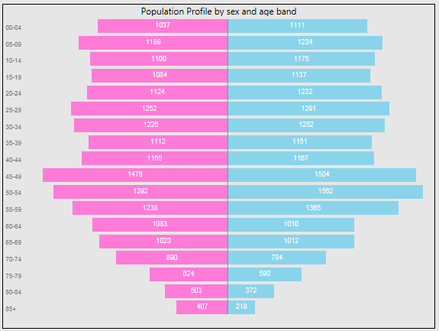

West Lancashire as a whole is fairly affluent with 48% being in the 40% most affluent areas of England, however there are pockets of deprivation. 20% of the population reside in the 40% most deprived areas in England (based on Indices of Multiple Deprivation 2015 provided by the Office of National Statistics). These pockets of deprivation are mainly clustered around the area of Skelmersdale. People living in poorer socio-economic circumstances or in the more deprived areas of the CCG tend to experience poorer health. They have higher levels of chronic disease and disability, more early deaths (under 75) and they experience the adverse effects of ageing at an earlier stage in their lives. They usually have difficulty accessing health and social care services and when contact is made it is often at a later stage in their condition. As a consequence, they require more complex treatment and experience poorer health outcomes, contributing to health inequalities.
During the pilot phase, access to a Social Prescriber will be limited to patients registered with a Skelmersdale GP practice.
3.3.2
Core requirements
What is Social Prescribing?
Social Prescribing is a structured process through which the ‘prescriber’ works with their patient to address the wider social and lifestyle issues that impact on their health. It is based upon an asset-based approach to health, understanding that health is a positive states of wellbeing rather than seeing health as just about illness and disease. It’s based upon the principles of co-production, personalization, choice and control to achieve and maintain wellbeing. Importantly, it is something performed with people, not to them or for them. There can be different levels to social prescribing as shown in the diagram below.
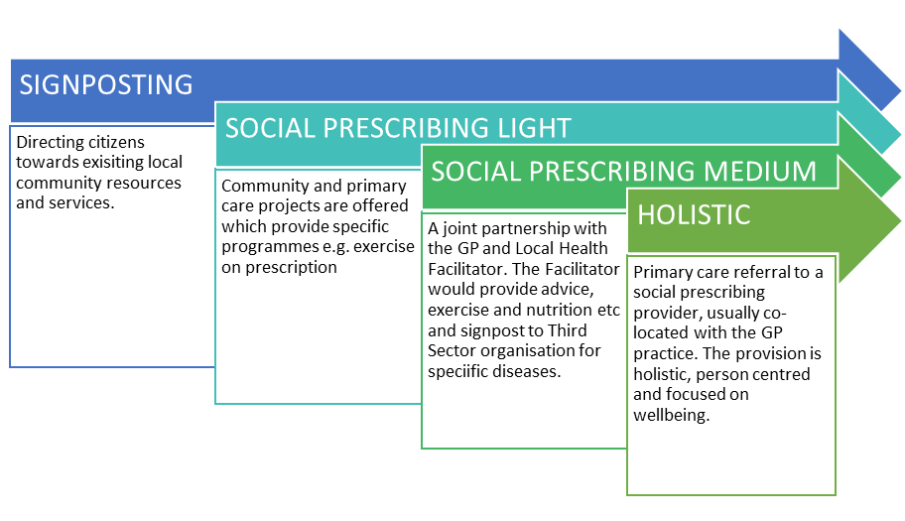
Social Prescribing schemes can involve a variety of activities which are typically provided by voluntary and community sector organisations, but services for onwards referral may include those from the statutory sector. Examples include volunteering, arts activities, group learning, gardening, befriending, cookery, healthy eating advice and a range of sports. There are many different models for Social Prescribing, but most involve a Social Prescriber who works with people to address areas of behaviour change and access local sources of support. The Bromley by Bow Centre in London is one of the oldest and best-known social prescribing projects. Staff at the Centre work with patients, often over several sessions to help them get involved in more than 30 local services ranging from swimming lessons to legal advice. The aim of the service is to provide core, additional and enhanced services.

The approach:
- Provision of a holistic approach to health and wellbeing that places greater emphasis on preventative measures that reduce the progression towards Long Term Conditions (LTC) or prevent the worsening health for individuals with existing LTC’s.
- Development of strong relationships between VCFS, wider NHS structures and other providers who can support the approach. Provide the link between VCFS sector and emerging multi-disciplinary teams in Skelmersdale.
- Provide a focal point for the changing relationship between clinician and patient. Supporting this changing dynamic by engaging the service and wider team with Better Conversations, Solution-Focused Practice and evidence-based behaviour change methodologies.
- Provide robust evidence based on utilisation rates and outcomes, linking with Well Skelmersdale evaluation.
- Work with Well Skelmersdale associates and the VCFS sector and other providers to develop and maintain a local Directory of Services, identifying gaps in local services where necessary.

Capacity:
- Provide a minimum of 60 minutes per consultation. Number of consultations per patient to be needs-led.

Advertising and ease of access:
- Ensure services are advertised to patients, including notification on practice websites, provision of information to partner agencies and publicity that reaches into the community, so that it is clear to patients and partner agencies how individuals can access these appointments and associated services;
- Development of a clear referral and feedback process between the referrer and those referred to.
- Ensure ease of access for patients that will include out-of-hours appointments during evening and weekends.

Digital:
- Self-management is a term used to include all the actions taken by people to recognise, treat and manage their own health. They may do this independently or in partnership with the healthcare system. Use of some digital approaches enable people to make informed decisions about their health. Our local health economy uses ORCHA – the Organisation for the Review of Care and Health Applications. ORCHA uses a scoring and function system to identify and compare the best apps for the needs that have been identified, in conjunction with other methods these tools can be used to support the attainment of health and wellbeing goals (https://www.orcha.co.uk/).

Records:
In conjunction with partners, the service provider will ensure that Data sharing agreements are in place for access to patient records to ensure continuity of care.
Full records of all onward referrals should be maintained in such a way that aggregated data and details of individual patients are readily accessible. The providers must ensure that details of consultations and referrals are sent to the practice by 8am the next working day and that systems are in place for exchanging information.
Staffing and Competencies:
The service provider will be required to provide sufficient qualified and appropriately trained staff to ensure that the Service is provided in accordance with the Service Specification.
Equipment
Adequate and appropriate equipment should be available for the Social Prescriber. This equipment must be maintained and reviewed regularly to an appropriate standard by the provider.

Information/Data
Data will be collated on the following and tracked pre, during and at the end of the pilot:
- How many patients have been referred to the Social Prescribing service?
- How many patients have seen the Social Prescriber?
- How many sessions per patient has the Social Prescriber provided?
- For how many patients was a Social Prescription issued?
- What are the key issues that are being met as a result of the Social Prescribing service?
- How many patients have been referred to onward services and which services?
- DNA’s by practice and referral organisation.
Monthly reports must be submitted in a timely manner.
3.3 Population covered
All patients registered with a GP practice in Skelmersdale or who reside in Skelmersdale will be eligible to receive services under this agreement.

3.4 Any acceptance and exclusion criteria and thresholds
The Provider shall ensure that the service does not discriminate on grounds of age, gender, sexuality, ethnicity or religion. The service should be sensitive to the needs of patients whose first language is not English and those with hearing, visual or learning disabilities. All aspects of the service must be compliant with the Disability Discrimination Act ensuring disabled patients are able to access the service.

3.5 Interdependence with other services/providers
The service will routinely work closely with other providers in both primary, community and secondary care settings, where a case is outside of the scope of the service, the provider will ensure the patient receives the appropriate care required. The provider will ensure this is carried out in a timely fashion and does not delay treatment where treatment is required.

4. Applicable Service Standards
4.1 Applicable national standards

NHS England. Involving people in their own health and care: Statutory guidance for clinical commissioning groups and NHS England.

NICE Guidance [PH49] Behaviour Change: Individual Approaches

4.2 Applicable standards set out in Guidance and/or issued by a competent body (Royal Colleges)

4.3 Applicable local standards

5. Applicable quality requirements and CQUIN goals
  - Applicable Quality Requirements (See Schedule 4A-C)

  - Applicable CQUIN goals (See Schedule 4D)

6. Location of Provider Premises
The Provider’s Operating Premises should be located across the neighborhood of Skelmersdale within West Lancashire.

7. Individual Service User Placement

