DIGITAL LABELS

Objective
These digital touchscreen labels will be an engaging tool for the visitor to learn and discover, in their own terms, further information about objects within the gallery. The digital labels will offer layered information that will include text, images, including object images and complementary images, film footage and audio clips. Each unit will have tailored content to represent the connected display. Only certain object displays will require a digital label and not all of the objects within the display will be identified for digital interpretation.

Technical information
We foresee the labels being on a small tablet type touchscreen, no bigger than A4 size. The label unit would sit either in front of each case or on the wall next to the display (see visuals below). The design will need to be streamlined and minimalistic and it must not detract or obscure the view to the objects. The hardware must be selected in agreement with the NML’s Information Systems team, who are responsible for their maintenance.

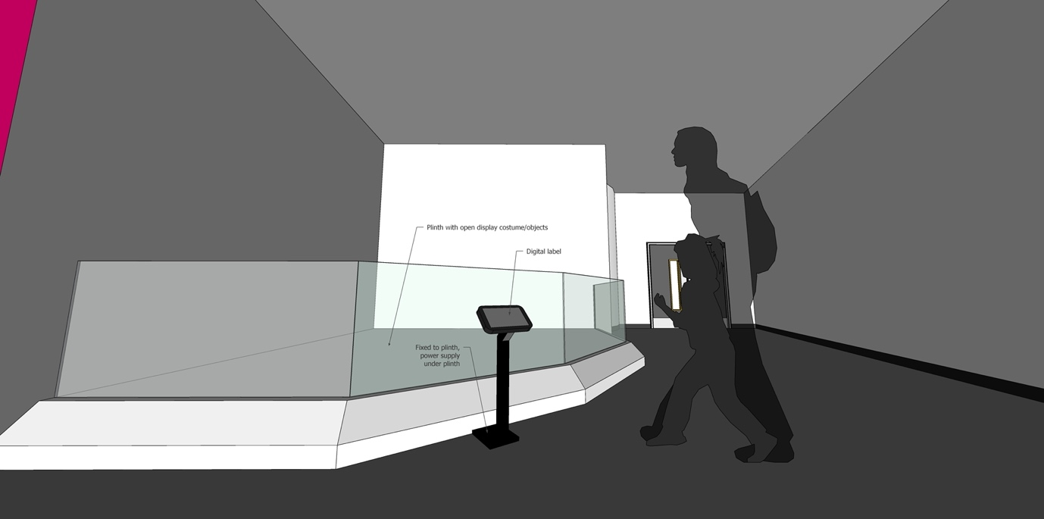

The labels will be spread across the gallery. Most of the label units will need to be physically connected to the case or plinth, as we will feed a power supply from under the cases. The units will also need to be fixed back securely either to a wall, case or plith. They cannot be fixed into the floor. We are open to suggestions on the design of this unit, but it will need to adhere to NML’s access guidelines. Two of the case labels will be mounted on the wall next to the case.

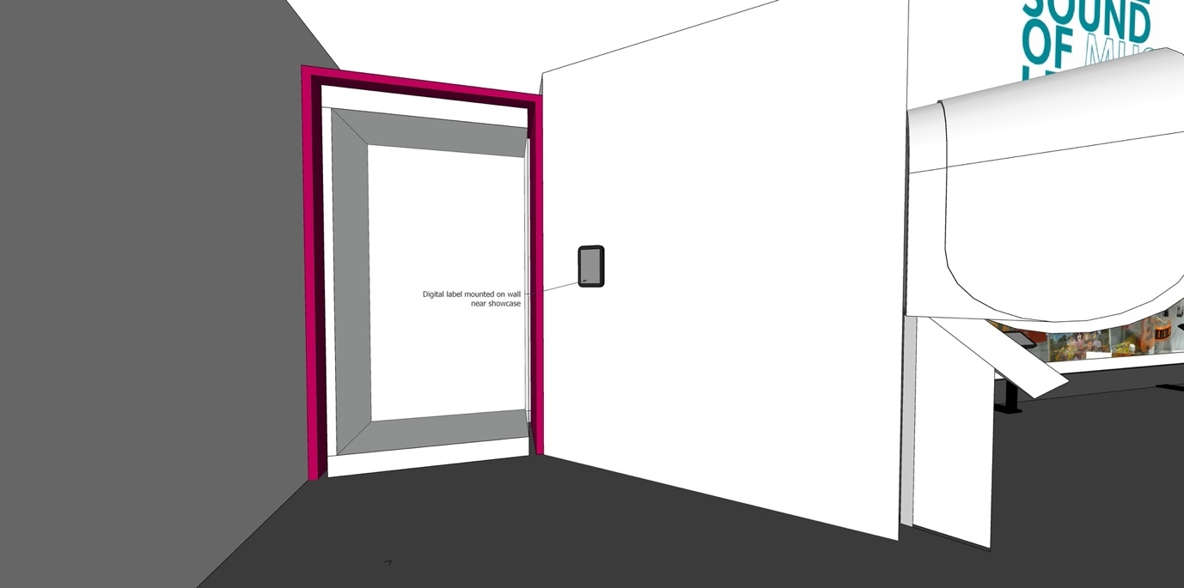

We would like to explore with the Producer two sound options: either sound delivered through a small single headphone or a small speaker set within the unit. The gallery contains many AV elements, most of which have sound, the balance of sound needs to be correct across the gallery.

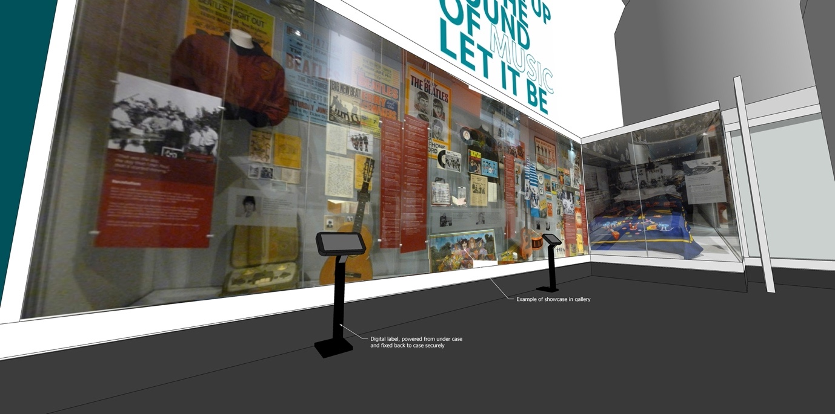

The gallery has been designed to have a light colour palette, with most walls being white and the flooring a mid-grey tone.

Below are some visual reference examples of digital label units to give a look and feel of what NML are looking to produce on the gallery:
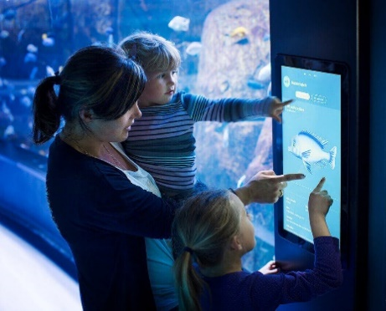
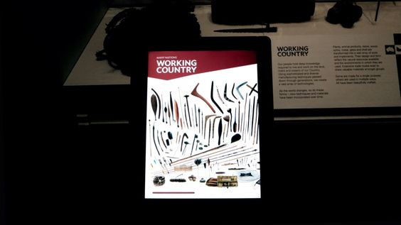
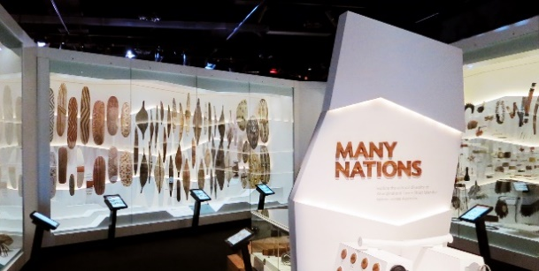
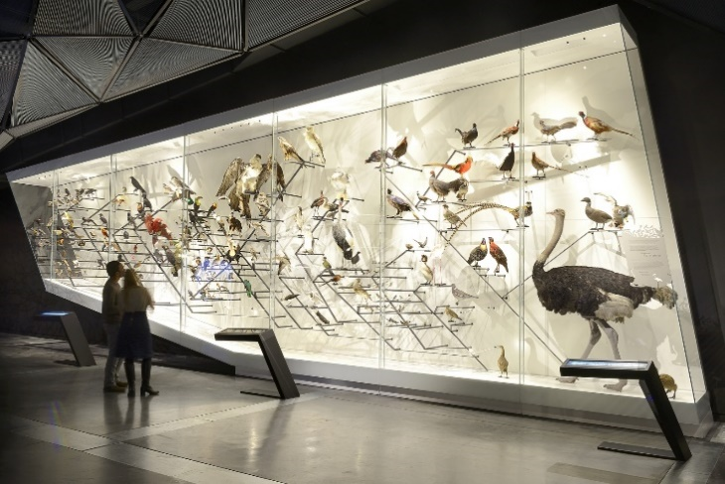
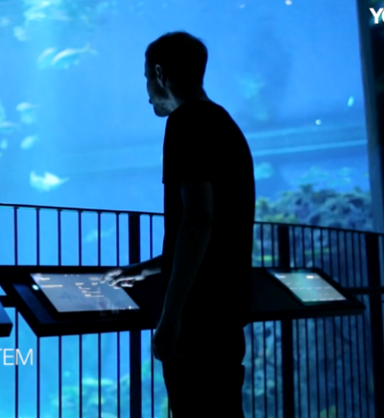

Content Look and Feel
The label home screen should be engaging and invite the visitor to interact with the screen to find out more about a particular object(s) in an easy and intuitive way. The look and design will engage the user and enhance the core content, through the potential use of text, images and film clips and music. The design of the labels will need to tie in closely with the look and feel of the gallery design, so the design will need to follow the graphic approach used within the section, which will be provide to the Producer by NML’s Project Team. Specific colours and suggested fonts will be supplied by the Client. All content will need to adhere to Client’s access guidelines policy.

Content must be layered in a dynamic way which will enable the Curatorial Team to provide further information about the object identified, but also to link to other objects both in the display and elsewhere in the gallery/Museum collection. Further supporting material can also be linked to the object, for example, film footage of shebeen gatherings could be linked to a music club membership card, or newspaper articles and posters could be linked to a musician’s object, or players’ biographies could be linked to football items.

We expect that the front-end screen to show a series of images of objects on display. The visitor could touch the icon on the screen to interrogate the object. The second layer could offer the image in high resolution so the visitors could zoom in on and read description of the object – also on the second layer could be more icons/options to access further information – when the visitor touches one of these icons, they could move through to a third layer of information; either another object and description; a film clip, an audio; or an image that connects to varied content (newspaper articles, biographies etc).

Content to be included
Any object images and text interpretation used will be provided by the Client, once a format has been agreed. The additional ‘layered’ content connected to each object will be created in discussion between the Client and the Producer.

Where appropriate, the additional content will be provided or identified by the Client, but the contractor will also be required to source and secure additional content.

The displays currently identified to be supported by digital labels are as follows:

- Stage & Screen - costume (open display) - 1 x freestanding label unit*
- Stage & Screen - Royal Court Theatre – 1 x wall-mounted label unit
- Music - Beatles and Merseybeat – 2 x freestanding label units (both containing the same content)
- Music – Black to the Future - 1 x wall-mounted label unit
- Music – Liverpool sound - 2 x freestanding label units (both containing the same content)
- Sport – The Grand National - 1 x freestanding label unit
- Sport – Football - 2 x freestanding label units (both containing the same content)

*The costume (open display) digital label must, in addition, include the following visual content:

Film Stars - Footage from the film (we do have permission to use interviews with Annette Bening and Jamie Bell so this may be enough)

Killing Eve - Footage from ‘Beautiful Monster’, Episode 7, Season 3. BBC America

Ken Dodd - Footage from The Ken Dodd Laughter Show, 1979 (features him wearing suit)
It is expected that each unit would feature in the region of 8 - 10 objects.

Audience
Aimed at a general audience but the interactives need to be accessible for visitors on the autism spectrum and dementia.

Copyright
The research, sourcing and purchase of all footage and imagery copyright licenses/rights, under the guidance of the NML content, are the responsibility of the supplier. NML requires all copyright license clearance to be at least ten year or a lifetime, nothing less. NML will require copies of the project files and media, as well as access to the content management system or web platform (if applicable), so the Multimedia Interactives can be updated if and when necessary, by NML.

