YATE OUTDOOR SPORTS COMPLEX
Yate Athletics Track
PQQ Stage – Indicative Project Description
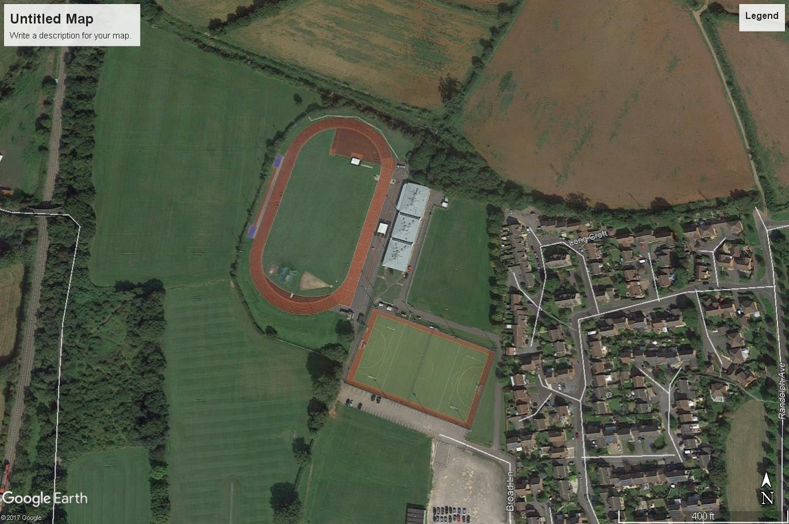



Conditions of Contract
It is the intention that the whole of the works will be carried out under the terms described within JCT Design and Build Contract 2016 together with a specification and accompanying contract drawings, the whole of which together will form the contract documents.
Employers Objective
It is the Employer’s objective to refurbish an existing competition athletics track and associated field event features.
The works will involve the removal and disposal of the existing surface materials, the resetting of existing perimeter kerbing and laying of new, extension of surfacing, replacement of throwing facilities and accommodation works necessary to ensure the facility is DDA compliant with relevant guidance related to disabled sports provision and the resurfacing of the main track and new areas together with field event jump run ups including all necessary markings. In addition the Employer wishes to consider the provision of additional / ancillary works which will be included within the final tender documentation as ‘’Provisional Items’’. The indicative extent of the revised layout of the facility is as illustrated on Drawing No. YOSC/02.
All works will be completed so as to ensure compliance with all current UK Athletics and IAAF standards as appropriate.

Historic Site Use

The track was installed in the late 1980’s (c 1987 – 88). Following a ground re-engineering process by ‘cut and fill’ method utlising the indigenous sub strate types (known to comprise fragmentary limestone within orange brown mottled clay subsoil); a formation layer was created to specific tolerances. A permeable geotextile membrane is believed to have been laid to increase ground stability and avoid mixing of the limestone base with the reformed sub base formation layer. The indicative depth of the limestone sub base layer is believed to be approximately 300mm. A macadam layer of approximately 60mm was laid to specific design tolerances to facilitate the laying of the track surface materials.
The existing track surface comprises a principal layer of polyurethane resin-bound rubber granules (crumb). An existing textured finish comprising a mixture of polyurethane and coloured EPDM (ethylene propylene diene monomer) synthetic rubber is evident. The original surface was a fully porous system.
The original laid depth of the track surface materials is believed to have been approximately 12mm. Increased depths are thought to have been laid within recognised high wear (impact) areas such as the high jump, javelin, long / triple jump and pole vault areas. The original laid depth within the impact zones is believed to have been approximately 20mm. The running track surface and field event (jumping) run ups have undergone various repairs and re-texturing processes in the intervening period.
The existing site layout is illustrated on Drawing No. YOSC/01.

Site Conditions

The YOSC complex provides a range of facilities open for school and public use. Access to the working area of the site will be via the existing site access route. Other areas of the site will continue to be used and accessed by school pupils and members of the public throughout the course of the works.
It will be the responsibility of the contractor to ensure that all persons engaged upon the works remain vigilant and exercise extreme care and attention at all times in order to safeguard school pupils and members of the public particularly when operating and driving any plant and transport equipment.
During the tender period the contractor will be required to undertake their own individual assessment and necessary evaluation of the range of conditions and material depths to be found on the site and the associated risks to be considered when preparing their tender submission.
The contractor will be deemed through their own individual assessment at tender stage to have fully understood the composition of the existing construction profiles to all track and field event areas and also including the substrate types within any areas of extension to the athletics track, affected by the works and the potential obstacles to be encountered when preparing their tender submission. The contractor will be required to allow for all extra costs arising from any situation which may affect his ability to perform the works. No claim on the grounds of want of knowledge of the nature of the existing site conditions and the range of works to be performed will be entertained by the Employer.
PROJECT PARTICULARS
EMPLOYER (CLIENT):
Yate Town Council
Poole Court
Poole Court Drive
Yate BS37 5PP

PRINCIPAL CONTRACTOR: The Contractor

PROJECT SUPERVISING AGENTS:
GLDM
Suite 1
1 Aubrey Street
Hereford
HR4 0BU

Tel: 01544 319352
Email: info@gldm.co.uk

CDM CO-ORDINATOR:
GLDM
Suite 1
1 Aubrey Street
Hereford
HR4 0BU

Tel: 01544 319352
Email: info@gldm.co.uk

PROVISIONAL PROJECT PERIOD:
Date of Possession of the site: - On or before 4th June 2018.
Date for Completion of the Works: 28th September 2018.

NOTE: Subject to review by Employer

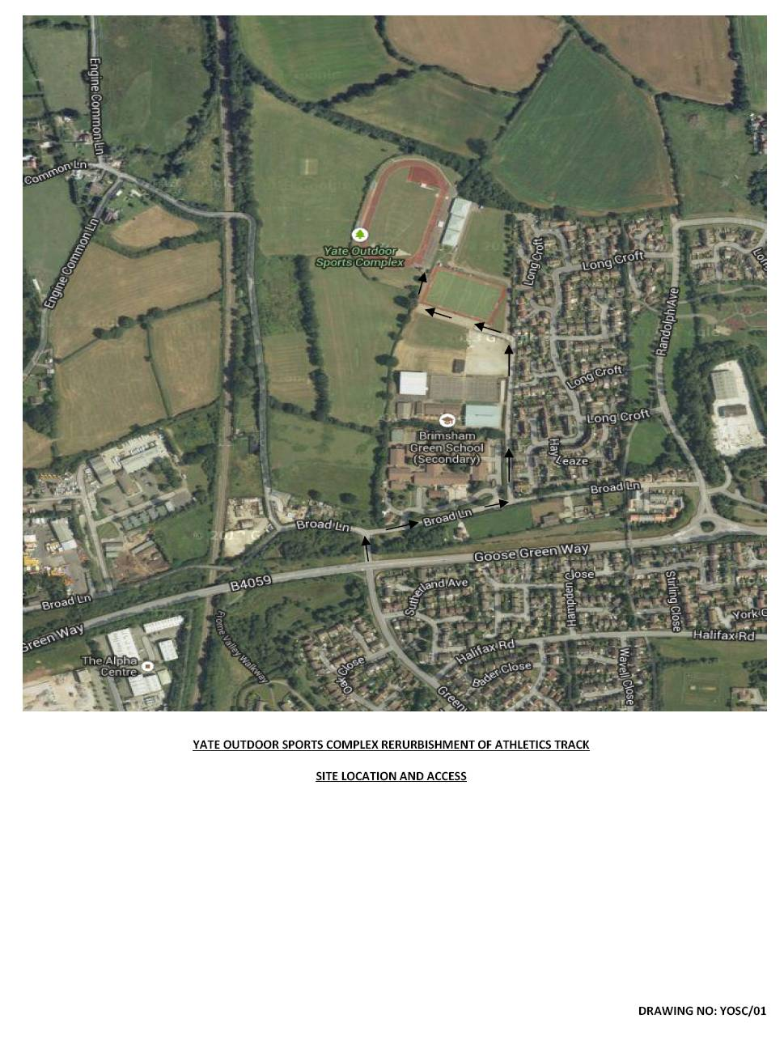

THIS DRAWING IS ISSUED FOR PQQ INFORMATION PURPOSES.

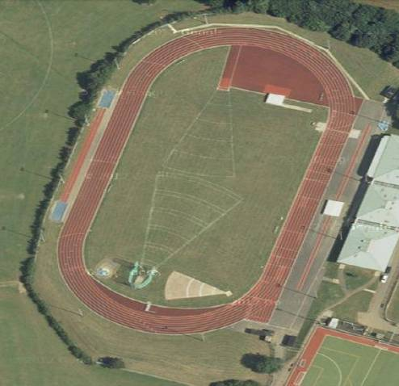
^{HIGH JUMP AREA}
^{JAVELIN}
^{SHOT PUT}
^{HAMMER AND DISCUSS CAGE}
^{LONG / TRIPLE JUMP}
^{POLE VAULT}
^{SPRINT LANES}
^{STEEPLE CHASE JUMP}
^{FIELD EVENTS AREA}
^{YOSC Athletics Track}
^{YOSC/01}
^{Existing General Site Layout}
^{FINISH}
^{NORTH}
^{WINTER GAMES PITCHES}
^{MACADAM APRON}
^{TARGET RANGE}

THIS DRAWING IS ISSUED FOR PQQ INFORMATION PURPOSES.
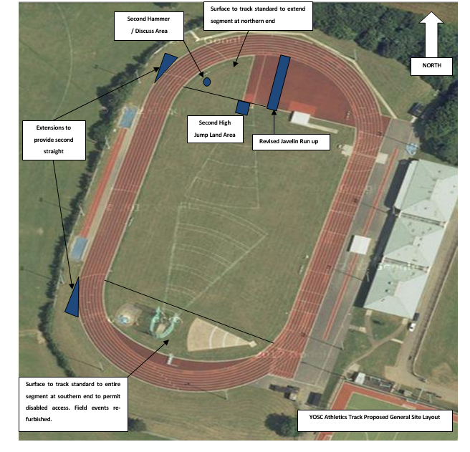
^{TARGET RANGE}
^{YOSC Athletics Track}
^{YOSC/02}

YOSC Athletics Track Proposed General Site Layout

THIS DRAWING IS ISSUED FOR PQQ INFORMATION PURPOSES. THE LAYOUT IS INDICATIVE ONLY.
FINAL EXTENT AND POSITION OF FACILITIES TO BE DETERMINED FOLLOWING APPRAISAL OF TENDER BY THE EMPLOYER

