

ESSEX COUNTY COUNCIL

0460 Software, Hosting and Associated Services

SPECIFICATION

Issued 26 September 2016

Procurement Project 0460

- Introduction
  - Essex County Council (the Authority) is looking to develop its services to meet the current and future needs of residents in the digital age, delivering an even better service. The Authority will embrace digital first at every opportunity either via direct service delivery or through partners. All interactions are optimised for a fast, accessible, user-friendly, inclusive and reliable digital experience.
  - The Authority is seeking to establish a Framework Agreement to provide it, and other Contracting Bodies access to a sole supplier who would work in partnership to meet the Parties requirements in delivering software and hosting services supporting their business needs.
  - The Authority has a diverse range of applications/services currently running on its infrastructure and being hosted externally. These range from office software (winzip, adobe and MS Office) to large projects such as Social Care Case Management systems.
  - It is proposed that the Framework would be procured on terms which would allow access for other Public Sector organisations including but not limited to subsidiaries, LATVs, LATCs, Unitary, Borough and District Councils, Higher Education Institutes / Universities, CCGs and NHS partners. These Contracting Bodies will be responsible for ordering of, and payment for, their own services through this agreement.
- Background
  - The Authority’s current agreement for the provision of its Microsoft Enterprise Agreement (MEA), and other software is due to expire in December 2016. ECC currently procures Software through this current agreement or other procurement routes. Hosting services are currently procured through other procurement routes. The Authority requires an agreement for the provision of its MEA, General Software Services, General Hosting Services, including associated maintenance and support services.
  - The following is an example of some of the products and services provided through the current agreement;
Product | Description of service
Windows Enterprise - Desktop | Licence for desktop 7000 devices. Office Pro Plus, Windows O/S & ECAL
Core Infrastructure Agreement (ECI) 89230138 | Windows & System Centre Servers
Server Cloud Enrolment (SCE) 76214846 | Microsoft Azure services (Microsoft’s Cloud Platform) Essex CC us StorSimple Appliance for storage, providing approx 75TB of storage.
Trustwave SIEM Application | Event Logging & Management Tool (Security)
Innate Resource Management Tool | 500 User Resource Management Licence, Support & Hosting
Check Point Endpoint Total Security | VPN, Full Disk Encryption, Media Encryption, Port Protection, AV/AS, Program Control & Web Check
Check Point Software | 4,200 Check Point Full Disk Encryption Licences 1 Year - Only licences. New license needed 11/15 another year licenses.
Snow Licence Manager | Snow Inventory collects audit information such as:  Software & Operating System  Hardware  Peripherals  Network
Hornbill | Service desk support software. Rolling 1 year agreement
Egress | Egress Switch 8,500 Licences & Gateway inc. 3 Yrs. Support & Maintenance
Hosted Universal Pensions Management (UPM) | UPM 50 users which includes Civica Web, Civica Payroll, Civica Police & Civica Fire
Sophos | Sophos Email Protection Suite 3 Year Licence
Vision Ware Licence | Vision Ware Licence (S&M) + Delivery Services - 1 Years
MetaCompliance | 3 Years Unlimited Subscription Licence Including APP Admin Module and 4 Days Training

  - The provision of the Authority’s corporate MEA needs to be in place by 16th December 2016
  - The Authority is currently reviewing how its hosting services are delivered. Services maybe provided by utilising Software as a Service (SaaS), Cloud hosting or use of data centres and will be defined by the service requirements for those individual services.
- Scope
  - The Authority seeks to procure a sole supplier Framework Agreement based on the following requirements;
      - Source and manage Microsoft Enterprise Agreement licenses;
      - Source and manage Software licenses, including support and maintenance;
      - Source and manage hosting facilities, including support and maintenance;
      - Audit and asset management of services procured through the Agreement;
      - Market analysis – pre market engagement and market intelligence;
      - Implementation – support during and post implementation;
      - Benchmarking – ensuring continuous improvement and value;
      - Contract Management support – contract and supplier management of third party suppliers
      - Project Management and consultancy – end to end process management
  - These requirements will be called off the framework in the following services;
    - Microsoft Enterprise Agreement
    - General Software Services
    - General Hosting Services
  - The Agreement will be awarded to a sole supplier who will be responsible for delivering all services under this agreement. It is not possible to ascertain the likely throughput on the Framework but it will cover the Authority’s Microsoft Enterprise Agreement. No other commitment will be given to purchase services through the framework.
- Service Requirements
  - The Supplier will be required to work with the Authority to manage the overall requirements / scope of the services. The Supplier will need to demonstrate and maintain their market expertise / knowledge in undertaking work called off from the Framework is of the highest quality and industry best practice.
  - The Supplier will maintain an audit and asset management of all Services procured by any of the Contracting Bodies through the Agreement that is available to the Authority This must as a minimum include, the Contracting Body, contract expiry, renewal costs and early termination cost information.

  - The Supplier will maintain expert market intelligence in software solutions and where necessary undertake pre market engagement / analysis to identify the most cost effective solution.

  - The Supplier will support the Authority during and post implementation of any software procured through the agreement.

  - The Supplier will ensure continuous improvement and value through ongoing benchmarking reviews;

  - The Supplier will undertake regular reviews of third party contracts and suppliers as well as contract managing this Framework Agreement.

  - The Supplier will undertake any Project Management and consultancy required for individual call offs to support the end to end process management.

  - The Supplier may be required to work with other suppliers to support the end to end process management

  - The Authority and Supplier will work towards a gain share / Rebate on presentation of a proposal with an outline business case, the Authority would consider such proposal on its own merits, including level of gain/share and required inputs from all parties. The Authority would not be bound to accept any proposal of this nature. The Authority may choose to deliver any savings concepts/proposals presented at Outline Business Case stage on its own or in partnership with others. Should the Authority wish to pursue the offer with the Supplier, any governance, intellectual property, baseline and savings/ gain measurement methodology and reward/payment will be agreed on a case by case basis.

  - The Supplier shall ensure that any item of software or hosting provided under this agreement has been quality assured before delivery ensuring that all security requirements are complied with.

  - The Supplier shall ensure during delivery of the Services that it promotes and encourages knowledge and skills transfer between the Supplier and the Authority.

  - The Supplier will support the Authority in the interpretation of Software usage information from the Inventory Management toolset and utilise this information to provide recommendations on how to right-size the contract. The Authority is to recognise the reduction in support/maintenance payments at renewal as a saving delivered by the Supplier (by calculating the reduction in quantity x the unit price paid at renewal). This saving will be recorded and reported as outlined in schedule 6 (Contract Management)

  - The Supplier will be required to work to agreed targets for the following; Benefits Realisation, Financial Savings and Innovation. The Supplier shall be pro-active in working with the Authority to realise benefits, identify potential savings and identify options to be innovative in the way in which services are provided.

  - The Supplier shall undertake negotiations on behalf of the Authority to include, but not limited to:

    - Better than Market rate commercials for new software and renewals
    - Additional functionality, either at a better than market rate, or free of charge

  - General Software Services and General Hosting Services will be classified as Simple, Medium or Complex using the following definitions:
    - Simple – Where the service is a renewal of an existing service, e.g. renewal of support and maintenance, or is a new requirement for software licences with support and maintenance without the need for project support or implementation support. This work should not exceed 1.5 FTE or 12 hours to deliver
    - Medium – As Simple but will require an element of market analysis prior to more than one quote being submitted to the Authority and the potential to provide implementation support. This work should require between 1.5 and 5 FTE, or 12 – 40 hours, to complete
    - Complex – Where there is a requirement for the supplier to provide market analysis, project management of the end to end process and implementation support. This work would require more than 5 FTE or in excess of 40 hours to complete.
    - The quoted transaction fee for Simple, Medium or Complex should include all the Service Requirements outlined in this Section 4 (Service Requirements)
  - The Supplier shall support the ongoing review of Performance under the contract and meet the Service levels as required by the Authority outlined in Schedule 6 (Contract Management).
  - Where the Supplier fails to meet the Service Levels the Supplier shall produce an improvement plan and commit to carry out agreed improvements to meet the agreed Service Levels as outlined in Schedule 6 (Contract Management).

- Microsoft Enterprise Agreement:
  - The Supplier is expected to:
    - Maintain accurate Microsoft Licence information, for the purposes of budgeting and software asset management.
    - Notify the Authority when the MEA is due for renewal within a suitable timeframe to enable the Authority to consider financial implications and undertake options appraisal.
    - Commit that the prices quoted in the pricing schedule will be the maximum unit price to be paid by the Authority.
    - Ensure any efficiencies secured on behalf of the Authority will be reflected in revised lower unit prices.

- General Software Services
  - The Supplier is expected to:
    - Proactively source software licences and associated services (eg Support and Maintenance, hosting etc), maintain accurate licencing information for all software procured through this Agreement
    - Proactively plan the provision of software budgeting and software asset management.
    - Notify the Authority when software licencing, agreements and maintenance is due for renewal within a suitable timeframe to enable the Authority to consider financial implications and undertake options appraisal.
    - Demonstrate value add from software licensing agreements held by The Authority by best leverage the additional benefits from the software procured through this Agreement.
    - Proactively provide guidance on their most cost-effective procurement methods e.g. applicability of offerings, future proofing purchases based on projected licensing changes.
    - Develop vendor relationships that ensure the most value is provided throughout the duration of the Agreement.
    - Support The Authority during implementation and post implementation; of the software services being provided.
    - Undertake any Project Management and consultancy required for individual call offs to support the end to end process management.

- General Hosting Services
  - The successful supplier is expected to provide, management, maintenance and support services for hosting services. This will include;
    - Audit and asset management of services procured through the Agreement;
    - Market analysis – pre market engagement and market intelligence;
    - Implementation – support during and post implementation;
    - Contract Management support – contract and supplier management of supply chain
    - Benchmarking – ensuring and evidencing continuous improvement and delivering best value
  - The Supplier will undertake any Project Management and consultancy required for individual call offs to support the end to end process management.
  - This is not exhaustive individual call offs for General Hosting Services will specify requirements.
- Delivery Models
  - Where the Supplier is required to provide either General Software Services or General Hosting Services then there shall be two options in relation to the delivery of the services as outlined in the following diagram.
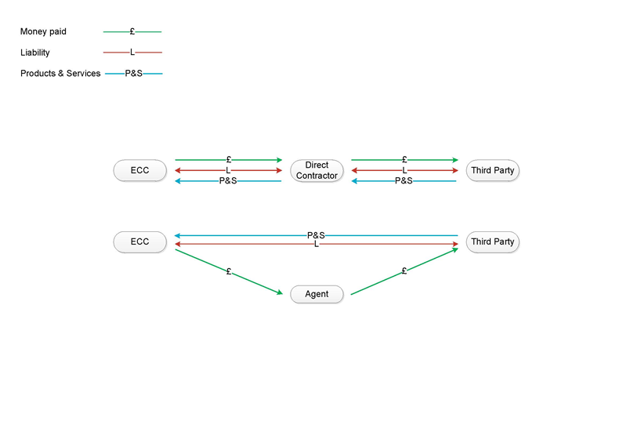
    - The Supplier will act as an agent – The Supplier will be required to provide the service on a transactional basis only. The Authority will own the contractual relationship with the third party supplier with payment only via the Supplier.
    - The Supplier will act as a direct contractor – The Supplier will be required to provide a managed service. The Supplier will own the commercial relationship with the third party supplier with ECC only having a relationship with the Supplier.

- Call Off Process
  - For each service required by the Authority or any Contracting Body a Call Off Agreement of in accordance with the provisions outlined in Section 6 and Schedule 7 (Ordering Procedure).
  - Where services are provided to a Contracting Body within the County of Essex the Authority will not levy a management fee for the use of this Agreement. However the Authority reserves the right to be able to levy such a charge against an organisation outside of the County of Essex.

- Required Delivery Dates
  - Renewal notice of Microsoft Enterprise Agreement to be given to Microsoft by – 16th November 2016.
- Contract Management
  - The Authority will review the Suppliers performance against the Agreement in accordance with the provisions of Schedule 6 (Contract Management). The Authority reserves the right to alter its contract monitoring and review procedures when in its reasonable opinion it is necessary to do so. The Council will provide the Supplier with reasonable notice in the event that the contract monitoring and review processes within this Agreement are altered.

  - The Authority reserves the right to amend any aspect of this Specification during the Agreement period. In the event of any change, the Authority will advise the Supplier in accordance with this agreement and will inform the Supplier of any amendments to this Agreement in writing.

- Standards
  - The Supplier shall adhere to the following Standards:
    - certified Microsoft Gold partner including Cloud platform
    - ISO27001 compliant or equivalent.
    - Imbedded ITIL methodologies within the company and demonstrate best practices.
    - Able to supply pink elephant accredited software aligned to best practices such as ITIL, Agile, Prince2, DevOps, Organisational change management and Business Relationship Management
  - The Authority reserves the right to amend the provisions of this section (Standards) where in its reasonable opinion it is necessary to do so.
- Implementation of Framework Agreement
    - The Supplier must have the appropriate mechanism in place to accept a request for renewal of the MEA to meet the Required Delivery date outlined in section 10 of this Specification.
    - The Supplier will be required to provide an implementation plan, which details the approach that will be taken by the Supplier to initiate mobilisation and support delivery, to support the call off process in awarding a contract under this Framework..
    - The Authority require that the Supplier works collaboratively with the Authority (where relevant) to shape plans at the appropriate point in time, depending on the scope of works commissioned.

- Apprentices
  - Suppliers should consider apprenticeship opportunities as part of the delivery of the Agreement. The Authority requires that an apprenticeship should have the following components:
    - -Minimum of NVQ2
    - -Technical Certificate
    - -Key-Functional Skills
    - -Module on Employment Rights and Responsibilities
    - -A minimum of one apprenticeship per £1 million contract spend

