**Cheltenham Borough Council Staff Travel Plan DRAFT V1**

**Welcome – Message from Pat / Cabinet/ Unions = to be drafted**

1. **Setting the scene**
   1. As a Council we recognise that our activities have an impact on our environment and our neighbours.
   2. We know that the traffic currently using our roads is a major source of air quality problems and in order to address our increasingly congested town centre road network we need to encourage and enable alternative travel choices to the car.
   3. Our main headquarters – the Municipal Offices – is located in the centre of the town, next to the inner ring road and our staff see on a daily basis the impact of traffic on the immediate environment.
   4. The way we deliver our services and the way our staff and visitors travel to and from the offices has an impact on both the highway network and air quality. Through the development and implementation of this travel plan we can begin to address our impacts on the town and help meet our own objectives related to improving our environment, delivering effective services and encouraging healthy lifestyles.
   5. For more information on the travel plan, contact Rhonda Tauman – Transport Projects Officer on 01242 26 4382.
2. **What is a travel plan?**
   1. The Department of Transport defines a travel plan as

“… a long-term management strategy for an occupier or site that seeks to deliver sustainable transport objectives through positive action and is articulated in a document that is regularly reviewed” (DfT 2009).

* 1. In preparing and implementing our travel plan we can take our lead from this definition:
* The travel plan is a long term initiative – a good fit with Cheltenham’s on-going corporate business development;
* The travel plan applies to either an occupier or a site – by applying the plan to the Council’s main Municipal Offices site we can consider initiatives which impact on all that use it – those that work in it, those that visit it and those that deliver to it; by considering the Council as a body occupying the site, we can consider initiatives which might impact on Council operations across all its locations.
* The travel plan is achieved through positive action – we need a set of proactive initiatives and improvements
* The travel plan needs to be regularly reviewed – it will not stand still and is not a one-off document – there will be an annual monitoring report and a review of the plan at the end of its third year.

1. **How can it contribute to our vision for Cheltenham?**
   1. Our long term corporate vision is for:

**“…a vibrant Cheltenham that delivers the very best quality of life for its people**.**”**

And we have identified that key elements to achieving this vision include:

* protecting and enhancing the built heritage and green spaces;
* building strong, safe and healthy communities;
* facilitating the provision of a wide range of sustainable travel options; and
* accepting our responsibility to present and future generations to live within environmentally sustainable limits

Our value for money agenda also requires a programme of initiatives to bridge the funding gap.

* 1. As part of our response to this we have:
* committed to influencing the Cheltenham Transport Plan, which will deliver improvements to traffic flow and public transport linkages within the town centre. Important parts of the plan are a shift to less environmentally damaging transport modes and a reduction in vehicle numbers, particularly those on journeys starting and finishing within a kilometre of the town centre.
* committed to progressing work around the promotion of walking and cycling as part of our healthy lifestyles agenda.

Our planning and air quality policies also contribute to achieving the vision

* 1. Successful implementation of our Travel Plan can contribute to our corporate goals:
* Healthy lifestyles – by encouraging our staff and visitors to walk and cycle more
* Environmental improvement - by reducing the number of cars used in association with our business, which will have a consequential impact on air quality (and, again, health)
* Bridging the gap – by enabling flexible working arrangements and different travel modes for business travel we may be able to reduce budgetary demands.

1. **What are our travel plan objectives?**
   1. Our headline objective for this Travel Plan is:

* **To influence the amount of travel associated with our business and the mode of transport used in a manner which helps to** 
  1. **reduce the amount of car and lorry traffic in the town centre**
  2. **reduce levels of carbon emissions in the town centre**
  3. **improve opportunities for our staff and visitors to have healthier lifestyles**
  4. **make better use of town centre space through reduction in demand for road and parking space**
  5. **to make a positive contribution to bridging the gap.**
  6. The objective will be achieved by concentrating on the following strategic aims:

1. encouraging staff to use more sustainable travel modes in their commute and for business travel
2. enabling working practices which minimise the need to travel
3. encouraging our suppliers to use more sustainable methods of delivery
4. maximising the opportunities which technology offers to reduce the need to travel in the delivery of our business
5. offering opportunities for members of the public to either travel sustainably to our offices or accessing our services without the need to travel.
6. **What is the context for the travel plan?**

Cheltenham

* 1. Cheltenham is a town which should be capable of delivering on sustainable and active travel.
* It is comparatively compact
* It has a street network which allows people to easily move around town
* It has attractive streets which make walking and cycling pleasurable
* It has a developing network of cycle and walking routes and facilities
* It has a vibrant town centre with good public transport links
* It is relatively flat over much of its area.
  1. This is reflected in travel to work data for the town as a whole, which places it in the top 20 local authority areas for both walking (18% of journeys to work – 2011 Census) and cycling (7% of journeys to work).

Municipal Offices

* 1. The Municipal Offices is the Council’s headquarters building.
  2. The offices are centrally located on The Promenade, one of the town’s two main shopping streets with good transport links:
* It is within 3 minutes’ walk of all the main bus hubs – with the main south bound hub directly opposite the office. Bus connectivity to the centre is improving through the Cheltenham Transport Plan and there is an anticipated reduction in journey times on many routes.
* There is a network of off-road, lane-segregated and quiet-street cycle-routes which link the suburbs to the central area. Connectivity through the centre has recently been improved and there are reasonable links to the Municipal Offices, although there remains room for further improvement. There is secure, covered on-site cycle parking for about 30 cycles, with showers and changing facilities; pool bikes are available for business travel. There is a limited on-site visitor cycle-parking, but, the town centre is well provided with cycle parking immediately outside the Offices and nearby. Both the secure on-site parking and town centre parking are well-used.
* The pedestrian network is well developed and the Offices are easily accessible from all parts of the town to the centre. Again, improvements are underway – with a new pedestrian wayfinding strategy being implemented in stages and pedestrian crossing improvements being introduced through the Cheltenham Transport Plan, which will ease pedestrian movement across the inner ring road.
* The offices back on to the inner-ring road which has good connections to all strategic arterial town centre routes. There is ample short and medium stay parking around the site. Discounted all-day staff car parking is available in two town centre car parks, five and ten minutes’ walk respectively from the offices. There is on-site parking for the disabled and Councillors.
  1. The Municipal Offices is the base for about 250 employees from the Council and a number of partner organisations.
  2. The Offices houses most of the Council’s main functions and is its main reception point for the public. About 64,000 people visit the Municipal Offices every year (about 250 a day) to access the services provided by the Council and its partner organisations. Of these, about 1,400 are traders or contractors working on the offices or delivering goods and mail.
  3. In order to understand better, travel to and from the offices, a survey of staff travel habits was undertaken in the winter of 2015/16 – this forms the basis of actions for the plan. It is evident from the number of staff and the number of visitors that journeys by each will be fairly equally split; this makes visitor travel equally important, though it is probably more difficult to influence. Further work to understand visitor travel habits needs to take place during year one of the action plan.

1. **How do staff currently travel to work?**
   1. In winter 2015/16 a survey of all Council staff and all people working in the Municipal Offices was undertaken to assess travel patterns and propensity to adapt to change. A copy of the questionnaire is at Appendix A.
   2. The survey was completed by 161 staff – a 66% response rate, considered a robust basis for the development of this travel plan. 145 indicated that they are based at the Municipal Offices; 116 of them CBC staff.
   3. To start to influence staff work related travel behaviour, the survey asked for information about mode of travel, travel times and home address. The main findings are summarised below.

Travel to work

* 1. Travel to work by staff at the Municipal offices is detailed in Figure 1 – the details vary little from the census rates for the town as a whole. It shows that a little over half of staff travel alone in a car; 10% car-share. Journeys by bike (8%), on foot (19%) and by bus (8%) make up a significant proportion of the commute.

Start and finish times

* 1. Staff arrival and departure times are shown in Figure 2. There are clusters of arrivals between 8:00 and 9:00 and leavers between 5:00 and 5:30. This may present an opportunity to encourage some living close to each other to combine journeys, as buddies for walking, cycling or car-share.

Home address and travel mode

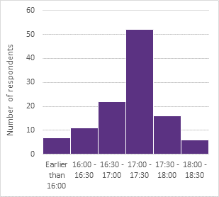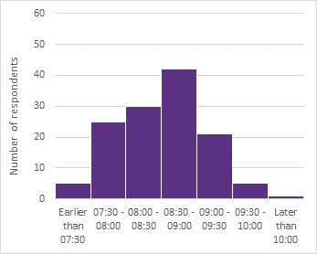

**Figure 2 - Municipal Offices - Start and Finish Times**

* 1. Figure 3 shows where staff responding to the survey live (postcodes taken from the survey) and their usual mode of travel to work.
  2. A significant number living within the town walk to work whereas those who live beyond about 8 miles from the office usually travel by car. Most bus users live in Gloucester or Cheltenham’s suburbs. There are a number of car drivers living comparatively close to the Municipal Offices – and certainly within areas where those nearby have a tendency to walk – this reflects findings from the survey work carried out in connection with the Cheltenham Transport Plan, which identified that 14% of car journeys in the town centre started and finished within a 1km radius of Boots Corner; it was these journeys that the travel planning work sought to change. Additionally a number of car-users live in suburban areas where there are high frequency bus routes and a number of their nearby colleagues frequently use the bus.

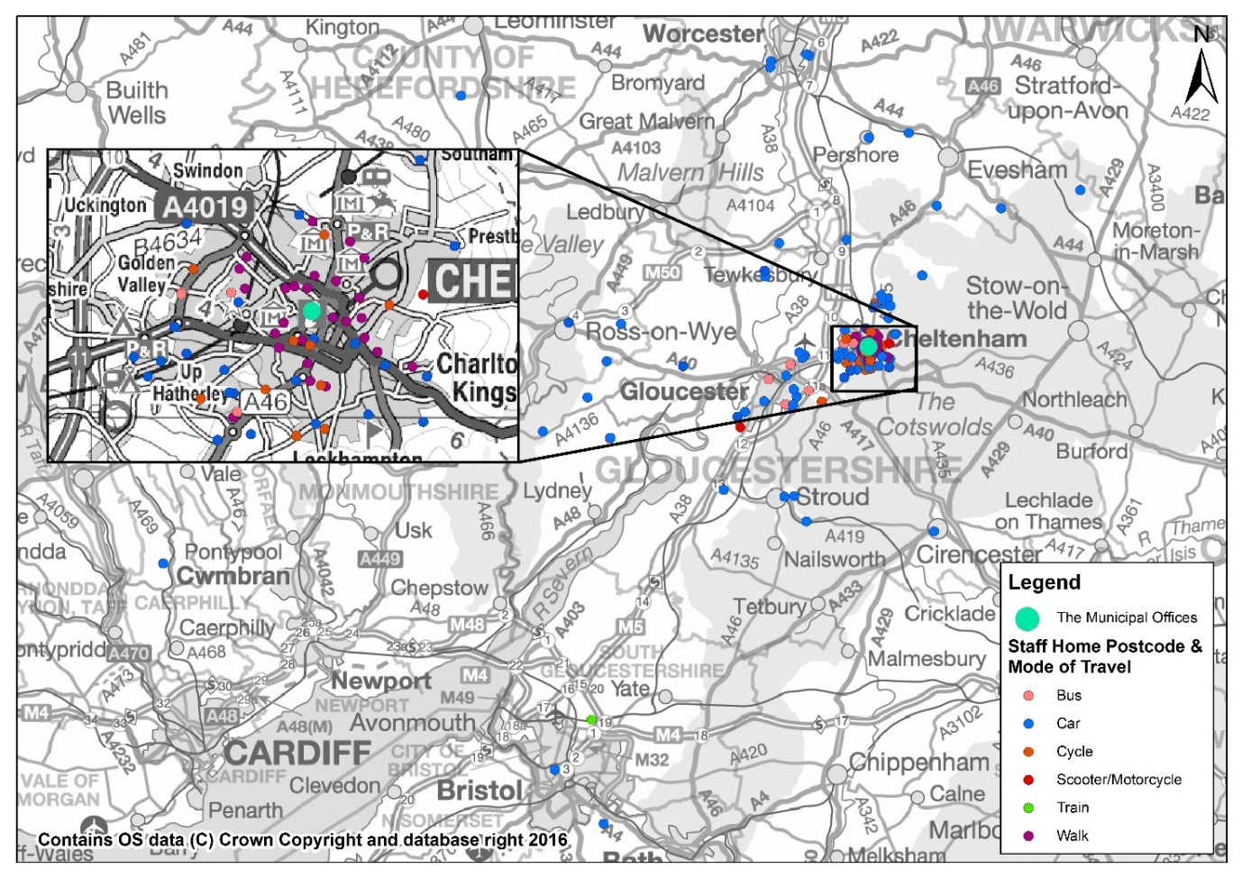

**Figure 4 – Staff Home Postcode Distance from Municipal Offices**

**Figure 3**

|  |  |  |  |
| --- | --- | --- | --- |
| **Distance** | **Number of Respondents** | **Percentage** | **Cumulative**  **Percentage** |
| Less than 0.5 miles | 11 | 8.1% | 8.1% |
| 0.5 – 1.0 miles | 13 | 9.6% | 17.6% |
| 1.0 – 1.5 miles | 17 | 12.5% | 30.1% |
| 1.5 – 2.0 miles | 19 | 14.0% | 44.1% |
| More than 2 miles | 76 | 55.9% | 100% |
| Total | 136 | 100% |  |

1. **What are the opportunities to affect travel?**
   1. The Municipal Offices attract a significant number of journeys. Nevertheless, the Offices are located centrally within Cheltenham, a town with good sustainable transport links. Furthermore, the Council has policies on working patterns and practices which are a basis for enabling staff to undertake their work in a way which reduces the need to travel. Both these factors offer opportunities for reducing the impact of travel related to our business.

Walking

* 1. The staff survey shows that 18% of staff walk to work – this reflects the 17% of Cheltenham’s population that travels to work on foot measured in the 2011 Census. Very few respondents to the survey, who do not currently walk, indicated that they could be encouraged to walk to work, the main reason being the distance was too far.
  2. The Department for Transport refers to research (which is now 16 years old) indicating that a walking commute distance of 1km (0.6 miles) is considered acceptable – though the distance can be further if conditions (topography, street scene, individual fitness etc.) are right – para 5.1 above indicates that Cheltenham’s characteristics are favourable.
  3. Whilst Figure 3 suggest that staff are “out-performing” the DfT cited research; the map shows that a number of staff members who live in Cheltenham and drive to work live in areas where others close-by walk as their preferred option. This would seem to indicate that there is likely to be room for “improvement” - some modal-shift in favour of walking.

Cycling

* 1. When asked in the staff survey, ‘which of the following would encourage you to cycle to work’, almost 63% answered ‘nothing’ citing the distance being too far, journey too long, or having other errands to run before/after work. However, about 80% were aware of the pool bikes, showers and changing facilities and 37% were aware of the on-site bicycle pump.
  2. Nevertheless, there may be opportunities to encourage a shift in favour of cycling, as 20% answered that ‘improved cycling paths’ could encourage them to cycle, and 12% requested improved changing facilities at work. Anecdotal evidence suggests that one of the main difficulties in encouraging cycling is confidence. By building confidence and improving cycling opportunities it may be possible to encourage more cycling.
  3. The DfT suggests that the average of 4km (2.4 miles) is an acceptable distance for cycling, although as with walking, this distance can be further in the right circumstances. This, together with the evidence in Figure 3, suggests that there should be opportunities for an increase in cycling to work, particularly for medium suburban journeys (1 – 2 miles).

Public Transport

* 1. Respondents to the survey were asked what would encourage them to use public transport for their journey to work. Figure 5 shows that 25% of respondents would be encouraged by ‘cheaper fares’ and 24.1% by a ‘work discount scheme’ (in reality, a staff discount scheme would, in effect, offer a cheaper commuting fare). Other popular responses included ‘more frequent services’ and ‘more direct routes/lines’.
  2. This Travel Plan cannot address all the factors, but it could influence those shown in blue in Figure 4 (discount and route planning). In fact, Cheltenham has a very good high frequency bus service from residential areas to the centre, with many areas served by a 10-20 minute frequency throughout the day. This suggests that there are opportunities for greater bus travel if it is possible to make the price attractive and improve information.

Car sharing

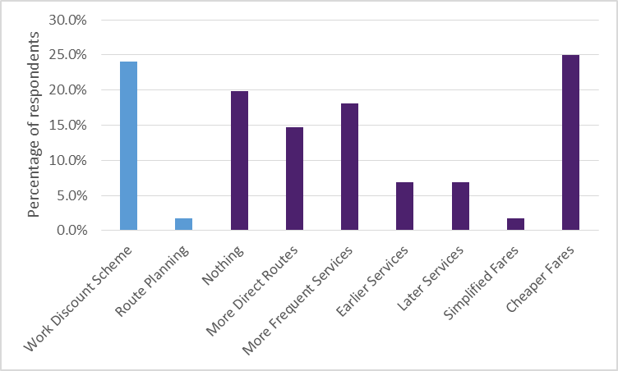

**Figure 4 – Factors which might encourage staff bus travel**

* 1. Over half of respondents indicated that they drive to work alone. The survey asked whether there were incentives which could encourage them to car share to work. About half of the 73 who answered said that help finding a suitable car share partner would encourage them; 18 considered that a ‘reserved car parking for car sharers’ would help. This suggests that initiatives relating to car sharing might succeed in influencing behaviour.

Car

* 1. Discounted car parking is currently available at Town Centre East and Chelt Walk Car Parks. The headline objective of the Travel Plan is to influence travel modes in order help to achieve a number of aims, including a reduction in town centre vehicular traffic and better use of road and parking space. It is clear that there will continue to be sizeable demand for travel by car and the Travel Plan needs to consider how it can best influence those who continue to choose car travel to contribute to the headline objective – encouraging sustainable travel options, rather than penalising others.
  2. Whilst active travel choices can offer benefits across a higher range of the aims listed in the headline objective, a strategy of staff car parking which allows parking at a point where it minimises impact on town centre roads would have benefits in reducing town centre traffic and freeing town centre road and parking space.
  3. The survey asked a question about what it called “park and stride” – i.e. allowing staff who drive to park in car parks away from the town centre and walk the remainder of their journey. There was some support for this; it may offer opportunities in terms of reduced congestion and health benefits to staff.

Sustainable Business Travel

* 1. Encouraging staff to travel to and from work in a more sustainable way also needs to extend into business travel options. Staff need to feel able to opt for a sustainable travel option - such as walk, bike, bus or train - when travelling on business, provided it is consistent with business needs.
  2. Around the town, the confident cyclist will anecdotally make 80% of site visit journeys within 10 minutes of leaving the Municipal Offices – the time it takes many to reach their car. A journey to Shire Hall in Gloucester is likely to be as quick, “door-to-door”, by bus as by car. Some journeys may take a little longer and management regimes may need to be adjusted to make these options a more attractive proposition. Nevertheless, the success of the Plan will require some consideration of how we enable staff to travel for business.
  3. The Council’s procurement polices pose questions about sustainability and its procurement strategy states that it will favour suppliers who can demonstrate that they have the ability to supply goods, works or services that have a clear environmental advantage. It is unclear how these impact travel by those providing goods and services to the Council. The Plan offers an opportunity to review the effect of current policies and establish whether improvements can be made.

Reducing the Need to Travel

* 1. The Council already has facilities which reduce the need to travel for business – through the availability of video and telephone conferencing facilities. These options are probably not used as often as they might be; the Plan offers an opportunity to promote and explore the options more thoroughly.
  2. Additionally, there are opportunities for flexible working arrangements e.g. home working or remote working from partner offices nearer to home. These are options which could ease the commute and reduce our carbon footprint; indeed, both are likely to be an important part of any solution to the accommodation strategy.
  3. Reducing the need to travel offers a range of benefits:
* Economic – increased staff productivity, reduced travel and office costs, improved staff retention, reduced absenteeism
* Environmental – reduced transport emissions; and
* Social – improved quality of life and work/life balance
  1. The Plan offers an opportunity to review current opportunities and how they are promoted or enabled.

1. **How will we implement the plan?**

Objective and Strategic Aims

* 1. Section 4 establishes the objective of the Plan, which is
* **To influence the amount of travel associated with our business and the mode of transport used in a manner which helps to** 
  1. **reduce the amount of car and lorry traffic in the town centre**
  2. **reduce levels of carbon emissions in the town centre**
  3. **improve opportunities for our staff and visitors to have healthier lifestyles**
  4. **make better use of town centre space through reduction in demand for road and parking space**
  5. **to make a positive contribution to bridging the gap.**
  6. It states that it will achieve this objective by concentrating on the following strategic aims:

1. encouraging staff to use more sustainable travel modes in their commute and for business travel
2. enabling working practices which minimise the need to travel
3. encouraging our suppliers to use more sustainable methods of delivery
4. maximising the opportunities which technology offers to reduce the need to travel in the delivery of our business
5. offering opportunities for members of the public to either travel sustainably to our offices or accessing our services without the need to travel.

Action Planning

* 1. The Plan covers a three year period between October 2016 and September 2019. It will be implemented through a series of actions which will be identified in an annual Action Plan to be agreed each September and Appended to the Travel Plan.
  2. The actions will cover a number of topic areas, including:

1. Communications and Marketing
2. Walking
3. Cycling
4. Public Transport
5. Car Share
6. Car
7. Reducing the Need to Travel
8. Procurement
9. Visitors
10. Overarching Actions
    1. It is intended that the action plan will include quick-wins, in order to demonstrate swiftly our ability to influence travel, and actions which will take longer to implement. The feasibility of the Actions has not been fully investigated in advance and each Acton will represent a project in its own right. The initial stage of work relating to each Action will be an investigation of its feasibility; only where a project appears feasible, will it move into development and implementation.

Targets & Monitoring

* 1. Our aim is to publish a monitoring report on an annual basis and review the Plan following year 3 so we have set targets to reflect this. In order to monitor the effectiveness of the Travel Plan, targets for staff travel to work are set out in Figure 5. Targets are based on the evidence of the staff survey and our objective for the Plan to influence the amount of travel associated with our business and the mode of transport used in a manner which helps to achieve a range of environmental and health ambitions.
  2. The targets are intended to affect the commute to work, as a basis for influencing travel patterns whilst at work. Further work needs to be take place in order to establish targets for non-staff travel.
  3. The targets are modest in their ambition, but realistic, and if achieved will establish a strong basis for the first Travel Plan review in 2019. They envisage modest growth in active travel modes, and, by Year 3, 20% working from home (assuming 1 day per week for each staff member). The 20% working at home figure is taken from each mode, which reduces active modes as well as lone car travel numbers in Year 3. However, the overall cumulative effect is aimed at reducing lone car travel to 28% of all commuting journeys by Year 3 – in itself an ambitious reduction of about 50%. The targets are based on stable staff numbers, in order to enable easy comparison; however, staff numbers are not easily predictable over a three year period.

|  |  |  |  |  |  |  |  |  |
| --- | --- | --- | --- | --- | --- | --- | --- | --- |
| **Mode** | **Baseline** | | **Year 1** | | **Year 2** | | **Year 3** | |
| **Percent** | **Number** | **Percent** | **Number** | **Percent** | **Number** | **Percent** | **Number** |
| Car alone | 53% | 129 | 47% | 114 | 41% | 101 | 28% | 67 |
| Car share | 10% | 24 | 11% | 26 | 11% | 28 | 10% | 26 |
| Cycle | 8% | 20 | 10% | 24 | 11% | 28 | 10% | 26 |
| Walk | 19% | 46 | 20% | 49 | 21% | 52 | 18% | 45 |
| Scooter / Motorcycle | 1% | 3 | 1% | 3 | 1% | 3 | 1% | 2 |
| Public Transport | 9% | 22 | 11% | 28 | 13% | 32 | 12% | 30 |
| Remote Working |  | Not measured |  |  |  |  | 20% | 49 |
| **Total** | **100%** | 244 | **100%** | 244 | **100%** | 244 | **100%** | 244 |

**Note:** Survey results have been factored up to the total number of staff (taken as 244)

**Figure 5 – Annual travel plan targets – travel to work**

Funding

* 1. The impetus for this Plan was the establishment of a fund raised from a levy on staff parking. The aim of that fund was to provide a budgetary source for staff green travel initiatives. At August 2016, the funds amounted to about £33,000 held in Council reserves.
  2. However, this Plan establishes that travel associated with the Council arises not only from commuting by staff, but from travel by those using the Council’s services, those doing business with the Council and business related trips generated directly by the staff going about their normal daily business.
  3. Funding for actions arising from this Plan is likely to reflect this range travel “generators” and will, itself, come from a variety of sources, including:
     + **the Council’s base budget** where delivery is substantially related to the Council’s business as usual – for example changes to the web-site;
     + **the staff parking levy** where projects specifically arise from this Plan – for example discounted staff travel ;
     + **Council project budgets**, where an action is entirely or substantially aligned with the delivery of that project – for example remote working through the accommodation strategy;
     + **external funding**, from Government or charitable sources where opportunities arise – for example the Government’s Local Sustainable Transport Fund (LSTF) which provided the funding for this Plan;
     + **a range of funds**, where a match or top up is needed – for example the staff electric vehicle charging points in Town Centre East Car Park where 80% was funded by the LSTF; the remainder by the staff parking levy.

Governance

* 1. The Travel Plan and its annual Action Plan is the responsibility of the Cabinet Member Corporate Service. It is adopted by Cabinet.
  2. Because the impetus for the Plan came from the establishment of the staff parking levy, production has been overseen by the Joint Liaison Form (JLF), which brings together unions and management. The Travel Plan and Annual Action Plan moves forward for Cabinet approval on the recommendation of the JLF.
  3. The Travel Plan and annual Action Plan is produced by the Green Travel Plan Working Group, established by the JLF. The Working Group consists of:

|  |  |
| --- | --- |
| **Representative** | **Current Group Member** |
| Union representative, JLF | Gareth Jones |
| Human Resources Business Partner West, GOSS | Carmel Togher |
| Client Officer, Business Change Team, CBC | Gill Morris |
| Transport Projects Officer Townscape Team, CBC | Rhonda Tauman |
| Townscape Manager, Townscape Team, CBC | Wilf Tomaney |

Implementation of the Plan is led by the Transport Project Officer.

**Year 1 Action Plan – 2016/17 Appendix**

These actions will be commenced in Year 1 of the Plan. Completion may take more than a year.

The actions set out below identify the broad scope of the various actions envisaged. Each will need investigation to establish their feasibility; each will have its own implementation and monitoring plan. They are not exclusive; other actions not yet envisaged can be brought in to effect where they benefit the Plan’s objective.

Funding for action could come from a number of sources. Some will be funded through the staff parking levy; some might need only a small amount of staff time and have no budget implications. Others might be funded through Council budgets as invest-to-save initiatives or as part of other funded Council projects. Eternal funding sources will be accessed where possible.

|  |  |  |  |  |  |
| --- | --- | --- | --- | --- | --- |
| **Ref** | **Action** | **Responsibility** | **Strategic Aim** | **Cost &**  **Budget Source** | **Complete** |
| **1** | **Communication and Marketing** | | | | |
| 1a | Provide travel information to all staff and as part of the staff induction process | HR | Aim A - Staff commuting and business travel | Low  Staff time - Business as usual | Year 1 |
| 1b | Ensure ‘how to get here’ webpage is up-to-date - walking, cycling & public transport information; copy of travel plan | Townscape  Communications | Aim E - Visitors | Low  Staff time - Business as usual | Year 1 |
| 1c | Establish staff travel plan intranet page – to include regular updates and copy of the plan | Townscape  Communications | Aim A - Staff commuting and business travel | Low  Staff time - Business as usual | Year 1 |
| 1d | Hold a travel plan launch event | Townscape | Aim A - Staff commuting and business travel | Low  Staff Parking Levy | Year 1 |
| 1e | Participate in travel awareness days/weeks | Townscape | Aim A - Staff commuting and business travel  Aim E - Visitors | Low  Staff Parking Levy | Year 1 |
| **2** | **Walking** | | | | |
| 2a | Establish buddy system | Townscape | Aim A - Staff commuting | Low  Staff time - Business as usual | Year 1 |
| 2b | Make bags available for carrying papers to meetings etc. | Townscape | Aim A – Staff business travel | Low  Staff Parking Levy | Year 1 |
| 2c | Make available pedometers and personal alarms | Townscape | Aim A - Staff commuting and business travel | Low  Staff Parking Levy | Year 1 |
| **3** | **Cycling** | | | | |
| 3a | Investigate cycle loan scheme | HR | Aim A - Staff commuting and business travel | Medium (though recoverable)  Staff Parking Levy | Year 2 |
| 3b | Establish 6 monthly maintenance of pool bikes | Townscape | Aim A - Staff business travel | Medium  Staff Parking Levy | Year 1 |
| 3c | Establish 3 year rolling replacement of pool bikes | Townscape | Aim A - Staff business travel | Medium  Staff Parking Levy | Year 1 |
| 3d | Provide cycling lessons for staff | Townscape | Aim A - Staff commuting and business travel | Medium  Staff Parking Levy | Year 1 |
| 3e | Relaunch cycle mileage scheme | HR | Aim A - Staff business travel | Medium  Service level Operational Travel Budget | Year 1 |
| 4 | Public Transport | | | | |
| 4a | Investigate corporate season tickets or discount travel schemes between Municipal Offices and regular meeting locations (bus - Shire Hall, Tewkesbury etc.; rail – London, Birmingham, Bristol) | Townscape | Aim A - Staff business travel | Medium  Base Operational Budget | Year 1 |
| 4b | Investigate loans for season tickets on bus/rail travel for staff | Townscape  HR | Aim A - Staff commuting and business travel | Medium (though recoverable)  Staff Parking Levy | Year 2 |
| 4c | Investigate opportunity for discount bus tickets to staff | Townscape | Aim A - Staff commuting and business travel | Low  Staff time - Business as usual | Year 1 |
| 5 | Car Share | | | | |
| 5a | Preferential car space for car sharers | Public Protection | Aim A – Staff commuting | Low  Staff time - Business as usual | Year 1 |
| 5b | Relaunch Car Share website | Townscape (Transport) | Aim A – Staff commuting | Low  Staff Parking Levy | Year 2 |
| 5c | Discount parking badge for car sharers | Public Protection | Aim A – Staff commuting | High  Staff Parking Levy | Year 2 |
| 6 | Car | | | | |
| 6a | Broaden range of car parks available for staff parking to   * reduce demand focus on two car parks; * enable car parks on route to work, to minimise cross-town travel & reduce congestion * encourage “park & stride” | Public Protection | Aim A – Staff commuting | Low  Staff car park payment scheme | Year 2 |
| 6b | Introduce pool car | Townscape (Transport) | Aim A – Business travel | High  Budget to be agreed | Year 2 |
| 7 | Reducing the need to travel | | | | |
| 7a | Promote availability of video conferencing facilities | ICT | Aim B – Reduce the need to travel  Aim D - Technology | Low  Staff time – Business as usual | Year 1 |
| 7b | Encourage home working | HR  ICT | Aim B – Reduce the need to travel | Low (saving?)  Staff time – Business as usual | Year 1 |
| 7c | Encourage compressed days and extended hours | HR | Aim B – Reduce the need to travel | Low (saving?)  Staff time – Business as usual | Year 1 |
| 7d | Explore potential for staff to work some of the time at an office local to them, e.g. staff in the Forest work at Coleford | HR  ICT | Aim B – Reduce the need to travel | Cost unknown  Budget to be agreed | Year 2 |
| 8 | Other initiatives | | | | |
| 8a | Establish working group to include Union representation, to oversee implementation and review off travel plan; and report back to joint liaison forum | Joint Liaison Forum | All | Low  Staff time – Business as usual | Year 1 |
| 8b | Guarantee taxi home in emergencies | HR | Aim A – Staff commuting | Low  Staff Parking Levy | Year 1 |
| 8c | Consider how procurement can further promote sustainable delivery | GOSS – Procurement | Aim C – Suppliers | Medium | Year 2 |

1. **APPENDIX A - Staff Survey**

1 Is your primary place of work the Municipal Office building?

If “No” then…

*This survey is to inform a Travel Plan for Cheltenham Borough Council, for employees who work in the Municipal Office Building. Therefore, you are not eligible to participate further in this survey. If you would like to tell us your primary place of work please do so*

*What is your main mode of travel to work (the one you use for the longest distance)?*

*Which of the following would encourage you to car share to work?*

*Help finding a suitable car share match*

*Help with travel home in the event of an emergency*

Reserved car parking for car sharers

Nothing

Other (please specify)

Which of the following would encourage you to cycle to work?

Help purchasing a bike

Adult cycle training

Improved facilities to mend a bike at work

Improved cycle paths

Improved changing facilities at work

Help with route planning

Access to a 'cycling buddy'

Nothing