

Commercial Medicines Unit

NHS England

2nd Floor

Rutland House

Runcorn

Cheshire

WA7 2ES

**Friday 14 October 2022**

**Invitation to offer for NHS National Framework Agreement for the supply of Eculizumab**

**Offer reference number: CM/PHR/22/5659**

**Period of framework: 01 January 2023 to 31 December 2023 with an option or options to extend (at the Authority’s discretion) for a period or periods up to a total of 24 months**

Dear Sir/Madam, we would like to bring the following information, pertinent to the specific drugs within this procurement to your attention.

This is a procurement for:

DBC069 ECULIZUMAB (BIOSIMILAR) SOLUTION FOR INJECTION VIAL 300MG/30ML and

DIA179 ECULIZUMAB (SOLIRIS) SOLUTION FOR INJECTION VIAL 300MG/30ML

**DBC069 ECULIZUMAB (BIOSIMILAR) SOLUTION FOR INJECTION VIAL 300MG/30ML is being tendered for all uses except use in the treatment of:**

**Atypical haemolytic uremic syndrome (aHUS),**

**myasthenia gravis (MG) and**

**neuromyelitis optica spectrum disorders (NMOSD).**

CMU will share the same explanation at the tender evaluation stage. If an award is made against DBC069 ECULIZUMAB (BIOSIMILAR) SOLUTION FOR INJECTION VIAL 300MG/30ML, the above information will be communicated to Participating Authorities before the framework commencement date.

Yours faithfully

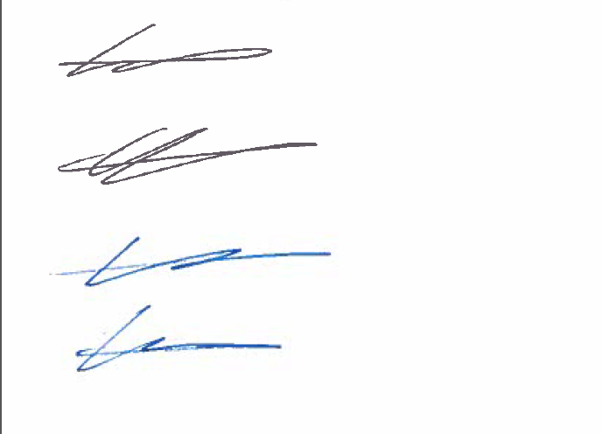

Katie Noonan

Operations Adviser and Developing Commercial Practitioner

Branded, Biosimilars and IV Fluids Procurement Support