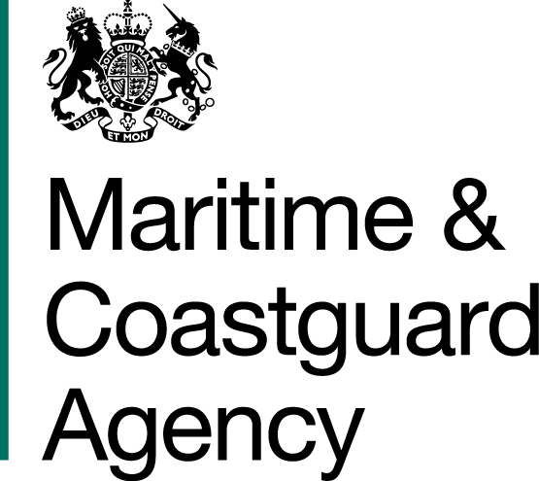 |  |  | Bay 3/19  Spring Place  105 Commercial Road  Southampton  SO15 1EG
To whom it may concern, |  | Tel:  E-mail: |  | +44 (0)20 381 72984  contracts@mcga.gov.uk
 |  | Our ref: |  | TCA 003/007/1077
 |  | 6th March 2019

INVITATION TO TENDER FOR CCTV AT
NATIONAL MARITIME OPERATIONS CENTRE,
FAREHAM, PO14 4LW.

You are invited by the Secretary of State for Transport, to submit a tender for the above requirement.

Please read all the documents listed in the Form of Tender. Should your tender be accepted these documents, your tender and any changes agreed in writing will form a binding contract between you and the Department.

One original and one copy (so marked) of your tender and proposals, including any covering letter, are required.

Tenders must be delivered by: 11:00 HOURS ON 25TH MARCH 2019.

To ensure that all tenderers have access to the same information you can only obtain further information about contractual issues and Technical Information from the Procurement Team. All requests must be submitted in writing as set out in the Instructions for Submission of Tenders, no later than 17:00 HOURS ON 18TH MARCH 2019.

Yours faithfully,

Gillian Norris
MCA Procurement Team

