**NHS South Yorkshire Integrated Care Board (Doncaster)**

**Barnburgh Surgery APMS Contract**

**Description**

NHS South Yorkshire Integrated Care Board (ICB) Doncaster Place (the Commissioners) are seeking a suitable provider of primary medical care services delivered through an Alternative Provider Medical Services (APMS) contract. The ICB would like potential providers to submit a written overview of the intended service, including previous track record, indicative team structure, local staff capacity, and any improvements proposed.

Please direct any queries and send your submission via the tender portal by the deadline of 12:00 Noon on the 5th December 2022.

The ICB is not liable for any costs incurred by those expressing an interest in tendering, for any future contract activity.

The Commissioners are looking to secure a primary medical services contractor through an APMS Contract for the Barnburgh Surgery list of 2,488 patients (as at July 2022). The contract will be a total of nine years with a break after the first five years.

We are looking for providers who can mobilise a service by end April 2023 in readiness for contract start date of 9th May 2023 to ensure continuity of services to the patients in Barnburgh and surrounding areas.

**Barnburgh Surgery**

Barnburgh is a village and civil parish in the Metropolitan Borough of Doncaster; the Barnburgh surgery is located in the centre of the village and serves primarily the populations of Barnburgh and neighbouring Harlington and is a rural settlement that has expanded with some suburban developments. It borders the villages of Goldthorpe in Barnsley and Wath upon Dearne in Rotherham and approximately 20% of the practice population resides outside of Doncaster.

The current practice is in a leased building, the lease is coterminous with the contract, any new provider would need to establish an early relationship with the landlord to negotiate terms. The surgery premise is a mid 19th century stone barn conversion with an extension to the front elevation some internal refurbishment works have been undertaken by the current contract holder. The surgery has its own car park with a shared access driveway. TUPE may apply to this service. Bidders are advised to form their own view on whether TUPE applies, obtaining their own legal advice as necessary

The practice was rated as good by CQC in January 2020. The practice website is here <https://www.barnburghsurgery.nhs.uk/>

The practice is one of ten practices within the South Primary Care Network which in turn is one of five PCNs covering the Doncaster footprint

**The Contract**

Delivery of the contract will be in accordance with the national Standard APMS Contract as published by NHS England. The Contractor is expected to be a Health Service Body.

The Contractor must deliver the full range of Directed Enhanced Services available to it including Minor Surgery DES, Learning Disability Health Checks DES, Network Contract DES and the Weight Management DES and all of the vaccination and immunisation requirements including COVID and Flu immunisations.

Doncaster place also commissions a range of Tier 1 Local Enhanced Services which it is required to provide Glucose Tolerance Test, Helicobacter Pylori Carbon Testing, Hepatitis B, Methotrexate Monitoring, PSA Monitoring, Routine Ring Pessary Change, Shared Care, Single Dose Vaccination and Treatment Room along with a menu of Tier 2 Local Enhanced Services provided to the local population: Diabetes Mellitus: Insulin Initiation, IUCD for Heavy Menstrual Bleeding and control of bleeding for HRT and Routine Ring Pessary Initial Fit.

The service specification included in Schedule 2 of the APMS contract is intended to bring the contract in line with GMS Contracts and covers general service delivery requirements, GP practice services and clinical service requirements as well as QOF.

The Patient registration area is defined in black below:

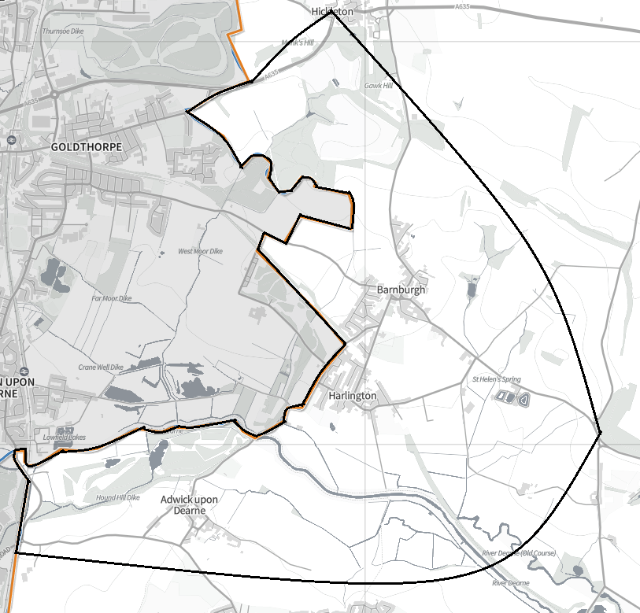

KEY

**Black**: Inner Boundary

**Red:** Outer Boundary

**Orange:** Doncaster

The Core Contract value is £216,161 per annum with a contract duration of nine years based on the weighted list size as at 1 July 2022 plus enhanced services which are paid separately.

The ICB would like potential providers to submit a written overview of the intended service, including previous track record, indicative team structure, local staff capacity, and any improvements proposed for the patients of Barnburgh, in 2000 words or less.

Please send your submission through the ‘Health Family Single e-Commercial System’ (Atamis) to register please follow link : <https://health-family.force.com/s/Welcome> by the deadline of **12:00 Noon on the 5th December 2022.** The information you provide to NHS South Yorkshire will be to assess interest in the market.Dependent upon the response to this PIN the Board will determine if this requirement will form the basis of a competitive procurement process. Contracts may be awarded without further publication.

If a competitive procurement is to take place the ICB will simultaneously and in writing invite those organisations who have registered an interest to confirm their continuing interest. The information to be provided by NHS South Yorkshire will include, but not be limited tothe type of procurement process, the timescales, and the evaluation criteria for any future procurement process.