Chipping Norton Town Council
19 January 2022

INVITATION TO TENDER
FOR PROVISION OF
GROUNDS MAINTENANCE SERVICES

LOT 1 | New Street Road Recreation Ground  Cornish Road Play area  Cotswold Gate Play area and Open Space  Cotswold Crescent Open Space
LLOT 2 | Worcester Road Cemetery
LOT 3 | St Marys Church (Closed Cemetery)  The Almshouses  Millennium Garden  Middle Row Shrub beds
LOT 4  Occasional work on day rates. | Day Works Schedule for work at above sites not included in the specification and at Pool Meadow, The Allotments and Town Centre

PLEASE RETURN BY:
Noon on 21 February 2022 to Chipping Norton Town Council, the Guildhall, Market Place, Chipping Norton OX7 5NJ

Tender Ref. CNTC/GM1/2022
SCHEDULE 1
1. Definitions
Term | Meaning
“Authority” | Means “Chipping Norton Town Council”.
“Arisings” | Means grass cuttings, weeds, shrub/rose off-cuts, unwanted soil etc, leaves, rubbish, dirt and debris at any location or in its immediate environment.
“Authorised Officer” | Means the principle contact of the Authority or such representatives that may be notified by the Authority.
“Conditions of tender” | Means the terms and conditions set out in this ITT relating to the submission of a tender.
“Contract” | Means the agreement (as set out in Schedule 3 of this ITT) to be entered by the Authority and the Provider(s) following any award under the procurement exercise.
“Council Premises” | Means any premises owned, occupied or used by the Council.
“Due diligence information” | Means the background and supporting documents and information provided by the Authority for the purpose of better informing the tenderers responses to this Invitation to Tender
“Invitation to Tender” or “ITT” | Means this invitation to tender document and all related documents published by the Authority and made available to tenderers and includes the due diligence information.
“Location” | Means any location where work under the Contract is to be executed or where the Services are to be performed by the Supplier.
“Lot” | Means a discrete sub-division of the requirements.
“Order” | Means an order for goods / services / works served by the authority on the provider.
“Provider” | Means the organisation admitted to the Contract.
“Potential Provider” | Means the organisations being invited to respond to this invitation to tender.
“Services” | Means the whole or any part of the work to be executed under the Contract including any goods or materials to be supplied by the Supplier in accordance with the Specification.
“Specification” | Means the description of the Services, and any modification thereof or addition thereof as may from time to time be furnished or approved in writing by the Authorised Officer or otherwise duly made under the Contract.
“Sub-Contractor” | Means any contractor carrying out work on behalf of the Council which is being overseen by the Provider.
“Tender Response”,  or “ITT Response” | Means the tenderers formal response to this invitation to tender
“Tenderers” | Means the organisations being invited to respond to this invitation to tender

2. INTRODUCTION
2.1 The Council is seeking to award a three year contract with the option to extend for a further two years. This Contract is being procured under the Councils open tender process.

2.2 The Council is looking for 1 provider per Lot to be appointed to to provide Contract for the supply of services at the following locations:
- New Street Recreation Ground.
- Cornish Road Play Area.
- Cotswold Gate Play Area and open spaces.
- Cotswold Crescent open space
- Worcester Road Cemetery.
- St Mary’s Church (Closed Churchyard).
- The Almshouses.
- Millennium Garden.
- Middle Row Shrub beds (in the Town Centre)

From time to time services may also be required at:

- The allotments
- Pool Meadow
- Town Centre

When such work is required at these sites Works Orders will be issued by the Council to be carried out at Day Rates.
The Potential Provider may bid for one or more Lots.

2.3 You are invited to complete the attached invitation to tender (ITT) and to submit it together with any requested supporting information, to Luci Ashbourne, Town Clerk, Chipping Norton Town Council by noon on 21 February.
2.4 Potential Providers shall accept and acknowledge that by issuing this ITT the Council shall not be bound to accept any tender and reserve the right not to conclude a contract for some or all of the Services for which tenders are invited.
3. PURPOSE AND SCOPE OF THIS ITT
These instructions are designed to ensure that all Potential Providers are given equal and fair consideration. It is important therefore that you provide all the information asked for in the format and order specified.
The Potential Provider shall not make contact with any other employee, agent or consultant of the Council who are in any way connected with this procurement exercise during the period of this procurement exercise, unless instructed otherwise by the Council.

4. CONTRACT TERM
4.1 The Contract shall be for 3 years from 1 April 2022 to 31 March 2025 with the option to extend for a further 2 years at the discretion of the Council and subject to performance during the initial 3 years of the contract.

4.2 The Contract shall be required to be fully operational by 1 April 2022.

5. INSTRUCTIONS FOR COMPLETION
5.1 Potential Providers should read these instructions and the Specification carefully before completing the Tender documentation. Failure to comply with these requirements for completion and submission of the Tender Response may result in the rejection of the Tender. Potential Providers are required therefore to acquaint themselves fully with the extent and nature of the Services and contractual obligations. These instructions constitute the Conditions of Tender. Participation in the tender process automatically signals that the Potential Provider accepts these Conditions of Tender.
5.2 Potential Providers should contact the Town Council if they would like to carry out site visits.
6. TENDER VALIDITY
6.1 Your tender should remain open for acceptance for a minimum period of 90 days. A tender valid for a shorter period may be rejected.

7. RETURN OF THE QUESTIONNAIRE
The completed questionnaire must be returned to Luci Ashbourne, Town Clerk, Chipping Norton Town Council no later than 21 February 2022.
The Tender must be submitted in the form specified. Failure to do so may render the response non-compliant and it will be rejected.

8 DISCLAIMERS
8.1 Whilst the information in this ITT, Due Diligence Information and supporting documents has been prepared in good faith, it does not purport to be comprehensive nor has it been independently verified.
8.2 Neither the Council, nor any advisors, officers, members, partners, employees, other staff or agents:
(a) makes any representation or warranty (express or implied) as to the accuracy, reasonableness or completeness of the ITT; or
(b) accepts any responsibility for the information contained in the ITT or for their fairness, accuracy or completeness of that information nor shall any of them be liable for any loss or damage (other than in respect of fraudulent misrepresentation) arising as a result of reliance on such information or any subsequent communication.

9. INDICATIVE TIMETABLE
9.1 Set out below is the proposed procurement timetable. This is intended as a guide and whilst the Authorities do not intend to depart from the timetable it reserves the right to do so at any stage.
Stage in the Procurement | Deadline
Deadline for return of ITT to the Authority | 21 February 2022
Evaluation of the ITT responses commences | 22 February 2022
Clarification meetings if required | Ist week of March 2022
Report to Community Committee | 9 March 2022
Award of Contract | 10 March 2022
Contract start date | 1 April 2022

11. ELIGIBILITY, SELECTION AND AWARD CRITERIA
11.1 In addition to price, all Tenders will be evaluated against the selection criteria set out in the table below.
Selection Criteria | Weighting
Health and Safety | 20%
Environmental Sustainability (particularly limiting use of pesticides) | 20%
Technical capacity, expertise and experience | 60%
Total | 100%

12. CONTRACT AWARD
12.1 Contract award is subject to the formal approval process of the Council which will take place at a meeting of the Community Committee on 9 March.. Until all necessary approvals are obtained no agreement will be entered into.
    - The Council shall be under no obligation to accept the lowest or any Tender.

SCOPE AND SPECIFICATION OF WORKS
SCHEDULE 2
SPECIFICATION
GRASS CUTTING
Key Aims
- To provide a good quality sward, within agreed levels, which is fit for the particular purpose for which it is intended
- To ensure each site is left tidy

The specification of work is as follows:

1  2 | General Scope of work  Plant and Transport | The work involves cutting grass on public open spaces and amenity areas, cemetery and closed cemetery and at the recreation grounds. Grass is defined as to include all other vegetation within the specified area. Any weed growth, such as nettles, from adjoining properties that overhangs the grass areas indicated is to be cut back flush to the boundary on each occasion.  The Contractor is to provide all tools, plant and cutting machinery, together with fuel etc. The Council will not be liable for any damage to any contractor’s equipment caused by carrying out these works. The contractor is to provide any equipment including transport which he requires to carry out the work
3 | Areas to be cut | The areas to be cut are specified in the attached plans.
4 | Period of work | In year 1 the grass cutting contract will start on 1 April. Thereafter the grass cutting contract will run from 1st March to 31 October each year of the contract.
5 | Date of cuts | Two grass cuts per month are required between 1 April and 31 October and one cut in November and March (except in year 1 when there will be no cut in March).  These dates may be varied by agreement with the Clerk having regard to growing conditions and any other material considerations. The Council reserves the right to omit any cut or cuts.
6 | Removal of litter | Clear any litter from the site and empty litter bins as identified. All rubbish disposed of to an approved disposal site. Task to be undertaken twice weekly on Mondays and Thursdays from 1 June – 30 September and once every two weeks between 1 October – 31 March.  Prior to mowing, all areas must be litter picked and the resulting debris and rubbish disposed of to an approved disposal site.
7 | Bulb areas | Plants must be allowed to complete their growth cycle before mowing takes place. The first cut should take place at least six weeks following completion of flowering. All clippings should be removed from site and the area should then revert to the regime of the surrounding grass.
8 | General grass cutting | The contractor shall keep all grass areas mown using pedestrian operated or ride on rotary or cylinder mowers or strimmers. Unless specified otherwise clippings may be left on and evenly distributed over the area.
9 | Obstacles | At each mowing it will be necessary for the contractor to cut around the base of walls, fences, hedges, play equipment and other obstacles to the same height and standard as the surrounding areas. All due care must be taken whilst mowing or strimming around memorials and gravestones and any damage caused must be reported to the Town Clerk immediately. Any damage to memorials or graves caused during the execution of grass cutting works shall be rectified at the Contractors expense.
10 | Cleaning up after mowing | At the end of grass cutting operations, the contractor shall ensure that any grass cuttings or debris that have been distributed over roads, footpaths or other hard surfaces shall be swept up or blown on to grassed area.
11 | Lawn Grass Cutting | Where a location is identified as lawn grass cutting, the grass cuttings are to be collected and removed from site at no additional cost to the Council.
12 | Pesticides and Herbicides | The contractor should quote on the basis of using only HSE approved pesticides and herbicides on areas outside the town centre and by hoeing in the town centre. The Council has stated its wish to become pesticide free during the course of this contract. There will be separate discussions between the Council and the successful provider and it is recognised that the extra costs may be incurred. Potential Providers are asked to give details of their approach to the use of pesticide in the questionnaire.
13 | Completion | Once the contractor has commenced grass cutting in an area, he shall complete it without delay before moving on to the next area.
14 | Rectify | The contractor shall be required to recut, within 24 hours, any area deemed to be unsatisfactorily mown, at his expense.

SPECIFICATION
HEDGES
Key Aims
- To provide neatly clipped hedges which are weed free
- To prevent hedges affecting footpaths or vision splays
- To ensure that footpaths wide enough to allow access for wheelchairs and pushchairs

Plant and Transport

The Contractor is to provide all tools, cutting machinery and plant together with fuel etc. The Council will not be liable for any damage to any contractor’s equipment caused by carrying out these works. The contractor is to provide any equipment including transport which he requires to carry out the work

Prunings

The Contractor shall be responsible for disposing of all material cut back and pruned et and for leaving all sites in a tidy condition

The specification is as follows:
To cut hedges and small trees to an accepted horticultural standard with particular reference to the nesting season and to hibernating animals. To strim overgrown vegetation. Pernicious weed, such as Old Mans Beard should be cut off at the base. A contractor may use a flail to cut hedges where in larger, open area.
The hedges identified in Schedule xx are to be cut according to the following specification.
- The Contractor shall trim and prune the hedges to encourage a stable hedge.
- The Contractor shall cut back the current growth to the point of the previous cut, and the hedge shall be trimmed, pruned back to the same height, width and general shape as that which existed at the completion of the last trim,
- All hedges shall be cut both sides and top.
- The Contractor shall cause minimum disturbance to nesting birds and wildlife in compliance with the Wildlife & Countryside Act 1985.
- For the hand cut only, the Contractor shall make all cuts cleanly and remove any ragged edges using a sharp blade
- The Contractor shall leave grass edges adjacent to hedges neat, vertical, tidy and weed free at the time of cutting.

SPECIFICATION
Gardens and shrub beds
Key Aims:
- To provide high quality [ floral and] shrub displays that are healthy, vigorous and allowed to reach their full flowering potential
- To achieve weed and litter free displays
Plant and Transport

The Contractor is to provide all tools, cutting machinery and plant together with fuel etc. The Council will not be liable for any damage to any contractor’s equipment caused by carrying out these works. The contractor is to provide any equipment including transport which he requires to carry out the work

Prunings and Litter

The Contractor shall be responsible for disposing of all material cut back and pruned etc and for leaving all sites in a tidy condition. Litter may be bagged up and removed.
Where possible, beds should be hoed once a month until plants have grown sufficiently to make this impractical. Thereafter large weeds should be removed by hand.

LOCATION REQUIREMENTS
New Street Recreation Ground | Maintenance of grassed areas.  Strimming of grassed areas.  General Grass Cutting of complete site.  De-littering of site. Please note the litter bins on site are emptied by West Oxfordshire District Council.
Cornish Road | Maintenance of grassed areas.  Strimming of grassed areas.  General Grass Cutting of complete site.  De-littering of site and litter bin emptying. One litter bin is on site in accordance with the specification.
Cotswold Gate Play Area and open spaces | Maintenance of grassed areas.  Strimming of grassed areas.  General Grass Cutting of complete site - Mowing the grass as per specification.  De-littering of site. Please note the litter bins on site are emptied by West Oxfordshire District Council.
Cotswold Crescent open space | Maintenance of grassed areas.  Strimming of grassed areas.  General Grass Cutting of complete site - Mowing the grass as per specification.  De-littering of site and litter bin emptying. One litter bin is on site in accordance with the specification.
Worcester Road Cemetery | Maintenance of grassed areas.  Strimming of grassed areas.  De-littering of site and litter bin emptying once every two weeks throughout the year. Eight litter bins are on site. Rubbish may be left in the skip which is on site.  General Grass Cutting of complete site. To include the strimming of all obstacles including grave stones and memorials at the same time as mowing to ensure a well-kept appearance (Two strims per month are required between 1 April and 31 October and one cut in November and March). Graves and memorials may need grass being blown from stone work.  Mowing the grass.  Maintenance of one section of leylandii hedge and one section of beech hedge adjoining the ashes section. Top and both sides to be cut in accordance with the specification. Note additional hedge cutting is currently carried out by a different contractor but this work may be added to the contract at a later date.  Additional Duties  Footpaths to be kept free of weeds, leaves, litter and debris and edged each year during the winter.  The Colonnade is to be swept on each grass cutting visit.  Dead flowers and wreaths to be removed from the Colonnade weekly throughout the year.  The area between the main gates and the public footpath is to be kept clear of leaves and debris following each grass cutting visit and also once in November and December.  The area at the top of the cemetery is managed as a wilder area and should only be cut. As this area is developed a different maintenance regime may be required. This will be discussed separately with the successful contractor.
The Closed Churchyard, St Mary’s Church | Maintenance of grassed areas.  Strimming of grassed areas.  General Grass Cutting of complete site
The Almshouses, Church Street | Maintenance of grassed areas.  Strimming of grassed areas.  General Grass Cutting  Maintenance of Shrubs Beds in accordance with the specification.
The Millennium Garden, Burford Road/West Street | Maintenance of grassed areas.  Strimming of grassed areas.  Grass Cutting – Lawn Grass Cutting.  Maintenance of Shrubs Beds in accordance with the specification.
Town Centre | Middle Row - Maintenance of shrub beds in accordance with the specification.  Occasional grounds maintenance work may be required for which separate works orders will be issued. Day rates should be charged for this work.
Pool Meadow | There is no regular maintenance regime in this area. Occasional grounds maintenance work may be required for which separate works orders will be issued. Day rates should be charged for this work.
The Allotments | There is no regular maintenance regime in this area. Occasional grounds maintenance work may be required for which separate works orders will be issued. Day rates should be charged for this work.

Site Plans

Worcester Road Cemetery, New Street Road Recreation Ground and Pool Meadow.

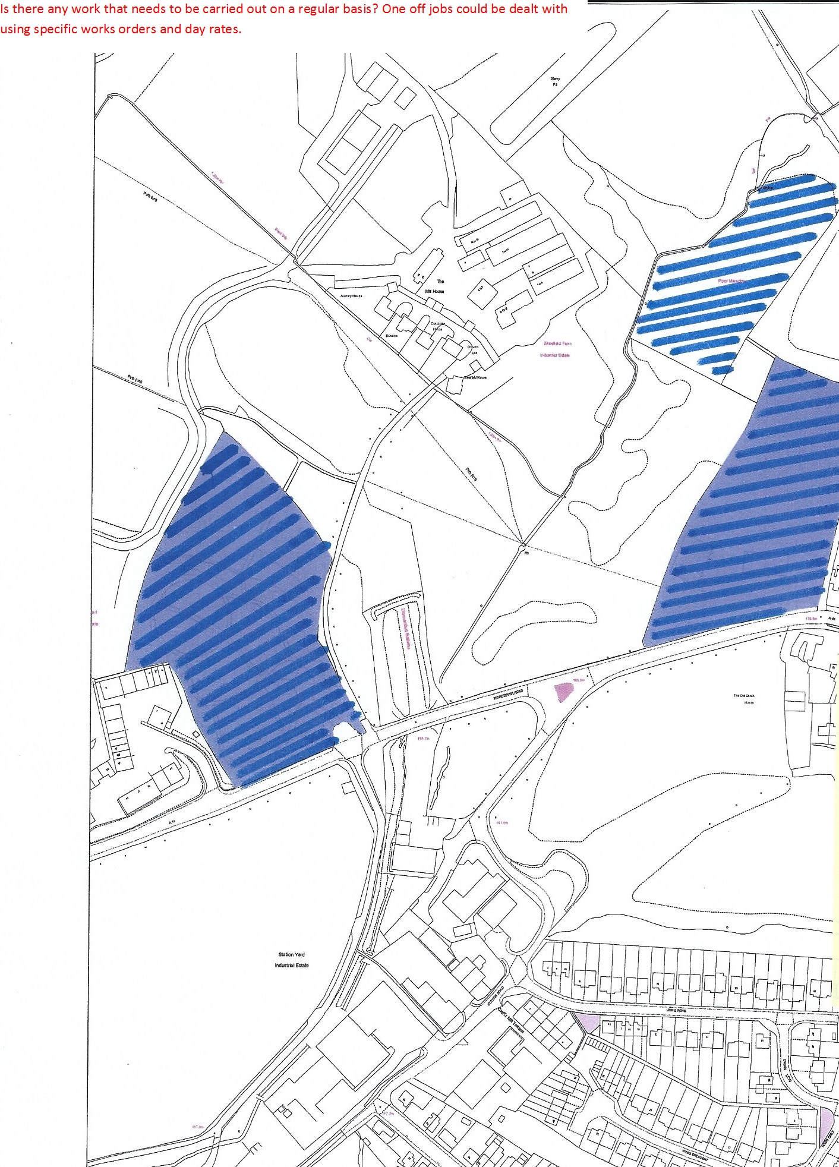

Cotswold Gate Open Space

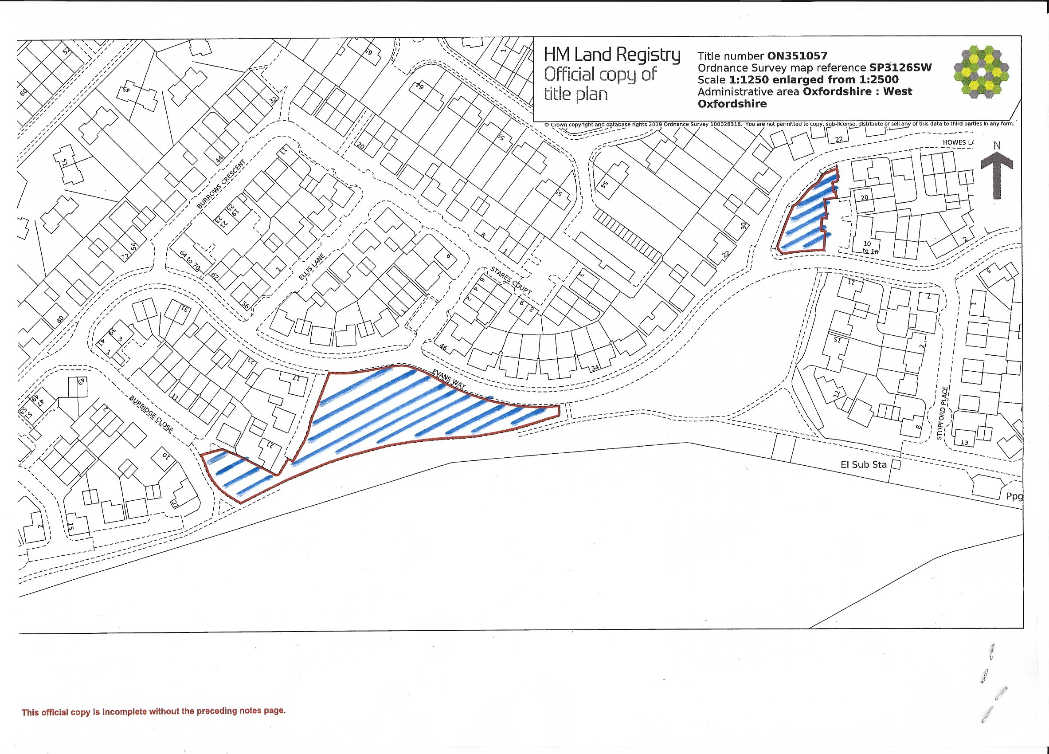

Cotswold Crescent Play Area

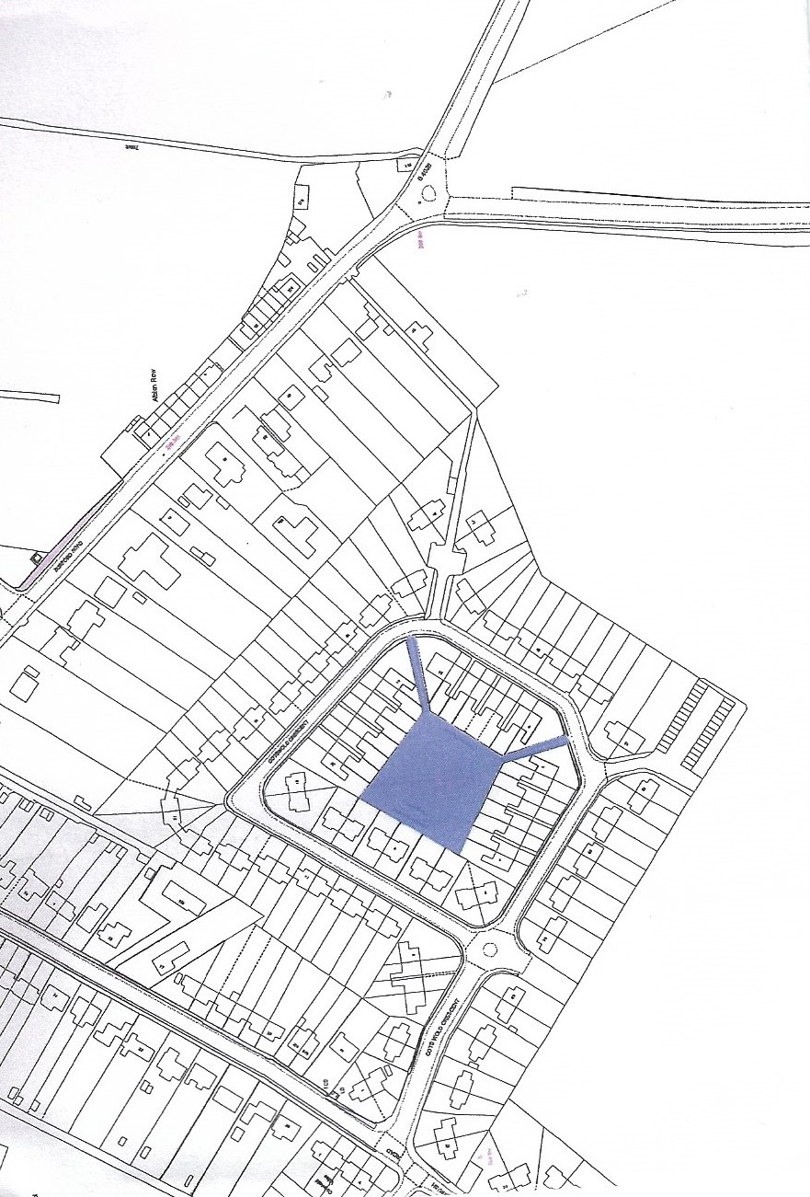

Cornish Road Play area and recreation ground
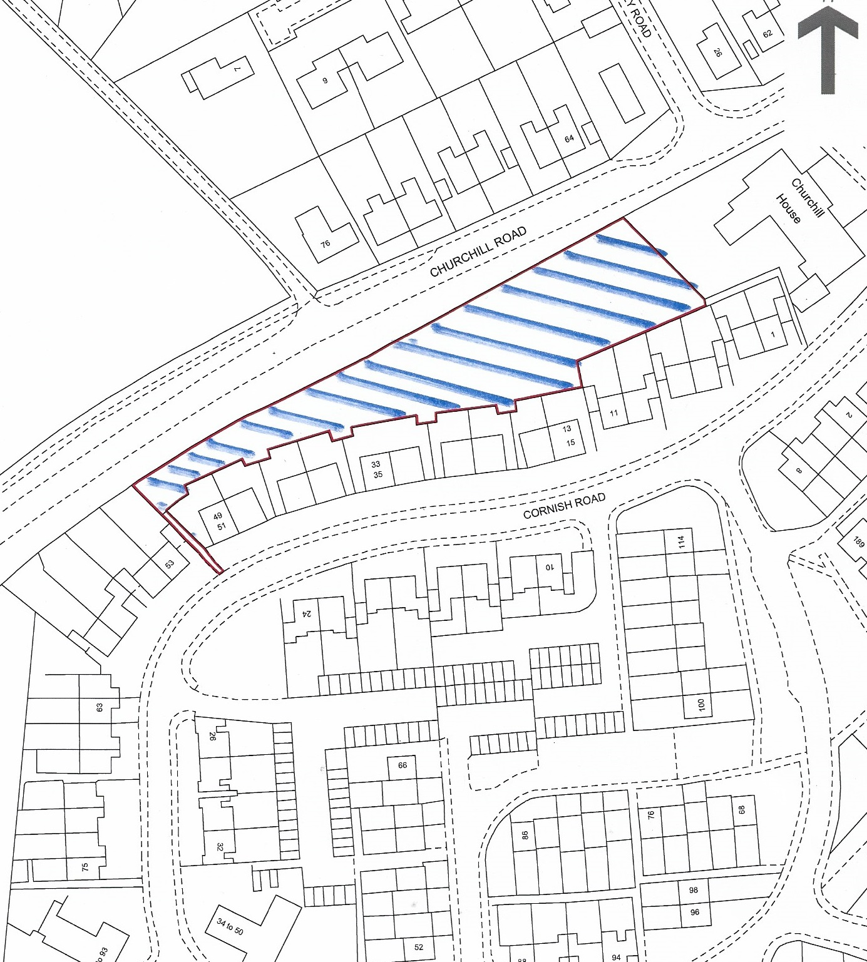

Millennium Gardens

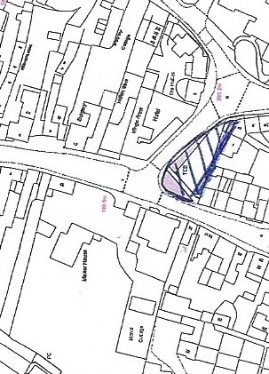

St Mary’s closed burial ground and Almshouses
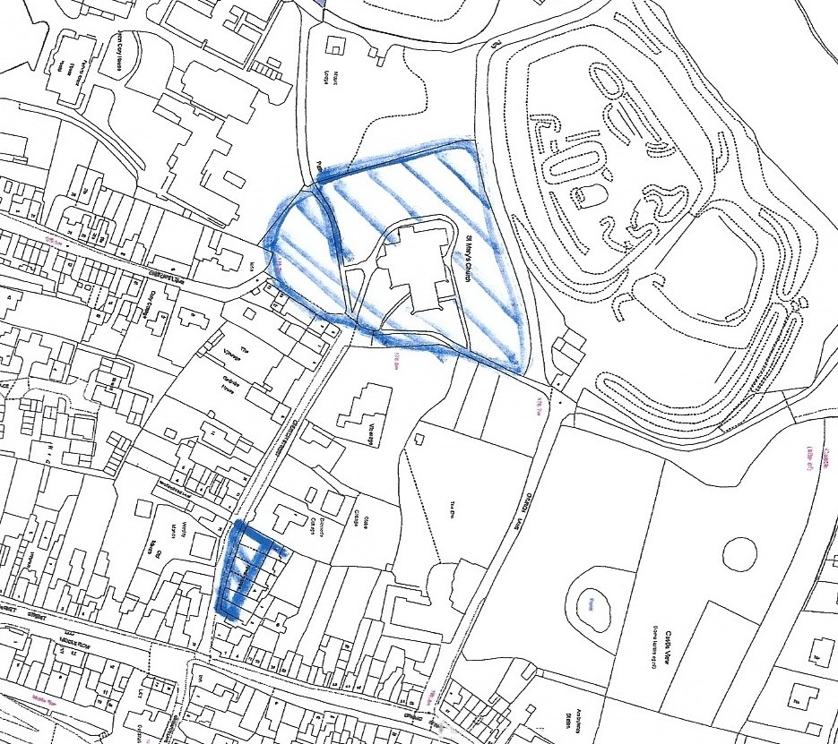

SCHEDULE 3

TENDER RESPONSE
For the Provision of Grounds Maintenance Services

Tenderers are to complete Schedule 3
Please return response sections by post to:

Luci Ashbourne, Town Clerk, to Chipping Norton Town Council, the Guildhall, Market Place, Chipping Norton OX7 5NJ
By noon on 21 February 2022
All tenders to be in sealed envelopes and marked in the top left hand corner
‘Tenders – to be opened only by tender panel’

Part A

Commercial Information

A.1. Company/Organisation identity –
A.1.1. Company name of organisation submitting the tender:

A.1.2. Contact name and position in organisation:

A.1.3. Company address:
A.1.4. Contact telephone number:
A.1.5. Contact e-mail Address:
A.1.6 Company Web Site Address:
A.1.7 Company Registered Address if different from above:

A.2 Areas of Business
A.2.1 Please indicate below the principle areas of business activity of your organisation:
A.2.2 Please indicate which elements if any of the services your organisation anticipates may be sub-contracted:

A.3 Insurance
A.3.1 Please provide a copy of your organisation’s insurance certificates and provide the required information regarding your company/organisation's insurance cover:

Public Liability Insurance Min £10,000,000
Insurer
Policy Numbers
Expiry Date
Limits of indemnity (per occurrence and aggregate)
Excess (if any)
Employers Liability Insurance £5,000,000
Insurer
Policy Numbers
Expiry Date
Limits of indemnity (per occurrence and aggregate)
Excess (if any)

A.4 Health and Safety

A.4.1 Please supply the name and designation of the person responsible for the implementation of the organisations Health and Safety Policy.
A.4.2 If you employ 5 or more employees, please enclose a copy of your current health and safety policy.
A.4.3 If you employ less than 5 employees, please tell us how you ensure that your Health and Safety measures are put into place and practiced within your organisation.

A5 Environmental Sustainability

A5.1 Please enclose a copy of any environmental management certification that your organisation holds. If you do not have any certification please detail how your organisation complies with environmental legislation.

A5.2 Does your organisation measure its energy/fuel use and carbon dioxide emissions?

Please detail any plans that your organisation has in place to reduce fuel use and emissions. Does your organisation recycle water?

A5.2 The Council is committed to undertaking maintenance of its open spaces by using methods which have minimum damaging impact on the natural environment. Please detail plans comply with the Council’s Pesticide and herbicide policy (copy attached).

Part B
TECHNICAL CAPABILITY

B.1 Previous Experience
B.1.1 Please provide information of your organisations technical capacity and expertise and experience over the past five years of carrying out similar services under a formal contract to the public sector, in particular parish councils or other public bodies.

B.1.2 Please detail below any problem/delay that has been encountered by your organisation when implementing new contracts such as this. If problems / delays have been encountered, please explain how the situation was resolved.

B.1.3 Bidders must have existing experience of all the equipment that is currently in use in order to ensure that they can deal with faults from the start of the contract.

C.3 Staff Skills and Development
C.3.1 Please indicate below whether any operatives you employ and would expect to engage on this contract have specific skills/qualifications related to the range of requirements set out in the specification.
Skill / qualification | Number of operatives

C.3.2 Please provide details of your current training policy/procedures (including any health and safety training), and describe how you ensure that skills are maintained. Max 400 words

C.4 References – please provide 2 references
C.4.1 Please provide details for three companies for which you have delivered similar projects that will provide a reference. The Authorities will take up two references.

Reference 1
Company Name
Company Address
Contact name
Contact Phone Number
Contact e-mail address
Website details
Contract start / end dates
Value of contract
Brief description of contract including use of sub-contractors if applicable

Reference 2
Company Name
Company Address
Contact name
Contact Phone Number
Contact e-mail address
Website details
Contract start / end dates
Value of contract
Brief description of contract including use of sub-contractors if applicable

Part D
TECHNICAL PROPOSAL

D.1 Service Requirements
D.1.1 Please detail below the format in which your organisation can receive Service Requests

D.2 On-site Arrangements
D.2.1 What arrangements does your organisation have for the removal and recycling of any rubbish and debris accumulated during the supply of the services?

D.3 Quality of work and Supplier conduct
D.3.1 Please detail the checks that your organisation will make to ensure that
a) that the services will be carried out by a suitably trained and competent team / member of staff:

D.4 Sub-Contracting
D.4.1 Please detail your organisations methodology for employing sub-contractors and ensuring that sub-Contractors if used on this contract are fully compliant with the terms and conditions of the Framework Agreement.

Part E
FINANCIAL PROPOSAL

 |  | Per cut | Per year
LOT 1 | New Street Road Recreation Ground  Cornish Road Play area  Cotswold Gate Play area and Open Space  Cotswold Crescent Open Space
LLOT 2 | Worcester Road Cemetery
LOT 3 | St Marys Church (Closed Cemetery)  The Almshouses  Millennium Garden  Middle Row Shrub beds
 | Total (excluding VAT)
 | Total including VAT

LOT 4

Is for works outside the specification above and also at the Allotments, Pool Meadow and the Town Centre at Day Rates. Some of this work may be required outside normal working hours (which are deemed to be Monday – Friday 07.00 – 18.00).

The Council will not pay an additional “per task call out charge” and will make payment on a time and materials basis. Hourly rates are to be fixed for the periods 1st April 2022 until 31 March 2025.

ADDITIONAL WORK RATES 1 ARPIL 2022 UNTIL 1 MARCH 2025
Please complete the table below.
Hourly Rate Monday - Friday 07.00 – 18.00 | £
Hourly rate Monday – Friday 18.00 – 24.00, 00.00 – 07.00 | £
Hourly Rate Saturday 07.00 – 18.00 | £
Hourly rate Saturday 18.00 – 24.00, 00.00 – 07.00 | £
Hourly Rate Sunday / Public Holiday 07.00 – 18.00 | £
Hourly rate Sunday / Public Holiday 18.00 – 24.00, 00.00 – 07.00 | £
Mark up on plant and equipment hire | %
Mark up on materials | %
Travel cost (per call out or additional visit) | £

Document 1

Form of Tender
To be completed by the Tenderer
To: Chipping Norton Town Council
PROVISION GROUNDS MAINTENANCE SERVICES under the contract
To: The Authorities
From:
Having examined the Invitation to Tender and all other Schedules, and being fully satisfied in all respects with the requirements of the ITT (including the Conditions of Tender) for the above mentioned Services, I/We hereby offer to provide the whole of the services for the term of 4 years from the Date of Commencement stated above with conformity with the Conditions of Contract and the Methods of Work, Specifications and the Pricing Documents for the prices in the Pricing Documents. If this offer is accepted I / we will execute documents in the form of the Contract within 30 days of being called upon to do so.
Unless and until a formal contract is prepared and executed this tender, together with your written acceptance thereof, shall constitute a binding contract between us.
I / We understand that you are not bound to accept the lowest or any tender you receive.
I / We understand that no payment will be made for any expenses or losses incurred in the preparation of my / our tender.
I/we agree that this tender remain open for acceptance for 90 days after the closing date for submission.
I/we warrant that I/we have all the requisite corporate authority to sign this Tender.

Signed: …………………………………………………………………………….

For and on behalf of: ………………………………………………………………………………………………………..

Address: …………………………………………………………………………………………………………………………..
…………………………………………………………………………………………………………………………………………
…………………………………………………………………………………………………………………………………………
Date: …………………………………………………………………………….

Document 2

Declaration

I certify that the information supplied is accurate to the best of my knowledge and belief.
I understand that Chipping Norton Town Council may contact anyone to verify this information, and that false or misleading information could result in my/our exclusion from the select tender list.
I also understand that it is a criminal offence, punishable by imprisonment to give or offer to give any gift or consideration whatsoever as an inducement or reward to any servant or member of a public body. In addition your specific attention will be drawn to the clause in the proposed contract empowering the Authorities to cancel the contract and to recover any loss from the contractor if the contractor has offered any gift or inducement of any kind in relation to obtaining the contract.

Signed _____________________________________

Position held _____________________________________

For and on behalf of _____________________________________

Date _____________________________________

Before returning this application form, please ensure that you have: -
- Answered all questions.
- Enclosed all relevant documents.
- Completed the above declaration.

N.B. APPLICATIONS MAY NOT BE CONSIDERED UNLESS ALL THE ABOVE HAS BEEN PROVIDED

