30 July 2026

Dear Sir or Madam:

Invitation to Tender: Email Marketing Services: BIG001-0703

You are invited by the Big Lottery Fund, to tender for the above referenced Contract. Our requirements are contained in this ITT document.

The Contract Terms and Conditions that you will be required to sign up to are available to view at this link: http://www.biglotteryfund.org.uk/index/about-uk/procurement_portal.htm.
The Preferred Bidder will not be permitted to enter into any negotiations on the terms of the Contract. Any attempt to negotiate amendments will breach the terms of this ITT and will result in the Preferred Bidder being excluded from the tender process. In such circumstances BIG reserves the right to invite the next highest scoring Bidder to enter into the Contract.
You must follow all the instructions set out in this Invitation to Tender when responding to it. The deadline for submission is 12.00 (Noon) Thursday 3rd March 2016. Failure to provide all information required will result in rejection of the tender.

Yours faithfully,

Lauren Coakeley

Big Lottery Fund

Telephone: (02072113993)
Email: (lauren.coakeley@biglotteryfund.org.uk)

CONTENTS:

SECTION ONE
Instructions to Bidders

SECTION TWO
Scope of Work

SECTION THREE
Annex 1 - Response to Tender and Evaluation Criteria
Annex 2 – Schedule of Charges
Annex 3 - Bidder’s Details
Annex 4 - Form of Tender
Part I: Declaration

Annex 5-
Part I: Transparency Requirements

SECTION ONE
INSTRUCTIONS TO BIDDERS
- General Information

  - This is an invitation only. The Big Lottery Fund reserves the right to vary any or all parts of the information contained in the Invitation to Tender.
  - The Big Lottery Fund intends to accept the tender which scores the most marks against the criteria set out below. The Big Lottery Fund at its sole discretion, reserves the right to accept or reject any tender. The Big Lottery Fund does not bind itself to accept the lowest priced or any tender and shall not be liable for any costs incurred in the production of your submission.
  - The Big Lottery Fund reserves the right to change the timing or any other aspect of the procurement process or to cancel the procurement process at any stage or not to proceed with the procurement for any reason whatsoever without prior notice. Under no circumstances will the Big Lottery Fund or any of its advisers be liable for any costs or expenses incurred by Bidders and/or their members in this procurement.
  - The Big Lottery Fund reserves the right not to disclose information that it feels would put them at a commercial or unacceptable contractual disadvantage.
  - Tenders, all documents and all correspondence relating to the tender must be written in English.
  - The Big Lottery Fund may evaluate the financial status of the Preferred Bidder by reviewing its audited accounts for example to ensure contracting with it does not pose a risk to the Big Lottery Fund. Where the Big Lottery Fund considers the bidder does not have the financial capability to carry out the contract, it reserves the right to appoint the next highest placed bidder as Preferred Bidder (subject o the same assessment).

- Tender Documents

  - Tenders shall be submitted in accordance with the following instructions.
  - All pages of the tender shall be sequentially numbered (including any forms to be signed and returned).
  - The bidder is expected to examine all of the instructions, forms, Contract and specifications that comprise the tender documents. Unless the bidder provides all of the information required the tender will be rejected. If you have any queries about the information that must be submitted then you must raise them prior to the tender deadline in accordance with 3 (clarification) below.
  - All information issued in connection with the Invitation to Tender remain the property of the Big Lottery Fund and are to be used solely for the purpose of tendering.
  - The Preferred Bidder will not be permitted to enter into any post tender negotiations on the terms of the Contract. Any attempt to negotiate amendments will breach the terms of this ITT and will result in the Preferred Bidder being excluded from the tender process. In such circumstances the Fund reserves the right to invite the next highest scoring bidder to enter into the Contract.

- Clarification

  - If you require clarification with respect to the contents of this ITT or this ITT process, please email lauren.coakeley@biglotteryfund.org.uk . Questions or requests for clarification must be submitted prior to the closing date for the submission of questions.
  - The Big Lottery Fund will distribute questions and responses (without identifying the author of the question) to all bidders involved in the Tender save where the Big Lottery Fund considers the question and response to be commercially sensitive.

- Schedule of Charges

  - Bidders shall complete Section Three, against each capitalised description, detailing a total and full cost for the service provision.
  - The rates and or percentage charges entered in Section Three shall be deemed to include complete provision for full compliance with the requirements of the Contract.
  - The rates and or percentage charges contained within Section Three are, unless otherwise expressly agreed between the parties, firm and fixed and will not be subject to any variation.
  - The Charges must be quoted in pounds sterling and inclusive of VAT.
  - The Big Lottery Fund reserves the right to discuss and agree with the Contractor a maximum sum for all expenses.
  - ANY ATTEMPT TO QUALIFY PRICING OR INCLUDE ASSUMPTIONS IN THE SCHEDULE OF CHARGES THAT YOU ARE REQUIRED TO SUBMIT WILL RESULT IN THE REJECTION OF YOUR TENDER.

- Timetable

The indicative timetable for the procurement is as follows:

Key Actions | Dates
Issue of Invitation to Tender | Thursday 25th February 2016.
Closing Date for Questions | 12.00 Noon Tuesday 1st March  The Fund will upload responses to clarification questions on this site regularly and it is bidder’s responsibility to review it regularly. http://www.biglotteryfund.org.uk/index/about-uk/procurement_portal.htm
Tender Return Deadline and initial review/evaluation of tenders | 12.00 (Noon) Thursday 3rd March 2016
Initial evaluation of tenders | Friday 4th March 2016.
Clarification and identify preferred bidder | Week Commencing Monday 7th March 2016.
Contract Award | Week Commencing Monday 7th March 2016.
Contract Work Commencement Date | Week Commencing Monday 14th March 2016.

*The Big Lottery Fund may vary these dates.
*The Fund reserves the right to carry out clarifications via email or by inviting Bidders to a clarification meeting.
In order to ensure that both the Fund’s and Bidder’s resources are used appropriately, the Fund will only invite the top two or three (depending on the closeness of scores) highest scoring bidders to attend a clarification meeting.
Scores will be moderated based on any clarifications provided during this meeting.

- Legal Documentation
  - Achieving greater transparency of public sector procurement and contracting
Government has set out the need for greater transparency across its operations to enable the public to hold public bodies and politicians to account. This includes commitments relating to public expenditure, intended to help achieve better value for money.
As part of the transparency agenda, Government has made the following commitments with regard to procurement and contracting:

- All new central government tender documents for contracts over £10,000 and Contracts over £10,000 to be published on a single website from September 2010, with this information to be made available to the public free of charge.
Bidders should be aware that if your organisation is awarded this contract, the resulting contract between you and the Big Lottery Fund will be published. In some circumstances, limited redactions will be made to some contracts before they are published in order to comply with existing law and for the protection of national security.

  - Bidders must complete and return all documents in Section 3
- Annex 1 Response to Tender and Evaluation Criteria
- Annex 2 Schedule of Charges
- Annex 3 Bidders Detail
- Annex 4 Form of Tender
Part 1 Declaration
- Annex 5

Part I: Transparency Requirements

Bidders shall notify The Big Lottery Fund of any errors, omissions or details contained within the documents, which precludes them from tendering for this service.
  - Where a group of companies are bidding jointly for this Contract, they will need to have in place a robust partnership agreement outlining the individual roles and responsibilities of each in relation to the delivery of the Contract. BIG will need to see a copy of this agreement as part of the tender process. When such consortium tenders are submitted, a lead bidder needs to be clearly identified as it will be with them that the Contract will be held and they will be the contractor and ultimately be accountable for its overall delivery.
  - Bidders are required to detail within their tender submission if it is their intention to sub contract any element of the services detailed in section 2, ‘Scope of Works’.
  - NB: Bidders must declare any known or potential conflicts of interest.

- Submission Of Tenders

  - Bidders must submit an electronic copy of your tender submission in a zip folder to lauren.coakeley@biglotteryfund.org.uk no later than 12.00 (Noon) Thursday 3rd March 2016. The subject line should be as follows;
BIG001-0703: Email Marketing Services – Invitation to tender
Tenders received after that time will not be considered and it is your responsibility to ensure the tender is submitted in a zip file and that we have received it. If you do not submit the information in this way it may be too large for our email inbox and we will not receive it.
  - By submitting a tender, the bidder agrees to keep that tender open for acceptance by the Big Lottery Fund for 60 days following the closing date for submission of tenders.
  - The Big Lottery Fund does not bind itself to award a contract or contracts and shall not be liable for any costs incurred in the production or submission of ITT. Under no circumstances will the Big Lottery Fund or any of its advisers be liable for any costs or expenses incurred by Bidders and/or their members in this procurement.

- Notification Of Award Of Contract

  - The issue of a signed Contract shall constitute the Big Lottery Fund’s acceptance of the tender.

SECTION TWO-SCOPE OF WORK
- Background

Big Lottery Fund

The Fund is a non-departmental public body sponsored by the Cabinet Office. We operate across all countries in the UK.
The Fund’s Mission and Values state that it is committed to bringing real improvements to communities, and to the lives of people most in need. To achieve this, we have three values that underpin all our work:
- Making the best use of Lottery money
- Using knowledge and evidence
- Being supportive and helpful

The Fund’s Vision and Principles

The Big Lottery Fund’s vision is that people should be in the lead in improving their lives and communities. Our approach will focus on the skills, assets and energy that people can draw upon and the potential in their ideas.

We feel that strong, vibrant communities can be built and renewed by the people living in them – making them ready for anything in the face of future opportunities and challenges.

Our work and the choices will be guided by the following principles:

- Confidence, not control
We trust in people’s ability to make great things happen, believing that our funding should enable rather than control.
- Simple processes, good judgements
We use simple, proportionate processes which enable us to make good judgements.
- The strengths people bring
We start with what people can contribute, and the potential in their idea.
- A catalyst for others
We listen to, learn from, act on and facilitate the things that matter to people, communities and our partners.
- Shared direction, diverse approaches
We value the diversity of communities we work with across the UK, are consistent in the quality and opportunities we offer, and support people to tackle
inequalities.
- Using resources well
We make informed choices about the resources given to us by National Lottery players: with knowledge, with people and with money, and in an environmentally sustainable way.

Further details about the Big Lottery Fund, including our vision and principles are available on our website (www.biglotteryfund.org.uk/about-big/strategic-framework/our-vision).

- Introduction

The Big Lottery fund (“the Fund”) is seeking a suitably qualified service provider to enable staff across our organisation to send out and analyse email marketing campaigns in bulk.
Email marketing campaigns are a vital part of our overall digital communications strategy to engage with our audiences. An email marketing provider is required to supply a service that will allow approximately 30 members of staff across the Fund to send out email campaigns in bulk and to also provide us with analytics on how our campaigns are performing.
In addition we would like the provider to give specialist advice, to contribute ideas and suggestions to maximise our audience engagement. We also want to investigate how we can improve and add value to our current email marketing activities; in particular we would like to investigate how we can target emails using dynamic and user selected content with the ability to store emailing preferences on our subscribers.

- The Requirements

We’re looking for a service provider who can provide an online system that will enable approximately 30 members of Big Lottery Fund staff to have access to a ‘do it yourself’ system to create and send email campaigns.

Specifically we need a system that allows:
- Staff to be able to send out multiple and varying size email campaigns on a regular basis.
- Real time in depth analysis of campaign performance.
- Ability to produce dynamic and user selected content with the ability to store emailing preferences on our subscribers.
- To allow us to cross-reference contact lists to keep track of how much of our audience we are emailing and when (desirable but not essential).
- Template design to ensure our email marketing activities are on brand.

In addition we require an agency to:

- Provide client support, including staff training.
- To work with us as a consultant, advising on industry best practice.

Our current contract with our service supplier has run for three years and comes to an end on 31 March 2016.
Staff across the organisation use the current service supplier to send out a range of branded emails, including:
- monthly Country-specific ebulletins;
- ad hoc corporate messages to our customers;
- event invitations;
- targeted, themed emails, such as those promoting campaigns that we are running.
- email updates to staff, such as daily parliamentary monitoring.

Examples of current emails are in appendix A.

Our current contacts lists vary in size from 10 to 9,500, but total 94,583. We expect this to grow as use of the system increases and we grow our database (for example we have plans that our internal communications team use the new service provider to send out regular staff updates).

We currently send out between 30,000 and 50,000 ‘emails’ each month and would expect this to increase over the course of the new contract as our database grows.

Targeting content:

We currently have four country specific ebulletin lists that can be signed up to via our website (https://www.biglotteryfund.org.uk/about-big/ebulletin-subscription) and that are sent separate content. We would like to investigate targeting dynamic and user selected content to our subscribers to these lists. We currently send out ‘new subscriber’ surveys via surveygizmo (see appendix B) which provides us with insights into users interests and relationship to the Fund. We need a system that will allow us to save and utilise this information.

The value of this three year contract is up to £30,000 inclusive of VAT and expenses. Bids in excess of this total will be considered unaffordable and will be excluded from the tender process.

Suppliers must adhere to the new legislation regarding the safe harbour agreement. Data must either by hosted in the EU or data processing agreements must incorporate the EU model clauses.

Welsh Language Scheme

To meet our Welsh Language requirements we must be able to send bilingual emails (an example of which is provided in appendix A).
The successful contractor will need to ensure that services provided through this contract are compliant with the Big Lottery Fund’s Welsh Language scheme and the Welsh Language Act. A copy of the scheme can be found on our website: http://www.biglotteryfund.org.uk/wales/about-big/our-approach/welsh-language-scheme.]

4. Required Service Levels
The Service provider should suggest service levels as part of their bid. These will be finalised between the Fund and the successful service provider.
5. CONTRACT TERM
The term of the contract is 3 years and shall commence in March 2016 with a break clause after each year.

6. COMMUNICATION AND ACCOUNTABILITY
The Service Provider will maintain excellent communications with the Fund at all times ensuring that it is well informed, aware of issues and central to decision making in relation to progress. The successful bidder will:
Identify a named contact acting as Contract Manager. The designated person will carry prime responsibility for the contract and will be the Accountable Officer
- Identify a named contact person as Service Manager. The designated person will carry prime responsibility for the delivery and implementation of services under this contract. The Service Manager and Contract Manager can be the same person, provided they have the relevant skills

- The Contract Manager/Service Manager will liaise with and take instruction from the Fund’s Contract Manager.

The Service Provider must provide the following deliverables to the Fund:

DELIVERABLES

Action | Due Date/timescale
Enable approximately 30 Big Lottery Fund staff to have access to a ‘do it yourself’ system to create and send email campaigns | Immediately/ ongoing
Sending out multiple and varying size email campaigns on a regular basis | Immediately/ ongoing
Providing real time in depth analysis of campaign performance | Immediately/ ongoing
Providing client support | Immediately / When requested
Staff training | When requested
Template design to ensure our email marketing activities are on brand | Immediately / When requested
Ability to produce dynamic and user selected content with the ability to store emailing preferences on our subscribers. | Immediately / ongoing
To work with us as a consultant, advising on industry best practice. | Immediately / ongoing
To allow us to cross-reference contact lists to keep track of how much of our audience we are emailing and when (desirable but not essential). | Immediately / ongoing
* The Fund reserve the right to amend this timetable where required.

SECTION THREE

ANNEX 1
Response to Tender & Evaluation Criteria
You are required to respond to ALL of the criteria below. To assist our evaluation of your tender submission, please ensure you clearly cross-refer your responses to the assigned numbers. Any relevant supporting tender documentation must also be clearly identifiable by a criteria number.

Initially we will evaluate your tender to see if you meet our minimum PASS/FAIL CRITERIA set out below.

Bidders who do not pass all the Pass/Fail criteria below will be excluded from further consideration in the competition (i.e. their tenders will not be evaluated further and will be excluded from the competition).

Pass/Fail Criteria
Pass Fail Criteria A | PASS/FAIL
Bidder has submitted a complete tender that accords with every instruction and requirement set out in this ITT.

The Bidder’s Total Costs in Table A do not exceed £30,000 (including VAT and expenses). Bidders whose costs exceed this amount will be excluded from further consideration in the tender process.

If you pass all of the pass/fail criteria set out above, we will evaluate your tender response using quality and price criteria which are set out below.

Your Bid will be scored out of 100. 70% of the marks will be allocated to your response to the Quality Questions Below. Each question will be scored using the methodology in the Table below.

Your overall score for each question will be calculated by multiplying the quality score you receive with the weighting for that question, set out below. This score will then be divided by the maximum available score for this Quality Criterion (400) and multiplied by (70) to get your final score for that question.

Example: assume Bidder A scores 3 for Question 1: the formula is 3 x 15 = 45, 45 ÷ 400 x 70 = 8% out of 100.

30% of the marks will be available for your Price Proposal. The methodology for scoring price is set out further below.

Please note – Though questions are numbered, this does not relate to any order of importance.
Your responses should be supported by evidence/previous successful implementation of proposed solution for meeting our requirements.
Question |  | Quality Evaluation Criteria | Weighting | Max Score
 | Provide a clear and realistic project plan that responds to the aims and constraints set out in Section 2 and which will enable us to achieve the email marketing we desire within the specified budget. |  | 15 | 75
 | Please set out your abilities to provide dynamic user selected content with the ability to store emailing preferences on subscribers. |  | 15 | 75
 | Please set out your abilities to provide real time analysis of stats. |  | 15 | 75
 | Please identify the risk to delivering this project to time and budget and your proposals for mitigating them. |  | 10 | 50
 | How will you ensure you have adequate resources to meet our requirements? |  | 10 | 50
 | How will you provide adequate training so that several members of staff are confident at using your system and in particular at creating and sending out dynamic campaigns? |  | 5 | 25
 | Demonstrate how you will monitor quality and comply with the maintenance response times on an ongoing basis. |  | 5 | 25
 | Demonstrate how you will meet high levels of customer service standards throughout this project implementation phase, particularly given the demanding time scales. |  | 5 | 25
Max Score Available |  |  |  | 400
Responses to each question above will be allocated a score based on the methodology contained in the table below. This score will then be multiplied by the weighting in the column on the right.

Quality Questions scoring methodology

0 | Poor | No response or partial response and poor evidence provided in support of it. Does not give the Fund confidence in the ability of the Bidder to deliver the Contract.
1 | Weak | Response is supported by a weak standard of evidence in several areas giving rise to concern about the ability of the Bidder to deliver the Contract.
2 | Satisfactory | Response is supported by a satisfactory standard of evidence in most areas but a few areas lacking detail/evidence giving rise to some concerns about the ability of the Bidder to deliver the Contract.
3 | Good | Response is comprehensive and supported by good standard of evidence. Gives the Fund confidence in the ability of the Bidder to deliver the contract. Meets the Fund’s requirements.
4 | Very good | Response is comprehensive and supported by a high standard of evidence. Gives the Fund a high level of confidence in the ability of the Bidder to deliver the contract. Exceeds the Fund’s requirements in some respects.
5 | Excellent | Response is very comprehensive and supported by a very high standard of evidence. Gives the Fund a very high level of confidence the ability of the Bidder to deliver the contract. Exceeds the Fund’s requirements in most respects.

Price scoring methodology: 30% overall

Price: The evaluation of price will be carried out on the Schedule of charges you provide in response to Annex 2 Table A.
Price Criterion  Question | 30 marks will be awarded to the lowest priced bid and the remaining bidders will be allocated scores based on their deviation from this figure. Your fixed and total costs figure in Table A will be used to score this question.  For example, if the lowest price is £100 and the second lowest price is £108 then the lowest priced bidder gets 30% (full marks) for price and the second placed bidder gets 27.6% and so on. (8/100 x 30 = 2.4 marks; 30-2.4 = 27.6 marks) | %

The scores for quality and price will be added together to obtain the overall score for each Bidder. The Bidder with the highest score will be the preferred Bidder.

ANNEX 2
Schedule of Charges

Bidders must complete the schedule of charges table A below estimating the number of days and travel and subsistence costs associated with their bid. The total fixed price will be inclusive of VAT and inclusive of expenses and all costs to be incurred.

TABLE A:  (firm and fixed costs) |  | e.g. Project Manager/ Director | e.g. Senior Consultant/manager/researcher | Junior  Consultant/equivalent | Total days | Total Fees
 |  | e.g. £500 | e.g. £300 | e.g. £200
 | Quantity
Inception meeting to agree plans and finalise requirements with the Fund | 1 | e.g. 0.5 | 1 | 1.5 | 3 | 850
Other (insert additional rows to include other deliverables as per section two of the tender)
[Add as necessary]
Expenses
Travel and subsistence
Other (non-staff) costs –
Please specify
Sub-total
VAT
Total Costs including VAT and expenses (this figure will be used for the purposes of allocating your score for the price criterion and must cover the cost of meeting all our requirements )

Notes: The Fund reserves the right to reject abnormally low tenders.

You should not submit additional assumptions with your pricing submission. If you submit assumptions you will be asked to withdraw them. Failure to withdraw them will lead to your exclusion from further participation in this competition.

* The Fund reserve the right to amend this timetable where required.
Please note any contract awarded will be based on the Fund’s standard terms and conditions of contract and you will be required to sign up to these if successful.

ANNEX 3

Bidder’s Details

Company Details
1. | Registered Company Name:
2. | Company Registration Number:
3. | Main Operational address for the service:
 | Tele:
 | Fax:
 | Email:
4. | Address for all contractual correspondence –
 | (If one of the above, please specify)
5. | Address for all service management correspondence
 | (If one of the above, please specify)
6. | Contacts:
 | a. Responsible Person for the Contract
 | Tele:
 | Fax:
 | Mobile:
 | Email:
 | b. Responsible Person for the Service:
 | (If different to the above)
 | Tele:
 | Fax:
 | Mobile
 | Email:
7. | VAT registration Number (if applicable)
8. | Payment Details
 | Account Name:
 | Bank Name:
 | Address:
 | Sort Code:
 | Account Number:

ANNEX 4
Form of Tender
Part I – Declaration

Note: The Bidder is to type the following on its own letter headed paper
Dear Big Lottery Fund

CONTRACT FOR Tender Title: Provider of email marketing services (‘the Contract’)

Having examined the proposed Contract comprising, we do hereby offer to enter into a Contract with THE FUND on the terms and conditions in the said Contract.
We undertake to keep the Tender open for acceptance by THE FUND for a period of thirty (60) days from the return date.
We declare that this is a bona fide Tender, intended to be competitive, and that we have not fixed or adjusted the amount of the Tender by, or under, or in accordance with, any agreement or arrangement with any other person. We further declare that we have not done, and we undertake that we will not do, any of the following acts prior to award of this Contract:
- Collude with any third party to fix the price of any number of Tenders for this Contract;
- Offer, pay, or agree to pay any sum of money or consideration directly or indirectly to any person for doing, having done, or promising to be done, any act or thing of the sort described herein and above.
We understand that you are not bound to accept the lowest priced, or any, Tender.

Signed:
Date:
Name:
In the capacity of:
Duly authorised to sign tenders for and on behalf of:

ANNEX 5

Part I: Transparency

Note: In compliance with the Government’s transparency agenda, all Big Lottery Fund contracts over £10,000 (net of recoverable VAT) issued on or after 1 January 2011 will be published on the Government’s Contracts Finder website. We are required to publish contracts in full, and as a minimum must publish the specification, terms and conditions and associated schedules (which may include the winning bidder’s bid).

In limited circumstances redactions can be made prior to publication to protect certain types of information. Redactions are permitted in line with the exemptions set out by the Freedom of Information Act 2000. Examples of information which may be exempt under the FOIA include: personal data; information amounting to a trade secret; and information which if disclosed would or would be likely to prejudice the commercial interests of any person.

If the Bidder believes redactions ought to be made, these should be identified by the Bidder in the following table on their own letter headed paper. Bidders must provide explicit justification and reasoning for each redaction requested. The Big Lottery Fund is responsible for determining in its absolute discretion whether any information is exempt from publication.

CONTRACT FOR Tender Title: Provider of email marketing services
Contract clause or section of tender to be redacted | Justifications for redaction

Appendix A

Examples of our current email campaigns we are sending


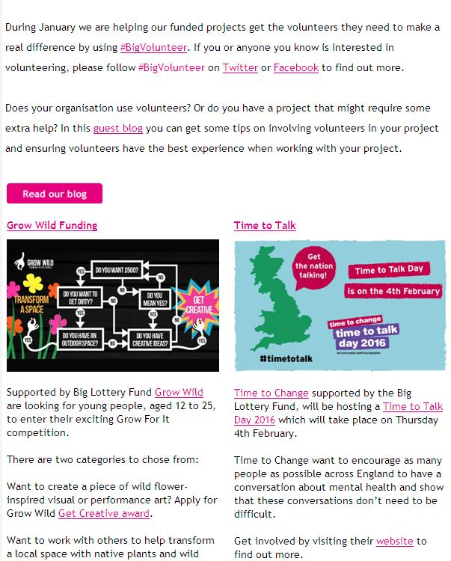

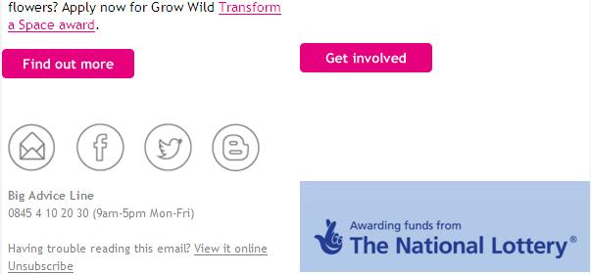





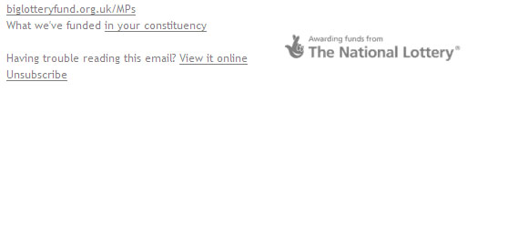

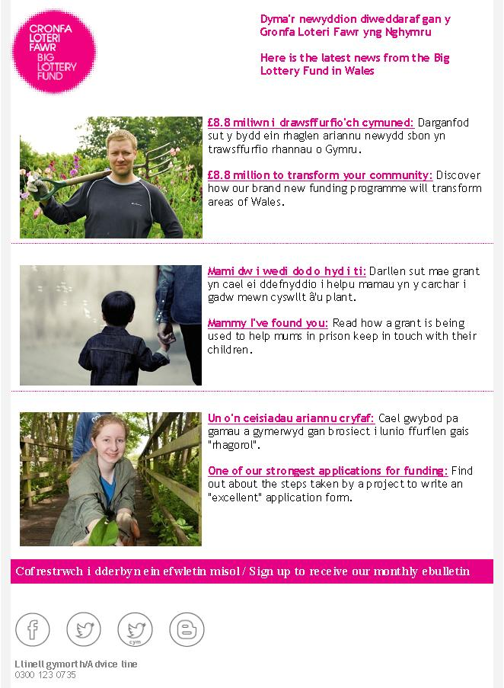

Appendix B
Our eBulletin subscriber survey
We want to make sure our eBulletins are relevant to your interests.
We'd be grateful if you answered this short survey.

- Where are you based? *This question is required.

- England
- Scotland
- Northern Ireland
- Wales

- Tell us about yourself. Tick all that apply
- I am a grant holder
- I was a grant holder
- I am an applicant
- I use the services of a group funded by the Big Lottery Fund
- I am a volunteer
- I am interested in the community and voluntary sector
- Other

- Do you think you could benefit from help to raise awareness or promote your project?
- Yes
- No
- Not sure

- What’s your area of interest? Tick all that apply
- Events
- Latest news
- Existing projects
- Advice on applying for funding
- Other

- Which of the following topics are you interested in?
- Community
- Education
- Environment
- Economic regeneration
- Health
- Older People
- Young People
- Families
- Health and well being
- Other

