 |  |  | Bay 3/21  Spring Place  105 Commercial Road  Southampton  SO15 1EG  United Kingdom
 | All Applicants for the REFURBISHMENT WORKS AT CROSSKILL HOUSE, MCA HULL MO (BEVERLEY)  Via Contracts Finder |  | Tel:  E-mail: | 020 381 72476  contracts@mcga.gov.uk
 |  |  | Your ref:  Our ref: |  | TCA 3/7/1018
 |  |  | 11 September 2017

Dear All

Tender for REFURBISHMENT WORKS AT CROSSKILL HOUSE, MCA HULL MO (BEVERLEY)

Please see below for information provided and questions raised during the site visit on 6 September 2017. To ensure that all applicants have access to the same information we will publish this document on Contracts Finder. Please note that the deadline for clarifications questions closed on 8 September.

Matters raised by MCA/ CA:

- MCA noted a change to the specification regarding 10.00. Toilet facilities are available for use by the contractors on the unoccupied First Floor until the point that the deep cleaning is undertaken. DeFRA has permitted the use of an office in the first floor demise for the duration of the works.
- MCA raised that the server in the ground floor cannot be moved for the installation of the M&E to the server room, therefore it must be protected with a tarpaulin around the base (to prevent dust entering the server).
- MCA raised that although the power can be isolated on the ground floor for the works, this needs to be permission needs to be sought each time from MCA ICT so that the server can be powered down safely.

Question 1: Should the new corridor walls reach the extent of the ceiling?

Answer: The new walls should reach the structural timber in the roof.

Question 2: What is the preferred option for the ceiling works?

Answer: Contractors are to price for both Options A and B and the MCA will take a view on the preferred option in due course.

Question 3: Should noisy works such as the removal of the masonry wall towards the back of the First Floor be undertaken out of hours?

Answer: Considering that the Ground Floor office is occupied, contractors should propose an optimal programme combining normal working hours and out of hours work to minimise disruption to other users on site.

Question 4: Should the blinds on the First Floor be recovered?

Answer: Yes, the existing blinds should be removed for the duration of the works and refitted prior to handover.

Question 5: Can a list of issues with the ground floor lighting be provided so that the cost of remedial works can be estimated more accurately.

Answer: A full list of reported issues with the lighting scheme as well as an annotated version of drawing LEBS0789-M&E-01 has been provided at Annex 1. Our M&E advisor has indicated that the majority of these issues should be resolved through recommissioning (by/ in collaboration with the original manufacturer) to deliver standard lux levels at desktop for an office space environment (clause 18.01). Note that additionally, the contractor is to install 4 new luminaires over the storage units as per the SOW.

Question 6: What is the propose location of site cabins, skips and is there parking available.

Answer: Crosskill House and its grounds are owned by DeFRA. Minimum parking is available onsite, contractors will need to identify how many spaces they need during the programme. It is anticipated that the skip will be located adjacent to the rear door within the compound. Toilet facilities and an office on the First Floor can be utilised for the majority of the works (see I).

Question 7: Can we view/ obtain photos of the heat pumps and distribution boards?

Answer: Photos of the mains distribution boards for the MCA Ground Floor area of demise are provided at Annex 2. Please note these are located within the MCA server room. The MCA area of demise will be physically and logically separated from the main building BMS.

Question 8: Will out of hours work be overseen by appointed MCA/ DeFRA security?

Answer: The Principal Contractor will be responsible for the security of the work area handed over to them. Crosskill House is an occupied Government building, therefore all workers on site must be have the equivalent of BPSS clearance. This means the Principal Contractor must have checked IDs, have evidence of Right to Work, DBS clearance (criminal record), 3 year employment history and an account of when any worker has spent 6 months or more abroad in the last 3 years for all workers on site. MCA/ DeFRA must have assurances that this has been done prior to the works commencing.

Question 9: How to move bulky materials to the First Floor?

Answer: Contractors must use the main entrance lobby stairwell. The contractor will allow within his method statement adequate protection measures to ensure no damage is caused and that manual handling legislation is adhered to.

ANNEX 1
List of lighting issues, Ground Floor Crosskill House

The Principal Contractor is to liaise with OEM for lighting scheme to arrange full recommissioning and set lux levels to standard for office space at desk level, and to resolve/ rectify any issues around control cabling or power to individual existing luminaires. If the recommissioning identifies a faulty luminaire, this should be raised as an Early Warning Notice. Additionally, to install 4 No. luminaires in accordance with the SOW.

- Main office. Lighting is not bright when turned on at the beginning of the day. Staff have to hold down button to increase intensity. Not known if this is by design, contractor to liaise with manufacturer.
- All lights. Lighting does not appear to be adapting to light levels in the room, and has to be manually adjusted throughout the day.
- Breakout room. When lights are switched on, one (random) light does not switch on. When the switch us held down, all switch on.
- Breakout room. When switch is held down, either emergency light gets brighter and other lights get dimmer, or the other way round.
- Main office. With exception of one, all emergency lights fail to light when switch is flicked on and off. When the switch is held down, emergency lights come on (with exception of broken lights, see below).
- All lights. For information, all lights seem to have been moved slightly during ground floor refurbishment works. We do not propose moving the lights back but contractors should be aware.
- Conference room. One light remains off when light switch is flicked on/ held down. Holding down switch does not increase light intensity.
- All lights. Allow for Lux levels to be retested as part of recommissioning, as perception is still that light levels not bright enough (in particular at locker area).
- Running man signs – should be illuminated, may be resolved through recommissioning.
- See plan:
- One light does not exist as shown on plan (N)
- Location of running man signs (RM)
- Some lights not working at all (however, this may be addressed by MCA maintenance prior to works) (X)
- One light remains on continuously, even when switched off (ON)
- Location of Emergency Lights in green (E)

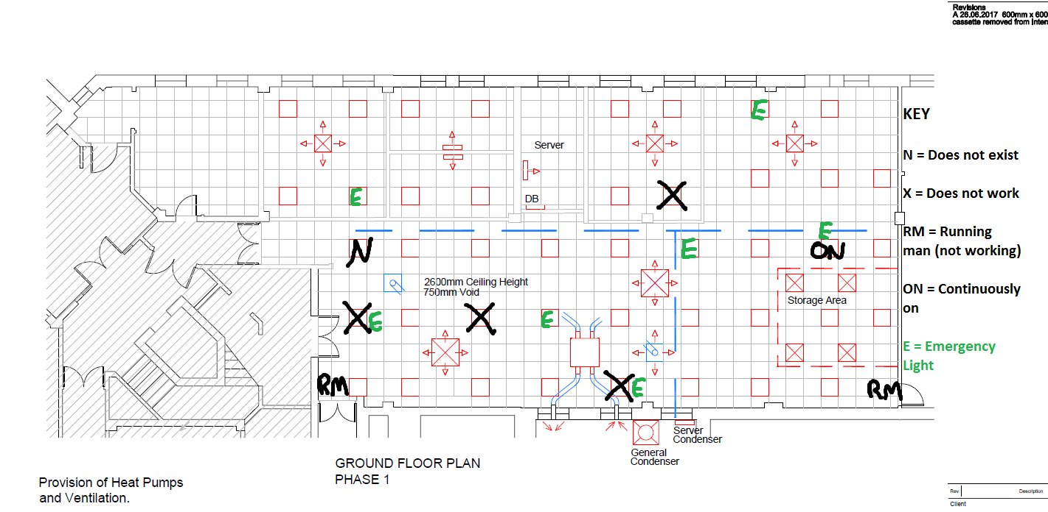
Annotated drawing LEBS0789-M&E-01

ANNEX 2
Photos of mains distribution boards
Serving MCA GF office, located within the Server Room in MCA office

