The Crescent Play Area

Description | Work Needed | Action
Swings – 1 Bay 2 Seat (Cradle) | Cradle Swings  Damaged wet pour – trip hazard | Cradle Swings  AGREED: No further action to be taken.
Swings – 1 Bay 2 Seat (Flat) | Flat Swings  Damaged wet pour – trip hazard | Flat Swings  AGREED: No further action to be taken.
Free Standing Slide | Slide  Damaged wet pour – trip hazard | Slide  Remove & Dispose of existing wet pour flooring and replace with either wet pour or grass matt.

Northfield Park, Leicester Road

Description | Work Needed | Action
Swings – 2 Bay 3 Seat (Cradle) | Wetpour surface has subsided in some areas  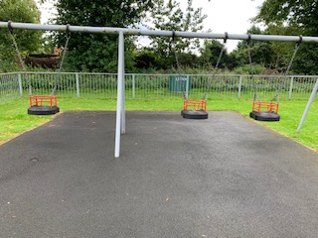 | Remove & Dispose of existing wet pour flooring and replace with either wet pour or grass matt.

Oakfield Park, Hospital Lane

Description | Work Needed | Action
Rocket – Climbing Frame | Gaps opening between the surface | Resurface the rocket climbing frame area.  Remove and dispose of existing wet pour replace with new wet pour or grass matt.
Igloo – Climbing Frame | Surface has subsided in some areas | Resurface the igloo climbing frame area.  Remove and dispose of existing wet pour replace with new wet pour or grass matt.
Swings – 2 Bay 4 Seat (Cradle) | - Algae/moss growth  - Tree debris  - Gaps between the surface  - Wear to the shackles  - Chain wear  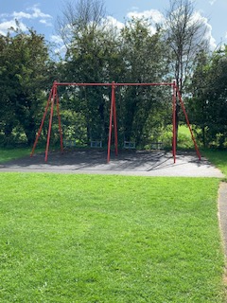 | Remove cradle swings and wet pour and make ground good.
Swings – 2 Bay 4 Seat | - Movement in the cast iron bracket when the swing is under load  - Trip hazard at the edge of the surface  - The seat has minor damage  - Chains are corroded and the links are worn in excess of 40%  - Wear to the shackles  - The swing seat connectors are loose  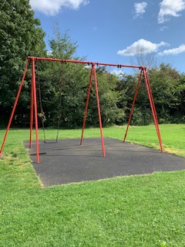 | Remove cradle swings and replace with new ones with grass matt not wet pour.
Swings – 2 Bay 4 Seat  (Flat) | - Trip hazard at the edges of the surface  - Gaps in the opening between the surfacing and the edging  - Replace missing swing chains and seat  - Minor damage to seat  - Swing frame is bent  - Chain links are worn in excess of 40% and require renewing  - Wear to the shackles  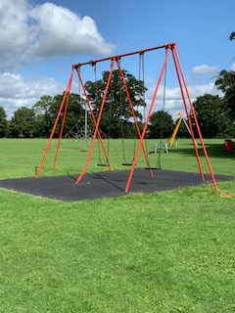 | Remove flat swings and replace with new ones with grass matt not wet pour.
Free Standing Slide | Gaps in the opening between the surfacing and the edging | Fill in wet pour gaps
Multi Use Games Area (MUGA) | 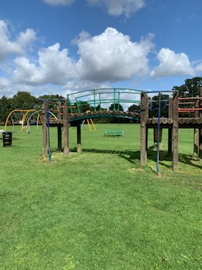 | Remove this equipment and seek quotations for a replacement climbing frame.
Table Tennis | Surface has eroded | Add grass matt to the eroded areas.

